Sunday, August 9th Order of Worship
GOD WELCOMES US
Opening Greeting and Opening Prayer
Call to Worship: Psalm 117 (CEV)
Hear Our Praises
Lord, I Lift Your Name on High
Isaiah 53:4-9
This is Amazing Grace
Call to Confession
Prayer of Confession
Assurance: Romans 8:38,39
In Christ There is No East or West
Children blessed and leave for KIDS Faith Group
GOD GIVES US HIS WORD
Scripture: Acts 8:26-40
Message: “Reason for Rejoicing”
Take My Life
Baptism
GOD SENDS US OUT TO SERVE
Prayers of the People
Offering: LifeWater Canada (Haiti)
Benediction
I Have Decided to Follow Jesus

******************************************


After-service fellowship time is a great chance to meet and make friends. Stay for refreshments and let the fellowship continue!





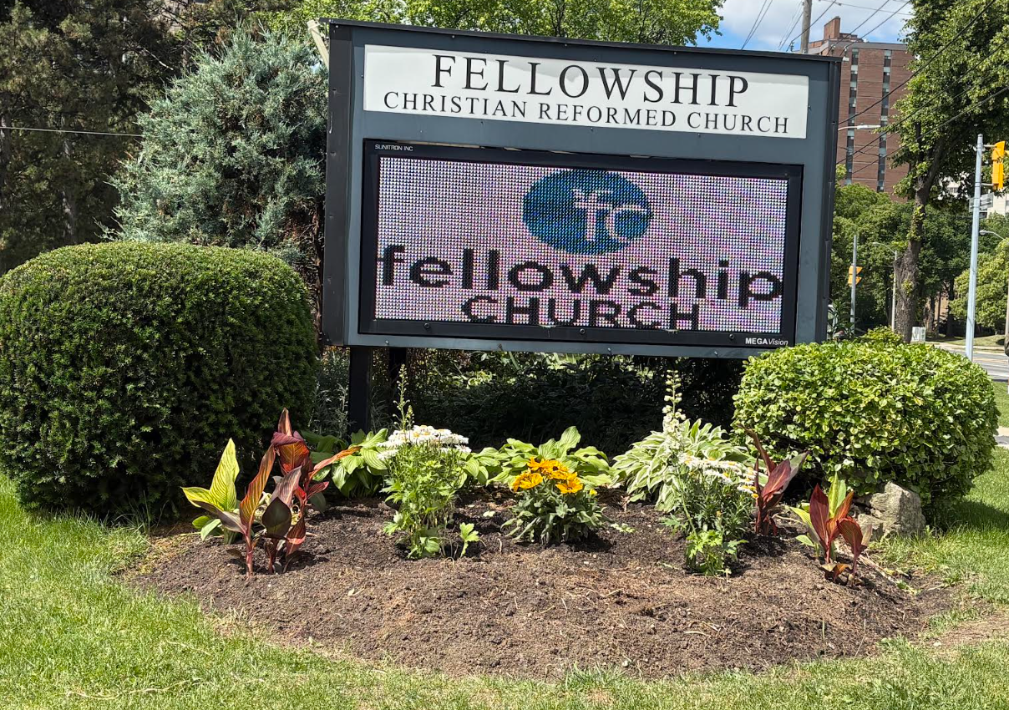

800 Burnhamthorpe Road
Etobicoke, ON, M9C 2Z3

Sunday, August 9th, 2026
Welcome to Fellowship. We are so glad that you chose to worship with us! This morning, Pastor Mark will be sharing a message with us titled: “Reason for Rejoicing” and we will celebrate a baptism!

Our sacred space is a children-friendly space. All children Grade 5 and under are welcome to attend our Fellowship Kids Faith Group during the Sunday service. If this is your first time, thanks for coming! Get a Connect Card from our greeter and leave it on the plate in the foyer.

LIFE TOGETHER
See the list of activities below. We look forward to you joining us! For more information, see the website or ask for an email bulletin.

Sundays: K.I.D.S. Faith Group: ongoing, during the church service
Mondays: The George Hull EarlyON Outdoor Summer Program, weather permitting, begins at 9:00 AM and runs until August 31st, on our church lawn.
Tuesdays: Older Adult Luncheon: We hope you will join us when we re-commence these monthly sessions beginning Sept. 15th.
Wednesdays: Women’s Coffee Break Bible Study: We hope you will join us when we re-commence these sessions in the Fall beginning on Sept. 9th. We will be studying the book of John.
Thursdays: Bible and Life Group, 10:30 AM
Fridays: Walking Group at 9:00 AM for the summer months. Join us for fun, exercise and fellowship!
Family Games Night: We hope you join us when we re-commence these sessions beginning on Fri. Sept. 4th.
SAVE THE DATE
Please join us for a joint worship service and lunch on Sunday August 23rd with Our Presbyterian Church at 10:30 AM.
WAYS TO GIVE
Your financial faithfulness is so appreciated! Our first offering is always for the ongoing ministry of Fellowship Church in our neighbourhood, the second for a special cause. Please use this email address to e-transfer donations or to set up pre-approved donations: fcrc_accounting@fellowshipchurchto.org.
SERMON NOTES
Scripture: Acts 8:26-40 Message: “Reason for Rejoicing”

CONNECT

MINISTER: Rev. Mark Broadus, extension 0403
OFFICE ADMINISTRATOR: Carol De Val, extension 0401
WORSHIP COORDINATOR: Janie Robertson


Call Us: 416-622-9647

Church Office Email: admin@fellowshipchurchto.org
WEBSITE: www.fellowshipetobicoke.com
LIVESTREAM: www.fellowshipetobicoke.com/live
RECORDED SERMONS: on our website, click on www.fellowshipetobicoke.com/podcasts/sermons

