

Wednesday Dinners will resume on August 12 at 5:00 pm Menu: Baked Pork Chops, roasted potatoes, green beans, rolls & dessert Adults $6 Kids $2 To Go plates $7. The signup sheet is located on the bulletin board or you can call Faith at 850-785-6296. Please sign up by noon on Tuesday.
Coffee Chit Chat & Adult Coloring meets on Tuesdays from 8:30-10:30am in room 102 .
Conversations Over Coffee will break for the summer and resume on September 1.
Women’s Tuesday night Bible study will resume on September 22. Our study will be “Letters to the Church” by Francis Chan.
Women’s Thursday morning Bible Study will resume on August 20 at 10:00 am. Our new study is “Forever For Our Good” by Katie J. McCoy, an in depth study of the Book of Deuteronomy. Join us for fellowship, fun fulfillment in the study of the Holy Scriptures.

5th Sunday is August 30 - One Service Only at 10:30 am followed by a Pot Luck Lunch in the fellowship hall. The church will furnish the meat. Please bring a salad, side dish or dessert to share.

FPC Staff
David Willis, Senior Pastor—david@fpcpc.org Chris Barnes, Worship Director, chris@fpcpc.org Stephanie Houser, Children’s Ministry Directorstephanie@fpcpc.org Sailor Crump, Small Group Coordinator-sailor@fpcpc.org Faith Williams, Admin. Assistant - faith@fpcpc.org

Forest Park Church 1401 W. 23rd St. Panama City, Florida 32405 (850) 785-6296 FPCPC.ORG

Forest Park seeks to make disciples of Jesus by sharing the hope of the gospel, helping discover purpose in God’s Kingdom,
and offering a place of belonging in God’s family.

HOPE * PURPOSE * BELONGING


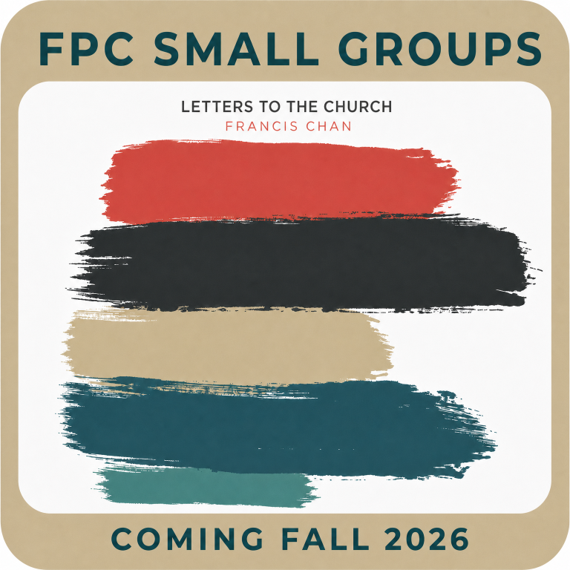
FP Family Ministry
Every Sunday Morning! Pre-k- 5th grade. Come sit with us in the VIK seating in church until Children’s Bread. Then we go to the Kids Hall for a kid-friendly message and fun activities.

Sunday School- Did you know there is a class specifically designed for your child to learn those vital Bible stories throughout the Old and New Testaments? We meet from 9:15-10:15 in the FP Kids Hall. There is a class for pre-K/Kindergarten and one for Elementary so they can understand God's Word at their level!

♦ Nursery is available for children. 0-3yrs.

Blessing of the Backpacks - Students, teachers, school staff, and college students are invited to bring their backpacks, briefcases, or tote bags to the altar today at the 10:30 service, for a special Blessing of the Backpacks. Together, we will pray for God's protection, wisdom, and guidance as a new school year begins. Join us as we send everyone into the new year encouraged, supported, and covered in prayer.

End of Summer Pool Party- Celebrate the end of summer with us at our End of Summer Pool Party today, from 12:00–3:00 PM at Kestrel Pool, 1609 Plover St., Panama City, FL 32405. Bring your swimsuit and towel for an afternoon of swimming, food, & fellowship as we enjoy one last summer celebration together before the new school year begins. We can't wait to celebrate with you!

Forest Park Kids Learning Center We are happy to announce that registration for the 2026-2027 FPK Learning Center is open. To register or for more information, contact Vicki Ahearn or Stephanie Houser at 850-381-3099.

Fall Small Groups Registration opens August 16th Groups begin the week of September 14th The Study will be “Letters to the Church” by Francis Chan

FP Student Ministry
Today is the End of Summer Pool Party from 12-3 pm at the Kestler Pool in Sweet Bay.
-Wednesdays 5:45-7:15 pm
-Sundays 4-6:30 pm NO YOUTH TONIGHT

Young Adults- (18-30) will hangout at Papa Joe’s Bayside on August 14th at 6:00 pm.

FP Men’s Ministry
Men’s Breakfast meets on Wednesdays from 7:00-8:00 am in the fellowship hall.
All the men of Forest Park are invited to join us for the monthly Saturday Morning Men’s Bible Study. We will take a few minutes to fellowship and enjoy biscuits, donuts and coffee before starting a short faith-based lesson. We will continue our study entitled 33 The Series-A man and His Traps. Our next meeting will be Saturday, August 15th from 8 - 9 AM. Looking forward to seeing all the men of Forest Park and please bring a friend!

.

-


