Colington United Methodist Church
We are a Lighthouse Congregation, committed to offering safety and stability to United Methodists who have been displaced or wounded through disaffiliation.

August 9, 2026
Eleventh Sunday after Pentecost

welcome and announcements
call to worship
prelude and lighting of altar candles
Peace Like A River
confession and pardon
Singing Triune God, we confess thick tongues and awkward lives; we are slow to sing your praise. Give us a longing for the gospel song: the rhythm of hope, the harmony of love, the drumbeat of peace, and the passionate joy of our Savior, Jesus
Christ.
In the name of Jesus Christ, we are forgiven people. Glory to God!
Alleluia! Amen.
introit
Every Moment of the Day Loes
opening prayer
†opening hymn
There’s Within My Heart a Melody ǀ UMH 380
sharing joys and concerns
call to prayer
Got Any Rivers?
prayers of the people
the first lesson
Genesis 37:1-4, 12-28
anthem
Springs of Living Water
the second lesson
Psalm 105:1-6, 16-21, 45b
sermon
“Addendum to Saint Cyprian”
†affirmation of praise
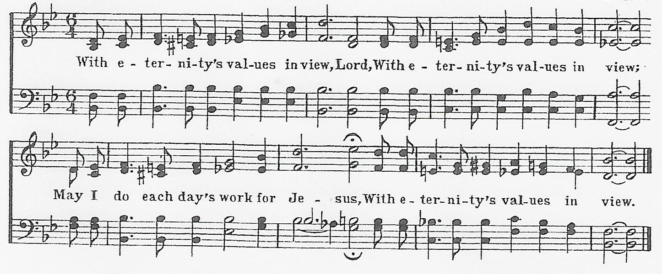
With Eternity’s Values in View

creed
The Apostles’ Creed ǀ UMH 881
prayer of thanksgiving
All things come from you, O God, and with praise and thanksgiving we return to you what is yours. You created all that is, and with love formed us in your image. When our love failed, your love remained steadfast. You gave your only Son Jesus Christ to be our Savior, that we might have abundant and eternal life. All that we are, and all that we have, is a trust from you. And so, in gratitude for all that you have done, we offer you ourselves, and all that we have, in union with Christ’s offering for us. By your Holy Spirit make us one with Christ, one with each other, and one in ministry to all the world; through Jesus Christ
our Lord. Amen.
†closing hymn
God Will Take Care of You ǀ UMH 130
_________________________________________________________
this week at colington
These opportunities to serve as the Body of Christ are available.
Tuesday – 9 am – Prayer Group
6:15pm – Beach fellowship
Wednesday – 10am – Knitters and crocheters
Thursday – 4pm – Mobile food pantry at FFES.
Saturday – 9am - Men’s ministry breakfast meeting.
10:15am – Worship service at Spring Arbor Memory Care Unit.

coming up
Next Sunday –– 8:30am – choir practice
9:30 am – Worship, in-person and Facebook Live and YouTube.
Wed., Aug. 19 – 10am - Admin. Council meets.
4:00-6:00pm – Farewell reception for Evelyn Irelandat Run Hill Community Center.
Sat., Aug. 22 – 10am -2pm – Dare County Special Olympics picnic at North Beach Rec. Center, Mustain St., KDH
Wed., Aug. 26 – 10am – Knitters and crocheters.
1:45 – Volunteers to beach food pantry.
Sun., Aug. 30 – Manna meal following worship.

Thanks to today’s volunteers!
Ushers – Steve Knowles/Ozzie Gray
Scripture Reader – Sherry Rollason
The flowers on the altar are given in memory of Arnette Smith.

Last Week’s attendance – 70.


To make an electronic donation, please use the QR code below.

