

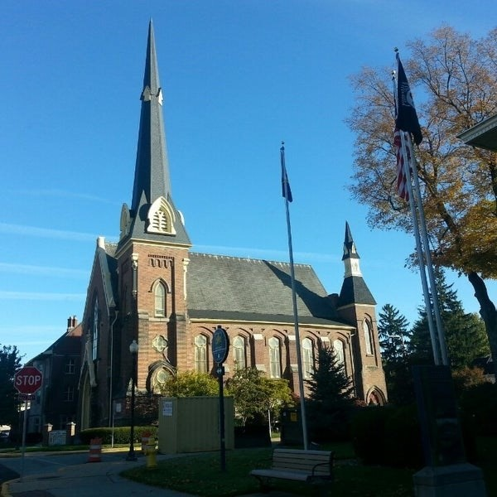
August 5, 2026

A Global Methodist Church
214 S. 5th Street
Goshen, IN 46528
Phone: 574-533-9518
Web Site: goshenfirstgmc.org

Office Hours: Monday-Thursday,
8:00 a.m.-1:00 p.m.
Worship: 9:00 a.m.
Sunday School: 10:30 a.m.
Pastor Jeff & Lisa
Associate Pastor Rich Hull
OUR VISION: “Growing in Faith, Gathering in Community, and Giving in Love”.

Grief Share
Grief Share will start on August 12th at 6pm at the church and will continue through November 11th. Sue Wirt will be leading the class. If you plan on attending the class please contact Sue at 574-238-2894.

The Monday morning Bible Study continues to meet this summer. They are
studying the book, “Knowing God,” by J.I. Packer. All are welcome.

We are asking for granola bars for Waterford Schools. They can be put in the boxes in the garden room by the office. Thank you so much.

Primetimers will be going to Ride the Dixie in North Webster on August 20th. We will be collecting money at coffee hour on August 9th and the 16th. The cost is $10.00. We will be having lunch at Chubbies at 11:00. We will leave the Life Center at 10:15.

SHRED 60 Class
Shred 60 class will start back up August 13th -Every Tuesday and Thursday from
9- 9:45am here at the church in the gym.
Walking/ Piyo Class will start August 17th from 10:45-11:45am on Mondays. We will meet outside at different parks/ locations in Goshen. We will meet in the church gym if it is raining. If you have any questions contact Mindi Swihart
574-370-3172.

VOLUNTEERS – Thank you for your service - Sunday morning, August 9th
Greeters: Bob and Terri Krug VIP: Kelley Leeper
Elevator Hosts: Sue Graves
Ushers: Chuck Rink, Max Leatherman, Kent Evans, Mary Ann Eash, Carter Martin
Scripture Reader: Jeanne Bigler
Elementary Junior Church:
Junior High Church:
Coffee Hour: Ben’s / Twigbenders/ Bob’s SS Class
Bus Driver: Steve Warner


INVITATION
All ladies of the church are invited to an Afternoon Tea with the Bride-to-Be, a bridal shower for Kyndal Hazen on Saturday, August 15, at 11:00 a.m. Join us for a delightful afternoon of refreshments, games, and celebrating the bride-to-be as she prepares for her wedding day. Scott and Kyndal have a registry on Amazon. Please RSVP to Elisabeth Morgan at 616-315-5492. The shower will be held at: 300 Norther Lites Drive, Middlebury.

LAST SUNDAY
Attendance: 136
Offering: $6,684.50

