

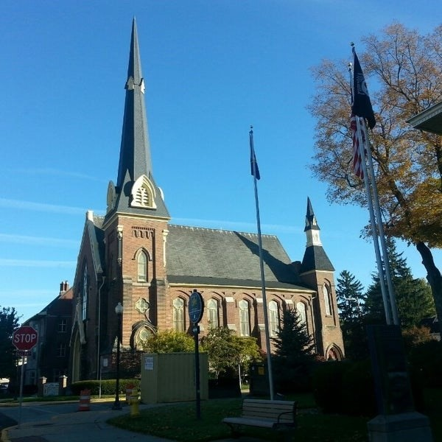
July 22, 2026

A Global Methodist Church
214 S. 5th Street
Goshen, IN 46528
Phone: 574-533-9518
Web Site: goshenfirstgmc.org

Office Hours: Monday-Thursday,
8:00 a.m.-1:00 p.m.
Worship: 9:00 a.m.
Sunday School: 10:30 a.m.
Pastor Jeff & Lisa
Associate Pastor Rich Hull
OUR VISION: “Growing in Faith, Gathering in Community, and Giving in Love”.

SPECIAL CHURCH CONFERENCE – JULY 26
On Sunday, July 26, at 6:00 p.m., in the Garden Room, our Presiding Elder,
Pastor Gary Lewis, will host a special Church Conference pertaining to the
possibility of us gaining the parking spaces which border the north side of our
building. All members and attenders are welcome to be a part of this important
meeting. A vote will be taken by members of Goshen First Methodist. Please
come and be a part of this special church conference.

WELCOME, KRISTI!
We welcome our new Office Administrator, Kristi Sandt. She has begun her training in the office since Harriet’s last day will be August 7. Kristi is married to Colin and they have two adult children and one grandchild. They live in Middlebury. Come and introduce yourself and make her feel welcome!

Vacation Bible School will be held at our church on August 3-6, from 9:00-11:00 a.m. We will have VBS work days on Thursdays from 9:00-11:00 a.m. Anyone is welcome to join and help us, even if you haven’t signed up to help or won’t be around for VBS.

The Monday morning Bible Study continues to meet this summer. They are
studying the book, “Knowing God,” by J.I. Packer. All are welcome.

VOLUNTEERS – Thank you for your service - Sunday morning, July 26
Greeters: Dan & Kathy Seltenright VIP: Cathy Smith
Elevator Hosts: Sharon Hull, Sandy Priem
Ushers: Erv Herschberger, Sharon Hull, Ken Smith, Dan Becker, Steve Warner
Scripture Reader: Jeff Griffin
Elementary Junior Church: Rachel Parsons, Kelley Leeper
Junior High Church: Jeanne Bigler
Coffee Hour: Fisherman’s S.S. Class
Bus Driver: Al Eppert


INVITATION
All ladies of the church are invited to an Afternoon Tea with the Bride-to-Be, a bridal shower for Kyndal Hazen on Saturday, August 15, at 11:00 a.m. Join us for a delightful afternoon of refreshments, games, and celebrating the bride-to-be as she prepares for her wedding day. Scott and Kyndal have a registry on Amazon. Please RSVP to Elisabeth Morgan at 616-315-5492. The shower will be held at: 300 Northern
Lites Drive, Middlebury.
LAST SUNDAY
Attendance: 110
Offering: $12,606.50

