Parkside Lutheran Church
Rediscovering the Radical Love of Jesus
Gathering All
Serving All
Caring For All



August 16th, 2026
Holy Communion 10:00am
The Rev. Randy Milleville
Parkside Lutheran Values

Proclaiming Grace - Jesus shared and lived out a message of grace, love, and new life. We believe these promises come from God freely, as a gift for all. We are loved and the Spirit inspires us to share this good news in accessible, relevant, and new ways. Luke 4:17-19, John 1:16-17, John 3:16-17, Ephesians 2:8-9

Practicing Hospitality – Jesus welcomed the little children, broke bread with outcasts, and proclaimed the Good News to all. Whether you are strong in faith, wrestling with doubt, or somewhere in between, we affirm that you are welcome here. Jesus is for everyone. Leviticus 19:34, Matthew 9:10, Matthew 19:14, Hebrews 13:2

Loving Boldly - Jesus challenged traditions to demonstrate God’s justice and love of neighbor. His compassionate and sacrificial love inspires us to take risks. Striving to follow his command to love neighbor, our ministries serve, transform, and advocate for folks near and far. Micah 6:8, Mark 11:15-17, Luke 10:25-28, John 15:12-13

Cultivating Community - Jesus built communities that transformed lives. We are the body of Christ and we are called to continue this ministry of transformation. Guided by the Holy Spirit, we build connections within and outside of these walls, and with all of God’s creation. Ecclesiastes 4:9-12, Matthew 28:16-20, 1 Corinthians 12:12-14, Galatians 3:26-29

Welcome Visitors!
Please use QR code to let us know you were here today or to sign up for our weekly enewsletter. Find us on Facebook & Instagram
WIFI: Balcony password: FreeGrace

For your safety in the event of an emergency: In addition to the three exits in the back of the sanctuary, there are exits on either side of the altar (on left side: floor level near piano and up steps past altar. On right side: up steps to the altar, past band area)

Contact us: (716) 836-1361
2 Wallace Ave. Buffalo, NY 14214
parksidelutheran.org | parksidelutheran@gmail.com

GATHER
The Holy Spirit calls us together as the people of God.
Introduction to the Day: In Isaiah we hear that God’s house shall be a house of prayer for all people and that God will gather the outcasts of Israel. The Canaanite woman in today’s gospel is a Gentile, an outsider, who is unflinching in her request that Jesus heal her daughter. As Jesus commends her bold faith, how might our church extend its mission to those on the margins of society? In our gathering around word and meal we receive strength to be signs of comfort, healing, and justice for those in need.

Prelude Michael Hooker, Music

Please stand as you are able

Call to Worship
WA: Come and worship, all you who love and serve the Lord—
C: outsiders and insiders, old-timers and new-comers,
the young, old and the in-between.
WA: Come as you are, for this is God’s house—
C: a house of prayer for all people, and God welcomes each one who comes.

+Gathering Hymn: Build a Longer Table ACS # 1062 (printed next page)

Welcome and Announcements

Confession and Forgiveness
P: Blessed be the holy Trinity, + one God, whose compassion endures forever.
C: Amen.
P: Let us confess our sins to God.
Silence is kept for reflection.
P: Compassionate God,
C: we confess to you all our sins. Our burden is heavy, and we cannot free ourselves. In your mercy, call us back to you. Your yoke is easy and your burden is light. Restore us to dwell in your peace. In Christ’s name we pray, Amen.
P: Jesus says, “Come to me, all you who are weary and are carrying heavy burdens, and I will give you rest.” In the name of God, Father, + Son, and Holy Spirit, your sins are forgiven. Rest in God’s love.
C: Amen.
Greeting

WA: The grace of our Lord, Jesus Christ, the love of God, and the communion of the Holy Spirit be with you all. C: And also with you.

Kyrie ELW #157
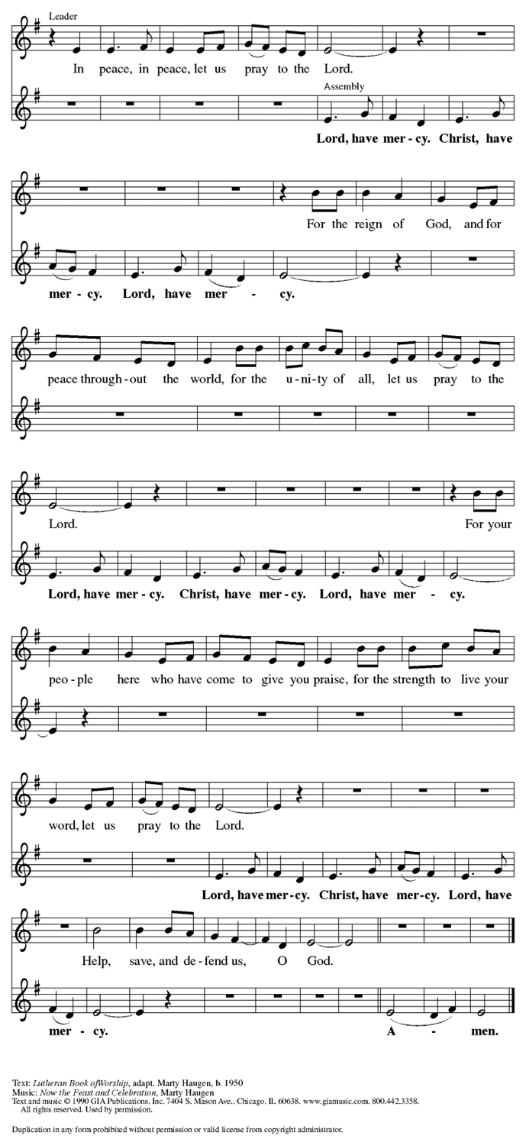

Prayer of the Day
WA: Let us pray together.
C: God of all peoples, your arms reach out to embrace all those who call upon you. Teach us as disciples of your Son to love the world with compassion and constancy, that your name may be known throughout the earth, through Jesus Christ, our Savior and Lord. Amen.

Children’s Sermon: Jesus said, “Let the little children come to me!”
We welcome children in worship.

WORD
God speaks to us in scripture readings, preaching and song.

First Reading: Isaiah 56:1, 6-8
The prophet calls upon Israel to do justice in view of God’s imminent intervention to save. Righteousness and obedience define who belongs to the Israelite community—not race, nationality, or any other category.
L: ¹ Thus says the Lord: Maintain justice, and do what is right, for soon my salvation will come and my deliverance be revealed.
⁶ And the foreigners who join themselves to the Lord, to minister to him, to love the name of the Lord, and to be his servants, all who keep the Sabbath and do not profane it and hold fast my covenant— ⁷ these I will bring to my holy mountain and make them joyful in my house of prayer; their burnt offerings and their sacrifices will be accepted on my altar, for my house shall be called a house of prayer for all peoples. ⁸ Thus says the Lord God, who gathers the outcasts of Israel: I will gather others to them besides those already gathered.
L: Word of God, word of life. C: Thanks be to God.
Psalm: Psalm 67 Let all the peoples praise you, O God. (Ps. 67:3)
L: ¹ May God be merciful to us and bless us;
may the light of God’s face shine upon us.
C: ² Let your way be known upon earth,
your saving health among all nations.
L: ³ Let the peoples praise you, O God; let all the peoples praise you.
C: ⁴ Let the nations be glad and sing for joy,
for you judge the peoples with equity and guide all the nations on earth.
L: ⁵ Let the peoples praise you, O God; let all the peoples praise you.
C: ⁶ The earth has brought forth its increase;
God, our own God, has blessed us.
L: ⁷ May God give us blessing,
and may all the ends of the earth stand in awe.
L: Word of God, word of life. C: Thanks be to God.

Second Reading: Romans 11:1-2a, 29-32
God has not rejected Israel. Rather, the call and gifts of God are irrevocable so that, while all have been disobedient, God has mercy upon all.
L: [Paul writes:] ¹ I ask, then, has God rejected his people? By no means! I myself am an Israelite, a descendant of Abraham, a member of the tribe of Benjamin. ^{2a} God has not rejected his people whom he foreknew.
²⁹ For the gifts and the calling of God are irrevocable. ³⁰ Just as you were once disobedient to God but have now received mercy because of their disobedience, ³¹ so also they have now been disobedient in order that, by the mercy shown to you, they also may now receive mercy. ³² For God has imprisoned all in disobedience so that he may be merciful to all.
L: Word of God, word of life. C: Thanks be to God.

Please stand as you are able

Gospel Acclamation Setting 10 (p. 205)
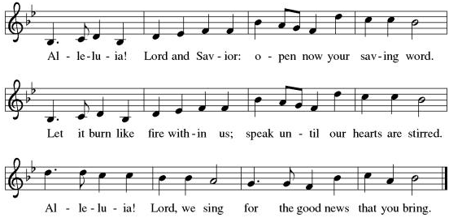

Gospel Reading: Matthew 15:10-28
Jesus teaches his disciples that true purity is a matter of the heart rather than outward religious observances. Almost immediately, this teaching is tested when a woman considered to be a religious outsider approaches him for help.

P: The Holy Gospel according to Matthew. C: Glory to you, O Lord.
P: ¹⁰ [Jesus] called the crowd to him and said to them, “Listen and understand:¹¹ it is not what goes into the mouth that defiles a person, but it is what comes out of the mouth that defiles.” ¹² Then the disciples approached and said to him, “Do you know that the Pharisees took offense when they heard what you said?” ¹³ He answered, “Every plant that my heavenly Father has not planted will be uprooted. ¹⁴ Let them alone; they are blind guides of the blind. And if one blind person guides another, both will fall into a pit.” ¹⁵ But Peter said to him, “Explain this parable to us.” ¹⁶ Then he said, “Are you also still without understanding? ¹⁷ Do you not see that whatever goes into the mouth enters the stomach and goes out into the sewer? ¹⁸ But what comes out of the mouth proceeds from the heart, and this is what defiles. ¹⁹ For out of the heart come evil intentions, murder, adultery, sexual immorality, theft, false witness, slander. ²⁰ These are what defile a person, but to eat with unwashed hands does not defile.”
²¹ Jesus left that place and went away to the district of Tyre and Sidon. ²² Just then a Canaanite woman from that region came out and started shouting, “Have mercy on me, Lord, Son of David; my daughter is tormented by a demon.” ²³ But he did not answer her at all. And his disciples came and urged him, saying, “Send her away, for she keeps shouting after us.”
²⁴ He answered, “I was sent only to the lost sheep of the house of Israel.” ²⁵ But she came and knelt before him, saying, “Lord, help me.” ²⁶ He answered, “It is not fair to take the children’s food and throw it to the dogs.” ²⁷ She said, “Yes, Lord, yet even the dogs eat the crumbs that fall from their masters’ table.” ²⁸ Then Jesus answered her, “Woman, great is your faith! Let it be done for you as you wish.” And her daughter was healed from that moment. P: The Gospel of the Lord. C: Praise to you, O Christ.

Sermon The Rev. Randy Millville

Please stand as you are able

+Hymn of the Day: O For a Thousand Tongues to Sing ELW #886

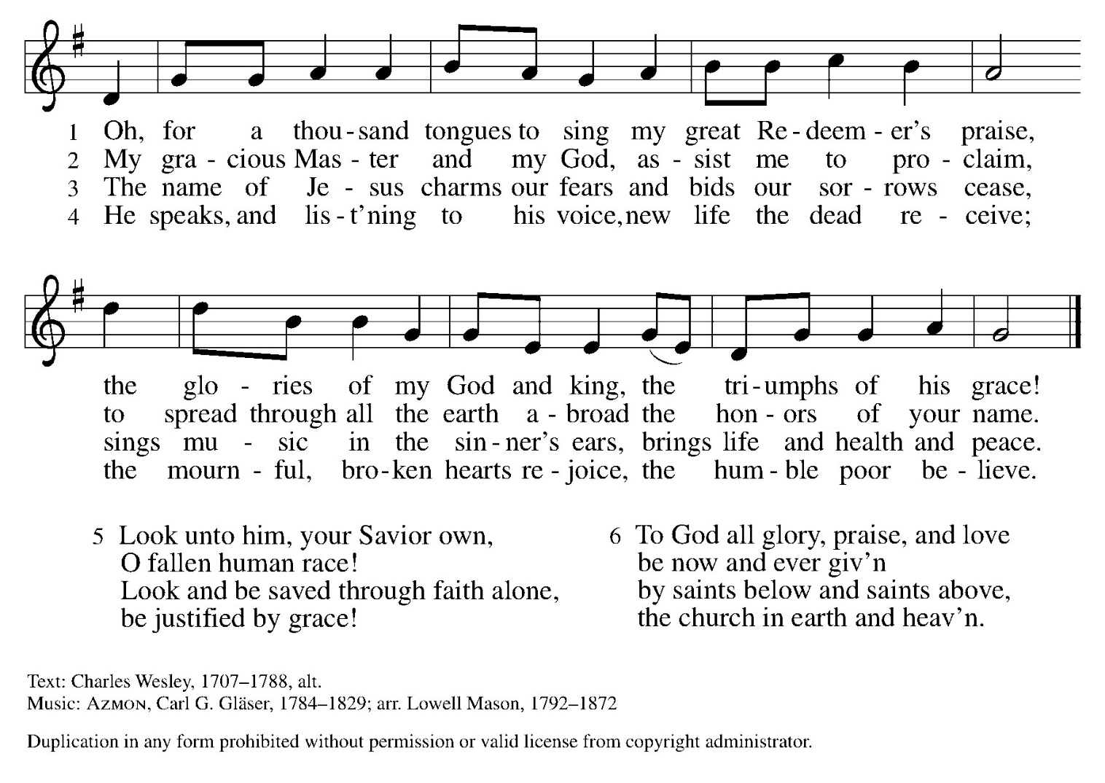

Apostles’ Creed WA: Let us confess the faith using the words of the Apostle’s Creed.
C: I believe in God, the Father almighty, creator of heaven and earth.
I believe in Jesus Christ, God’s only Son, our Lord, who was conceived by the Holy Spirit, born of the virgin Mary, suffered under Pontius Pilate, was crucified, died, and was buried; he descended to the dead. On the third day he rose again; he ascended into heaven, he is seated at the right hand of the Father, and he will come to judge the living and the dead.
I believe in the Holy Spirit, the holy catholic church, the communion of saints, the forgiveness of sins, the resurrection of the body, and the life everlasting. Amen.

Prayers of the People WA: With bold trust in God’s unfailing provision, we pray for the church, those in need, and all of God’s creation. (a brief silence)
WA: For believers around the world who stream to your holy mountain, that all be united in faith and harmony in the body of Christ. Let your church on earth be a witness to the beloved community of your heavenly kingdom. Merciful God, C: receive our prayer.

WA: For the nations of the world and all in authority, that they heed the cry of the outcast and ensure care for the most vulnerable. Give wisdom to leaders of countries, congregations, and communities, that they lead and serve justly. Merciful God, C: receive our prayer.

WA: For all who are lonely, grieving, or struggling with chronic pain, that they find comfort, community, and hope. Send relief to all who struggle with illness or difficulty of any kind, especially those we name aloud or in the silence of our hearts…. Merciful God, C: receive our prayer.

WA: For this congregation, for visitors and those new to this faith community, that all may recognize the presence of Christ in each new face. Draw this community together in love and strengthen it in unwavering faith. Merciful God, C: receive our prayer.

WA: For the saints before us whose work is done, that their faithful example continues to direct your church. May their witness remind us that your gifts and calling are irrevocable, whether in life or death. Merciful God,
C: receive our prayer.

WA: Receive our prayers and answer, O God, as you have promised. All this we ask in the name of your Son, Jesus Christ our Lord. C: Amen.

Peace
P: The peace of Christ be with you always. C: And also with you.

Meal - God feeds us with the presence of Jesus Christ

Offering
We are grateful to those who help sustain our mission. To donate online, please use QR code:


+ Offering Prayer
WA: Let us pray together:
C: Loving God, we offer at your table the gifts of our hearts. Help us take heart in you and share freely of your love, so that all creation can taste your abundance. We ask this in the name of Jesus, through the Spirit abiding with us now and forever. Amen.

+ Offertory Song: Let the Vineyards Be Fruitful ELW #184
(printed next page)

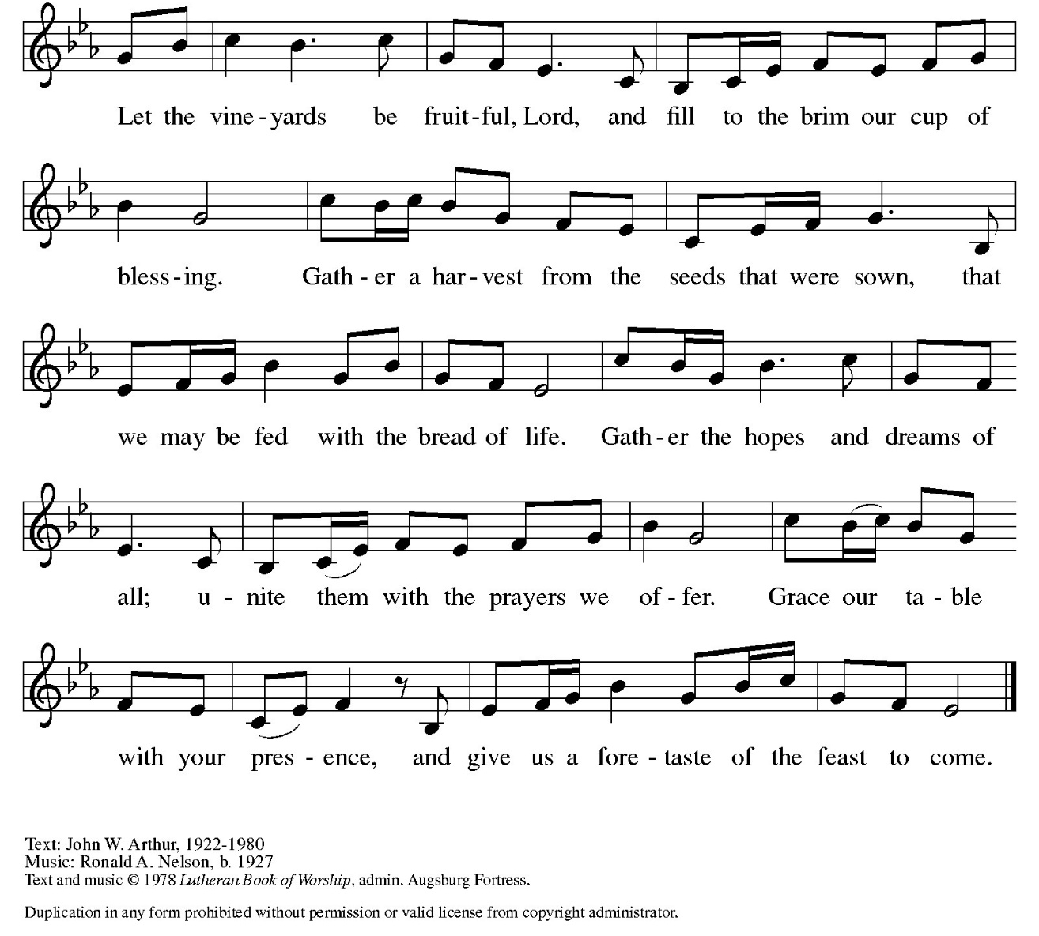

Great Thanksgiving
P: The Lord be with you. C: And also with you.
P: Lift up your hearts. C: We lift them to the Lord.
P: Let us give thanks to the Lord our God.
C: It is right to give our thanks and praise.

Preface
P: It is indeed right, our duty and our joy, that we should at all times and in all places give thanks and praise to you, almighty and merciful God, through our Savior Jesus Christ; who on this day overcame death and the grave, and by his glorious resurrection opened to us the way of everlasting life. And so, with all the choirs of angels, with the church on earth and the host of heaven, we praise your name and join their unending hymn:

Holy Holy Holy ELw setting 10 (p. 207)
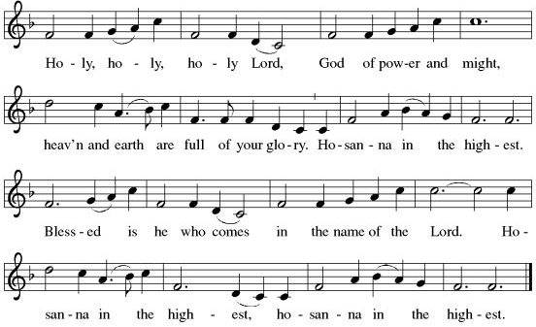

Thanksgiving at the Table

P: In the night in which he was betrayed, our Lord Jesus took bread, and gave thanks; broke it, and gave it to his disciples, saying: Take and eat; this is my body, give for you. Do this for the remembrance of me. Again, after supper, he took the cup, gave thanks, and gave it for all to drink, saying: This cup is the new covenant in my blood, shed for you and for all people for the forgiveness of sin. Do this for the remembrance of me.

Lord’s Prayer
P: Lord, remember us in your kingdom and teach us to pray.
C: Our Father in heaven, hallowed be your name, your kingdom come, your will be done, on earth as in heaven. Give us today our daily bread. Forgive us our sins as we forgive those who sin against us. Save us from the time of trial and deliver us from evil. For the kingdom, the power, and the glory are yours, now and forever. Amen.

Invitation to the Table
At Parkside Lutheran Church we have an open table. We believe the invitation to receive comes from Jesus himself and all are welcome at Christ’s table. More than just Bread and Wine these are tangible signs of God’s love for you! If you do not wish to receive communion but would like a blessing, come forward and cross your arms over your chest. The Pastor will give you a blessing before you return to your seat via the side aisle. You’ll receive a communion wafer* in your hands. You may dip it in the cup of wine or juice. When giving the bread and cup, the communion ministers say: “The body of Christ, given for you. The blood of Christ, shed for you.”
and each person may respond: Amen
*Please let Pastor know if you need a gluten-free wafer
P: Heaven has come near. Come, share in the feast!

The Communion Distribution

Communion Song ELW setting 10 (p. 208)
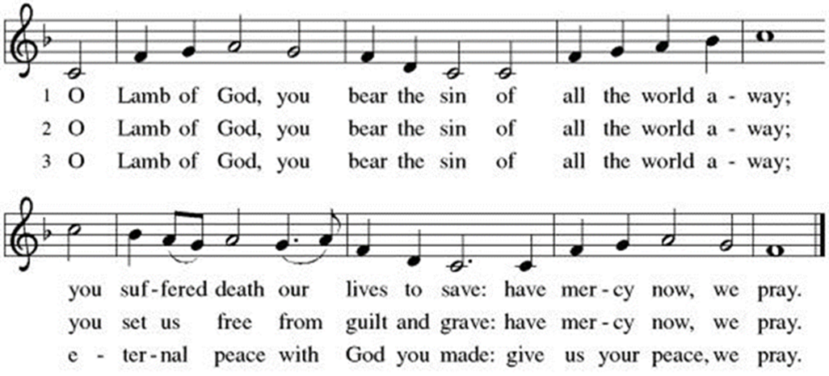

COMMUNION SONG: Ten Thousand Reasons ACS #1097
(printed next page)
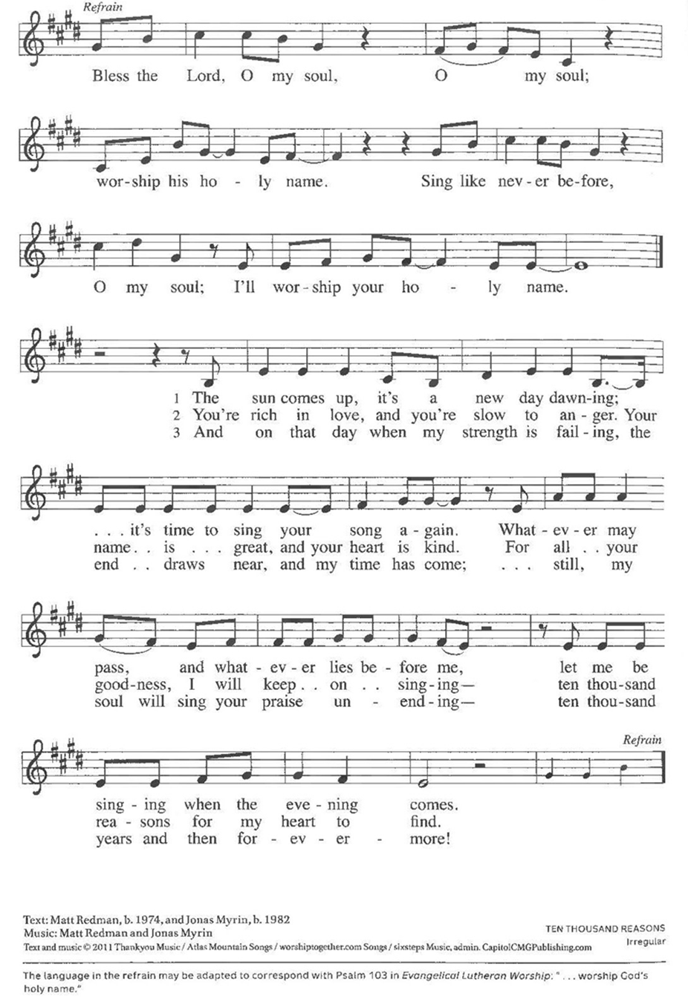

Communion Song: Lord, Listen to Your Children Praying

Post Communion Blessing
P: The Body and Blood of our Lord and Savior, Jesus Christ, strengthen you and keep you in God's grace. C: Amen.

Prayer After Communion
WA: Let us pray together.
C: Compassionate God, through the gifts of bread and wine our hearts are filled with the abundance of your love. Strengthen us that we, through this holy meal, may share your love freely, as you have shared with us. We ask this in the name of Jesus, through the Spirit nourishing us now and forever. Amen.

Sending - God blesses us and sends us in mission to the world.

Blessing
P: Creator, Redeemer, Sustainer, + one God, bless, heal, and hold you today and always. C: Amen.

Sending Hymn: Hymn Raffle

Dismissal and Postlude
P: Parkside Lutheran Church is rediscovering the radical love of Jesus.
C: Gathering All, Serving All, Caring for All
P: Heaven has come near. Go, share the good news.
C: Thanks be to God.
ELW Music licensed from Sundays & Seasons, Augsburg Fortress CCLI MUSIC License # 11440069 , CCLI Streaming License#21835523 Do not duplicate any music or Liturgy herein without license and permission
scripture readings adapted and written by susan lukey

PARKSIDE STAFF:
• The Rev. Jeremiah Smith: prjeremiahpsmith@gmail.com
• Kris Pope & Suzanne Gracie, Admin. Assistants (Church Office): parksidelutheran@gmail.com
• Mike Hooker, Music Director: mrhooker@me.com
CHURCH OFFICE HOURS: M/T/R 10:00am-3:00pm (716)836-1361
Acolytes: |  | Worship Assistants:
8/16 – Annalie & Emmet |  | 8/16 - Onda
8/23 – David & Grace |  | 8/23 - John
Readers: |  | Ushers:
8/16 – Anne |  | 8/16 – Nick, Tom, John, Charlie
8/23 – John F. |  | 8/23 – Ricky, Shannon, David

Coming up:
August 19th – Volunteer Meeting for Vacation Bible School – 5:30pm
August 24th – 28th – Vacation Bible School - SIGN UP TODAY!
Visit our website for more information about these and other Events at Parkside – www.parksidelutheran.org/events

