ChristLife is coming to SPN, Pennsburg, this Fall 2026
Discovering Christ will be on Tuesday evenings (6pm- 8;30pm): Oct. 13th-Nov 24th
Free dinner and fellowship. You do not need to be a parishioner to attend.
All are welcome.
Register Here
Location: St. Philip Neri Catholic Parish Social Hall
1325 Klinerd Rd. Pennsburg, Pa 18073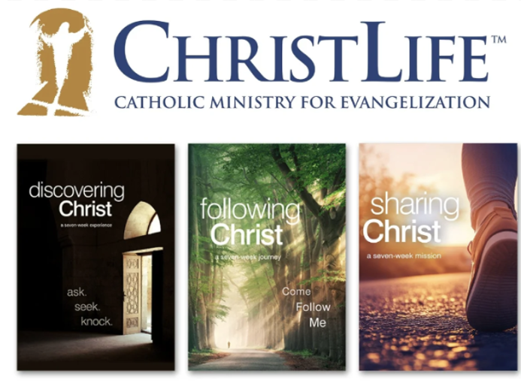
ChristLife Program:
- Discovering Christ: Do you have questions about your faith? Discover the meaning of your life and how Jesus wants to be an integral part of it.
Through the ChristLife journey, doors will open to the beautiful and joyful life of being a Christian disciple. In Discovering Christ, encounter the love of God the Father, enter into or renew a personal relationship with Jesus Christ and be empowered by the Holy Spirit to live as God’s children. And if you want more join us for….
- Following Christ (Jan/Mar 2027):Once you have encountered this personal love of Jesus you will hunger to dive deeper into this new relationship. Following Christ will provide the tools to help live this new abundant life of discipleship and grow in your knowledge of Christ and his love for you. And if you want even more, join us for….

- Sharing Christ (Apr-May 2027): Having experiences such Good News. It is hard to contain the joy that it brings. Sharing Christ will equip you to spread this Good News to others and truly live out Christ’s call to be missionary disciples.

