Parkside Lutheran Church
Rediscovering the Radical Love of Jesus
Gathering All
Serving All
Caring For All



August 9th, 2026
Holy Communion 10:00am
The Rev. Jeremiah Smith
Parkside Lutheran Values

Proclaiming Grace - Jesus shared and lived out a message of grace, love, and new life. We believe these promises come from God freely, as a gift for all. We are loved and the Spirit inspires us to share this good news in accessible, relevant, and new ways. Luke 4:17-19, John 1:16-17, John 3:16-17, Ephesians 2:8-9

Practicing Hospitality – Jesus welcomed the little children, broke bread with outcasts, and proclaimed the Good News to all. Whether you are strong in faith, wrestling with doubt, or somewhere in between, we affirm that you are welcome here. Jesus is for everyone. Leviticus 19:34, Matthew 9:10, Matthew 19:14, Hebrews 13:2

Loving Boldly - Jesus challenged traditions to demonstrate God’s justice and love of neighbor. His compassionate and sacrificial love inspires us to take risks. Striving to follow his command to love neighbor, our ministries serve, transform, and advocate for folks near and far. Micah 6:8, Mark 11:15-17, Luke 10:25-28, John 15:12-13

Cultivating Community - Jesus built communities that transformed lives. We are the body of Christ and we are called to continue this ministry of transformation. Guided by the Holy Spirit, we build connections within and outside of these walls, and with all of God’s creation. Ecclesiastes 4:9-12, Matthew 28:16-20, 1 Corinthians 12:12-14, Galatians 3:26-29

Welcome Visitors!
Please use QR code to let us know you were here today or to sign up for our weekly enewsletter. Find us on Facebook & Instagram
WIFI: Balcony password: FreeGrace

For your safety in the event of an emergency: In addition to the three exits in the back of the sanctuary, there are exits on either side of the altar (on left side: floor level near piano and up steps past altar. On right side: up steps to the altar, past band area)

Contact us: (716) 836-1361
2 Wallace Ave. Buffalo, NY 14214
parksidelutheran.org | parksidelutheran@gmail.com

GATHER
The Holy Spirit calls us together as the people of God.
Introduction to the Day: When the disciples face a great storm on the sea, they cry out with fear. Jesus says: “Take heart, it is I; do not be afraid.” Amid the storms of life, we gather to seek the calm presence of Christ that soothes our fears. In comforting words of scripture and in the refreshing bread and cup of the eucharist, God grants us peace and sends us forth to be a sign of God’s presence to others.

Prelude Michael Hooker, Music

Please stand as you are able

Call to Worship
WA: Here, in this place, God welcomes all the dreamers, as well as the doubters:
C: here, the worriers and wanderers can call on God by name.
WA: Here, in this time, we can remember all the ways God has graced us:
C: here, in these moments, we are reminded that God is with us, always!
WA: Here are gathered those daring enough to step out of comfort into the unknown:
C: here, in this faith space, we will find the courage to cry out, 'God, save us!' in every situation.

+Gathering Hymn: All Are Welcome ELW # 641 (printed next page)

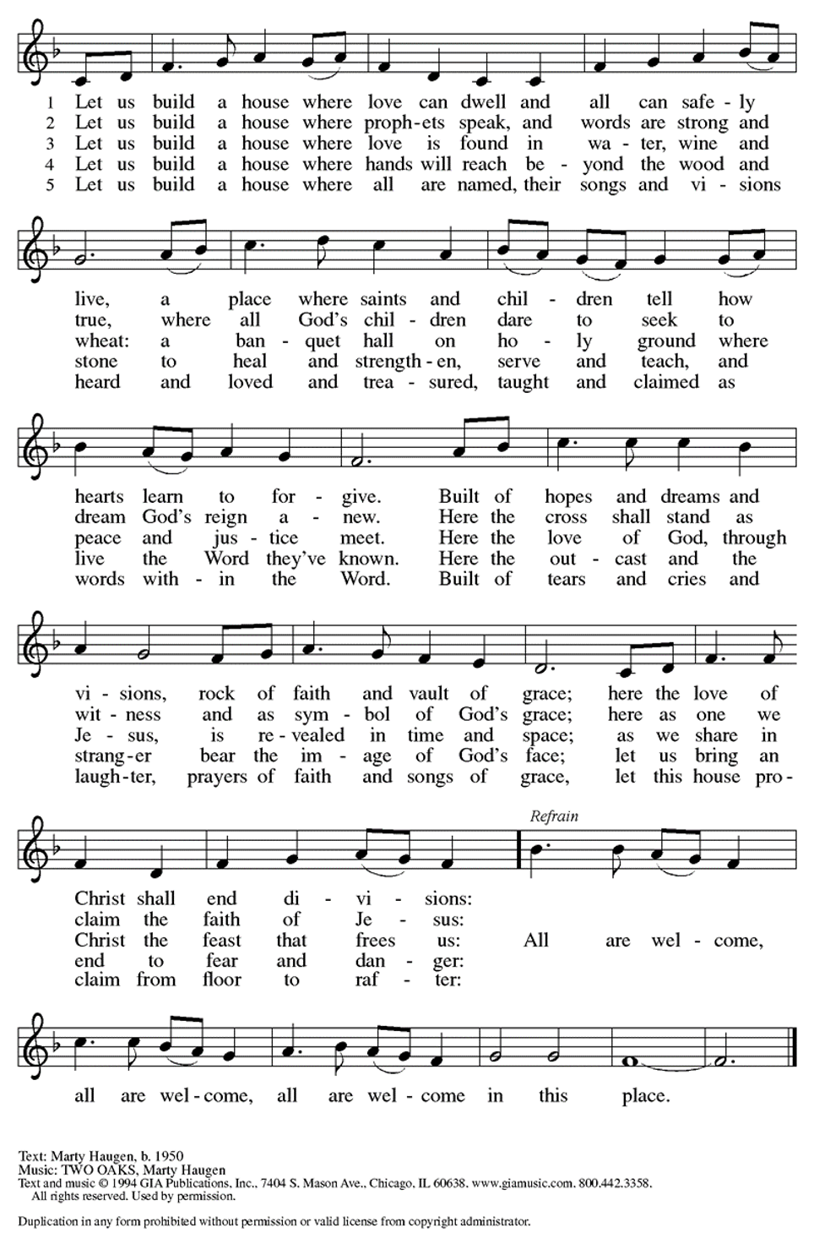

Welcome and Announcements
Today We Officially Welcome New Members

Confession and Forgiveness
P: Blessed be the holy Trinity, + one God, whose compassion endures forever.
C: Amen.
P: Let us confess our sins to God.
Silence is kept for reflection.
P: Compassionate God,
C: we confess to you all our sins. Our burden is heavy, and we cannot free ourselves. In your mercy, call us back to you. Your yoke is easy and your burden is light. Restore us to dwell in your peace. In Christ’s name we pray, Amen.
P: Jesus says, “Come to me, all you who are weary and are carrying heavy burdens, and I will give you rest.” In the name of God, Father, + Son, and Holy Spirit, your sins are forgiven. Rest in God’s love.
C: Amen.

Greeting

WA: The grace of our Lord, Jesus Christ, the love of God, and the communion of the Holy Spirit be with you all. C: And also with you.

Kyrie ELW #157
(printed next page)

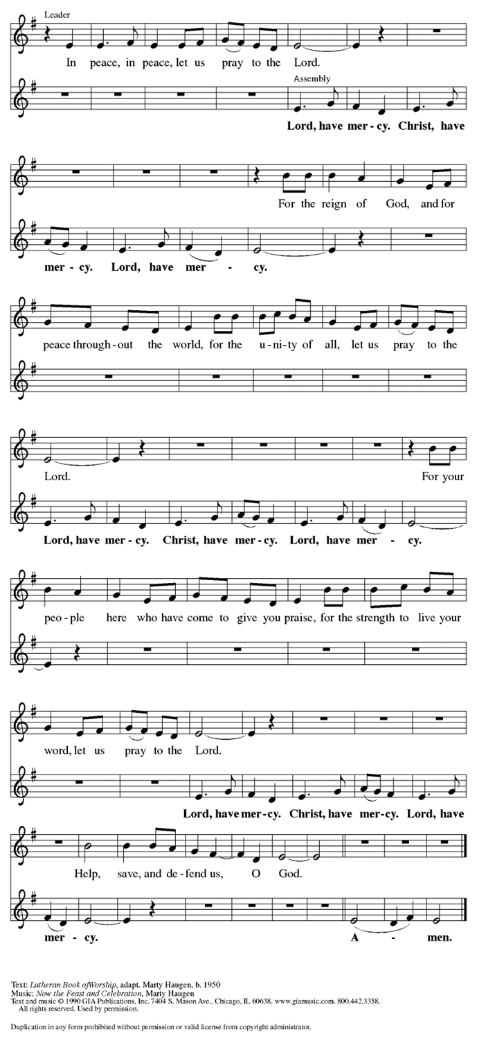
Prayer of the Day
WA: Let us pray together.
C: O God our defender, storms rage around and within us and cause us to be afraid. Rescue your people from despair, deliver your sons and daughters from fear, and preserve us in the faith of your Son, Jesus Christ, our Savior and Lord. Amen.

Children’s Sermon: Jesus said, “Let the little children come to me!”
We welcome children in worship.

WORD
God speaks to us in scripture readings, preaching and song.

Please stand as you are able

Gospel Acclamation Setting 10 (p. 205)
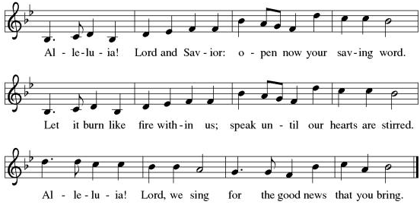
Gospel Reading: Matthew 14:22-33
Matthew’s gospel typically portrays Jesus’ disciples as people of “little faith,” who fail despite their best intentions. In this story, Matthew shows how Jesus comes to the disciples when they are in trouble and sustains them in their time of fear and doubt.

L: The Holy Gospel according to Matthew. C: Glory to you, O Lord.
L: ²² [Jesus] made the disciples get into a boat and go on ahead to the other side [of the Sea of Galilee,] while he dismissed the crowds.²³ And after he had dismissed the crowds, he went up the mountain by himself to pray.
When evening came, he was there alone, ²⁴ but by this time the boat, battered by the waves, was far from the land, for the wind was against them. ²⁵ And early in the morning he came walking toward them on the sea. ²⁶ But when the disciples saw him walking on the sea, they were terrified, saying, “It is a ghost!” And they cried out in fear. ²⁷ But immediately Jesus spoke to them and said, “Take heart, it is I; do not be afraid.”
²⁸ Peter answered him, “Lord, if it is you, command me to come to you on the water.” ²⁹ He said, “Come.” So Peter got out of the boat, started walking on the water, and came toward Jesus. ³⁰ But when he noticed the strong wind, he became frightened, and, beginning to sink, he cried out, “Lord, save me!” ³¹ Jesus immediately reached out his hand and caught him, saying to him, “You of little faith, why did you doubt?” ³² When they got into the boat, the wind ceased. ³³ And those in the boat worshiped him, saying, “Truly you are the Son of God.” L: The Gospel of the Lord. C: Praise to you, O Christ.
Reading: Daniel 6:1-23
P: ¹ It pleased Darius to set over the kingdom one hundred twenty satraps, stationed throughout the whole kingdom, ² and over them three administrators, one of whom was Daniel; to these the satraps gave account, so that the king might suffer no loss. ³ Soon Daniel distinguished himself above the other administrators and satraps because an excellent spirit was in him, and the king planned to appoint him over the whole kingdom. ⁴ So the administrators and the satraps tried to find grounds for complaint against Daniel in connection with the kingdom. But they could find no grounds for complaint or any corruption, because he was faithful, and no negligence or corruption could be found in him. ⁵ The men said, “We shall not find any ground for complaint against this Daniel unless we find it in connection with the law of his God.”
⁶ So the administrators and satraps conspired and came to the king and said to him, “O King Darius, live forever! ⁷ All the administrators of the kingdom, the prefects and the satraps, the counselors and the governors are agreed that the king should establish an ordinance and enforce an interdict, that whoever prays to any god or human, for thirty days, except to you, O king, shall be thrown into the den of lions. ⁸ Now, O king, establish the interdict and sign the document, so that it cannot be changed, according to the law of the Medes and the Persians, which cannot be revoked.” ⁹ Therefore King Darius signed the document and interdict.
¹⁰ Although Daniel knew that the document had been signed, he continued to go to his house, which had windows in its upper room open toward Jerusalem, and to get down on his knees three times a day to pray to his God and praise him, just as he had done previously. ¹¹ Then those men watched and found Daniel praying and seeking mercy before his God. ¹² Then they approached the king and said concerning the interdict, “O king! Did you not sign an interdict, that anyone who prays to any god or human, within thirty days, except to you, O king, shall be thrown into the den of lions?” The king answered, “The thing stands fast, according to the law of the Medes and Persians, which cannot be revoked.” ¹³ Then they responded to the king, “Daniel, one of the exiles from Judah, pays no attention to you, O king, or to the interdict you have signed, but he is saying his prayers three times a day.”
¹⁴ When the king heard the charge, he was very much distressed. He was determined to save Daniel, and until the sun went down he made every effort to rescue him. ¹⁵ Then the conspirators came to the king and said to him, “Know, O king, that it is a law of the Medes and Persians that no interdict or ordinance that the king establishes can be changed.”
¹⁶ Then the king gave the command, and Daniel was brought and thrown into the den of lions. The king said to Daniel, “May your God, whom you faithfully serve, deliver you!” ¹⁷ A stone was brought and laid on the mouth of the den, and the king sealed it with his own signet ring and with the signet ring of his lords, so that nothing might be changed concerning Daniel. ¹⁸ Then the king went to his palace and spent the night fasting; no entertainment was brought to him, and sleep fled from him.
¹⁹ Then at dawn, the king got up and at first light hurried to the den of lions. ²⁰ When he came near the den where Daniel was, he cried out anxiously to Daniel, “O Daniel, servant of the living God, has your God whom you faithfully serve been able to deliver you from the lions?” ²¹ Daniel then said to the king, “O king, live forever! ²² My God sent his angel and shut the lions’ mouths so that they would not hurt me, because I was found blameless before him; also before you, O king, I have done no wrong.” ²³ Then the king was exceedingly glad and commanded that Daniel be taken up out of the den. So Daniel was taken up out of the den, and no kind of harm was found on him because he had trusted in his God.

Sermon Rev. Jeremiah Smith

Please stand as you are able

+Hymn of the Day: A Mighty Fortress is Our God ELW #509
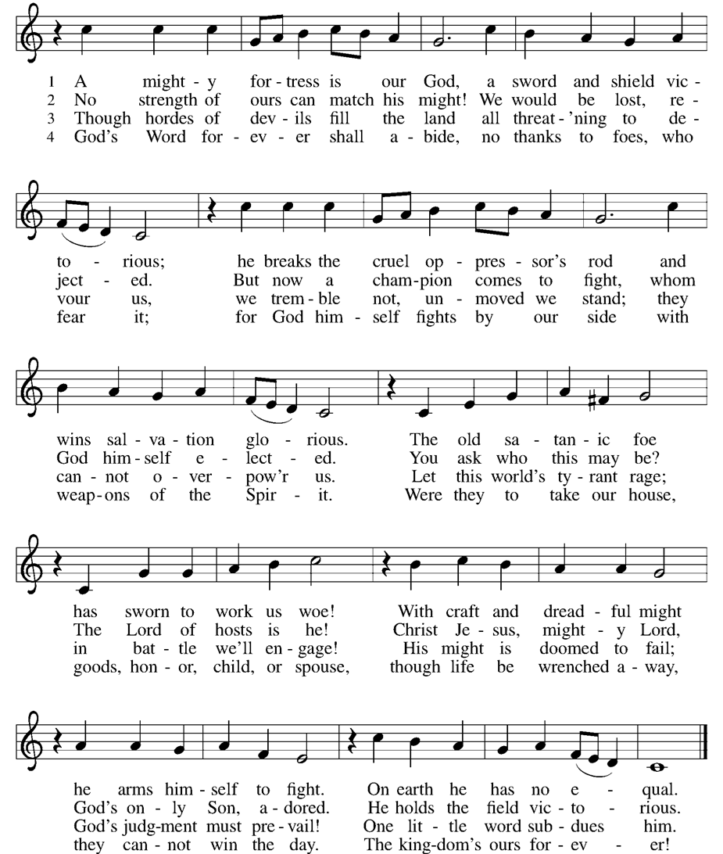

Prayers of the People WA: With bold trust in God’s unfailing provision, we pray for the church, those in need, and all of God’s creation. (a brief silence)
WA: We pray for the servants of your gospel in every place, that your word may be heard. Where your voice is scorned and your people persecuted, strengthen the church in its faithful witness. Merciful God, C: receive our prayer.

WA: For leaders of towns, states, nations, and organizations, and all who are in positions of authority, that they lead with justice and integrity. Teach us to respond with Christlike mercy to all who are afraid or in danger. Merciful God, C: receive our prayer.

WA: For all who struggle amid the storms of life, that they find peace and hope in your loving presence. Comfort any who are lonely and grieving and all who suffer, especially those we name aloud or in the silence of our hearts…. Merciful God, C: receive our prayer.

WA: For this congregation and its ministries, that they reflect your love and life amid a turbulent world. Guide council members and other church members with your still, calm voice. Merciful God, C: receive our prayer.

WA: We give you thanks for the faithful who have gone before us. Guide us in our earthly journey, that we may one day join them in your eternal kingdom. Merciful God, C: receive our prayer.

WA: Receive our prayers and answer, O God, as you have promised. All this we ask in the name of your Son, Jesus Christ our Lord. C: Amen.

Peace
P: The peace of Christ be with you always. C: And also with you.

Meal - God feeds us with the presence of Jesus Christ

Offering
We are grateful to those who help sustain our mission. To donate online, please use QR code:


+ Offering Prayer
WA: Let us pray together:
C: Loving God, we offer at your table the gifts of our hearts. Help us take heart in you and share freely of your love, so that all creation can taste your abundance. We ask this in the name of Jesus, through the Spirit abiding with us now and forever. Amen.
+ Offertory Song: Let the Vineyards Be Fruitful ELW #184

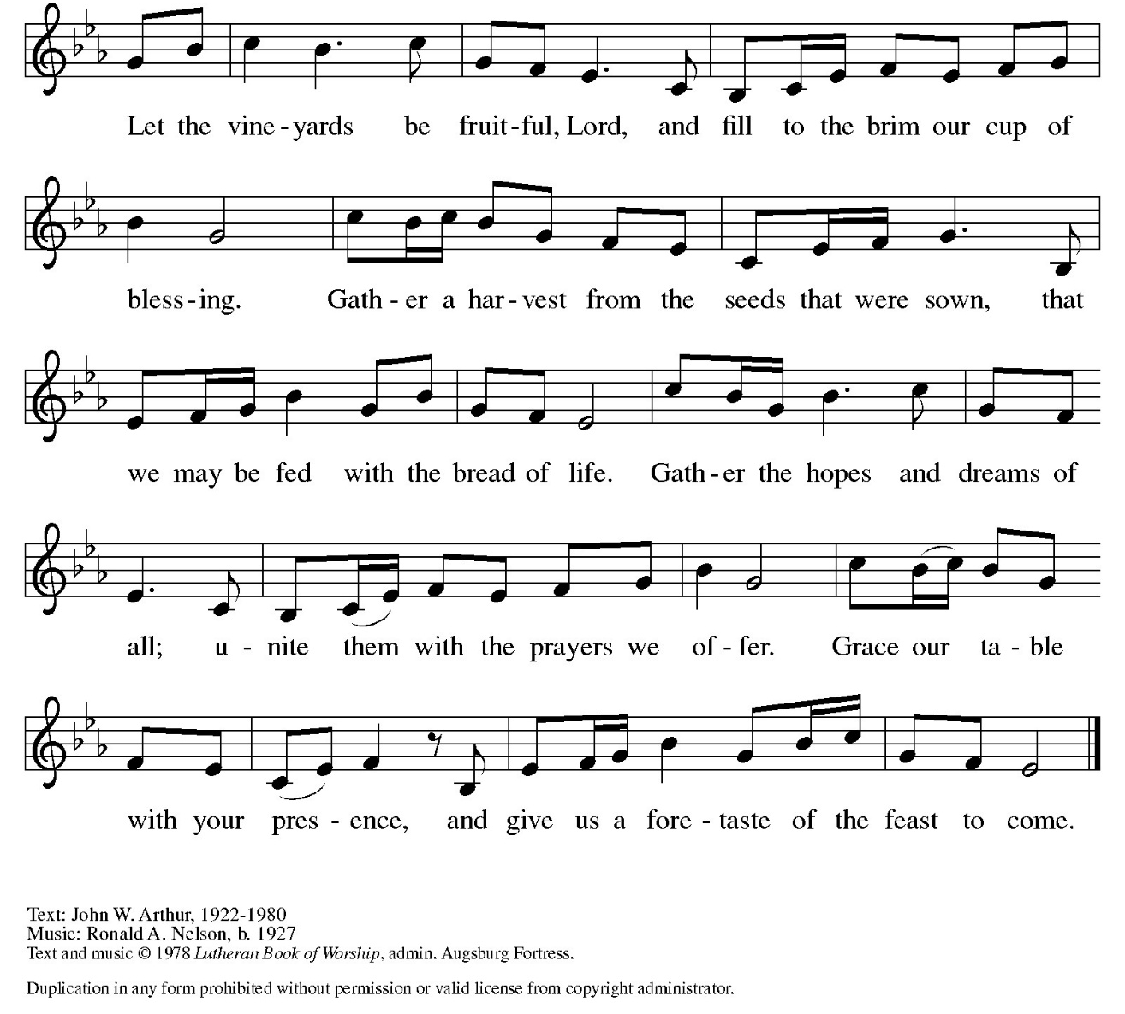

Great Thanksgiving
P: The Lord be with you. C: And also with you.
P: Lift up your hearts. C: We lift them to the Lord.
P: Let us give thanks to the Lord our God.
C: It is right to give our thanks and praise.

Preface
P: It is indeed right, our duty and our joy, that we should at all times and in all places give thanks and praise to you, almighty and merciful God, through our Savior Jesus Christ; who on this day overcame death and the grave, and by his glorious resurrection opened to us the way of everlasting life. And so, with all the choirs of angels, with the church on earth and the host of heaven, we praise your name and join their unending hymn:

Holy Holy Holy ELw setting 10 (p. 207)
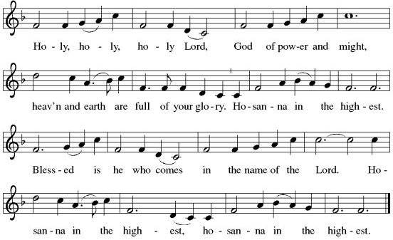

Thanksgiving at the Table

P: In the night in which he was betrayed, our Lord Jesus took bread, and gave thanks; broke it, and gave it to his disciples, saying: Take and eat; this is my body, give for you. Do this for the remembrance of me. Again, after supper, he took the cup, gave thanks, and gave it for all to drink, saying: This cup is the new covenant in my blood, shed for you and for all people for the forgiveness of sin. Do this for the remembrance of me.

Lord’s Prayer
P: Lord, remember us in your kingdom and teach us to pray.
C: Our Father in heaven, hallowed be your name, your kingdom come, your will be done, on earth as in heaven. Give us today our daily bread. Forgive us our sins as we forgive those who sin against us. Save us from the time of trial and deliver us from evil. For the kingdom, the power, and the glory are yours, now and forever. Amen.

Invitation to the Table
At Parkside Lutheran Church we have an open table. We believe the invitation to receive comes from Jesus himself and all are welcome at Christ’s table. More than just Bread and Wine these are tangible signs of God’s love for you! If you do not wish to receive communion but would like a blessing, come forward and cross your arms over your chest. The Pastor will give you a blessing before you return to your seat via the side aisle. You’ll receive a communion wafer* in your hands. You may dip it in the cup of wine or juice. When giving the bread and cup, the communion ministers say: “The body of Christ, given for you. The blood of Christ, shed for you.”
and each person may respond: Amen
*Please let Pastor know if you need a gluten-free wafer
P: Heaven has come near. Come, share in the feast!

The Communion Distribution

Communion Song ELW setting 10 (p. 208)
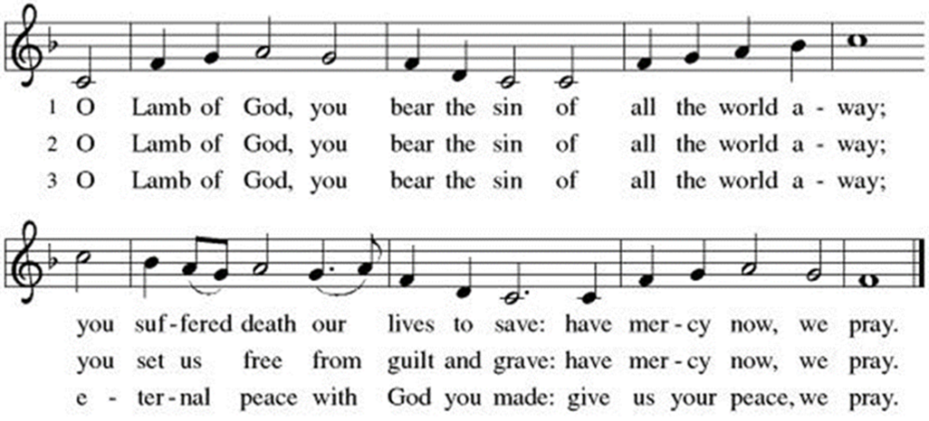

COMMUNION SONG: Ten Thousand Reasons ACS #1097
(printed next page)
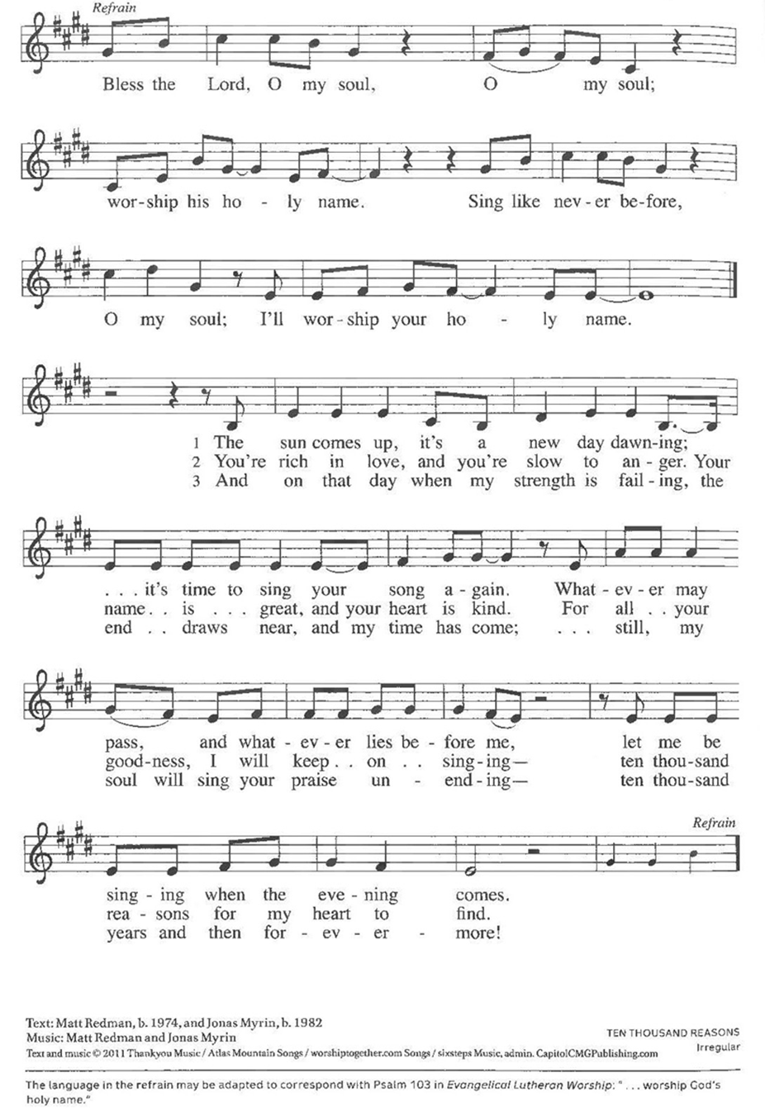

Communion Song: Lord, Listen to Your Children Praying

Post Communion Blessing
P: The Body and Blood of our Lord and Savior, Jesus Christ, strengthen you and keep you in God's grace. C: Amen.

Prayer After Communion
WA: Let us pray together.
C: Compassionate God, through the gifts of bread and wine our hearts are filled with the abundance of your love. Strengthen us that we, through this holy meal, may share your love freely, as you have shared with us. We ask this in the name of Jesus, through the Spirit nourishing us now and forever. Amen.

Evangelical Lutheran Worship Service of Reception of New Members
(“Affirmation of Baptism”)

PRESENTATION

P: Let us pray. Merciful God, we thank you for these siblings, whom you have made your own by water and the Word in baptism. You have called them to yourself, enlightened them with the gifts of your Spirit, and nourished them in the community of faith. Uphold your servants in the gifts and promises of baptism, and unite the hearts of all whom you have brought to new birth. We ask this in the name of Christ. C: Amen.

Profession of Faith
P: All together as the people of God, I ask you to profess your faith in Christ Jesus, reject sin, and confess the faith of the church.

P: Do you renounce the devil and all the forces that defy God?
C: We renounce them.

P: Do you renounce the powers of this world that rebel against God?
C: We renounce them.

P: Do you renounce the ways of sin that draw you from God?
C: We renounce them.

P: Do you believe in God the Father?
C: I believe in God, the Father almighty, creator of heaven and earth.
P: Do you believe in Jesus Christ, the Son of God?
C: I believe in Jesus Christ, God's only Son, our Lord, who was conceived by the Holy Spirit, born of the virgin Mary, suffered under Pontius Pilate, was crucified, died, and was buried; he descended to the dead.* On the third day he rose again; he ascended into heaven, he is seated at the right hand of the Father, and he will come to judge the living and the dead.
P: Do you believe in God the Holy Spirit?
C: I believe in the Holy Spirit, the holy catholic church, the communion of saints, the forgiveness of sins, the resurrection of the body, and the life everlasting.

AFFIRMATION OF BAPTISM

P: You have made public profession of your faith. Do you intend to continue in the covenant God made with you in holy baptism: to live among God's faithful people, to hear the word of God and share in the Lord's supper, to proclaim the good news of God in Christ through word and deed, to serve all people, following the example of Jesus, and to strive for justice and peace in all the earth?
C: I do, and I ask God to help and guide me.

P: People of God, do you promise to support these siblings and pray for them in their life in Christ? C: We do, and we ask God to help and guide us.

P: Let us pray. We give you thanks, O God, that through water and the Holy Spirit you give us new birth, cleanse us from sin, and raise us to eternal life. Stir up in this community the gift of your Holy Spirit: the spirit of wisdom and understanding, the spirit of counsel and might, the spirit of knowledge and the fear of the Lord,
the spirit of joy in your presence, both now and forever. C: Amen.

Those making public affirmation stand and face the assembly.
A representative of the congregation addresses the assembly.
P: Let us rejoice with these siblings in Christ.
C: We rejoice with you in the life of baptism. Together we will give thanks and praise to God and proclaim the good news to all the world. Amen.

Sundays and Seasons.com. Copyright 2007 Augsburg Fortress. All rights reserved. Reprinted by permission under Annual License #27963

Sending - God blesses us and sends us in mission to the world.

Blessing
P: Creator, Redeemer, Sustainer, + one God, bless, heal, and hold you today and always. C: Amen.

Sending Hymn: Hymn Raffle
Dismissal and Postlude
P: Parkside Lutheran Church is rediscovering the radical love of Jesus.
C: Gathering All, Serving All, Caring for All
P: Heaven has come near. Go, share the good news.
C: Thanks be to God.

ELW Music licensed from Sundays & Seasons, Augsburg Fortress CCLI MUSIC License # 11440069 , CCLI Streaming License#21835523 Do not duplicate any music or Liturgy herein without license and permission
scripture readings adapted and written by susan lukey

PARKSIDE STAFF:
• The Rev. Jeremiah Smith: prjeremiahpsmith@gmail.com
• Kris Pope & Suzanne Gracie, Admin. Assistants (Church Office): parksidelutheran@gmail.com
• Mike Hooker, Music Director: mrhooker@me.com
CHURCH OFFICE HOURS: M/T/R 10:00am-3:00pm (716)836-1361
Acolytes: |  | Worship Assistants:
8/9 – Franklin & Hudson |  | 8/9 - Onda
8/16 – Annalie & Emmet |  | 8/16 - Onda
Readers: |  | Ushers:
8/9 – Marlene |  | 8/9 - Kaitlyn , Gary S, Kathy
8/16 – Anne |  | 8/16 – Nick, Tom, John, Charlie

Coming up:
August 19th – Volunteer Meeting for Vacation Bible School – 5:30pm
August 24th – 28th – Vacation Bible School - SIGN UP TODAY!
Visit our website for more information about these and other Events at Parkside – www.parksidelutheran.org/events

