Dear Friends,
We are Ioan and Anna Veres, and we are grateful for the opportunity to introduce our family. The Lord has blessed us with four wonderful children: Nathanael, Miriam, Lydia, and Caleb. Originally from Romania and the Republic of Moldova, we have served in pastoral ministry, church planting, discipleship, and theological education in Europe and the United States. Most recently, the Lord led us to join Eternal Truth Ministries in Robbinsville, North Carolina. We are grateful for this new chapter and the opportunity to train and disciple others for the glory of Christ.
One of my primary responsibilities is developing an ethics discipleship curriculum that will equip pastors, church leaders, and believers to think biblically about contemporary ethical issues. While many excellent academic resources exist, discipleship-oriented materials are still needed to help Christians develop biblical wisdom and guide others through the complex challenges of our world.
The Lord has prepared me for this work through ministry and academic experience. I am an ordained pastor and hold a Ph.D. in Theological Ethics from Midwestern Baptist Theological Seminary and a master’s degree in Religious Studies from Aarhus University in Denmark, where we also participated in church planting. I also completed Clinical Pastoral Education and served as a healthcare chaplain.
As we begin this new season, we continue trusting the Lord for our financial support. We are currently at 16% of our monthly basic needs and remain confident that He will provide through His people. Above all, please pray that the Lord will strengthen our family, provide for our needs, open doors for effective ministry, and use us to serve pastors, churches, and believers in North America and around the world.
Thank you for learning about our family and ministry.
Serving Christ together,
Ioan, Anna, Nathanael, Miriam, Lydia, and Caleb Veres
To become a ministry partner, please scan the QR code.


Our Family: 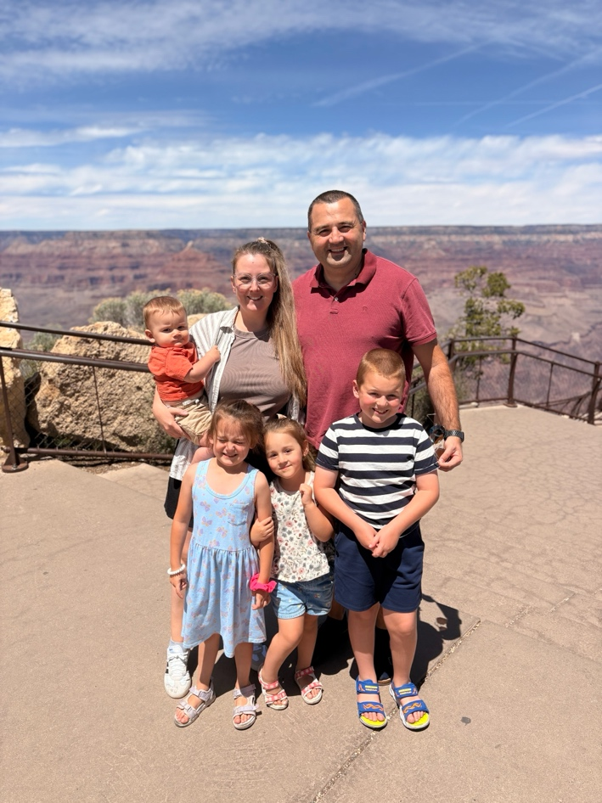
Ministry: 