Time After Pentecost
The Season of Parables – Year A
Setting 8
Sunday August 2, 2026

St. Paul Lutheran Church
9844 SW Greenville Road
Greenville, MI 48838

Sharing the joy of Christ.



MUSIC BEFORE WORSHIP

WELCOME

REFLECTIVE MUSIC TO CENTER OURSELVES IN GOD
We listen in silence and receive the gift to prepare our hearts.

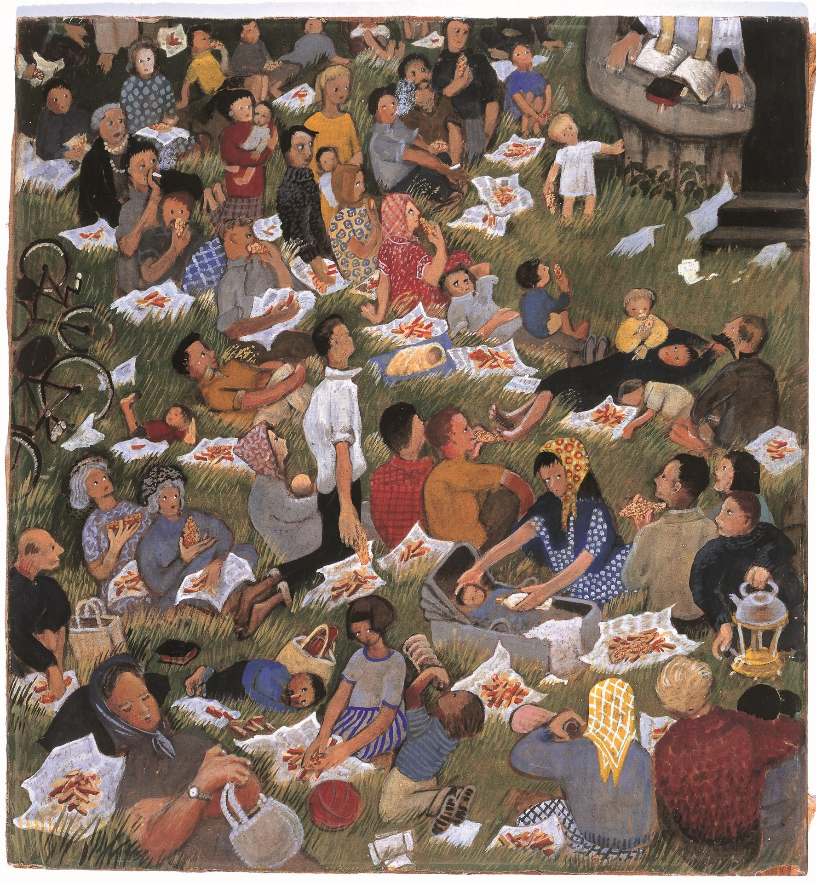
Artist: Eularia Clark
CONFESSION AND FORGIVENESS
All may make the sign of the cross, the sign that is marked at baptism, as the presiding minister begins.

Blessed be the holy Trinity, ☩ one God,
whose compassion endures forever.
Amen.

Let us confess our sin to God.

Silence is kept for reflection.

Compassionate God,
we confess to you all our sins.
Our burden is heavy, and we cannot free ourselves.
In your mercy, call us back to you.
Your yoke is easy and your burden is light.
Restore us to dwell in your peace.
In Christ’s name we pray,
Amen.

Jesus says, “Come to me,
all you who are weary
and are carrying heavy burdens,
and I will give you rest.”
In the name of the
Father, ☩ Son, and Holy Spirit,
your sins are forgiven.
Rest in God’s love.
Amen.

GATHERING SONG BB #25 HERE I AM TO WORSHIP

Verse 1
Light of the world
You stepped down into darkness
Opened my eyes let me see
Beauty that made this heart adore You
Hope of a life spent with You
Chorus
And here I am to worship
Here I am to bow down
Here I am to say that you're my God
You're altogether lovely
Altogether worthy
Altogether wonderful to me
Verse 2
King of all days
Oh so highly exalted
Glorious in heaven above
Humbly you came to the earth you created
All for love's sake became poor
Chorus
Here I am to worship
Here I am to bow down
Here I am to say that you're my God
You're altogether lovely
Altogether worthy
Altogether wonderful to me

GREETING

The grace of our Lord Jesus Christ, the love of God, and the communion of the Holy Spirit be with you all.
And also with you. (hands out)

KYRIE
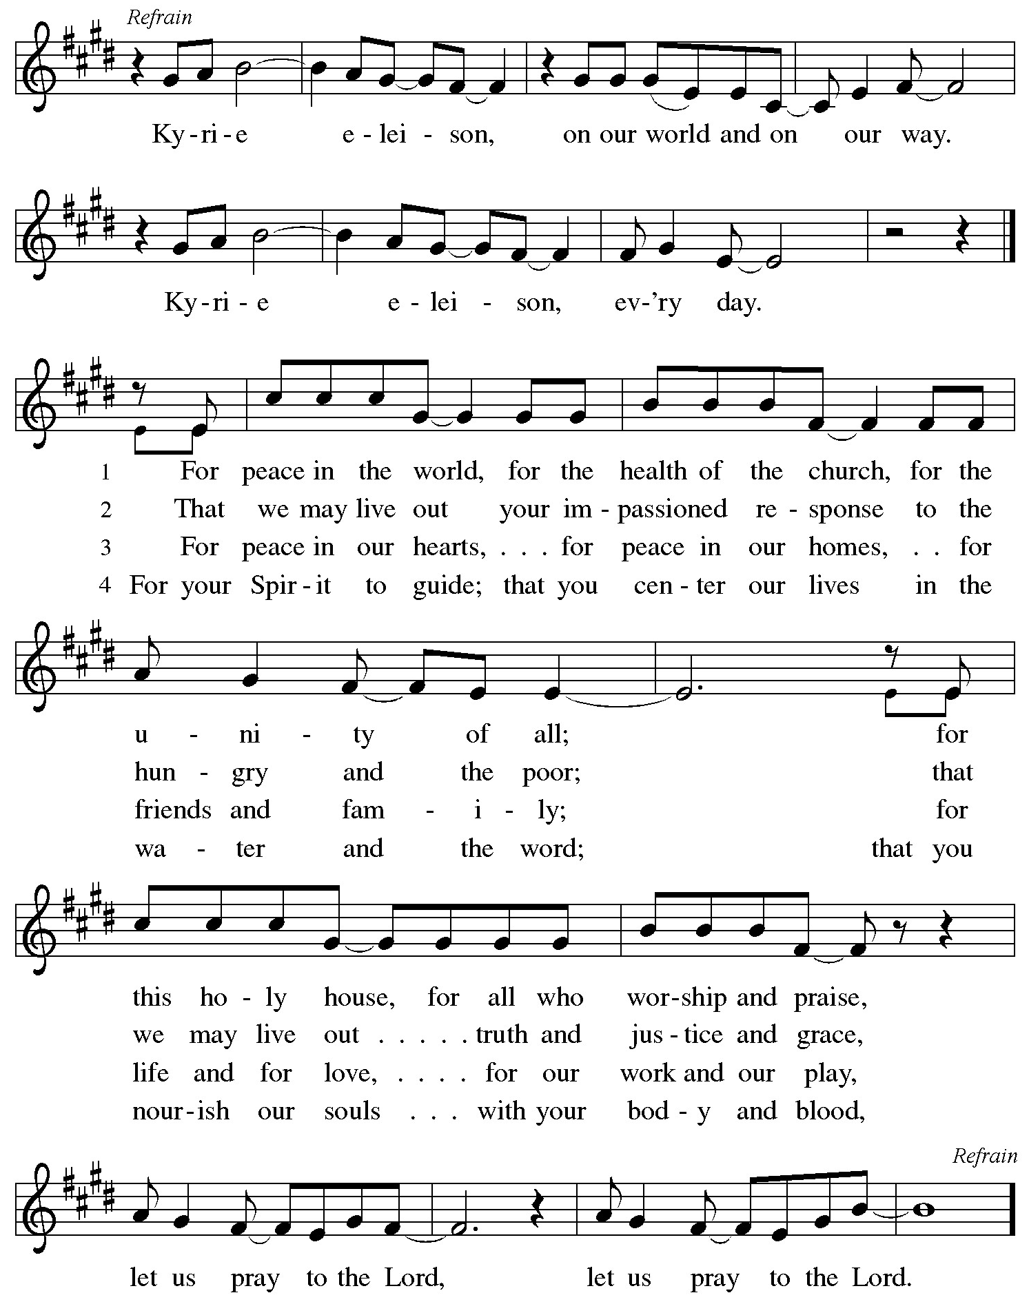
THIS IS THE FEAST

This is the feast of vict’ry for our God,
for the Lamb who was slain has begun his reign. Alleluia.
Worthy is Christ, the Lamb who was slain,
whose blood set us free to be people of God.

Power, riches, wisdom, and strength,
and honor, blessing, and glory are his.
This is the feast of vict’ry for our God,
for the Lamb who was slain has begun his reign. Alleluia.

Sing with all the people of God,
and join in the hymn of all creation:
Blessing, honor, glory and might
be to God and the Lamb forever. Amen.

This is the feast of vict’ry for our God,
for the Lamb who was slain has begun his reign. Alleluia.

PRAYER OF THE DAY

Let us pray.

A brief silence is kept before the prayer.

Glorious God, your generosity waters the world with goodness, and you cover creation with abundance. Awaken in us a hunger for the food that satisfies both body and spirit, and with this food fill all the starving world; through your Son, Jesus Christ, our Savior and Lord.
Amen.
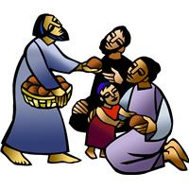
FIRST READING Isaiah 55:1-5

A reading from Isaiah. (pause)

55 Hear, everyone who thirsts;
come to the waters;
and you who have no money,
come, buy and eat!
Come, buy wine and milk
without money and without price.
² Why do you spend your money for that which is not bread
and your earnings for that which does not satisfy?
Listen carefully to me, and eat what is good,
and delight yourselves in rich food.
³ Incline your ear, and come to me;
listen, so that you may live.
I will make with you an everlasting covenant,
my steadfast, sure love for David.
⁴ See, I made him a witness to the peoples,
a leader and commander for the peoples.
⁵ Now you shall call nations that you do not know,
and nations that do not know you shall run to you,
because of the Lord your God, the Holy One of Israel,
for he has glorified you.

This is the word of the Lord.
Thanks be to God.

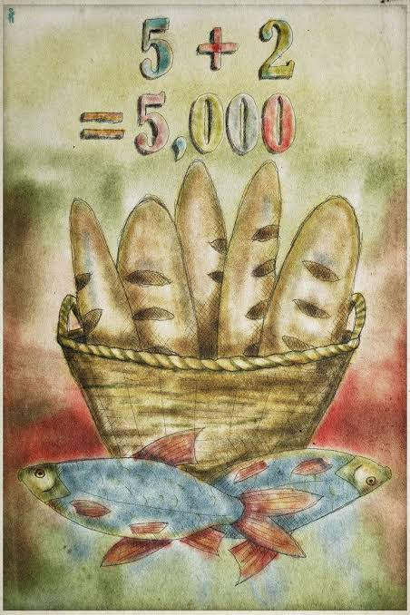
PSALM 145:8-9, 14-21

⁸ The Lord is gracious and merciful,
slow to anger and abounding in steadfast love.
⁹ The Lord is good to all,
and his compassion is over all that he has made.
¹⁴ The Lord upholds all who are falling
and raises up all who are bowed down.
¹⁵ The eyes of all look to you,
and you give them their food in due season.
¹⁶ You open your hand,
satisfying the desire of every living thing.
¹⁷ The Lord is just in all his ways
and kind in all his doings.
¹⁸ The Lord is near to all who call on him,
to all who call on him in truth.
¹⁹ He fulfills the desire of all who fear him;
he also hears their cry and saves them.
²⁰ The Lord watches over all who love him,
but all the wicked he will destroy.
²¹ My mouth will speak the praise of the Lord,
and all flesh will bless his holy name forever and ever.

SECOND READING Romans 9:1-5

A reading from Romans. (pause)

9 I am speaking the truth in Christ—I am not lying; my conscience confirms it by the Holy Spirit— ² I have great sorrow and unceasing anguish in my heart. ³ For I could wish that I myself were accursed and cut off from Christ for the sake of my own brothers and sisters, my own flesh and blood. ⁴ They are Israelites, and to them belong the adoption, the glory, the covenants, the giving of the law, the worship, and the promises; ⁵ to them belong the patriarchs, and from them, according to the flesh, comes the Christ, who is over all, God blessed forever. Amen.

This is the word of the Lord.
Thanks be to God.

CHILDREN’S MESSAGE

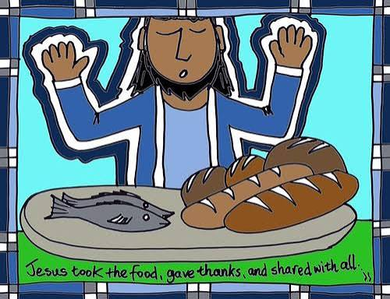

GOSPEL ACCLAMATION

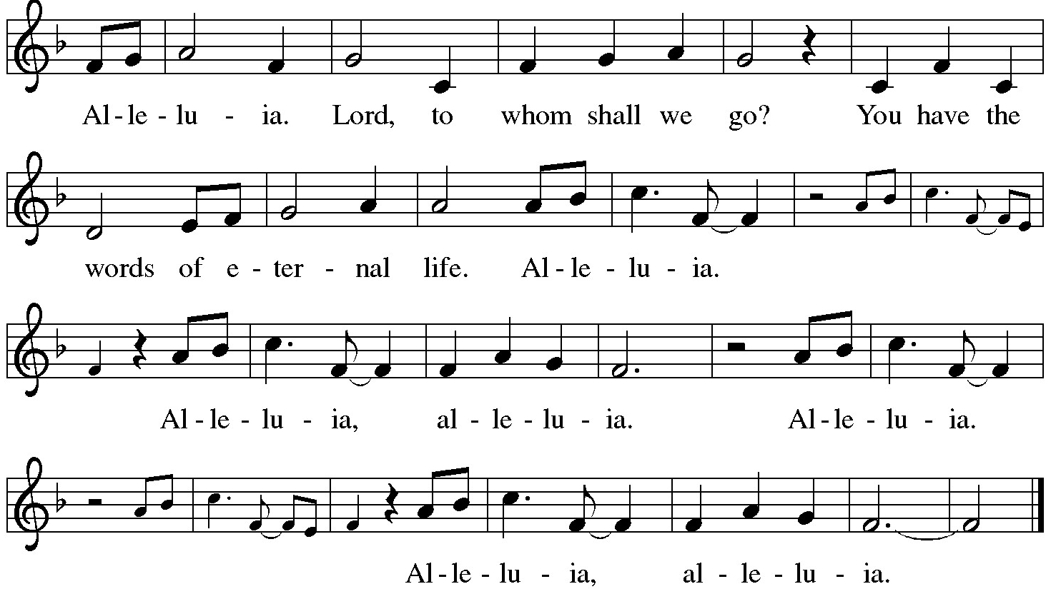

GOSPEL Matthew 14:13-21

The holy gospel according to Matthew.
Glory to you, O Lord.

¹³ Now when Jesus heard this, he withdrew from there in a boat to a deserted place by himself. But when the crowds heard it, they followed him on foot from the towns. ¹⁴ When he went ashore, he saw a great crowd, and he had compassion for them and cured their sick. ¹⁵ When it was evening, the disciples came to him and said, “This is a deserted place, and the hour is now late; send the crowds away so that they may go into the villages and buy food for themselves.” ¹⁶ Jesus said to them, “They need not go away; you give them something to eat.” ¹⁷ They replied, “We have nothing here but five loaves and two fish.” ¹⁸ And he said, “Bring them here to me.” ¹⁹ Then he ordered the crowds to sit down on the grass. Taking the five loaves and the two fish, he looked up to heaven and blessed and broke the loaves and gave them to the disciples, and the disciples gave them to the crowds. ²⁰ And all ate and were filled, and they took up what was left over of the broken pieces, twelve baskets full. ²¹ And those who ate were about five thousand men, besides women and children.

The gospel of the Lord.
Praise to you, O Christ.

SERMON
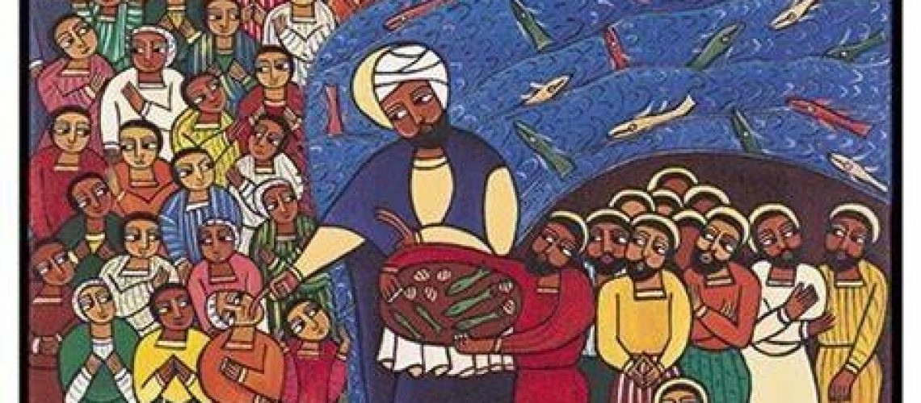
Artist: Laura James
HYMN OF THE DAY ELW #474 BREAD OF LIFE FROM HEAVEN

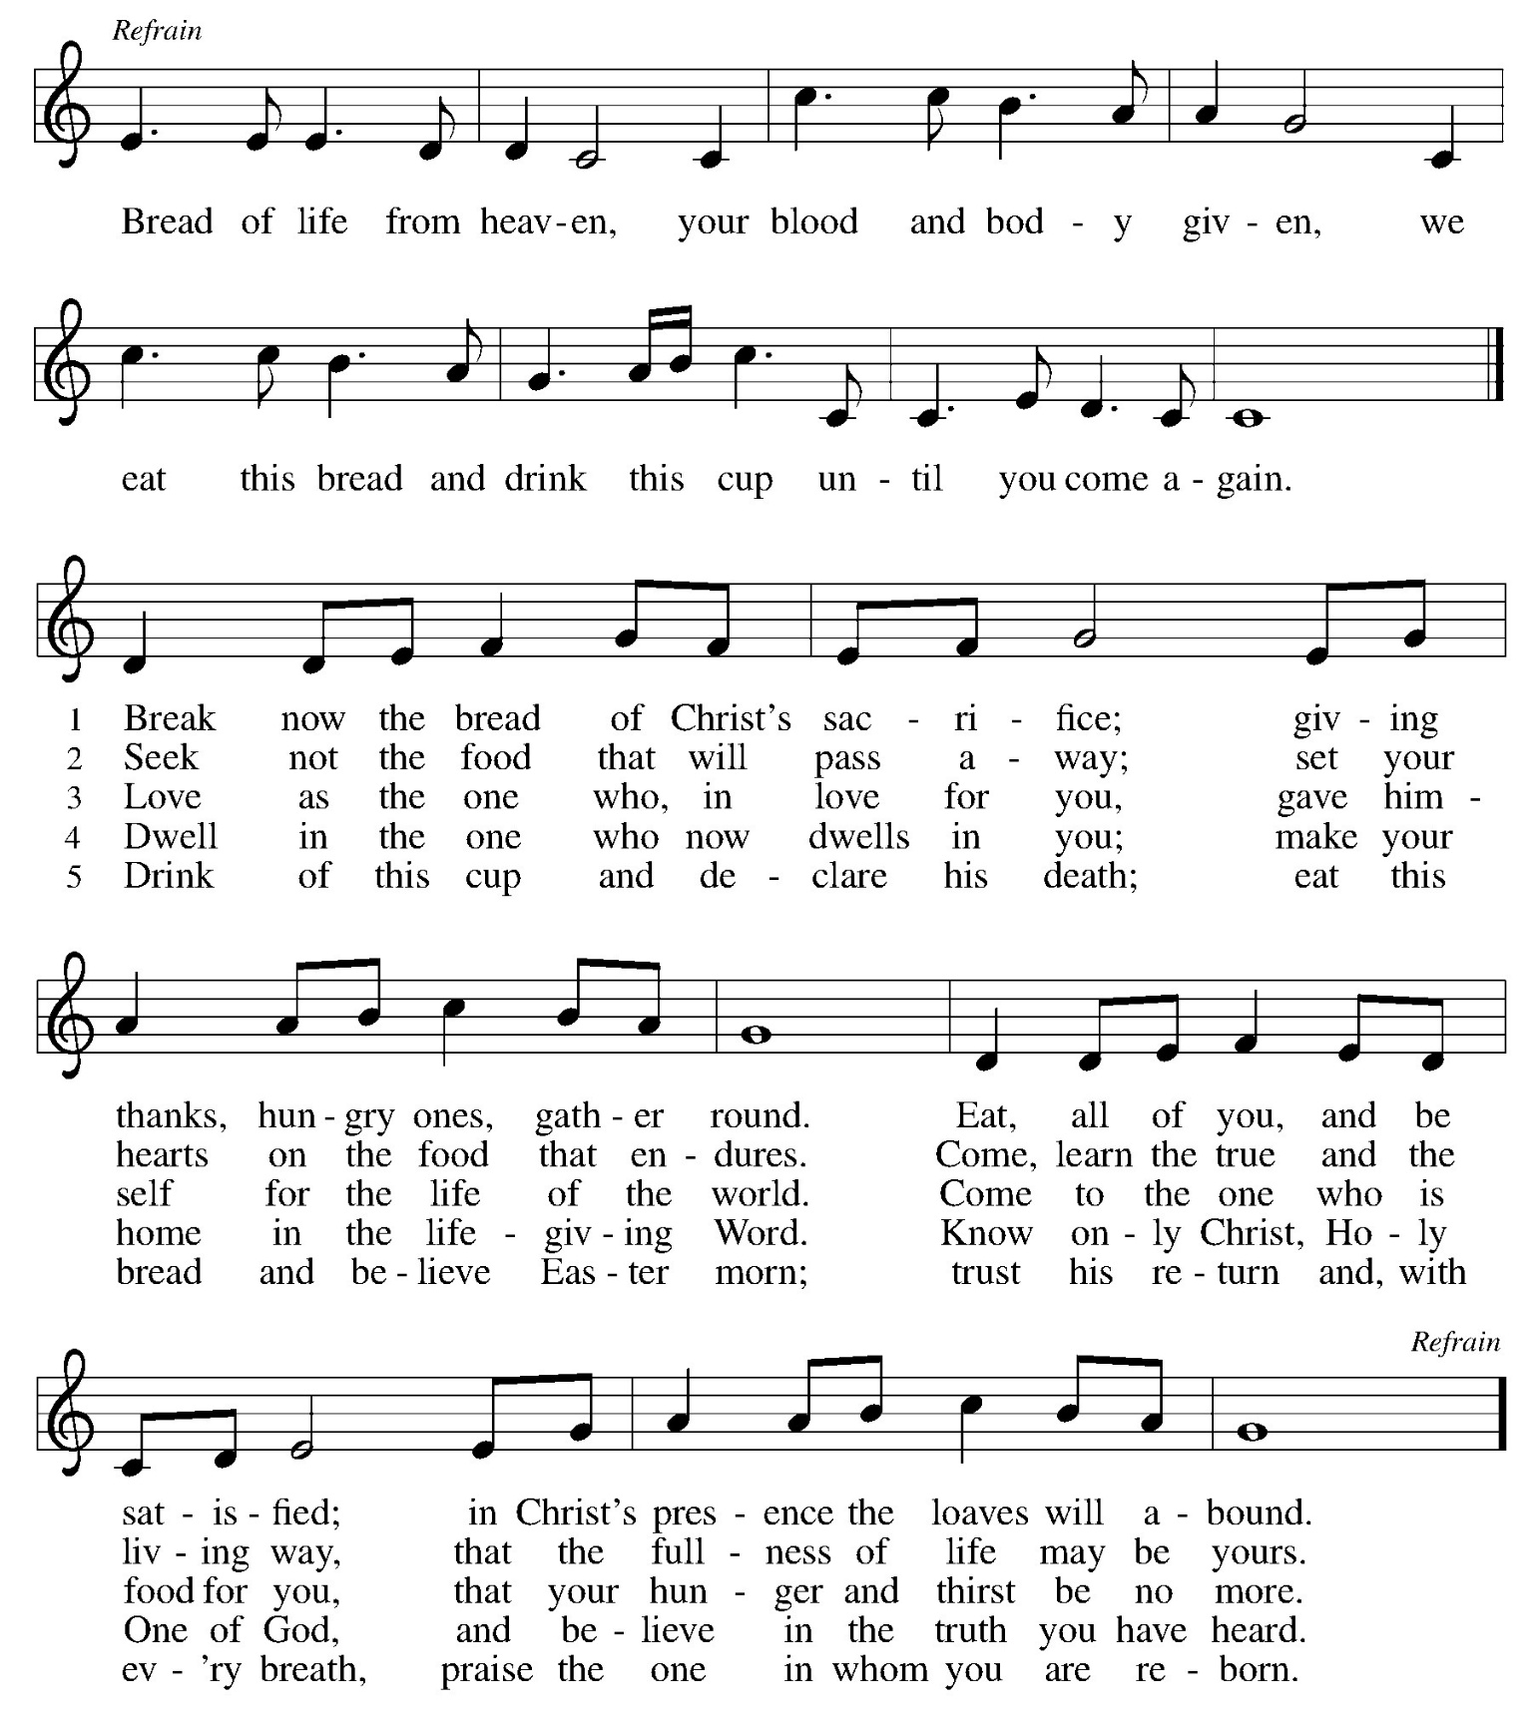

CREED

I believe in God, the Father almighty,
Creator of heaven and earth.

I believe in Jesus Christ, God’s only Son, our Lord,
Who was conceived by the Holy Spirit,
Born of the Virgin Mary,
Suffered under Pontius Pilate,
Was crucified, died, and was buried;
He descended to the dead.
On the third day he rose again;
He ascended into heaven,
He is seated at the right hand of the father,
And he will come to judge the living and the dead.

I believe in the Holy Spirit,
The holy catholic* church,
The communion of saints,
The forgiveness of sins,
The resurrection of the body,
And the life everlasting. Amen.

*The word catholic beginning with a small letter “c” means all Christians.

PRAYERS OF INTERCESSION

With bold trust in God’s unfailing provision, we pray for the church, those in need, and all of god’s creation.

A brief silence.

For your church in every place, that it satisfies those who hunger for your word. Bless the ministry of readers, translators, bible study leaders, and writers, that God’s word is broken open and shared with all.
Merciful God,
Receive our prayer.

For your wondrous creation and all the bounty it provides, that your creatures are fed and nourished. Bless the work of farmers, farmworkers, those who fish, and all whose labor brings your abundance to our tables. Merciful God,
Receive our prayer.

For your children in every nation, that they learn to love justice and live in harmony. As this week we remember the atomic bombings of Hiroshima and Nagasaki, keep us mindful of the horrors of war; draw our hearts instead toward your reign of love, hope, and peace.
Merciful God,
Receive our prayer.

For all who cry out with great sorrow and unceasing anguish, that they are comforted. Feed all who struggle with food insecurity; have mercy on all who are suffering in body, mind, and spirit. We especially lift prayers for… Merciful God,
Receive our prayer.

For this congregation, that it bears faithful witness to the abundance and joy of life in you. Bless all your faithful people gathered here, that they may become blessings for this community.
Merciful God,
Receive our prayer.

With thanksgiving for the faithful who now rest in your mercy, that their witness continues to inspire the church. By their example, may we trust your promises in life and in death.
Merciful God,
Receive our prayer.

Receive our prayers and answer, o God, as you have promised. All this we ask in the name of your son, Jesus Christ our lord.
Amen.

Peace

The peace of Christ be with you always.
And also with you. (hands out)
The people may greet one another with a sign of Christ’s peace, and may say, “Peace be with you,” or similar words.
The assembly is seated.
OFFERING

OFFERING RESPONSE ELW #692 WE ARE AN OFFERING

We lift our voices
We lift our hands
We lift our lives up to You
We are an offering
Lord use our voices
Lord use our hands
Lord use our lives they are Yours
We are an offering
All that we have
All that we are
All that we hope to be
We give to You
We give to You

OFFERING PRAYER

Let us pray. (pause)

Loving God,
we offer at your table the gifts of our hearts.
Help us take heart in you and share freely of your love,
so that all creation can taste your abundance.
We ask this in the name of Jesus,
through the Spirit abiding with us now and forever. Amen.

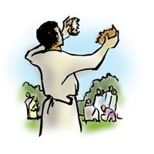
THE GREAT THANKSGIVING

The Lord be with you.
And also with you.

Lift up your hearts.
We lift them to the Lord.

Let us give thanks to the Lord our God.
It is right to give our thanks and praise.

PREFACE

It is indeed right, our duty and our joy,
that we should at all times and in all places
give thanks and praise to you, almighty and merciful God,
through our Savior Jesus Christ;
who on this day overcame death and the grave,
and by his glorious resurrection opened to us the way of everlasting life.
And so, with all the choirs of angels,
with the church on earth and the hosts of heaven,
we praise your name and join their unending hymn:

HOLY, HOLY, HOLY
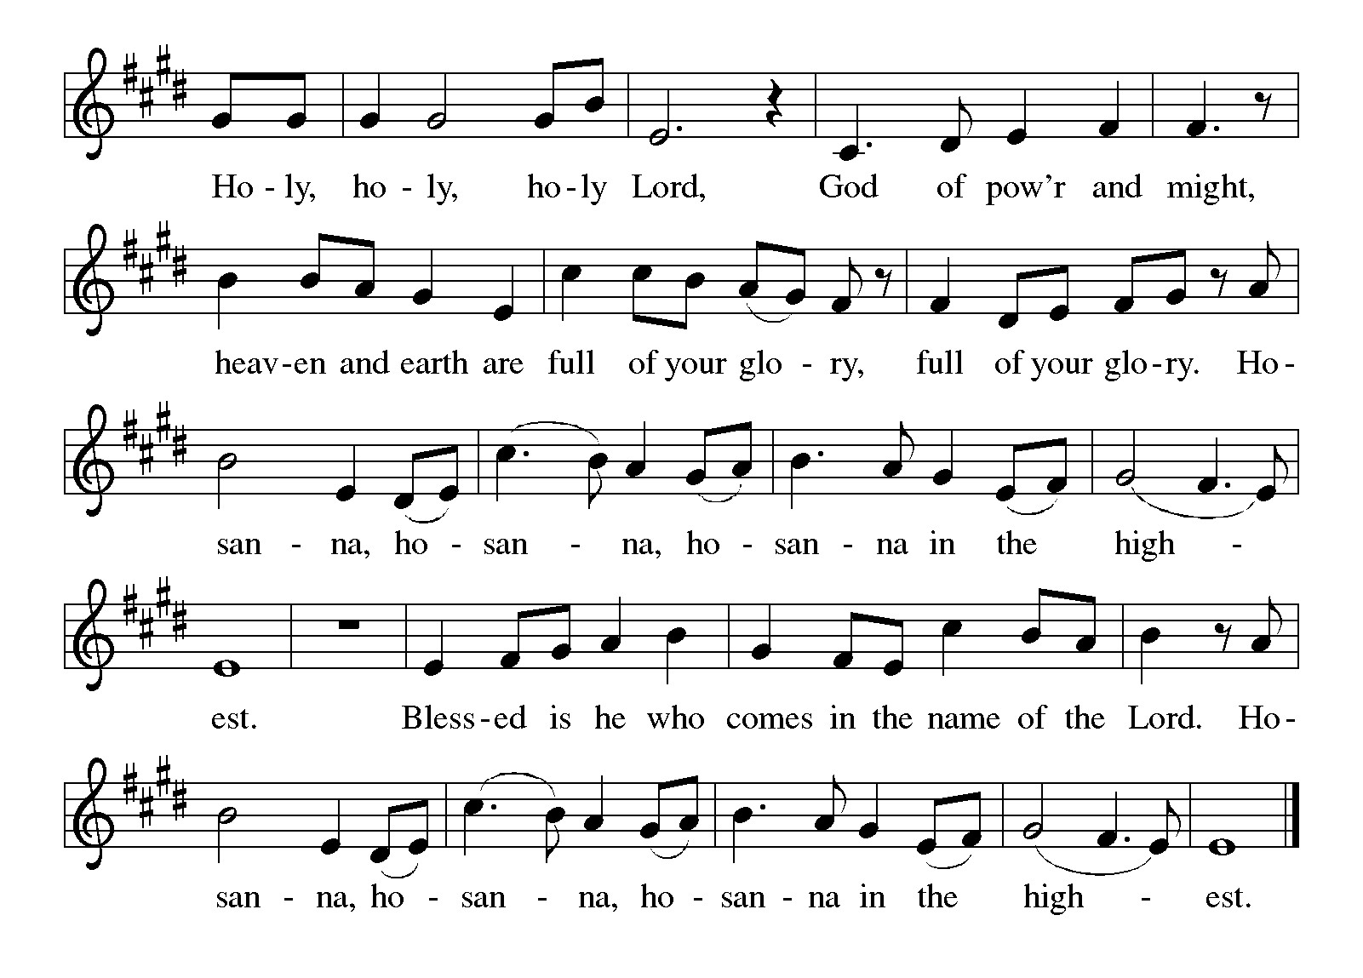
THANKSGIVING AT THE TABLE

In the night in which he was betrayed,
our Lord Jesus took bread, and gave thanks;
broke it, and gave it to his disciples, saying:
Take and eat; this is my body, given for you.
Do this for the remembrance of me.

Again, after supper, he took the cup, gave thanks,
and gave it for all to drink, saying:
This cup is the new covenant in my blood,
shed for you and for all people for the forgiveness of sin.
Do this for the remembrance of me.

THE LORD’S PRAYER

Our Father, who art in heaven,
hallowed be thy name,
thy kingdom come,
thy will be done,
on earth as it is in heaven.
Give us this day our daily bread;
and forgive us our trespasses,
as we forgive those
who trespass against us;
and lead us not into temptation,
but deliver us from evil.
For thine is the kingdom,
and the power, and the glory,
forever and ever. Amen.

Invitation to Communion

Heaven has come near.
Come, share in the feast!

COMMUNION

All are welcome to come to share in Holy Communion at God’s Table.

If it is too difficult to come to God’s Table, please let an usher know and Pastor Nan will bring holy communion to you.

When giving the bread and cup, the communion server says
As you receive the bread and wine:

The body of Christ, given for you.
The blood of Christ, shed for you.
Each person may respond: Amen.

LAMB OF GOD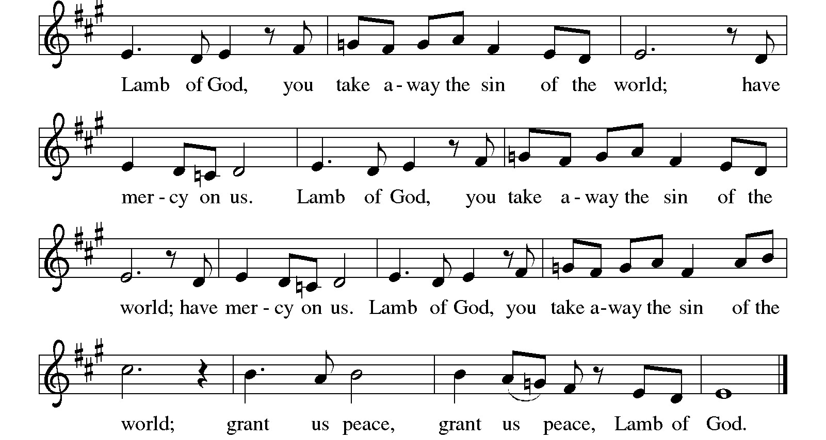
These songs are sung during Holy Communion to help us focus on the Gifts of God for the people of God.

TFF #234 LORD, I WANT TO BE A CHRISTIAN

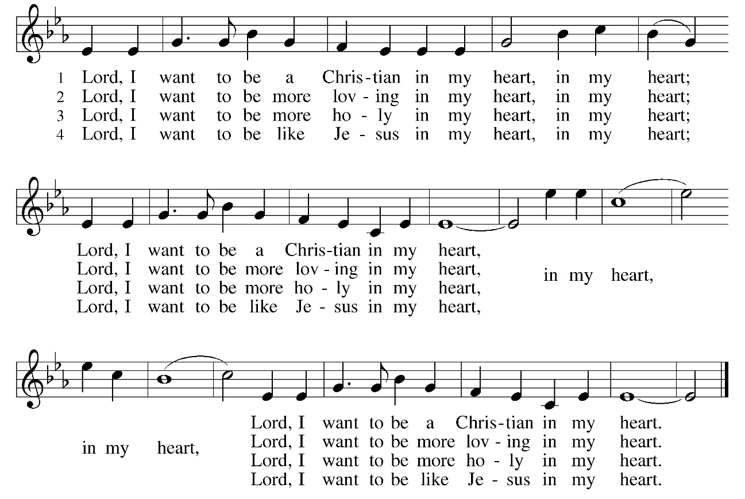
ELW #496 ONE BREAD, ONE BODY

Refrain
One bread, one body, one Lord of all;
one cup of blessing which we bless,
and we, though many throughout the earth,
we are one body in this one Lord.

1 Gentile or Jew, servant or free,
woman or man, no more. Refrain

2 Many the gifts, many the works,
one in the Lord of all. Refrain

3 Grain for the fields, scattered and grown,
gathered to one for all. Refrain

FINAL TABLE BLESSING
The body and blood of our Lord Jesus Christ strengthen you and keep you + in his grace. Amen.

HYMN AFTER COMMUNION
ELW# 857 LORD, I LIFT YOUR NAME ON HIGH sing 2 times

Lord, I lift your name on high
Lord, I love to sing your praises
I'm so glad you're in my life
I'm so glad you came to save us
You came from heaven to earth
to show the way
from the earth to the cross
my debt to pay
from the cross to the grave
from the grave to the sky
Lord, I lift your name on high

Prayer after Communion

Let us pray. (pause)

Compassionate God,
through the gifts of bread and wine
our hearts are filled with the abundance of your love.
Strengthen us that we, through this holy meal,
may share your love freely, as you have shared with us.
We ask this in the name of Jesus,
through the Spirit nourishing us now and forever.
Amen.

GOOD NEWS AND ANNOUNCEMENTS

Blessing

Creator, + Redeemer,
And Sustainer,
Bless, heal, and hold you
Today and always.
Amen.

SENDING SONG ELW #525 YOU ARE HOLY

You are holy, you are whole.
You are always ever more
than we ever understand.
You are always at hand.
Blessed are you coming near.
Blessed are you coming here
to your church in wine and bread,
raised from soil, raised from dead.
You are holy,
you are wholeness,
you are present.
Let the cosmos praise you, Lord!
Sing hosanna in the highest!
Sing hosanna!
Sing hosanna to our God!

DISMISSAL

Heaven has come near. Go, share the good news!
Thanks be to God.

PRAYER REQUESTS &
ANNOUNCEMENTS

ST. PAUL HEALING PRAYER LIST

Bob Perdue, Carol Rasmussen, David Johansen, Denise Hoppe, Dennis Dombkowski, Joan Chadwick, Joanne Bryer, Larry Ross, Leroy Hansen, Lois Davis, Katharine Serviss, Karen Buchholz,
Marlene Grams, Mary Ann Johnson, Mary Jean Mallo, Nelda Gallagher, Peter Hansen, Russ Lincoln, Shirley Hansen, Shirley Moerdyke, Shirley Sly, Steve Vanhoose, Terri Clark.

***If you want to have someone added, please email the main office, leave a voicemail on the main church phone number or text Pastor Nan

MILITARY

Brian Blomstrom, Chris Miller, Hanah MacMillen, JD Johansen, Marcus Roy, Ryan Treynor, Steve Kowalewicz, Troy Thornburg, Tyler Markum,
Vaughn Misner, Victor Rivera, Vinnie Baza.

PRAYER CHAIN FOR ST. PAUL If you would like to join the prayer chain, please contact Lynn Cooper at 616-754-5579.

Blood drive- August 4 – here at St. Paul 
WORSHIP ON THE PAVILION ON AUGUST 16


ANNUAL CONGREGATION REPORTS ARE DUE – AUGUST 31

ICE CREAM SOCIAL

BARRIE’S HOUSE
AUGUST 16
1 PM – 3 PM

This Week

Sunday Aug 2 930 am Worship with Holy Communion
Congregation Meeting after worship
ABP class after potluck or at 11 am

****Coffee Fellowship for August is posted on the bulletin table
AUGUST Newsletters are available
3rd quarter Christ in Our Home devotion books are out

Monday Aug 3 5 pm Al-Anon
Building closed
Pastor Sabbath

Tuesday Aug 4 10 am Food Mission
11 am – 3:30 pm BLOOD DRIVE

Wednesday Aug 5 Bonhoeffer book study
5:30 pm Food Mission
Mark Sabbath

Thursday Aug 6 1 pm – 3:30 pm Mark at Synod
Heart-Centered Connections
At Faith Okemos

Friday Aug 7 1:30 pm Shalom Zoom Meditation
COUNCIL REPORTS ARE DUE

Saturday Aug 8

Sunday Aug 9 930 am worship
Coffee time: Affirmation of Baptism project
ABP class after worship or 11 am
Pastor leads a prayer service at a local cemetary

AUGUST SERVING

St Paul Service Calendar | Assisting | Proclaimer | Sound | Lead Usher | Nursery | Counters | Music
August 2 | Janet W-M | Amy S | Lee H  Diane C  Karen H | Curt B | Donny M | Joy S  Karen H | Sarah F.
August 9 | Josh S | Barb B | Diane C  Paul R  Connie T | John C | Shirley H | John C  Lisa B | Sarah F.
August 16 | Rocky H | Connie T | Lee H  Diane C  Lisa B | Bob K | Amy S | Shirley H  Connie T | Sarah F.
August 23 | Alicia D | Janet W-M | Paul R  Lee H  Tara C | Kevand S | Volunteer | Kevand S  Diane C | Sarah F.
August 30 | Connie T | Karen P | Paul R  Lee H  Tara C-T | Curt B | Donny M | John C  Lisa B | Sarah F.

Dates, and names are Subject to change.

If you are going to miss a Sunday that your scheduled, please get a sub.

