All Saints Anglican Church
6904 Lougheed Highway, Agassiz, B.C. V0M 1A0
Bulletin July 27th, 2026 – August 2nd, 2026

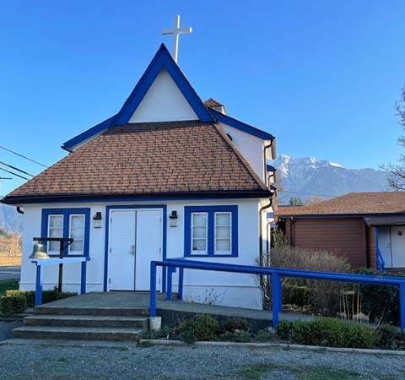

‘The ground we walk does not belong to us; for thousands of years it has been - and remains - the territory of the Stó:lō. We are grateful for their sharing.

Phone: 604-796-3553
Website: www.allsaints-agassiz.ca
https://www.facebook.com/groups/AllSaintsFamily
OUR DOOR IS OPEN AND ALL ARE WELCOME
August 2nd, 2026, Tenth Sunday After Pentecost
Priest in Charge: The Reverend Philip Barker
Hosts: Graham Featherstone/Jennifer Pinlac
Intercessor: Sheila Barker
Lay Administrator: Dorothy Cresswell
Announcer: Virginia Jennings
Organ/Piano: Francesca Froehlich
Readers: Liane Loeppky/Keith Fossey
Vicar’s cell phone: Revd. Philip Barker. 778-867-2461

Vicar’s Warden: Ginny Jennings. 604-796-2206
People’s Warden: Lynn Laughlin. 604-799-5131
Parish email: revpb1950@gmail.com
Please contact either warden if you have an issue that needs to be brought to the attention of the Vicar - or contact the Vicar direct (see above for details).

All Saint’s Calendar/Announcements:

- Book Club – On June 10th Book Club will be starting "Sensible Shoes" by Sharon Garlough Brown, an experienced leader of spiritual formation retreats in the UK and US. It follows 4 very different and very relatable female characters on their journey together through 12 one-day retreats.


Please contact Sheila Barker at sjbarker0379@gmail.com
if you would like an invitation to the Zoom meetings
at 5.00 pm on Wednesdays or a copy of the book.
The book is available on amazon for $34.11 including tax.

- Bible Study is every Saturday morning 0830-0900 on Zoom. All are welcome to preview and discuss the readings for the Sunday service. Please ask Valerie to add your email address to the invitation list.

- Prayer Requests can be given on a piece of paper to either of the Wardens or the Vicar or entered in the Prayer Request Book on the lectern. Alternatively, you can contact Anthea Lewis at antheamlewis@shaw.ca for Pray First Prayer Circle, which is a confidential online prayer circle.

- Music Requests may be given to the Wardens or the Vicar.

- AA meets in the hall every Tuesday and Friday at noon.

- Every Thursday in the hall 1100-1200 we have a social time with coffee, games if you like or just talk.

- At 1000-1100 on Thursdays there is an Interactive Bible Study on the day’s Lectionary readings. All are welcome – discover the treasures in this amazing book!

- 5th Sunday of each month will be a potluck lunch after the service

Ministerial Meandering
Change

Recently, one of my flock sent me a 23 minute clip of ancient Native wisdom on the subject of change.
Being a little on the Far Side of Middle Age, I have some idea of what change entails, but what I learned from this nugget of wisdom was that I have often been looking at it from the wrong perspective.

For most of us, change is both a challenge and uncomfortable, because it is designed to take us out of our comfort zone, and into a new land. We may have some idea of where we are going, or what we are going to be, but in most cases we will be wrong - at least in detail, if not in greater substance. So - honestly - we don’t know what lies ahead, and so we are uncomfortable.

The elder describing the process touched on so many of the feelings that I have at present - as we attempt to move continents to France - that I was profoundly moved by his insight. He described the sense of everything falling apart, and chaos creeping in - though he didn’t use the word ‘chaos’. He talked about ‘moulting’, like a snake shedding its old skin, and being acutely uncomfortable until he had got out of it, and reappeared in his new one. The old skin is tight and itchy, and doesn’t fit any more - we need to break free of it.
I thought perhaps that this wasn’t as good an image as that of the chrysalis, which must be burst for a completely new creature to emerge. The idea of the snake in his new skin suggesting to me that we just reappear as a newer version of our old self, whereas the grub in the chrysalis emerges to be a beautiful new moth or butterfly - unrecognisable from the old creature entirely.

Perhaps what impressed me even more than his imagery was his description of the feelings that come along with the need for change.
In addition to the sense of one’s life falling apart, comes the combination of losing focus or interest in old routines, a sense of flatness which is often felt as depression, but which he described as a clearing away of the old to make way for the new. It is not that you no longer enjoy what you are doing, but that it seems as though you know deep inside that it is time for it to come to an end.

The elder also noted that these feelings are often combined with a sense of intolerance. [I have always had a problem with tolerance.] He talked of putting more and more onto a shelf until one more small thing causes it to break - it has reached its capacity. He says this is the soul saying, “No more.”

He talked too of solitude - and the need for it. One cannot transform in public; the work of becoming is like that planting of a seed - it needs darkness and solitude to grow in the earth. He spoke of his grandmother going away by herself for a time, and, when asked what she did, told him that she went deep into herself to listen. That’s as good a description of prayer as you could want.

Lastly, he mentioned that it must be felt within us; he described a sort of inner trembling, which he said had happened three times in his life.
I don’t know how many times it has happened in my life - but I certainly feel it now. Maybe we as a church collectively feel it too.

Philip+

Something to think about…..



Birthdays in the August 

Pam Evans – 8 Leroy Burden – 14
Virginia Jennings – 14 Monica Gibson-Pigsley – 28

Diocesan Cycle of Prayer: We Pray for the Clergy and Congregation:

Mother’s Union – Diocese of New Westminster Chapter ; Holy Trinity, Vancouver

Anglican Church of Canada Cycle of Prayer – We Pray for:

The Rt. Rev. Lydia Mamakwa, The Rt. Rev. Larry Beardy, and the Rt. Rev. Morris
Fidler, Bishops, and the clergy and people of the Spiritual Ministry of Mishamikoweesh

Collect

Almighty God, your Son Jesus Christ fed the hungry with the bread of his life and the word of his kingdom. Renew your people with your heavenly grace, and in all our weakness sustain us by your true and living bread, who lives and reigns with you and the Holy Spirit, one God, now and for ever.

Genesis 32:22-31 Liane Loeppky

²² That night Jacob got up and took his two wives, his two female servants and his eleven sons and crossed the ford of the Jabbok. ²³ After he had sent them across the stream, he sent over all his possessions. ²⁴ So Jacob was left alone, and a man wrestled with him till daybreak. ²⁵ When the man saw that he could not overpower him, he touched the socket of Jacob’s hip so that his hip was wrenched as he wrestled with the man. ²⁶ Then the man said, “Let me go, for it is daybreak.”

But Jacob replied, “I will not let you go unless you bless me.”

²⁷ The man asked him, “What is your name?”

“Jacob,” he answered.

²⁸ Then the man said, “Your name will no longer be Jacob, but Israel, because you have struggled with God and with humans and have overcome.”

²⁹ Jacob said, “Please tell me your name.”

But he replied, “Why do you ask my name?” Then he blessed him there.

³⁰ So Jacob called the place Peniel, saying, “It is because I saw God face to face, and yet my life was spared.”

³¹ The sun rose above him as he passed Peniel, and he was limping because of his hip.

Psalm 17:1-7, 16

¹ Hear me, Lord, my plea is just;
listen to my cry.
Hear my prayer—
it does not rise from deceitful lips.
² Let my vindication come from you;
may your eyes see what is right.

³ Though you probe my heart,
though you examine me at night and test me,
you will find that I have planned no evil;
my mouth has not transgressed.
⁴ Though people tried to bribe me,
I have kept myself from the ways of the violent
through what your lips have commanded.
⁵ My steps have held to your paths;
my feet have not stumbled.

⁶ I call on you, my God, for you will answer me;
turn your ear to me and hear my prayer.
⁷ Show me the wonders of your great love,
you who save by your right hand
those who take refuge in you from their foes.

¹ Keep me safe, my God,
for in you I take refuge.

² I say to the Lord, “You are my Lord;
apart from you I have no good thing.”
³ I say of the holy people who are in the land,
“They are the noble ones in whom is all my delight.”
⁴ Those who run after other gods will suffer more and more.
I will not pour out libations of blood to such gods
or take up their names on my lips.

⁵ Lord, you alone are my portion and my cup;
you make my lot secure.
⁶ The boundary lines have fallen for me in pleasant places;
surely I have a delightful inheritance.
⁷ I will praise the Lord, who counsels me;
even at night my heart instructs me.
⁸ I keep my eyes always on the Lord.
With him at my right hand, I will not be shaken.

⁹ Therefore my heart is glad and my tongue rejoices;
my body also will rest secure,
¹⁰ because you will not abandon me to the realm of the dead,
nor will you let your faithful one see decay.
¹¹ You make known to me the path of life;
you will fill me with joy in your presence,
with eternal pleasures at your right hand.

Romans 9:1-5 Keith Fossey

¹I speak the truth in Christ—I am not lying, my conscience confirms it through the Holy Spirit— ² I have great sorrow and unceasing anguish in my heart. ³ For I could wish that I myself were cursed and cut off from Christ for the sake of my people, those of my own race, ⁴ the people of Israel. Theirs is the adoption to sonship; theirs the divine glory, the covenants, the receiving of the law, the temple worship and the promises. ⁵ Theirs are the patriarchs, and from them is traced the human ancestry of the Messiah, who is God over all, forever praised! Amen.

Matthew 14:13-21 Vicar Philip Barker
¹³ When Jesus heard what had happened, he withdrew by boat privately to a solitary place. Hearing of this, the crowds followed him on foot from the towns. ¹⁴ When Jesus landed and saw a large crowd, he had compassion on them and healed their sick.

¹⁵ As evening approached, the disciples came to him and said, “This is a remote place, and it’s already getting late. Send the crowds away, so they can go to the villages and buy themselves some food.”

¹⁶ Jesus replied, “They do not need to go away. You give them something to eat.”

¹⁷ “We have here only five loaves of bread and two fish,” they answered.

¹⁸ “Bring them here to me,” he said. ¹⁹ And he directed the people to sit down on the grass. Taking the five loaves and the two fish and looking up to heaven, he gave thanks and broke the loaves. Then he gave them to the disciples, and the disciples gave them to the people. ²⁰ They all ate and were satisfied, and the disciples picked up twelve basketfuls of broken pieces that were left over. ²¹ The number of those who ate was about five thousand men, besides women and children.

Odds and Ends


Church Cleaning – August 8th
Volunteers Needed

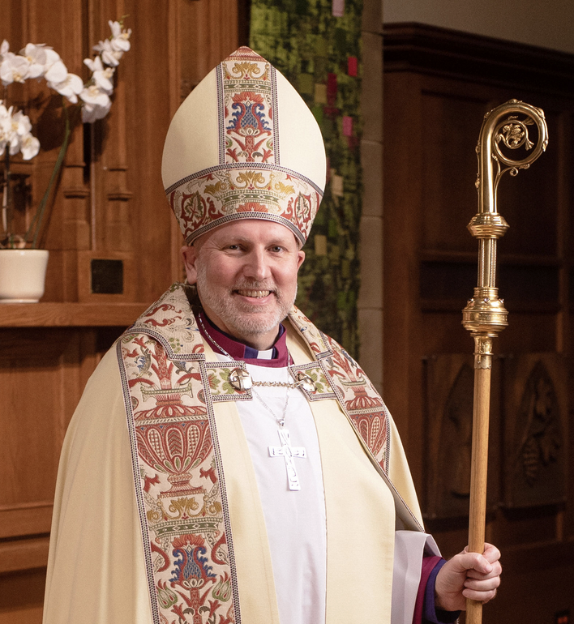

Archbishop John Stephens Visit
Sunday August 23rd, 2026


~Save the Date~

Saturday October 3rd

All Saints Anglican Church
Garage Sale



