Circuit Rider


Newsletter of Tekamah & Decatur United Methodist Churches
Parish Phone: (402) 374-2888
Parish Email: tekamahumc@abbnebraska.com
1408 L Street, Tekamah, NE 68061
May 2026
“Without a Doubt”
John 20:19-31
What do you find unbelievable? If you are like me, you probably have dealt with doubt in the past and continue to deal with doubt. Something amazing happens, but if it does not make sense, we doubt it.
The resurrection of Jesus, without a doubt is the most significant event in all human history. It is the lynchpin upon which Christianity hinges. In other words, if Jesus was not raised from the dead, then Christianity has no power. By the way, the Bible admits this; the Bible is brutally honest in admitting this.
I Corinthians 15:17 says, “If Christ has not been raised, then your faith is futile, and you are still in your sins.”
Another word for futile is pointless. What is the point? If Christ has not been raised from the dead then we should just be just patted on our heads and sent on our merry way. Here is the real problem; you are still in your sin.
You must appreciate the honesty in this. The consequence of sin is death. If Jesus did not have power over the consequences of sin, then what makes you think He can extend power to you? If He could not do that for Himself, you and I have no chance. Without a doubt everything rises and falls on the resurrection of Jesus.
Thomas Jefferson was a believer in creator God, but he was also a bit skeptical. He had an unorthodox view of Jesus later in life. He took a razor and cut out parts of the gospel that he did not like including the miracles and the resurrection. What was left was a complied into a book called “The Morals and Teachings of Jesus.” But here is the thing that Jefferson missed. To say Jesus was a moral teacher and to leave it at that is inaccurate. That is the great myth of our society today for many people. Jesus is a good moral teacher, and they put him alongside Buddha, Confucius, or Muhammad. But that cannot be. If Jesus did not do what He said, than that makes Him a liar, not just a small one but a colossal one. Because repeatedly He said, “I am going to die, and I am coming back to life.” If He did not do it, He would be a fake and He would be the biggest deceiver ever known.
Thomas Jefferson was a doubter, but he is not the most famous doubter of all time. The disciple Thomas has gone down in history known as Doubting Thomas. Thomas gets a bad rap; let me explain, he is actually a man of great courage. Let me set the record straight. In Luke 11, Jesus is with his disciples, and He hears that his friend Lazarus is dead. He eventually says, “Let’s go visit Lazarus.” The disciples immediately said, “You can’t do that!” Lazarus is back in Judea, Jesus, the last time you were there the people picked up stones to kill you. You cannot do that, You will die. Thomas, good old doubting Thomas, spoke up and said, “If Jesus dies we’re going to die with Him.” That is Thomas! What happened?

Page 1-2 – Pastor’s Article.
Page 3 – Birthday’s, Upcoming Messages, & Decatur’s Meals on Wheels.
Page 4 – Upcoming Events & Ongoing Prayers.
Page 5 – Financial Report
Page 6 - Pictures


Page 2
Circuit Rider
Like many people today, they must see in order to believe. Thomas was a man who wanted to figure things out for himself. As we are going to see, the beautiful thing about Jesus is He reveals Himself in a way that sincere people need Him too.

The days following Jesus’ death were a very dark time for the disciples. The disciples were in the upper room, behind locked door, afraid because they could be next. Jesus’ tomb was empty, but still they did not fully understand what all this meant.

When suddenly Jesus stands in their midst, and what does He say? Of all the things Jesus could have said, He does not say it once, but twice; “Peace be with you!” Why is that so important? Because in every human heart there is the deep desire for peace. What is the essence of peace? The essence of peace is to be secure. This is exactly what these men needed; they needed security, and so do you and I.

There are innumerable things in life that will disrupt your peace, circumstances beyond your control. As you read this, something probably has come to your mind. Twice Jesus says, “Peace be with you.” The resurrection means a lot of things, but one of the primary things it means is peace. Jesus breathed on them and they received the Holy Spirit. I think this is super encouraging for the disciples here. In John 14, Jesus says “I’m going to leave you.” The disciples did not like that one bit. Then Jesus makes this crazy statement, “It’s better that I leave because the Father is going to give you the Holy Spirit.” They must have been so pumped up to realize that this was the fulfillment of that promise.

Thomas was not present when Jeus appeared the first time and he does not believe what his friends say. He says, “Unless I put my fingers in the nail marks and my hand in His side I won’t believe.”

One week after Jesus first appeared, Jesus shows up again and Thomas is there: this whole encounter is really fascinating because of its details. Up to this point there had been no conversations between Jesus and Thomas. What does Jesus say to him? Jesus says, “Put your fingers in My hands and side.” Do you know what is interesting about the text? It does not say that Thomas did any of that. Instead, Jesus used the exact same words to prove He was alive. Thomas realized that Jesus knew exactly what he needed before he asked. He is shocked at the fact that Jesus appears with no previous conversation and says “Thomas, I know exactly what you need. See and touch!”

This is a beautiful admission on the part of Thomas, because it is one of the great all-time confessions, “My Lord and My God.” Realize that Thomas is a Jew, and Jews were fiercely monotheistic. And for a Jewish man to call Jesus his God, there is no stronger statement of belief. Jesus says, “Touch my wounds if you need too. They are there to help you.” In this sense, Jesus models sanctified wounding. Let me say it this way, all those unwanted, horrific, and terrible things in your life are ther to show you what is eternal.

What does the resurrection mean to you? Hopefully it gives you peace. The first words of Jesus were, “Peace be with you.” It gives you purpose. “Go and tell.”

Let me address any skeptics reading this, I am going to ask one small thing from you. Would you be like Thomas, and would you ask Jesus what it is you need to believe? Then be open minded to receive what you are given? Jesus actually ends the conversation by saying, “Have you believed because you see me? Blessed are those who have not seen yet believe.”

I am convinced that people do not reject the resurrection of Jesus because of lack of evidence. But rather they reject, they deny the resurrection, because it is a threat to their autonomy. In other words, if Jesus said that He’s coming back from the dead, it probably stands to reason that He has something to say about how I live my life. To deny the resurrection is to deny all the good things that God wants for you. But more than that, to actually deny the resurrection is to deny the deep love that God has for you.

Pastor Joel




Decatur:
3 – Mason Lami
3 – Lester Shaw
5 – Andrew Andersen
8 – Jean Morgan
9 – Bob Pickell
9 – Ivy Anderson
13 – Janet Bowers
15 – Erica Pickell
21 – Candy Roth
22 – Jessica Reppert
24 – Jane Judt
25 – Amy Jump
25 – Andrew Andersen
26 – Lance Anderson
27 – Anna Bowers
31 – Melanie Pickell
May 2026
TEKAMAH:
1 – Pam O’Mara
2 – Karen Elliott
2 – Carol Hansen
3 – Matthew Cass
4 – Trenton Elliott
6 – Gary Dorathy
6 – Andrew Smutny
7 – Bob Clements
7 – Larry Harmon
9 – Leah Schmeling
10 – Carol Brummond
11 – Brigette Neuber
12 – Brad Ray
13 – Gary Strong Jr.
13 – Teresa Strong-
Hilger
14 – Sam Hansen
14 - Will Jones
15 – Jaxsen
Oligmueller
16 – Samuel Bisanz
19 – Van Newell
21 – Hannah Kellogg
23 – Raynn Lambert
25 – Mary Dallmann
28 – Julie Cornish
28 – Maili Dean
28 – Cole Peterson
29 – Kayla Cass
30 – Jessica Nichols
New Series:
Life of King David
May 3
Fifth Sunday of Easter
I Samuel 17
Facing the Giant

May 10
Sixth Sunday of Easter
I Samuel 20
When God Wants You Alone

May 17
Seventh Sunday of Easter
I Samuel 26
Conflict

May 24
Pentecost
I Samuel 30:1-19
Failure

New Sermon Series: Apostles Creed
May 31
Trinity Sunday
I John 4:7-13
I Believe: Father

Upcoming Messages
Meals on Wheels:
Decatur:
May 11-15
Page 3
Circuit Rider
Decatur Ongoing Prayer List
Leanne Brockway Leonard Hansen
LeAnn Richards Connie Morgan Skip Farrens Marty Slaughter Don Drummond Phil Schroder
Marilyn Schroder Kathy McMann
George Kahlandt Roger Smith
Jimmy Webster Elaine Mitchell
Laurie Brokow (cousin of Jean Morgan)
Tyson Schmidt (grandson of Jim & Jane Judt)
Weston (grandson of Nico & Jenny Hardeman)
Jasmine (granddaughter of Ray & Julie Metcalf)
Amber (daughter-in-law of Ray & Julie Metcalf)

Decatur Home Bound & Care Center Friends
Norma Williams Darlene Smith
Barbara Bates Lynn & Karen Farrens Ethelyn Brewer Helen Tippery
Ed Maslonka Georgeann Dunning

Tekamah Ongoing Prayer List
Haley Deemer Bob Paul
Rose Johnson Barb Ray
Cindy Dahl Janet Orton JoEllen Davis Susan Sanders
Lois Weatherly Lori Titus
Finley Smith Gerald Method
Garold Method Titus Elliott
Steve More and Family Kim (daughter of Pat Crabb)
Nathaniel (grandson of Mary Brodersen)

Tekamah Home Bound & Care Center Friends
Mary Benne Donna Palmer
Irene Marhenke Yvonne Anderson
Bob Clements Van Newell
Carol Brummond Donna Mock
Joan Schuler Susan Method

Calendar of Events:
May 2026

No Summer Tekamah Bible Study. Return in September.
Wednesdays at 1:00 pm – Decatur Bible Study at the Sear’s Center.
Food Pantry Sunday in Tekamah First Sunday of every month.
Prayer Meeting – 1:00 pm – First Wednesday in Decatur at the Sears Center. 7:00 pm – Second Wednesday at Tekamah.
May 3 – 10:15 am – fruit and muffins. 11:00 am - Honoring the Seniors during the Tekemah Service & Children’s church party.
May 4 – 9:00 am – Tekamah UMW.
May 5 – 7:00 pm – SPPRC Meeting at Tekamah.
May 6 – 10:30 am – THDCCC Meeting at Presbyterian church in Tekamah.
May 6 – 7:00 pm – THDCCC Baccalaureate at the First Baptist church in Tekamah
May 13 – 6:00pm – Tekamah Trustees & 6:30 pm – Board Meeting
May 14 – 10:30 am – Unpack Food Truck at Pantry.
May 18-21 – 9:00 am – Noon – THDCCC Community VBS – Rain Forrest Falls Café at the Tekamah Lutheran Church.
May 20 – Decatur YUM’s at 5:30 pm & Board Meeting at 6:00pm.
May 27-30 – Annual Conference in Kearney, NE.

Need Prayer or Pastoral Visit
Call or Text Pastor Joel
(402) 670-4688
Email: jplisek@greatplainsumc.org

Page 4
Circuit Rider
I found this article on Pastor Brad Witt’s website, and I knew I had to share it. Enjoy.
Pastor Joel

God Takes the Summer Off
We are sorry to inform you that God will not be available during the summer, beginning June 1. He feels He deserves some time off, so He has cancelled His normal duties for summer. He has agreed to send the sun and rain…occasionally when He happens to be in town but expect delays on God answering prayers for the needs of your family.
God has let the church leaders know that they should not plan any outreach efforts, like mission trips during the summer. Or at least if you do, they will have to do it without Him because He plans to be gone a lot to see relatives, baseball games, and time out at the lake.
The board has reminded God of His promise, “Surely I will be with you always.” But He says He didn’t realize when He said it that it meant going two or three years without a break. He expresses His sincere regret and hopes that it will not cause any inconveniences.
God may be contacted anytime after September 1 at which time He hopes to get back into the routine. God requests, “Please defer all requests till then.”

Aren’t you glad that God doesn’t take the summer off! As we approach summer, make a determined effort to bring yourself to God’s house. Yes, you need rest, but we also need spiritual renewal that comes from being with other believers in worship. Even if you travel away from Nebraska, find a church where you are at. There’s many to choose from. God will be waiting for us to worship Him.
Decatur Financial Report

Budget for the Year: $44,079.91 Need a week: $847.69
Need for January – April: $14,410.73
Offering January – April: $12,557.25

Page 5
Circuit Rider
Tekamah Finance Report
Budget for the Year: $98,766.61 Need a week: $1,899,36
Need for January – April: $32,289.12
Offering for January – April: $20,639.00
,

Decatur UMC Children’s Church 2026
Astrid, Bonnie Hennig & Branch
Big Thank You to Bonnie Hennig.

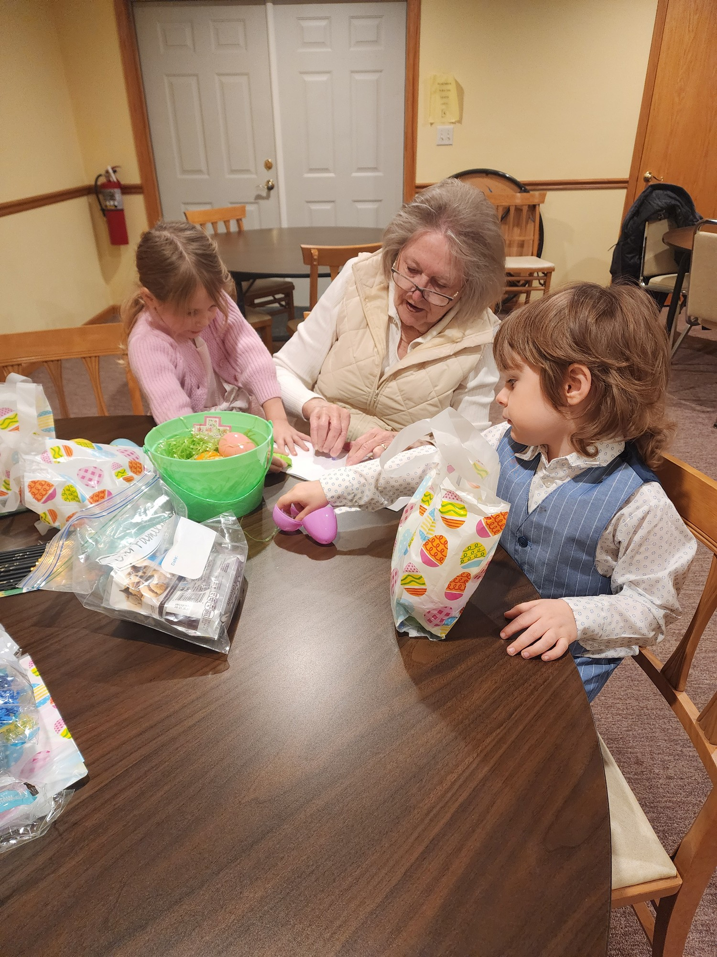
Something to Ponder:

"Faith is believing BEFORE what will only make sense AFTER." – Steven Furtick
Tekamah Card Ministry:
Cards for all occasions (.50 ¢ each) are available at the information table in the Narthex at Tekamah. A word of hope in trying times can make such a huge impact.
Tekamah UMC Children’s Church 2025/26
Charlie, Emma, Maesyn, Sutton, Axl, Olive, Rebel & Ripp
Big Thank You to Pam O’Mara & Mary Plisek


Check us out on Social Media:
Facebook: Website:
Tekamah Decatur Methodist Parish www.tekamahdecaturumcparish.org

New Sunday Services posted each Sunday before 5:00 pm.

Tekamah UMC Confirmation Class 2025/26
Cailyn Magill, Pastor Joel, & Brody Ahrens

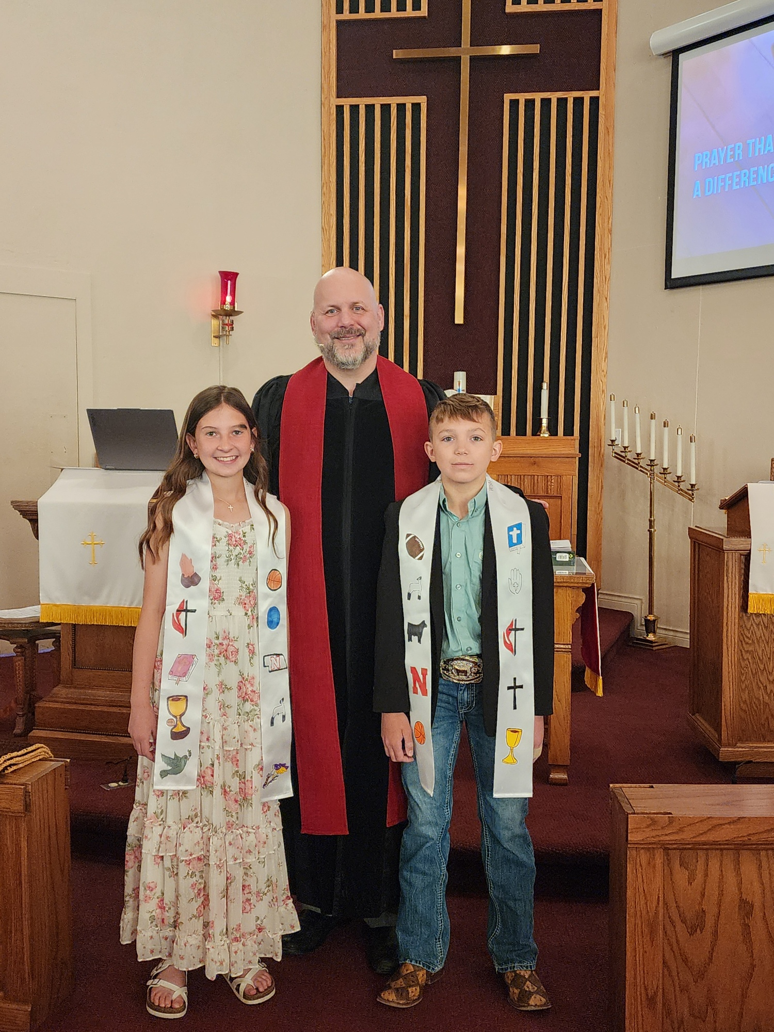

Page 6
Circuit Rider

