
Welcome to
St. John’s Evangelical Lutheran Church
By God’s example, St. John’s invites and welcomes everyone to
be ignited by the Spirit and to grow in God’s love.
May all those seeking love, acceptance and support find it here.
Tenth Sunday after Pentecost • August 2, 2026 • 9:30am

In today’s first reading God invites all who are hungry or thirsty to receive food and drink without cost. Jesus feeds the hungry multitude and reveals the abundance of God. At the eucharistic table we remember all who are hungry or poor in our world today. As we share the bread of life, we are sent forth to give ourselves away as bread for the hungry.


Our Mission:
Ignited by Spirit, Growing in Love
We strive to be a community that is open to the Spirit of God that moves, changes and inspires us to connect with God and one another, everyday, everywhere.

WELCOME
We are so glad you are here with us this morning. We pray that you will meet God in worship and that your faith will be strengthened as you prepare to go out into the world in the coming week. If you are a guest with us this morning, welcome to the family! We would love to share information with you about St. John's - fill out a pew card and place it in the offering plate or sign the guest book in the narthex so we can reach out!

PRAYER LIST
Please continue to keep the following people connected to our congregation in your prayers: Leonard Gibeon, David Mounts, Steve Keyser, Renee Fels, Rebecca Jellen, Richard Ditzler, Alyson Harvey, Marie Wolfe, Mary Eberle, Brandon Blanchard, Elizabeth Brossett and family, Paige Seasock, Tanner Antalosky, Will Morgan, Barry Long, Jim Martin, Mike Wolf, Michael Svanson, Marilyn Little-Logan, Ed Bowlin, Josephine D'Amico, Bob Schanely, Bob Ernst and Bill Hutt.

Names are kept on the prayer list for three weeks unless specifically requested by the family or for those struggling through long-term illness or treatment. If you would like to add a name to the prayer list, please contact the church office at 215-234-4888 or stj.stown@verizon.net.

+ THE GATHERING +

The congregation is invited to observe the prelude time as one of reverent silence.

PRELUDE Come, O thou traveler unknown - setting by Dale Wood

WELCOME AND GREETING

LIGHTING OF THE TRINITY CANDLE
We are a community of faith that is
Ignited by Spirit, Growing in Love.
We begin our worship in the name of the Father, the Son and the Holy Spirit.
Amen.

OPENING HYMN ELW 804 Come Down, O Love Divine

GREETING
The grace of our Lord Jesus Christ, the love of God
and the communion of the Holy Spirit be with you all.
And also with you.

CONFESSION AND FORGIVENESS
Blessed be the holy Trinity, one God, whose compassion endures forever.
Amen.

Let us confess our sin to God.

Silence is kept for reflection.

Compassionate God,
we confess to you all our sins. Our burden is heavy, and we cannot free ourselves. In your mercy, call us back to you. Your yoke is easy and your burden is light. Restore us to dwell in your peace. In Christ’s name we pray, Amen.

Jesus says, “Come to me, all you who are weary and are carrying heavy burdens,
and I will give you rest.” In the name of God, Father, Son, and Holy Spirit, your sins are forgiven. Rest in God’s love.
Amen.

PRAYER OF THE DAY
Glorious God, your generosity waters the world with goodness, and you cover creation with abundance. Awaken in us a hunger for the food that satisfies both body and spirit, and with this food fill all the starving world; through your Son, Jesus Christ, our Savior and Lord. Amen.

+ THE WORD +

FIRST LESSON: Genesis 32:22-31

At the conclusion of the reading:
The Word of the Lord.
Thanks be to God.

PSALM: Psalm 17:1-7, 15
Hear a just cause, O Lord; give heed to my cry;
listen to my prayer, which does not come from lying lips.
Let my vindication come forth from your presence;
let your eyes be fixed on justice.
Examine my heart, visit me by night,
melt me down; you will find no impurity in me.
I have not regarded what others do;
at the word of your lips I have avoided the ways of the violent.
My footsteps hold fast to your well-worn path;
and my feet do not slip.
I call upon you, O God, for you will answer me;
incline your ear to me and hear my words.
Show me your marvelous lovingkindness,
O Savior of those who take refuge at your right hand from those who rise against them.
But at my vindication I shall see your face;
when I awake, I shall be satisfied, beholding your likeness.

The Word of the Lord.

Thanks be to God.
GOSPEL ACCLAMATION
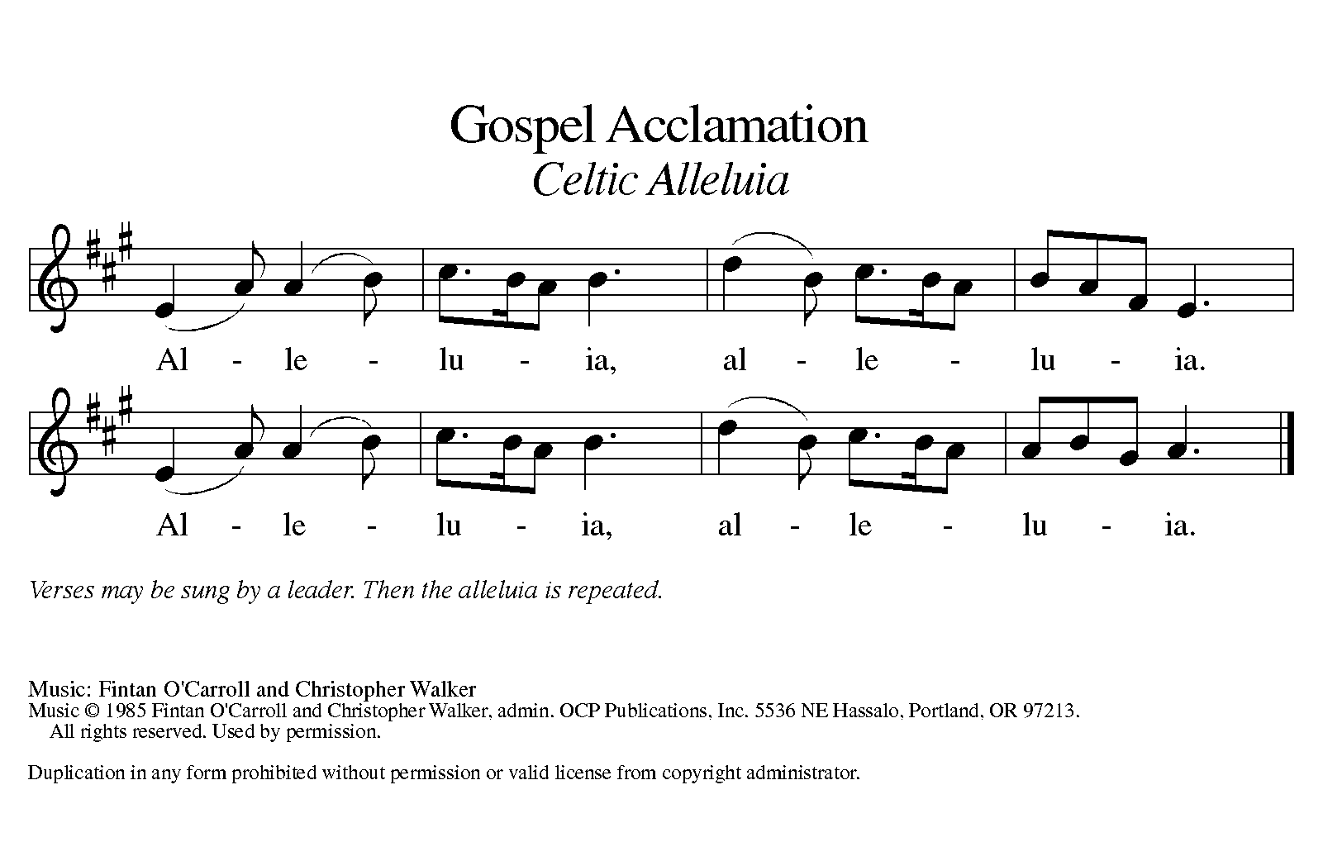
GOSPEL LESSON: Matthew 14:13-21

At the beginning of the reading:

The Holy Gospel according to Matthew.

Glory to you, O Lord.

At the conclusion of the reading:

This is the Gospel of the Lord.

Praise to you, O Christ.

SERMON The Rev. Dr. Dee Littleton

Please rise in body or spirit.

HYMN OF THE DAY ELW 689 Praise and Thanksgiving

APOSTLE’S CREED
I believe in God, the Father almighty, creator of heaven and earth.

I believe in Jesus Christ, God’s only Son, our Lord, who was conceived by the Holy Spirit, born of the virgin Mary, suffered under Pontius Pilate, was crucified, died, and was buried; he descended into hell. On the third day he rose again; he ascended into heaven, he is seated at the right hand of the Father, and he will come to judge the living and the dead.

I believe in the Holy Spirit, the holy catholic church, the communion of saints, the forgiveness of sins, the resurrection of the body, and the life everlasting. Amen.

Please be seated

PRAYERS OF THE PEOPLE

Each petition ends with the phrase:
Merciful God,
receive our prayer.

The prayers conclude:
Receive our prayers and answer, O God, as you have promised. All this we ask in the name of your Son, Jesus Christ our Lord. Amen.

+THE MEAL+
OFFERING

MUSICAL OFFERING Brethren, we have met to worship –
setting by Kenon D. Renfrow
Jadon Brewster, piano

Please rise in body or spirit.

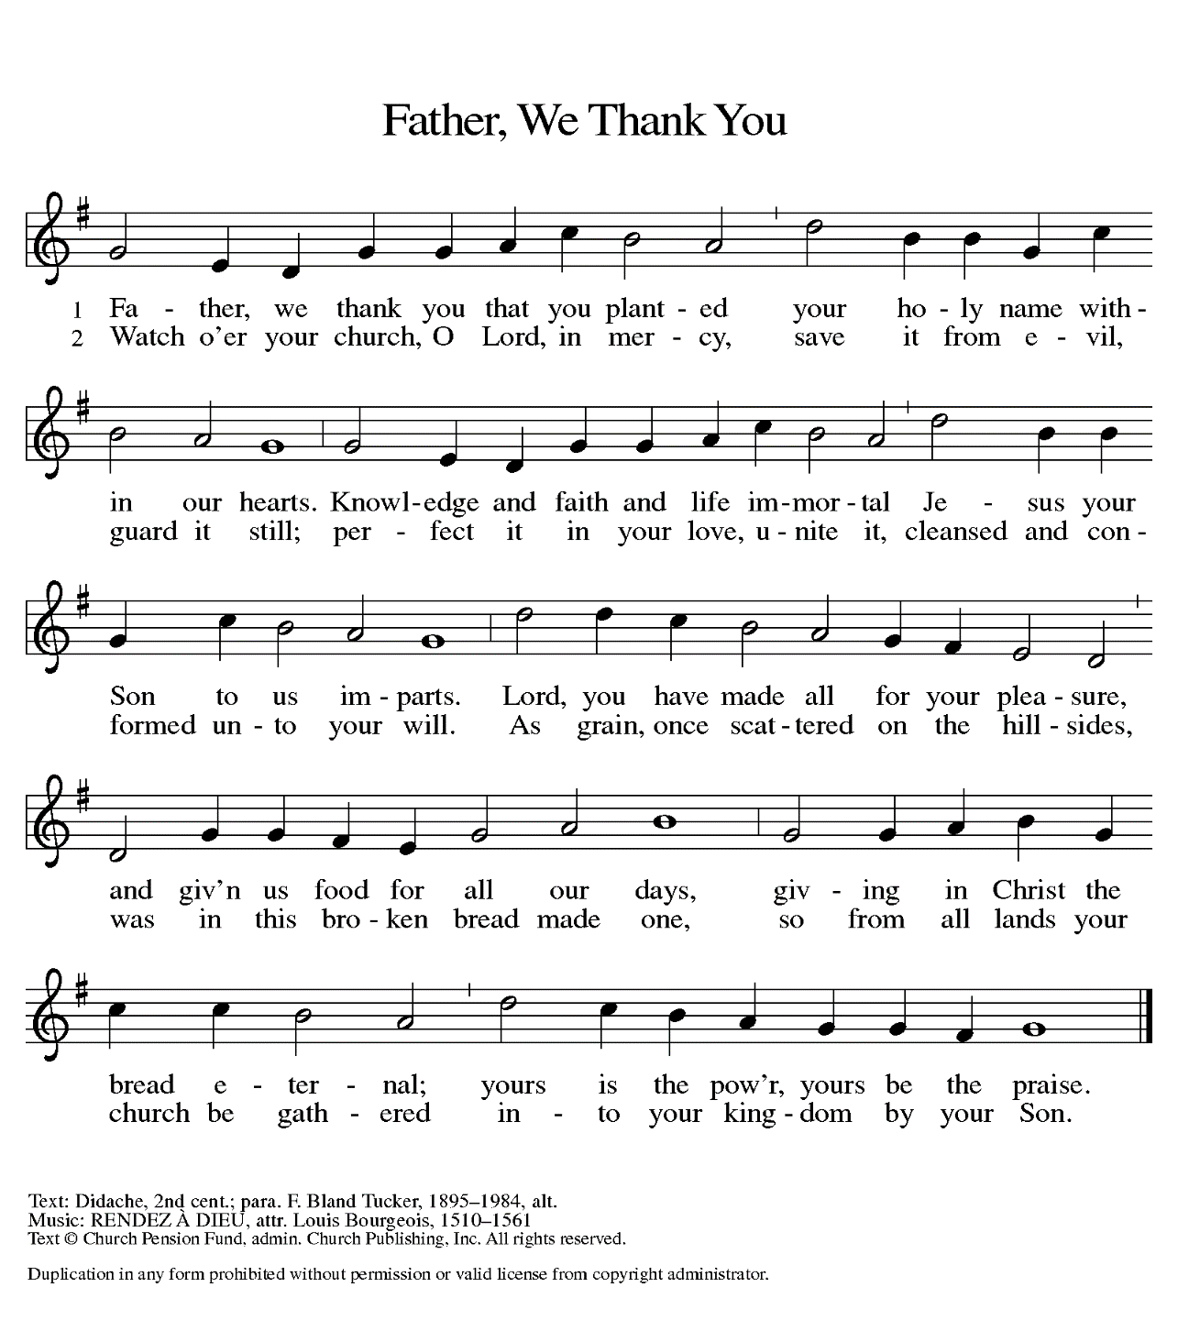
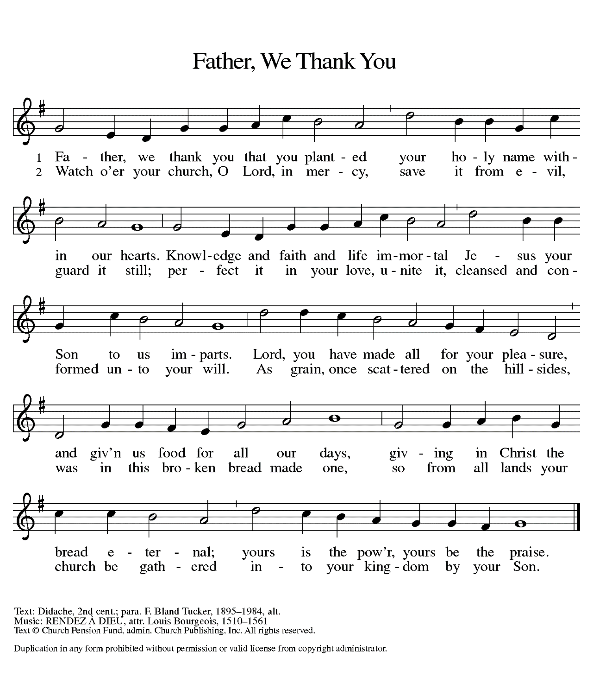
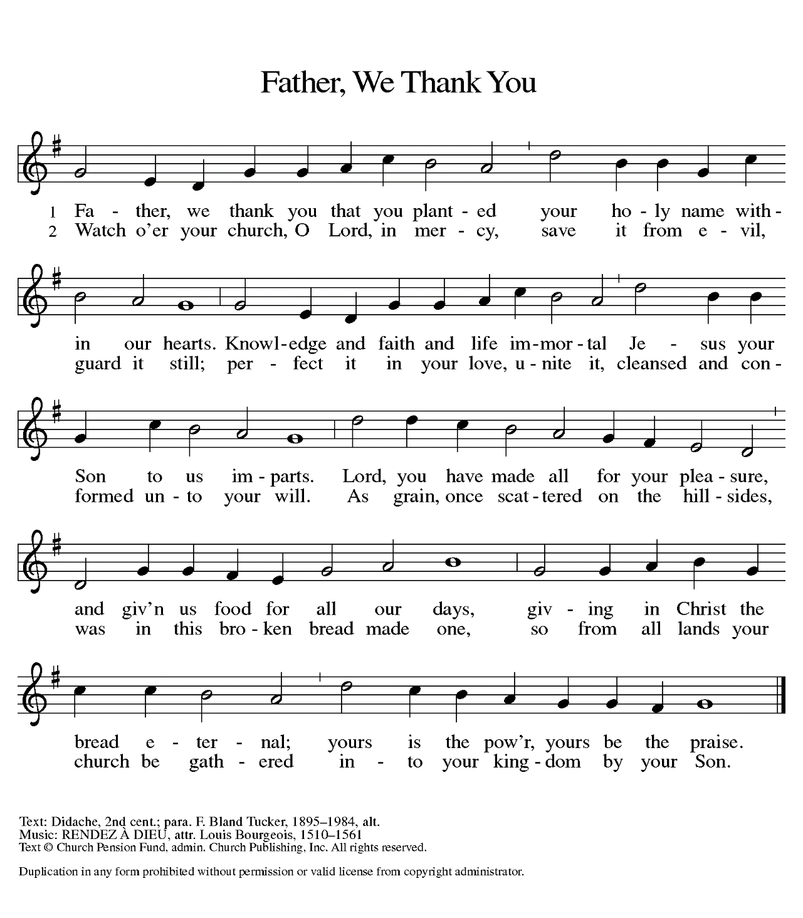
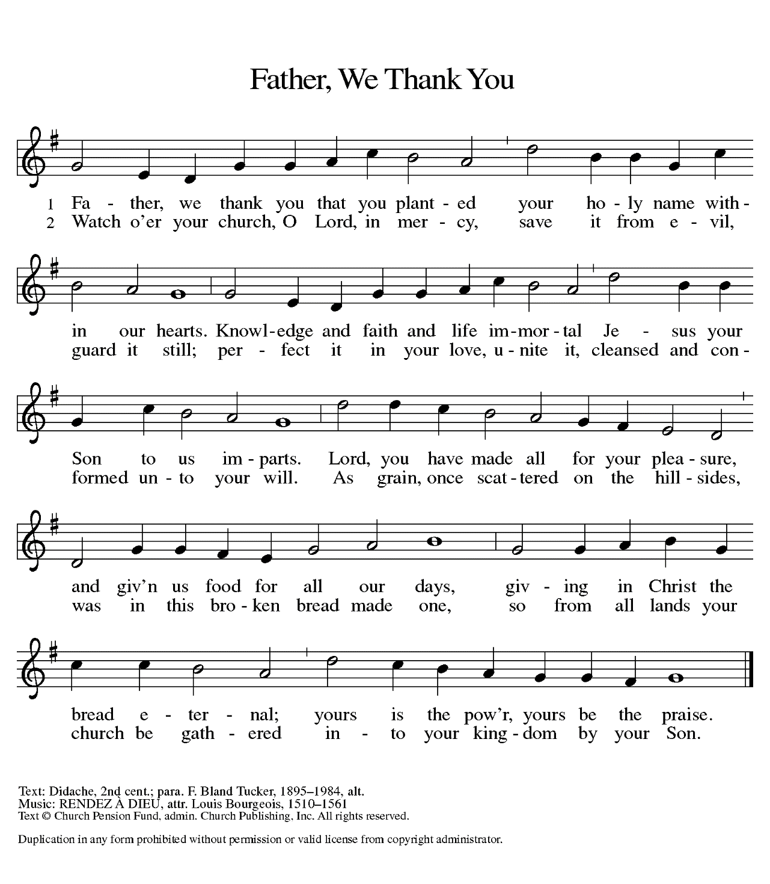
OFFERTORY

OFFERING PRAYER
Loving God, we offer at your table the gifts of our hearts. Help us take heart in you and share freely of your love, so that all creation can taste your abundance. We ask this in the name of Jesus, through the Spirit abiding with us now and forever. Amen.
THE GREAT THANKSGIVING
The Lord be with you.
And also with you.
Lift up your hearts.
We lift them to the Lord.
Let us give thanks to the Lord our God.
It is right to give God thanks and praise.

WORDS OF INSTITUTION
LORD’S PRAYER
As Jesus taught us, we are bold to pray,
Our Father, who art in heaven, hallowed be thy name, thy kingdom come, thy will be done on earth as it is in heaven. Give us this day our daily bread, and forgive us our trespasses, as we forgive those who trespass against us; and lead us not into temptation, but deliver us from evil. For thine is the kingdom, and the power, and the glory, forever and ever. Amen.

LAMB OF GOD
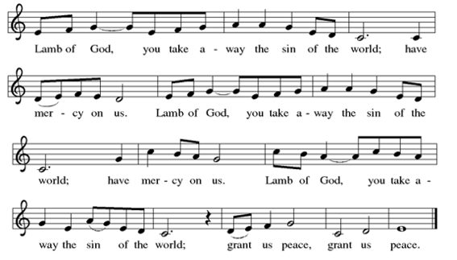

INVITATION TO THE TABLE
These are the gifts of God for the people of God.
Thanks be to God.

SHARING OF COMMUNION
Communion will be shared continuously. Please come forward down the center aisle and return to your seat by the side aisle. You will receive the bread from the pastor and then be invited to take a pre-filled cup from the tray held by the communion assistant. Wine is in the clear cups and grape juice is in the purple cups. Empty cups can be placed in the bowls at the end of the first pew as you return to your seat. All are welcome!

MUSIC DURING COMMUNION ELW 471 Let Us Break Bread Together

TABLE BLESSING
PRAYER AFTER COMMUNION
Compassionate God, through the gifts of bread and wine our hearts are filled with the abundance of your love. Strengthen us that we, through this holy meal, may share your love freely, as you have shared with us. We ask this in the name of Jesus, through the Spirit nourishing us now and forever. Amen.

+ THE Sending +
ANNOUNCEMENTS

BENEDICTION
Creator, Redeemer, Sustainer,
one God,
bless, heal, and hold you
today and always.
Amen.

SENDING HYMN ELW 632 O God, Our Help in Ages Past

DISMISSAL
Go in peace. Share the good news.
Thanks be to God.
POSTLUDE Ite, Missa Est – Eric DeLamarter

The liturgy for today’s worship service was reprinted by permission from Sundays and Seasons.com, copyright 2026 Augsburg Fortress Liturgies Annual License #45176. The hymns and songs unless otherwise noted, are covered under copyright licenses; CCLI 1490857, OneLicense.net A-709256, or are Public Domain. Copyright 2026.

Mark Your Calendar

Saturday, August 8 National Night Out 3-6 PM

Sunday, August 9 Heavenly Helpers Hoagie orders are due

Monday, August 10 Council meeting 7:30pm

Wednesday, August 19 Taizé worship service 6pm

Thursday, August 20 Heavenly Helpers Hoagie order pick-up 5-6pm

Friday, August 28 Fire Pit 7pm
Iron Pigs Faith Night

Taizé Prayer Service Reformation Sister congregations will meet again on August 19th for a candlelit service of song, scripture, silence and reflection. All are welcome regardless of church background or faith tradition.

Card Club is collecting birthday card donations. If you’d like to contribute, please place your cards on the kitchen serving-window counter. Thank you for your support!

The Open Link – The first Saturday of the month food donation drop off 9-11am. If you are not able to stop by on the scheduled time, donations can be left in the church gym. The Food Pantry is urgently in need of the following: shelf-stable milk, peanut butter, jelly, boxed cereals, soups, and tomato products. Questions, contact Diane Appold

Friday at the Firepit August 28th, join us for an evening of fellowship.
Relax and enjoy some sweet treats. Water and s’mores ingredients are provided.
Don’t forget your lawn chairs and any snacks or beverage of choice.

Reformation Sister Churches Faith night at the Iron Pig’s game, Friday, August 28th.
Tickets available at Frieden’s office or after worship. Cost $13 per person. (includes a $2 credit for food or merchandise) Gates open at 5pm – game starts at 6:46 PM. All are welcome!

Program Newsletter August is here already, which means it's time to start planning the upcoming program newsletter. Please submit your article(s) by Sunday, August 30th so we can begin assembling the issue. Thank you

Worship in the Park Sunday, September 6 at 10:30am, hosted by the Reformation Sister Churches. The Red Hill Band brass section will accompany the service. All are welcome to stay and share in fellowship while enjoying a potluck picnic lunch. See weekly email for additional details.

OUR RESPONSE TO GOD’S LOVE
Worship Attendance
07/26/2026 worship service - 43 Zoom - 9
 | Total received between  07/05/2026 – 07/19/2026 $4774.00 | Amount Needed per 2 weeks in 2026  $11,656
Weekly average is based on the 2026 budget. The above numbers include electronic giving. Mint duty is being done every other week.

Family Bathroom The family bathroom project has started. The fixtures were ordered and have arrived. If you would like to donate, please write “Family Bathroom” on an envelope to designate the funds to the family bathroom project or you may donate online through St. John’s website!

National Night Out Sponsored by the Marlborough Police dept. August 8 from 3-6 PM. Music, games and food. Safety demonstrations, youth events, exhibits and much more. Come out to St John’s church parking lot and meet the UP Emergency responders!
Christ in Our Home Daily Devotional Booklets for the summer months (July, August, and September) are now available. You can pick up your copy in the Narthex or Parlor. Both small and large print copies are available.

St. John’s Summer Service Project -As summer is quickly coming to a close, please have your donations placed in the collection containers by Sept 5th weekend.

You can drop off any of the items needed for the kits – OR drop of a fully complete kit.
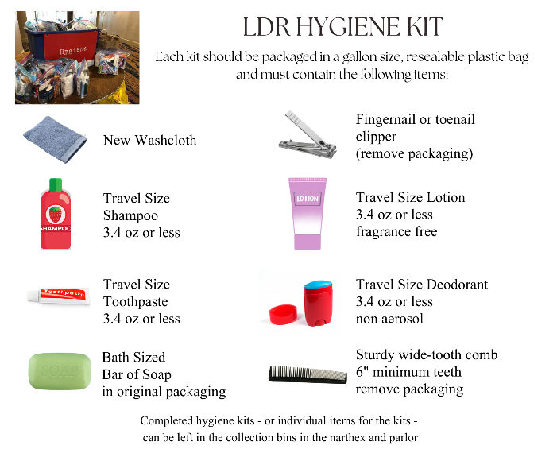
Each hygiene kit fits in a one-gallon resealable plastic bag and contains 8 items

Collection containers are located in the Parlor & Narthex

Kits will be delivered in early September to LDR to support local relief efforts.



SERVING THIS SUNDAY
Erika Haldeman & David Ramil – A/V team

COUNCIL MEMBERS
David Ramil, Council President
Shannon Renninger, Council Vice-President
Robyn Schramm, Council Secretary
Mike Herm, Council Treasurer
Tony Aleide, Finance
Brandon Bolton, Property
Joyce Foesig, Staff
Sheila Hercek, Outreach
Travis Hobson, Marketing and Communications
John Hovanec, Faith Formation
Nate Schramm, Youth Representative
Mike Wolf, Worship and Music

STAFF
Rev. Rebecca L. Schanely, Pastor
(pastorbecky74@gmail.com)
Denise Fox, Office Administrator (stj.stown@verizon.net)
Ben Modica, Director of Music (ben@patriciakeith.com)
Michele Peart, Bookkeeper
Jamie Nonkovic, Coordinator of Children’s Faith Formation
Bob Ernst, Facilities Manager
Michael Herm, Treasurer

3104 Main Street, Green Lane, PA 18054
215-234-4888 (phone) 215-234-0825 (fax)

