Name of Assembly: United Apostolic Church
Type of service: Bible Study
Date: July 28th, August 4th, 2026
Series Topic: “Living the 7 Ministry Pillars”
Lesson 1: “Evangelism: Fishing From Our Pond”
Text: John 1:35-41

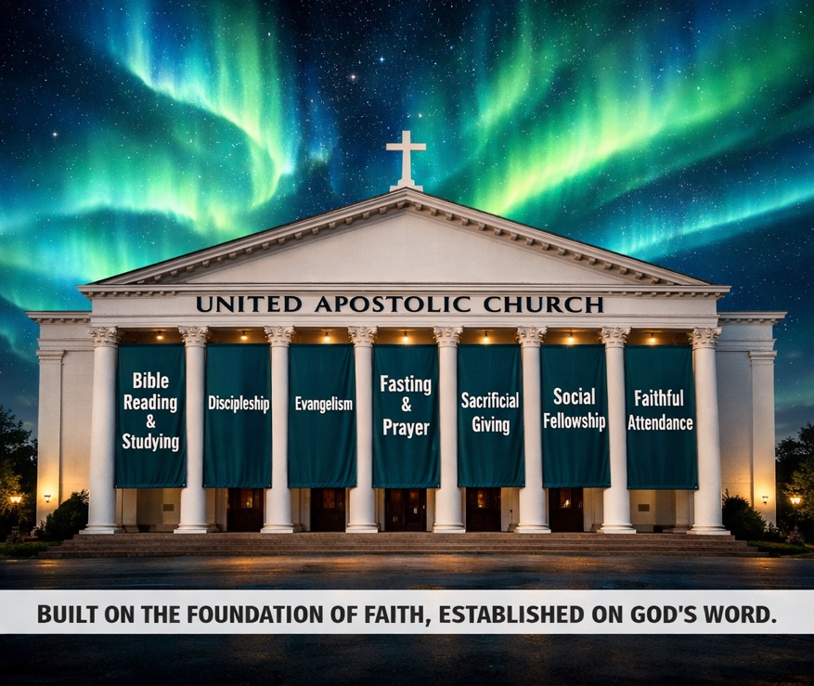
INTRODUCTION


We are continuing our Bible Study on Pillar #6, exploring “Evangelism: Fishing From Our Pond.”

“³⁵ Again the next day after John stood, and two of his disciples; ³⁶ And looking upon Jesus as he walked, he saith, Behold the Lamb of God! ³⁷ And the two disciples heard him speak, and they followed Jesus. ³⁸ Then Jesus turned, and saw them following, and saith unto them, What seek ye? They said unto him, Rabbi, (which is to say, being interpreted, Master,) where dwellest thou? ³⁹ He saith unto them, Come and see. They came and saw where he dwelt, and abode with him that day: for it was about the tenth hour. ⁴⁰ One of the two which heard John speak, and followed him, was Andrew, Simon Peter’s brother. ⁴¹ He first findeth his own brother Simon, and saith unto him, We have found the Messias, which is, being interpreted, the Christ” – St. John 1:35-41.

Here’s a thought that might surprise you: the most effective evangelist in the room is probably not the loudest voice or the sharpest apologist. It’s the one with the deepest relationships. We’ve been told — by training programs, big outreach events, and stories of fearless street preachers — that sharing our faith requires a special gift, a polished script, or the courage to approach a complete stranger. So most of us quietly opt out. We tell ourselves we’re not wired for it. We wait for someone braver, more articulate, or more theologically equipped. But what if that story has kept us from the very mission field God already placed us in? Think about the people who already know your name. The neighbor who’s watched your life from the other side of the fence. The coworker who noticed how you handled the hardest season of your career. The old friend who knows where you’ve been and is still watching to see where your faith has taken you. Your neighbors, your coworkers, your family members, your friends and your associates — represent your pond. And God didn’t put you there by accident.

The pond serves as a strong symbol. Unlike the ocean, it is smaller, more familiar, and easier to approach. It illustrates the relationships God has already established in your life—those who know your name, face, and story.

The Importance of this Lesson

In this study, we’ll explore relational evangelism — the art of sharing your faith through the relationships you already have. We begin with Andrew in John 1:41–42, a man who didn’t seek a crowd but simply found his brother Peter and brought him to Jesus. Simple. Personal. Effective. From there, we’ll look at the woman at the well (John 4), who ran back to her village — her own pond — and said, “Come, see a man who told me everything I ever did.” We’ll study the Gerasene demoniac (Mark 5), who begged to follow Jesus on the road but was sent home instead: “Go home to your own people and tell them how much the Lord has done for you.” We’ll examine Cornelius and Peter (Acts 10) and what it means when God orchestrates divine appointments through existing networks of trust. Along the way, we’ll build practical tools together: a “Most Wanted” prayer list for the people in your life who don’t yet know Jesus, and a pond map to help you see your relational world with fresh, missional eyes.

Why This Study Matters Now
We are living in one of the loneliest moments in modern history. People have fewer close friends than ever. Trust in institutions — government, media, even the church — sits at historic lows, and many are quietly aching for someone who genuinely knows them. And yet trust in personal relationships remains remarkably resilient. People still believe the people they love. They still listen to friends who’ve earned their confidence over years of shared life. In this cultural moment, the church’s greatest evangelistic asset is not its programs, its platforms, or its productions — it’s its people. It’s you, and the relationships God has already given you. Those relationships are not incidental to the mission. They are the mission.

Long before “relational evangelism” gained popularity, researchers identified a clear pattern in how individuals come to faith. During the 1970s and 1980s, C. Peter Wagner, together with Donald McGavran and researcher Win Arn, surveyed more than 10,000 church members using a straightforward question: “What or who was instrumental in drawing you to Christ and the church?”

The answers were consistent, measurable, and impossible to ignore:

- 70% to 90% – Friends and Relatives: People were invited or influenced by someone they already knew and trusted — a pre-existing relationship that opened the door to faith.

- 6% to 8% – The Pastor: People drawn primarily through the preaching or personal ministry of the lead pastor.

- 2% to 3% – Organized Church Programs: Evangelistic events, specialized campaigns, or structured outreach efforts.

- 1% to 2% – Visitation: Door-to-door or cold-contact ministry.

- 1% to 2% – Sunday School: Reached through classroom-based outreach.

- Less than 1% – Mass Evangelism Crusades: Conversions from stadium events or large-scale media campaigns without relational follow-up.

Wagner highlighted that although mass campaigns and professional clergy are useful, they are not the main drivers of sustained growth in conversion. Instead, the true catalyst is the daily web of ordinary relationships — what the Greeks referred to as Oikos: household, network, sphere of influence.

A generation after Wagner and McGavran, a new wave of research asked a different question — not just how people come to faith, but how willing the unchurched actually are to respond when someone reaches out. Dr. Thom Rainer pursued that question through large-scale data collection with Lifeway Research and Church Answers, producing findings that reframed how churches think about personal invitation.

- The 82% Invitation Metric: In The Unchurched Next Door, Rainer found that 82% of unchurched people are at least “somewhat likely” to attend a church service if personally invited by a friend, family member, or neighbor.

- The 60% Personal Influence Fact: Rainer’s research with Church Answers shows that 60% of active evangelical churchgoers cite a personal, relational invitation as the single primary reason they first walked through the doors of their current church.

Andrew and Peter: The Original Model

⁴⁰ One of the two which heard John speak, and followed him, was Andrew, Simon Peter’s brother. ⁴¹ He first findeth his own brother Simon, and saith unto him, We have found the Messias, which is, being interpreted, the Christ” – St. John 1:35-41.

Andrew had just spent the day with Jesus — John 1:39 tells us he and another disciple “came and saw where he dwelt, and abode with him that day.” He was not a seasoned theologian. He had not yet witnessed miracles or heard the Sermon on the Mount. He was simply a fisherman who had just had the most significant encounter of his life. And that was enough.

Notice the word “first” in verse 41: the first thing Andrew did was to find his brother. John does not say Andrew eventually got around to telling someone. The word “first” signals urgency, priority, and immediacy. The encounter with Jesus was so real, so undeniable, that Andrew could not wait. His very next move — before anything else — was to go and find someone he loved.

And he did not go looking for a stranger. He went to Peter — someone he already knew, trusted, and had shared a life with. This is the model. Andrew did not need a platform or a program. He needed a relationship. He had one, so he used it. That is relational evangelism in its purest form: one person, moved by what they have experienced, going to someone close to them to share the Good News.

We should also consider what this cost Andrew. He had no guarantee that Peter would respond. Peter could have laughed, dismissed him, or walked away. Andrew went anyway — not with a polished argument, but with a simple, urgent, personal invitation. Faithfulness rarely comes with guarantees. It comes with the willingness to speak even when the outcome is uncertain.

The same applies to Philip, who introduced Nathaniel to Jesus. “⁴³ The day following Jesus would go forth into Galilee, and findeth Philip, and saith unto him, Follow me. ⁴⁴ Now Philip was of Bethsaida, the city of Andrew and Peter. ⁴⁵ Philip findeth Nathanael, and saith unto him, We have found him, of whom Moses in the law, and the prophets, did write, Jesus of Nazareth, the son of Joseph. ⁴⁶ And Nathanael said unto him, Can there any good thing come out of Nazareth? Philip saith unto him, Come and see. ⁴⁷ Jesus saw Nathanael coming to him, and saith of him, Behold an Israelite indeed, in whom is no guile! ⁴⁸ Nathanael saith unto him, Whence knowest thou me? Jesus answered and said unto him, Before that Philip called thee, when thou wast under the fig tree, I saw thee. ⁴⁹ Nathanael answered and saith unto him, Rabbi, thou art the Son of God; thou art the King of Israel. ⁵⁰ Jesus answered and said unto him, Because I said unto thee, I saw thee under the fig tree, believest thou? thou shalt see greater things than these” – John 1: 43-50.

Andrew is a model for every ordinary believer. He was neither eloquent nor prominent — simply faithful to share what he had found with someone close to him. What is striking is how consistently this pattern appears throughout John’s Gospel: Andrew appears three times, and each time he brings someone to Jesus. In John 1:41, he brings his brother Peter — “He first findeth his own brother Simon, and saith unto him, We have found the Messias, which is, being interpreted, the Christ.” In John 6:8, he brings a boy with five loaves and two fish — “One of his disciples, Andrew, Simon Peter’s brother, saith unto him, There is a lad here, which hath five barley loaves, and two small fishes: but what are they among so many?” In John 12:22, he brings a group of Greeks who want to see Jesus — “Philip cometh and telleth Andrew: and again Andrew and Philip tell Jesus.” That is Andrew’s entire ministry — not preaching to crowds, not building institutions, but quietly and faithfully connecting people to Christ, one relationship at a time. This is a ministry every believer can practice.

Andrew’s Method: Simple, Relational, Powerful

Andrew’s encounter with Jesus in John 1 is one of the most understated moments in the New Testament. No sermon. No strategy. No committee. Just a man who found something real, went to someone he loved, and made an introduction. But look closer — there is a method embedded in that simplicity. Four movements, each one available to any believer.

- He Had a Personal Encounter- Andrew first spent time with Jesus himself — John 1:39 records it simply: “He came and saw where he dwelt, and abode with him that day.” That day changed everything. And notice: Andrew’s witness did not flow from secondhand knowledge, inherited religion, or theological training. It flowed from something he had personally lived. You cannot give what you have not received. This is why genuine witness always begins with genuine encounter. The most compelling testimony is not the most polished one — it is the most honest one. Andrew did not need to be impressive. He only needed to be real.

- He Found Someone He Knew — Andrew went to his own brother — and the Greek word behind “own” is idios, meaning “his personal,” “his private,” “his innermost circle.” Andrew didn’t scan the crowd for the most receptive stranger or calculate who might be easiest to convince. He went home. He went to the person he already knew and already loved. This is deeply liberating: it removes the pressure of cold outreach entirely. Your pond is already warm. The relationships you already have — family, friends, neighbors, coworkers — are not obstacles to evangelism. They are the very field in which it grows. You do not need to find new people. You need to go to the ones already in your life.

- He Made a Bold Declaration - The KJV renders John 1:41 this way: “He first findeth his own brother Simon, and saith unto him, We have found the Messias, which is, being interpreted, the Christ.” Hear what Andrew did not say. He did not offer a theological argument. He did not lay out a systematic case for the messianic credentials of Jesus of Nazareth. He simply said, “We have found.” A discovery shared between two people who trusted each other. That is all. The most effective evangelistic statement is often just a personal testimony framed as an invitation — not “Let me prove something to you.” Conviction is caught as much as it is taught, and Andrew’s joy was contagious long before it was argued.

- He Made the Introduction - John 1:42 closes the sequence with four words of breathtaking simplicity: “And he brought him to Jesus.” That was it. Andrew’s job was finished. He did not have to close the deal, answer every objection, manufacture conviction, or produce a conversion. He brought Peter to Jesus — and then he let Jesus do what only Jesus could do. This is the great relief of relational evangelism: we are not the Savior. We are just the bridge. Our responsibility is not to save anyone — it is to connect people with the One who already has. Faithfulness looks like bringing someone to Jesus and trusting Him with what happens next.

It is worth sitting with the sheer simplicity of what Andrew did — because the simplicity is not accidental. God chose to spread the Gospel not through spectacle, strategy, or institutional machinery, but through relationship. One person telling another. A brother finding a brother. A discovery shared over the warmth of an existing bond. The method — personal, relational, humble — reflects the very nature of the Gospel itself: grace that comes close, that enters our ordinary world, that speaks in a language we already understand. Andrew’s method is not a lesser form of evangelism waiting to be upgraded. It is the form. It is the thing itself.

More Pond Fishers in Scripture
Andrew and Peter are not the only example. The Bible is filled with people who changed eternity by sharing their faith within their existing relationships.

- The Woman at the Well: John 4:28–29 — She left her water jar and ran back to her town — the people who knew her story — and said, “Come, see a man who told me everything I ever did.” Her entire community came to faith because she fished in her own pond.

- Cornelius the Centurion: Acts 10:24 — Before Peter even arrived, Cornelius had already “called together his relatives and close friends.” He prepared his pond. When the message came, a whole household received the Holy Spirit.

- The Healed Demoniac: Mark 5:19 — Jesus told him, “Go home to your own people and tell them how much the Lord has done for you.” His assignment was not to travel far — it was to go back to his existing relationships.

Building a “Most Wanted” List
One of the most practical tools in relational evangelism is creating a personal prayer list—often called a “Most Wanted” List. These are the people in your personal “pond” whom you are intentionally praying for, building relationships with, and believing God to save.

- Write Their Names Down: There is something powerful about writing names on paper. Recording names transforms a good intention into a deliberate spiritual commitment before God. It also keeps your focus on the people God has placed within your sphere of influence.

- Pray for Them Specifically and Consistently: Pray for each person by name. Ask God to:
- Soften their heart toward the gospel.
- Create circumstances that draw them closer to Him.
- Open doors for meaningful spiritual conversations.
- Give you wisdom, boldness, and sensitivity to share your testimony and invite them to church at the right time.
- Surround them with godly influences that point them to Christ.
- Invest in the Relationship: Prayer should lead to intentional action. Look for opportunities to:
- Spend time together.
- Listen to their needs.
- Demonstrate genuine care and kindness.
- Invite them to church or a fellowship event.
- Share your personal testimony and the hope found in Jesus Christ.

People are often reached through authentic relationships long before they respond to a sermon.

- Review, Celebrate, and Refresh Your List:

- Revisit your list regularly.

- Celebrate every step of spiritual progress.
- Rejoice when someone accepts Christ, is baptized, or becomes connected to the church.
- Add new names as God brings new people into your life.
- Continue praying until every name has been given every opportunity to know Christ.

A “Most Wanted” List is not a one-time project—it is a lifestyle of prayer, intentional relationships, and faithful outreach.

“Pond fishing is an ongoing, prayerful lifestyle—not a one-time event.”

Begin or finish the worksheet we received last week to list the names of the unsaved souls in our ponds. After completing it, give the Pastor a copy so we can pray together for your pond. Then, seek God-inspired ways to introduce these souls to Jesus Christ, just as Andrew did with Peter.

