All Saints Anglican Church
6904 Lougheed Highway, Agassiz, B.C. V0M 1A0
Bulletin July 20th, 2026 – July 26th, 2026

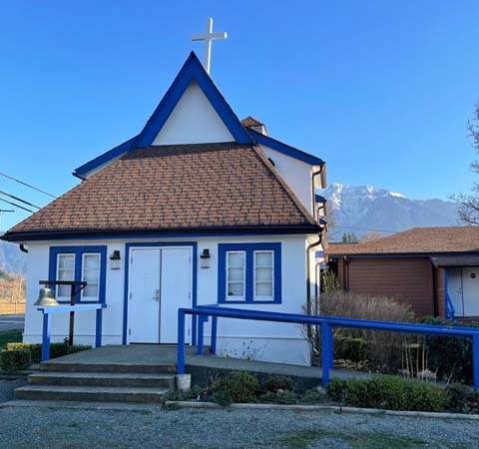

‘The ground we walk does not belong to us; for thousands of years it has been - and remains - the territory of the Stó:lō. We are grateful for their sharing.

Phone: 604-796-3553
Website: www.allsaints-agassiz.ca
https://www.facebook.com/groups/AllSaintsFamily
OUR DOOR IS OPEN AND ALL ARE WELCOME
July 26th, 2026, Ninth Sunday After Pentecost
Priest in Charge: The Reverend Philip Barker
Hosts: Graham Featherstone/Jennifer Pinlac
Intercessor: Keith Fossey
Lay Administrator: Dorothy Cresswell
Announcer: Virginia Jennings
Organ/Piano: Francesca Froehlich
Readers: Judy Gibb/Liane Loeppky
Vicar’s cell phone: Revd. Philip Barker. 778-867-2461

Vicar’s Warden: Ginny Jennings. 604-796-2206
People’s Warden: Lynn Laughlin. 604-799-5131
Parish email: revpb1950@gmail.com
Please contact either warden if you have an issue that needs to be brought to the attention of the Vicar - or contact the Vicar direct (see above for details).

All Saint’s Calendar/Announcements:

- Book Club – On June 10th Book Club will be starting "Sensible Shoes" by Sharon Garlough Brown, an experienced leader of spiritual formation retreats in the UK and US. It follows 4 very different and very relatable female characters on their journey together through 12 one-day retreats.


Please contact Sheila Barker at sjbarker0379@gmail.com
if you would like an invitation to the Zoom meetings
at 5.00 pm on Wednesdays or a copy of the book.
The book is available on amazon for $34.11 including tax.

- Bible Study is every Saturday morning 0830-0900 on Zoom. All are welcome to preview and discuss the readings for the Sunday service. Please ask Valerie to add your email address to the invitation list.

- Prayer Requests can be given on a piece of paper to either of the Wardens or the Vicar or entered in the Prayer Request Book on the lectern. Alternatively, you can contact Anthea Lewis at antheamlewis@shaw.ca for Pray First Prayer Circle, which is a confidential online prayer circle.

- Music Requests may be given to the Wardens or the Vicar.

- AA meets in the hall every Tuesday and Friday at noon.

- Every Thursday in the hall 1100-1200 we have a social time with coffee, games if you like or just talk.

- At 1000-1100 on Thursdays there is an Interactive Bible Study on the day’s Lectionary readings. All are welcome – discover the treasures in this amazing book!

- 5th Sunday of each month will be a potluck lunch after the service

Ministerial Meandering
Our own house

Sadly, I have been unable to find the photograph I took many years ago whilst I was working a Birmingham Children’s Hospital. It is at once one of the most beautiful pictures that I have of a child (who isn’t my own), and at the same time one of the most brutal and ugly.

The photograph is of a young girl around the age of nine or ten. It is only a head shot, but it shows on her face several scars. The first are round and blistered - from cigarettes being stubbed out on her face; the second is a linear abrasion from the angles of her mouth, tracking up to her ears; this is from the gag that was placed to reduce her screams; the next was an obvious black eye, and the final ones were bilateral sub-conjunctival haemorrhages, from being forcibly shaken or hit around the head. That is bleeding into the whites of the eyes- in case you weren’t sure.
I say that was the ‘final’ sign, but that’s not quite true - because her open mouth revealed broken front teeth - her new incisors - again from forcible trauma.

What on earth - you must be asking - can possibly have made this battered child look in any way beautiful? I’ll tell you; she had the most gorgeous smile I had ever seen. Your next question might reasonably be, “Why on earth would she be smiling, having been so abused?” And the answer to that is because for the first time in many years she felt safe.

When I told her parents that I was unhappy about the nature of some of her injuries - they came in with the usual lies about her falling or getting scratched, or some such utter rubbish - and I told them I wanted to keep her in to do one or two more tests, so they had no need to stay.

Her skeletal survey showed evidence of multiple old and recent fractures of her little, poorly-nourished body, and closer inspection of her wrists and ankles suggested that she had been tied up.

She was, of course, taken into care as soon as we could safely discharge her. What happened to her parents, I don’t know - but they were arrested and charged with child abuse. I didn’t have to go to court as a witness - I just sent the photograph I took, and that - plus the evidence of the skeletal x-rays - was enough to have them convicted.

I wish I could say that this was an isolated case. It isn’t - by a long way. I have many, many more from Africa and other places - but this one girl stands out in my memory because of her smile.

So, when I hear the likes of Stephen Fry and Christopher Hitchens going on about a ‘cruel, sadistic, and spiteful God,’ I stop before I answer them in my mind, and think about whether we have actually got our own house in order - before we start blaming God for all the faults we’d like to lay at his door. I think we have a long way to go before we have any right to throw manure at God’s creation - unless it is at the shitty individuals who perpetrate this kind of gratuitous violence on the helpless.

Philip+

A Little Chuckle…


Birthdays in the July 

Cohen Hill – 5 Mary Kirksey - 11
Neko Veltman – 19

Diocesan Cycle of Prayer: We Pray for the Clergy and Congregation:

The Administrators of the Anglican Initiatives Fund; St. Helen, Surrey - The Revd Robin Celiz, The Revd Steve Thompson

Anglican Church of Canada Cycle of Prayer – We Pray for:

The Rt. Rev. Stephen London, Bishop, and the clergy and people of the Diocese of
Edmonton

Collect

O God, the protector of all who trust in you, without whom nothing is strong, nothing is holy, increase and multiply upon us your mercy, that with you as our ruler and guide, we may so pass through things temporal, that we lose not the things eternal; through Jesus Christ our Lord, who lives and reigns with you and the Holy Spirit, one God, for ever and ever.

Genesis 29:15-28 Judy Gibb

¹⁵ Laban said to him, “Just because you are a relative of mine, should you work for me for nothing? Tell me what your wages should be.”

¹⁶ Now Laban had two daughters; the name of the older was Leah, and the name of the younger was Rachel. ¹⁷ Leah had weak eyes, but Rachel had a lovely figure and was beautiful. ¹⁸ Jacob was in love with Rachel and said, “I’ll work for you seven years in return for your younger daughter Rachel.”

¹⁹ Laban said, “It’s better that I give her to you than to some other man. Stay here with me.” ²⁰ So Jacob served seven years to get Rachel, but they seemed like only a few days to him because of his love for her.

²¹ Then Jacob said to Laban, “Give me my wife. My time is completed, and I want to make love to her.”

²² So Laban brought together all the people of the place and gave a feast. ²³ But when evening came, he took his daughter Leah and brought her to Jacob, and Jacob made love to her. ²⁴ And Laban gave his servant Zilpah to his daughter as her attendant.

²⁵ When morning came, there was Leah! So Jacob said to Laban, “What is this you have done to me? I served you for Rachel, didn’t I? Why have you deceived me?”
²⁶ Laban replied, “It is not our custom here to give the younger daughter in marriage before the older one. ²⁷ Finish this daughter’s bridal week; then we will give you the younger one also, in return for another seven years of work.”

²⁸ And Jacob did so. He finished the week with Leah, and then Laban gave him his daughter Rachel to be his wife.

Psalm 128

¹ Blessed are all who fear the Lord,
who walk in obedience to him.
² You will eat the fruit of your labor;
blessings and prosperity will be yours.
³ Your wife will be like a fruitful vine
within your house;
your children will be like olive shoots
around your table.
⁴ Yes, this will be the blessing
for the man who fears the Lord.

⁵ May the Lord bless you from Zion;
may you see the prosperity of Jerusalem
all the days of your life.
⁶ May you live to see your children’s children—
peace be on Israel.

Romans 8:26-39 Liane Loeppky

²⁶ In the same way, the Spirit helps us in our weakness. We do not know what we ought to pray for, but the Spirit himself intercedes for us through wordless groans. ²⁷ And he who searches our hearts knows the mind of the Spirit, because the Spirit intercedes for God’s people in accordance with the will of God.

²⁸ And we know that in all things God works for the good of those who love him, who have been called according to his purpose. ²⁹ For those God foreknew he also predestined to be conformed to the image of his Son, that he might be the firstborn among many brothers and sisters. ³⁰ And those he predestined, he also called; those he called, he also justified; those he justified, he also glorified.

³¹ What, then, shall we say in response to these things? If God is for us, who can be against us? ³² He who did not spare his own Son, but gave him up for us all—how will he not also, along with him, graciously give us all things? ³³ Who will bring any charge against those whom God has chosen? It is God who justifies. ³⁴ Who then is the one who condemns? No one. Christ Jesus who died—more than that, who was raised to life—is at the right hand of God and is also interceding for us. ³⁵ Who shall separate us from the love of Christ? Shall trouble or hardship or persecution or famine or nakedness or danger or sword? ³⁶ As it is written:

“For your sake we face death all day long;
we are considered as sheep to be slaughtered.”

³⁷ No, in all these things we are more than conquerors through him who loved us. ³⁸ For I am convinced that neither death nor life, neither angels nor demons, neither the present nor the future, nor any powers, ³⁹ neither height nor depth, nor anything else in all creation, will be able to separate us from the love of God that is in Christ Jesus our Lord.

Matthew 13:31-33, 44-52 Vicar Philip Barker
³¹ He told them another parable: “The kingdom of heaven is like a mustard seed, which a man took and planted in his field. ³² Though it is the smallest of all seeds, yet when it grows, it is the largest of garden plants and becomes a tree, so that the birds come and perch in its branches.”

³³ He told them still another parable: “The kingdom of heaven is like yeast that a woman took and mixed into about sixty pounds of flour until it worked all through the dough.”

⁴⁴ “The kingdom of heaven is like treasure hidden in a field. When a man found it, he hid it again, and then in his joy went and sold all he had and bought that field.

⁴⁵ “Again, the kingdom of heaven is like a merchant looking for fine pearls. ⁴⁶ When he found one of great value, he went away and sold everything he had and bought it.
⁴⁷ “Once again, the kingdom of heaven is like a net that was let down into the lake and caught all kinds of fish. ⁴⁸ When it was full, the fishermen pulled it up on the shore. Then they sat down and collected the good fish in baskets, but threw the bad away. ⁴⁹ This is how it will be at the end of the age. The angels will come and separate the wicked from the righteous ⁵⁰ and throw them into the blazing furnace, where there will be weeping and gnashing of teeth.

⁵¹ “Have you understood all these things?” Jesus asked.

“Yes,” they replied.

⁵² He said to them, “Therefore every teacher of the law who has become a disciple in the kingdom of heaven is like the owner of a house who brings out of his storeroom new treasures as well as old.”

Odds and Ends


Church Cleaning – August 8th
Volunteers Needed

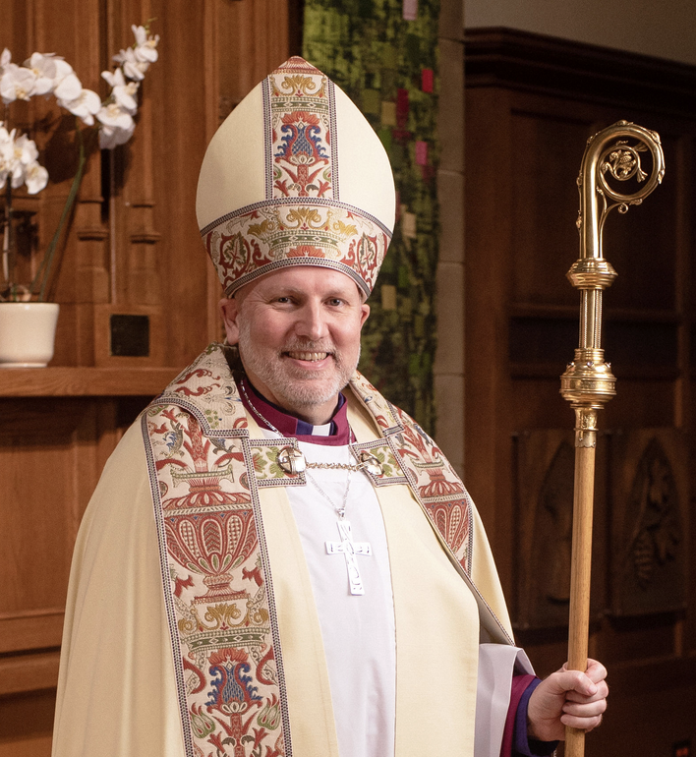

Archbishop John Stephens Visit
Sunday August 23rd, 2026


~Save the Date~

Saturday October 3rd

All Saints Anglican Church
Garage Sale

