Woodbury United Methodist Church

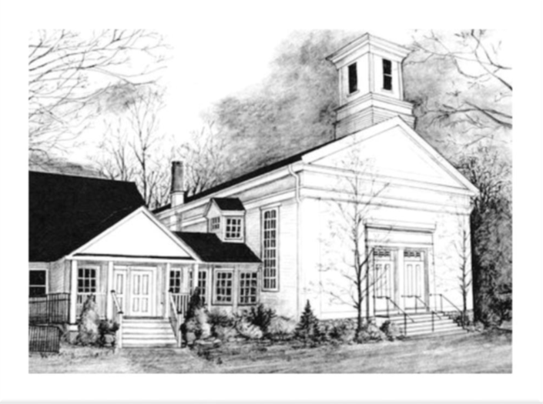

July 26, 2026

9th Sunday After Pentecost

9:30 AM Worship

Woodbury United Methodist Church
4 Church Street, Woodbury, CT 06798 | 203-263-4775
www.woodburyumc.net | Church e-mail: wumc@woodburyumc.net

July 26, 2026
*Please stand as you are able.

WE COME TOGETHER IN PRAISE
WELCOME AND ANNOUNCEMENTS

REPORT from ANNUAL CONFERENCE Catherine Mason & Pastor Bill

OPENING PRAYER (unison) UMC Discipleship Ministries (adapted)
Gracious God, your extravagant love has called us together. Long before we knew you, you knew us and had chosen us to be part of your own family, siblings of our Lord Jesus Christ. What amazing love you have shown toward us! And so, we come before you with praise and thanksgiving, offering you the worship of our hearts and lives, and opening ourselves to the prompting and leading of your Holy Spirit. Receive our worship through the intercession of your Son, Jesus Christ, our Savior and Lord. We glorify the name of Jesus Christ, Prince of Peace, now and forever. Amen.

PRELUDE “What a Beautiful Name” Fielding & Ligertwood
Rod Carnes, Peter Slifka, and Sarah Kate Walkup

*CALL TO WORSHIP Adapted from Psalm 105:1-6
L: O give thanks to the Lord, call on God’s name, make known God’s deeds among the peoples!
P: Sing to the Lord, sing praises! Tell of all God’s wonderful works!
L: Glory in God’s holy name; let the hearts of those who seek the Lord rejoice!
P: Seek the Lord and his strength; seek the Lord’s presence continually!
L: Remember the wonderful works God has done, the miracle and the judgments God has uttered,
P: O offspring of Abraham, God’s servant, children of Jacob, God’s chosen ones.
L: The Lord is our God, whose judgments are in all the earth.
ALL: They who wait for the Lord shall renew their strength.

*HYMN “Blessed Assurance” UMH #369

PRAYER OF CONFESSION (unison) Florin
Loving Divine One, you have created us and know us. You sent your Son, Jesus Christ, to reveal your heart of mercy and grace to us, yet our faith and actions fall short. We succumb to the temptations of pride and greed, self-interest and self-assurance, when Jesus modeled humility, generosity, and compassion for the whole world. Forgive us for our hard hearts and move us closer to you, to your gift of faith and the eternal reward of salvation if we would only believe. In the name of Jesus the Christ, we pray. Amen.

SILENT CONFESSION WORDS OF PARDON & ASSURANCE

WE LISTEN FOR THE WORD OF GOD

THE EPISTLE Romans 8:26-39

*THE GOSPEL Matthew 13: 31-33, 44-52

SERMON “Napster and Now” Pastor Bill

*RESPONSE “Seek Ye First” UMH #405

WE RESPOND IN FAITH
SHARING JOYS AND CONCERNS THE PASTORAL PRAYER

THE LORD’S PRAYER UMH #895
Our Father, who art in heaven, hallowed be thy name. Thy kingdom come, thy will be done on earth as it is in heaven. Give us this day our daily bread. And forgive us our trespasses as we forgive those who trespass against us. And lead us not into temptation, but deliver us from evil. For thine is the kingdom, and the power, and the glory, forever. Amen.

INVITATION TO THE OFFERING AND OFFERING OUR GIFTS

OFFERTORY “There Was Jesus” Smith & Beathard

*DOXOLOGY UMH #95

*PRAYER OF DEDICATION UMC Discipleship Ministries
Steadfast God, you search our hearts and know our needs even when we struggle to find the words. In your mercy, you strengthen us in our weakness and bind us together in love that cannot be broken. As we bring these gifts today, may they bear witness to your enduring promise: that nothing—not hardship, nor fear, nor even death itself—can separate us from your love in Christ Jesus. Bless these offerings, that they may bring hope to the weary, peace to the troubled, and joy to the hearts of your people. Through Christ, our Redeemer and Companion, we pray. Amen.
WE GO FORTH IN JOY
*HYMN “Jesus Loves Me” UMH #191

*BENEDICTION

POSTLUDE “All the People Said Amen” Maher, Moak & Morgan

+ + +

THE WORSHIP IS ENDED: THE SERVICE BEGINS.

Woodbury United Methodist Church
We are a welcoming Christian fellowship who celebrate and share God’s love with everyone. We seek a closer relationship with Jesus Christ. Inspired by His example, we strive to be God’s hands in this world. Empowered by God’s word, we proclaim the Gospel and serve through worship, study, mission, and community support.

Bill Florin, Pastor Jeff and Barbara Hunt, Lay Leaders
Christopher Shay, Director of Music Matti Paparazzo, Admin. Assistant

COMMON LECTIONARY TEXTS FOR TODAY:
Genesis 29:15-28 | Psalm 105:1-11, 45b
Romans 8:26-39 | Matthew 13:31-33, 44-52

WE THANK TODAY’S WORSHIP LEADERS
Liturgist: Catherine Mason
A.V. Tech: Mark Davis
Ushers and Greeters: Michael Pinevich and Eileen Bennett
Fellowship Time Host: Judy Wilhelms

TODAY AT WOODBURY UMC
WELCOME TO WOODBURY UNITED METHODIST CHURCH!
IF YOU ARE A VISITOR, PLEASE COMPLETE A VISITOR’S CARD AND PLACE IT IN THE OFFERING. Our desire is that you experience the warmth of Christ’s welcome and ours in this church.

LARGE PRINT BULLETINS are on the foyer document table.

FELLOWSHIP TIME follows worship downstairs. Invite someone new to you to join you!

VISION 2026 EMPHASIS TODAY is Evangelism. We consider one area weekly: Evangelism, Affirmation and Inclusion, Missions, Communications, Youth and Young Adults and Congregational Vitality and Growth (Spiritual Wellness, Financial Health, Inviting Facilities).

SPECIAL MUSIC is offered through the summer until our choirs return in September. If you are interested in being one of our summer musicians, please speak with Minister of Music Christopher Shay today.
THE WEEK AHEAD
SUNDAY, JULY 26
9:30 a.m. Worship (Summer Schedule)
10:30 a.m. (approx.) Fellowship Time
Communications Committee Meeting, 10:45 a.m., Assembly Room
Meet the Pastor Gathering, 2:00 p.m., Church

MONDAY, JULY 27
Office Hours, 10 a.m. – 4 p.m., Church
Meet the Pastor Gathering, 1:00 p.m., Church

WEDNESDAY, JULY 29
Office Hours, 10 a.m. – 4 p.m., Church
Stewardship Committee Meeting, 2:00 p.m., Assembly Room

THURSDAY, JULY 30
Office Hours, 9 a.m. – 3 p.m., Church

MEET PASTOR BILL
Pastor Bill will be meeting with small groups of about an hour each. These will be informal sessions for Pastor Bill to get to know you and to listen to your viewpoints about WUMC and its mission in the community. There are two more sessions, as follows: Sunday, July 26 (today!) at 2 p.m.; and Monday, July 27 at 1 p.m.

OUR PRAYER INTENTIONS
Prayers will be published for two weeks. If intentions wish to be continued beyond that time, please contact Matti Paparazzo in the church office (203.263.4775 or wumc@woodburyumc.net).

- For the tragic deaths in Maine and Texas due to ICE enforcement actions

- For Pastor Bill’s ministry at WUMC
- For Carol Quinby’s friend Cylde suffering with pain due to prostate issues and for Cylde’s nephew Rocco who had a heart attack

- For Sandy Purdy’s friend Brian Higgins who passed away and his wife, Joann

- For Michael Pinevich’s neighbor Bill Greene who fell off a ladder and broke 6 ribs

- For the gift of music from the Praise Band

- For Matthew King’s engagement to Katie

- For Lynne Ramsden’s friend Karen and her husband Michael as he undergoes cancer treatment

- For Rod Carnes’s father, Vance, who had successful heart valve replacement surgery on July 13

- For Lori

- For Mike Boisseau & Christa Fine in the preparations for their upcoming wedding

- For Missionaries, especially Sarah Flores (Ecuador) and Rev. Dexter Ceballos (Mongolia)

- Bishop Bickerton; our District Superintendent, the Rev. Heather Sinclair; and the churches and clergy of the NY Conference
ON-GOING MINISTRY

CURRENT FOOD BANK NEEDS are: Knorr Rice mixes, instant potatoes, pasta sauce, ramen, lentil, tomato and chicken and rice soup. Thank you in advance for your donations!

“I was hungry and you gave me food…” Jesus, Matthew 25:3

FOR THE CHURCH COMMUNITY
Are you on our “Living Through Grace” weekly email? If not, please contact the Church Office at wumc@woodburyumc.net

Publication deadline for the weekly bulletin and “Living through Grace” e-newsletter is 10 a.m. THURSDAY. Thanks in advance for your cooperation.

ALTAR FLOWERS

Do you have a special event, remembrance, or joy you would like to express through flowers for our worship service?

If so, contact Matti P. in the office at 203-263-4775 or by email at wumc@woodburyumc.net. We will include a message in the Sunday bulletin and the “Living Through Grace” weekly newsletter.



The Vision of the United Methodist Church

The United Methodist Church forms disciples of Jesus Christ who, empowered by the Holy Spirit, love boldly, serve joyfully, and lead courageously in local communities and worldwide connections.

Woodbury United Methodist Church Vision Statement
To be a more thriving, open-minded, spirit-filled Christian fellowship growing in faith, love, and service.

Getting in Touch with Pastor Bill
If you need to reach Pastor Bill quickly, the best way is with his dedicated number for voice calls and text messages. That number is 475-282-2800. You can also reach him through our church’s email at Pastor@WoodburyUMC.net.



