City Road United Methodist Church
A Lighthouse Congregation

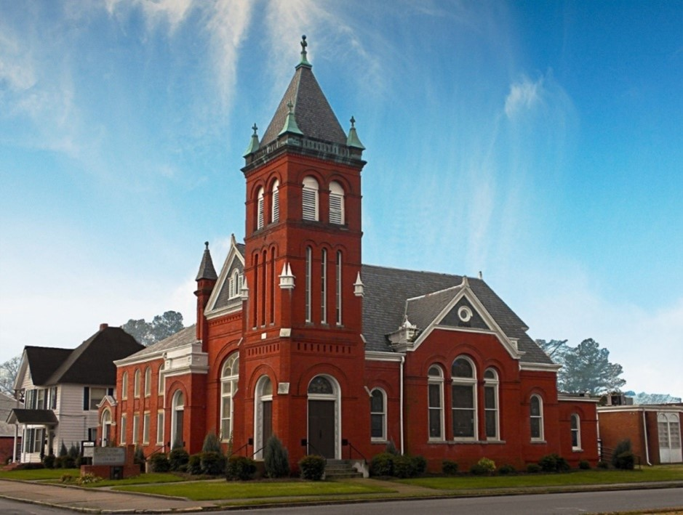
Rev. Tim Nicholson, Pastor

Office: (252) 335-2658
cityroadec.net crumcec@gmail.com

Facebook: https://www.facebook.com/CityRoadUMC

Sunday School: 10:00 a.m.
Sanctuary Worship: 11:00 a.m.

Tommy Venters- Organist/Choir Director
Dawn Baker- Secretary/Technology Specialist
JoAnn Herring- We Care

Service of Word
Pentecost Season
July 26th, 2026 11:00 am
Gathering
Prelude
*Introit “Holy God, We Praise Thy Name” UMH 79

Words of Welcome
*Call to Worship
Beloved, this is the core of our faith: nothing can separate us from the love of God in Christ Jesus.
Thanks be to God!
God’s never-ending love surrounds us and calls us, assuring us that through God’s love, all things will work together for God’s good purposes.
Thanks be to God!
God’s never-breaking love empowers us in the face of temptation, distress, division, and scarcity to hold onto our faith and work together for the flourishing of all God’s good creation
Thanks be to God!
Come, let us worship God who is Love, trusting that through joy and sorrow, happiness and despair, contentment and pain, Love will carry us through.
Thanks be to God who forms, connects, and guides us through Love. Amen.
Written by Dr. Lisa Hancock, Discipleship Ministries, February 2026.

*Hymn of Praise “How Great Thou Art” UMH 77

Prayers of the People
Silent Prayer
Pastoral Prayer
The Lord’s Prayer
Our Father who art in heaven, hallowed be thy name. Thy kingdom come; thy will be done on earth as it is in heaven. Give us this day our daily bread, and forgive us our trespasses, as we forgive those who trespass against us; and lead us not into temptation but deliver us from evil. For thine is the kingdom, and power, and glory forever. Amen

Proclamation & Response
Psalms Reading: Psalm 105:1-11

Children’s Time
Call to the Offering
Offertory
*Doxology UMH 95
*Prayer of Dedication

*Hymn of Preparation “Take Time to Be Holy” UMH 395
1st & Last Verse

Anthem Chancel Choir

Scripture: Romans 8:26-39
Message: Tim Nicholson

*Apostle’s Creed UMH 881

Sending Fourth
*Sending Hymn “I Love to Tell the Story” UMH 156
*Sending Hymn “Shalom to You” UMH 666
*Postlude

