Holy Spirit Lutheran Church
8th Sunday After Pentecost
July 19, 2026


God’s word is like the rain that waters the earth and brings forth vegetation. It is also like the sower who scatters seed indiscriminately. Our lives are like seeds sown in the earth. Even from what appears to be little, dormant, or dead, God promises a harvest. At the Lord’s table we are fed with the bread of life, that we may bear fruit in the world.

Holy Spirit Lutheran Church
2205 Old Liberty Road, Eldersburg, MD 21784.
Church Office- 410-795-6333
Church Email- hslc.eldersburg@comcast.net
HSLC Website- www.hslceldersburgmd.org
The Rev. Tom Kaye, Sr., Pastor
A Shared Ministry in the Evangelical Lutheran Church in America.

We extend the warmest welcome to all worshipping with us today. No matter who you are: if this is your first time worshipping with us, if you haven’t been here in a while, if you are here regularly, if you are seeking a community of people trying their best to follow Jesus, if you are curious about Jesus, or even if you are not entirely sure what or who you are looking for; know that you are welcome in this place, and we are so glad you are here! If this is your first time with us, we ask that you sign our Friendship Book, so that we might pray with/for you, get to know you better, and check-in with you from time to time.

Holy Communion is open to all. In this church, we preach, teach, and confess that this is the table of Jesus. It is Jesus who invites you to His table. You need not be a member of this church, or any other church; anyone who desires a deeper walk with Christ is invited. The ushers will direct you to proceed up the center aisle. You are invited to take an empty, individual cup from the silver tray near the baptismal font, and red wine, the blood of Christ, will be poured for you at the altar rail. You will also find red grape juice, the blood of Christ, in sealed individual cups in that same tray. As you come to the altar rail, you may stand or kneel as you are able, and the minister will place bread, the body of Christ, in your hand. If you are in need of a gluten free host, please let the minister know. If you prefer not to receive the Communion elements, Jesus still invites you into His Holy Communion; at the altar rail you may fold your arms and the minister will pray with and bless you.

We believe the varied sounds and actions from children of all ages during worship is evidence of Jesus among us, and bears witness to the life, growth, present and future of the Church. If your child makes noise, you are not bothering anyone, you are blessing everyone. If you would like an activity bag for your child during worship, please ask the greeter who handed you this bulletin.

We stream our worship service on a private zoom link and publicly on Facebook. We also setup a laptop in the lobby area, just outside of the sanctuary, so that we might connect with our members who regularly “Zoom-in” for service. Please stop by to say hello!

PRELUDE
ANNOUNCEMENTS
LIGHTING OF THE CANDLES
Let us prepare our hearts and minds for worship.
Please rise, in body or spirit.
INVOCATION, CONFESSION, AND FORGIVENESS
P: Blessed be the Holy Trinity, the Father, the ☩ Son, and the Holy Spirit, one God, who forgives all our sin, who’s mercy endures forever. C: Amen.
P: Almighty God, to whom all hearts are open, all desires known, and from whom no secrets are hid: cleanse the thoughts of our hearts by the inspiration of your Holy Spirit, that we may perfectly love you and worthily magnify your holy name, through Jesus Christ our Lord.
C: Amen.
P: Let us confess our sin in the presence of God, and of one another.
(We pause for reflection)
P: Gracious God,
C: Have mercy on us. We confess that we have turned from you and given ourselves into the power of sin. We are truly sorry and humbly repent. In your compassion forgive us our sins, known and unknown, things we have done and things we have failed to do. Turn us again to you, and uphold us by your Spirit, so that we may live and serve you in newness of life through Jesus Christ, our Savior and Lord. Amen.

P: God, who is rich in mercy, loved us even when we were dead in sin, and made us alive together with Christ. By grace you have been saved. In the name of ☩ Jesus Christ, your sins are forgiven. Almighty God strengthen you with power through the Holy Spirit, that Christ may live in your hearts through faith. C: Amen.

Gathering Hymn: Praise and Thanksgiving – LBW (Green) – 409.
Greeting
P: The grace of our Lord Jesus Christ, the love of God, and the communion of the Holy Spirit be with you all.
C: And also with you.
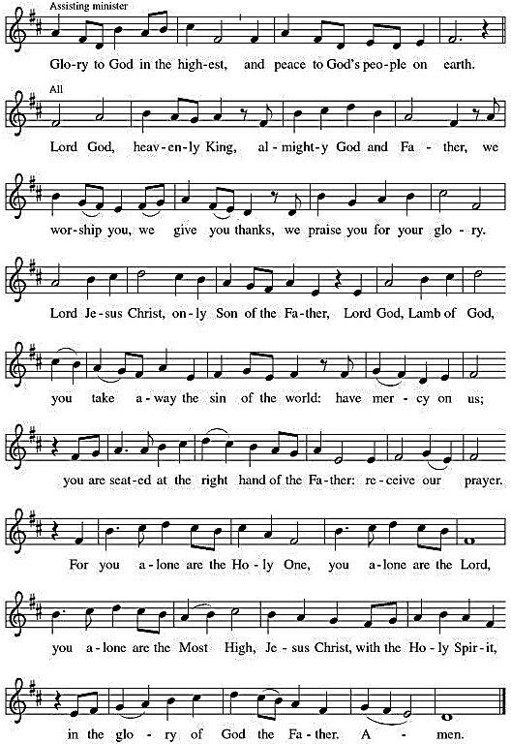
HYMN OF PRAISE Cantor chants first line, congregation sings the rest together.
PRAYER OF THE DAY
P: Let us pray. Faithful God, most merciful judge, you care for your children with firmness and compassion. By your Spirit nurture us who live in your kingdom, that we may be rooted in the way of your Son, Jesus Christ, our Savior and Lord. C: Amen.
Please be seated

FIRST READING: Isaiah 44:6-8
⁶ Thus says the Lord, the King of Israel, and his Redeemer, the Lord of hosts: I am the first, and I am the last; besides me there is no god.
⁷ Who is like me? Let them proclaim it; let them declare and set it forth before me. Who has announced from of old the things to come?
Let them tell us what is yet to be. ⁸ Do not fear or be afraid;
have I not told you from of old and declared it? You are my witnesses! Is there any god besides me? There is no other rock; I know not one.
L: The word of the Lord.
C: Thanks be to God.

Psalm: Psalm 86:11-17
¹¹ Teach me your way, O Lord, and I will walk in your truth;
give me an undivided heart to revere your name.
¹² I will thank you, O Lord my God, with all my heart,
and glorify your name forevermore.
¹³ For great is your love toward me; you have delivered me from the pit of death.
¹⁴ The arrogant rise up against me, O God, and a band of violent people seeks my life; they have not set you before their eyes.
¹⁵ But you, O Lord, are gracious and full of compassion,
slow to anger, and full of kindness and truth.
¹⁶ Turn to me and have mercy on me; give your strength to your servant, and save the child of your handmaid.
¹⁷ Show me a sign of your favor, so that those who hate me may see it and be put to shame; because you, Lord, have helped me and comforted me.

Second Reading: Romans 8:12-25
¹² So then, brothers and sisters, we are obligated, not to the flesh, to live according to the flesh—¹³ for if you live according to the flesh, you will die, but if by the Spirit you put to death the deeds of the body, you will live. ¹⁴ For all who are led by the Spirit of God are children of God. ¹⁵ For you did not receive a spirit of slavery to fall back into fear, but you received a spirit of adoption. When we cry, “Abba! Father!” ¹⁶ it is that very Spirit bearing witness with our spirit that we are children of God, ¹⁷ and if children, then heirs: heirs of God and joint heirs with Christ, if we in fact suffer with him so that we may also be glorified with him.
¹⁸ I consider that the sufferings of this present time are not worth comparing with the glory about to be revealed to us. ¹⁹ For the creation waits with eager longing for the revealing of the children of God, ²⁰ for the creation was subjected to futility, not of its own will, but by the will of the one who subjected it, in hope ²¹ that the creation itself will be set free from its enslavement to decay and will obtain the freedom of the glory of the children of God. ²² We know that the whole creation has been groaning together as it suffers together the pains of labor, ²³ and not only the creation, but we ourselves, who have the first fruits of the Spirit, groan inwardly while we wait for adoption, the redemption of our bodies. ²⁴ For in hope we were saved. Now hope that is seen is not hope, for who hopes for what one already sees? ²⁵ But if we hope for what we do not see, we wait for it with patience.
L: The word of the Lord.
C: Thanks be to God.
Please rise, in body or spirit.
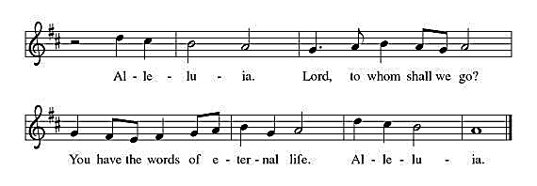
Gospel Acclamation Congregation sings acclamation once.

Holy Gospel: Matthew 13:24-30, 36-43

P: The Holy Gospel according to St. Matthew, the thirteenth chapter.

C: Glory to you, O Lord.
²⁴ [Jesus] put before [the crowds] another parable: “The kingdom of heaven may be compared to someone who sowed good seed in his field,²⁵ but while everybody was asleep an enemy came and sowed weeds among the wheat and then went away. ²⁶ So when the plants came up and bore grain, then the weeds appeared as well. ²⁷ And the slaves of the householder came and said to him, ‘Master, did you not sow good seed in your field? Where, then, did these weeds come from?’ ²⁸ He answered, ‘An enemy has done this.’ The slaves said to him, ‘Then do you want us to go and gather them?’ ²⁹ But he replied, ‘No, for in gathering the weeds you would uproot the wheat along with them. ³⁰ Let both of them grow together until the harvest, and at harvest time I will tell the reapers, Collect the weeds first and bind them in bundles to be burned, but gather the wheat into my barn.’ ”
³⁶ Then he left the crowds and went into the house. And his disciples approached him, saying, “Explain to us the parable of the weeds of the field.” ³⁷ He answered, “The one who sows the good seed is the Son of Man; ³⁸ the field is the world, and the good seed are the children of the kingdom; the weeds are the children of the evil one, ³⁹ and the enemy who sowed them is the devil; the harvest is the end of the age, and the reapers are angels. ⁴⁰ Just as the weeds are collected and burned up with fire, so will it be at the end of the age. ⁴¹ The Son of Man will send his angels, and they will collect out of his kingdom all causes of sin and all evildoers, ⁴² and they will throw them into the furnace of fire, where there will be weeping and gnashing of teeth. ⁴³ Then the righteous will shine like the sun in the kingdom of their Father. Let anyone with ears listen!”
P: The Gospel of the Lord
C: Praise to you, O Christ.
Please be seated

Children’s Message
SERMON
After the sermon, please rise, in body or spirit, as we lift our hearts and voices together in song.
Hymn of the Day: For the Fruit of All Creation- WOV (Blue) – 760.
Apostles’ Creed
A: Lets us confess our faith in the words of the Apostles’ Creed,
C: We believe in God, the Father almighty, creator of heaven and earth. We believe in Jesus Christ, God’s only Son, our Lord,
who was conceived by the Holy Spirit, born of the virgin Mary,
suffered under Pontius Pilate, was crucified, died, and was buried;
he descended to the dead. On the third day he rose again; he ascended into heaven, he is seated at the right hand of the Father,
and he will come to judge the living and the dead. We believe in the Holy Spirit, the holy catholic church, the communion of saints, the forgiveness of sins, the resurrection of the body, and the life everlasting. Amen.

Prayers of Intercession
A: Trusting in God’s steadfast love for all God has made, let us pray for the church, the world, and all of creation.
A brief silence.
A: God our source, protect your church from those who sow weeds among the wheat. Where we trade grace for judgment, restore us, and where we get lost among the complexities of life, guide us. God of grace,
C: Hear our prayer.
A: God our creator, sustain creation in places not easily seen; the depths of oceans, microscopic plants and animals, galaxies beyond our own. May we share earth’s dedication to hope for what we do not yet see. God of grace,
C: Hear our prayer.
A: God our soil, we yearn to live on your lands and waters with justice and in righteousness. Renew the hearts of all in authority, that our leaders guide wisely toward the flourishing of all. God of grace,
C: Hear our prayer.
A: God our rock, be a source of constancy for those whose lives have been uprooted by war, eviction, global climate change, unemployment, harassment, false witness to their character, or illness or injury. (We pray especially for . . .) God of grace,
C: Hear our prayer.
A: God our teacher, guide and provide for all summer camp staff and campers, daycare professionals, librarians, summer school educators and coaches, teachers preparing for the coming academic year, and youth becoming first-time babysitters. God of grace,
C: Hear our prayer.
Here other intercessions may be offered.
A: God our hope, the message of your salvation is planted among us in all times and places. We give you thanks for the witness of all the saints who shine like the sun in your presence. God of grace,
C: Hear our prayer.
A: Grateful for your abundant provision and trusting in your goodness, we cast all our cares upon you, through the abundant grace of Christ Jesus.
C: Amen.

PaSSING THE PEACE
P: The Peace of the Lord be with you always!
C: And also, with you.
P: Let us share a sign of peace with one another.
Please be seated

Offering
Here at Holy Spirit Lutheran Church, there are many ways you are able to give. Our ushers will pass around an offering plate, in which you can place your weekly offering. If you are attending worship online or you simply wish to give online, you may do so by visiting our website, hslceldersburgmd.org/give. We give thanks to God for the ways you continually offer your time, talent, and treasure for the sake of God and neighbor in our ministry.
Please rise, in body or spirit.

OFFERTORY HYMN
We lift our voices, we lift our hands, we lift our lives up to You: We are an offering. Lord, use our voices, Lord, use our hands. Lord use our lives, they are Yours. We are an offering; we are an offering

OFFERING PRAYER
P: Let us pray, Loving God, we offer at your table the gifts of our hearts. Help us take heart in you and share freely of your love,
so that all creation can taste your abundance. We ask this in the name of Jesus, through the Spirit abiding with us now and forever.
C: Amen.

THE GREAT THANKSGIVING
P: The Lord be with you.
C: And also with you.
P: Lift up your hearts.
C: We lift them to the Lord.
P: Let us give thanks to the Lord our God.
C: It is right to give our thanks and praise.

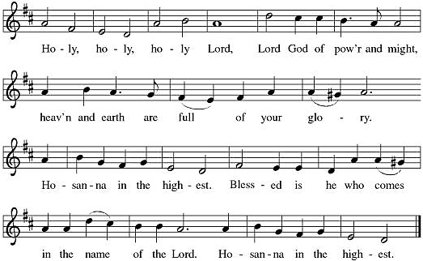
PREFACE : It is indeed right, our duty and our joy, that we should at all times and in all places give thanks and praise to you, almighty and merciful God, through our Savior Jesus Christ; who on this day overcame death and the grave, and by his glorious resurrection opened to us the way of everlasting life. And so, with all the choirs of angels, with the church on earth and the hosts of heaven, we praise your name and join their unending hymn:

EUCHARISTIC PRAYER & WORDS OF INSTITUTION
P: You are indeed holy, almighty and merciful God. You are most holy, and great is the majesty of your glory. You so loved the world that you gave your only Son, so that everyone who believes in him may not perish but have eternal life.
P: In the night in which he was betrayed, our Lord Jesus took bread, and gave thanks; broke it, and gave it to his disciples, saying:
Take and eat; this is my body, given for you. Do this for the remembrance of me.
P: Again, after supper, he took the cup, gave thanks, and gave it for all to drink, saying: This cup is the new covenant in my blood, shed for you and for all people for the forgiveness of sin. Do this for the remembrance of me.
P: Holy God, holy and merciful one, holy and compassionate, send upon us and this meal your Holy Spirit, whose breath revives us for life, whose fire rouses us to love.
C: Amen. Come, Holy Spirit.
P: Enfold in your arms all who share this holy food. Nurture in us the fruits of the Spirit, that we may be a living tree, sharing your bounty with all the world. C: Amen.

THE LORD'S PRAYER
P: Gathered into one by the Holy Spirit, let us pray the prayer our Lord Jesus taught us, in the language of our hearts:
C: Our Father, who art in heaven, hallowed be thy name, thy kingdom come, thy will be done, on earth as it is in heaven. Give us this day our daily bread; and forgive us our trespasses, as we forgive those who trespass against us; and lead us not into temptation but deliver us from evil. For thine is the kingdom, and the power, and the glory, forever and ever. Amen.

INVITATION TO COMMUNION
P: Jesus invites you. Jesus welcomes you. All are invited. All are welcome. Come taste and see that the Lord is good! C: Amen.
Please be seated.
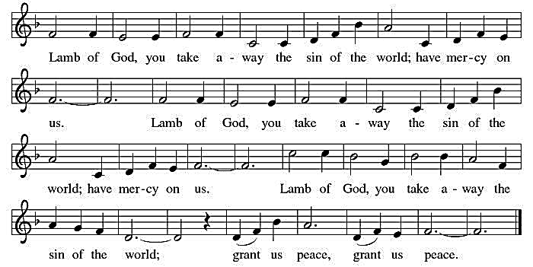
COMMUNION HYMN- Lamb of God
Please come forward at the direction of the ushers. Guidance for receiving Communion is on Page 2. After all have communed, please rise, in body or spirit.
POST-COMMUNION BLESSING
P: May the body and blood of our Lord Jesus Christ bless us and keep us in God’s grace, from now and until life everlasting. C: Amen.
POST-COMMUNION PRAYER
A: Let us pray, Compassionate God, through the gifts of bread and wine our hearts are filled with the abundance of your love.
Strengthen us that we, through this holy meal, may share your love freely, as you have shared with us. We ask this in the name of Jesus,
through the Spirit nourishing us now and forever.
C: Amen.

BENEDICTION
P: You are exactly who God created you to be. Created in Christ Jesus for good works. Created and called holy. Created and called beloved. Now go forth into the world in peace and be of good courage. Hold fast to that which is good. Render to no one an evil thing for an evil thing. Strengthen the fainthearted. Support the weak. Help the afflicted. Show Christ’s love to everyone and let the blessing of almighty God, the Father, the +Son, and the Holy Spirit, be among you and remain with you now and forever. C: Amen.

Sending Hymn: Sing to the Lord of Harvest – LBW (Green) – 412.

DISMISSAL
P: Go in peace, be of good heart!
C: Thanks be to God!
A: Our purpose is to love God,
C: And bring people into a growing relationship with Jesus and his church.

“We all serve as ministers in the mission of the Church.”
From Sundays and Seasons.com. Copyright 2012 Augsburg Fortress. All rights reserved.
Reprinted by permission under Augsburg Fortress Liturgies Annual License #23995.
New Revised Standard Version Bible, copyright 1989, Division of Christian Education of the National Council of the Churches of Christ in the United States of America. Used by permission. All rights reserved.

ACTIVITIES AT HOLY SPIRIT LUTHERAN CHURCH:
Sunday (07/19) 10:30 am – Fellowship
11:00 am – Worship w/Holy Communion
Sunday (07/26) 10:30 am – Fellowship
11:00 am – Worship w/Holy Communion
Congregational Meeting following service.
Please contact Pastor Tom by email at HSLC.pastor@comcast.net if you would like to meet, have any questions, or for any pastoral emergencies.
Upcoming Events Reminder:
Please see the “Events” tab on our website for all our upcoming events.
July 26 after the 11:00 am service: Congregational Meeting
July 27-31: VBS 2026
Volunteers
 | This Week (07/19/2026) | Next Week (July 26, 2026)
Greeters | Kim N. | TBD
Ushers | John F.  Luke F. | Henry K.
Acolyte | Maryann F. | Lily K.
Assisting Minister | Holly deB. | Krissy K.
Communion Assistant | Holly deB. | Krissy K.
Lector | Megan F. | Laura B.
Altar Care | Linda L. | Holly deB.
Fellowship/Coffee | Kallemyn | Bowman

.

