All Saints Anglican Church
6904 Lougheed Highway, Agassiz, B.C. V0M 1A0
Bulletin July 13th, 2026 – July 19th, 2026

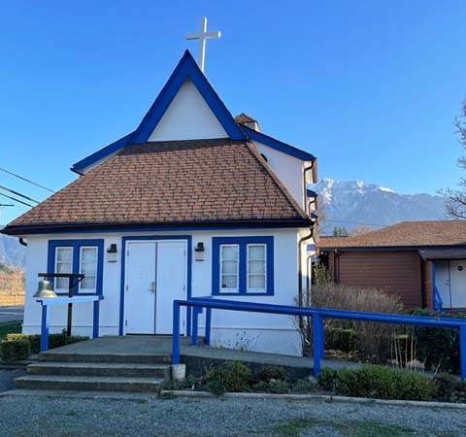

‘The ground we walk does not belong to us; for thousands of years it has been - and remains - the territory of the Stó:lō. We are grateful for their sharing.

Phone: 604-796-3553
Website: www.allsaints-agassiz.ca
https://www.facebook.com/groups/AllSaintsFamily
OUR DOOR IS OPEN AND ALL ARE WELCOME
July 19th, 2026, Eighth Sunday After Pentecost
Priest in Charge: The Reverend Philip Barker
Hosts: Graham Featherstone/Jennifer Pinlac
Intercessor: Valerie and David Hamilton
Lay Administrator: Dorothy Cresswell
Announcer: Virginia Jennings
Organ/Piano: Francesca Froehlich
Readers: Ginny Jennings/Sheila Barker
Vicar’s cell phone: Revd. Philip Barker. 778-867-2461

Vicar’s Warden: Ginny Jennings. 604-796-2206
People’s Warden: Lynn Laughlin. 604-799-5131
Parish email: revpb1950@gmail.com
Please contact either warden if you have an issue that needs to be brought to the attention of the Vicar - or contact the Vicar direct (see above for details).

All Saint’s Calendar/Announcements:

- Book Club – On June 10th Book Club will be starting "Sensible Shoes" by Sharon Garlough Brown, an experienced leader of spiritual formation retreats in the UK and US. It follows 4 very different and very relatable female characters on their journey together through 12 one-day retreats.


Please contact Sheila Barker at sjbarker0379@gmail.com
if you would like an invitation to the Zoom meetings
at 5.00 pm on Wednesdays or a copy of the book.
The book is available on amazon for $34.11 including tax.

- Bible Study is every Saturday morning 0830-0900 on Zoom. All are welcome to preview and discuss the readings for the Sunday service. Please ask Valerie to add your email address to the invitation list.

- Prayer Requests can be given on a piece of paper to either of the Wardens or the Vicar or entered in the Prayer Request Book on the lectern. Alternatively, you can contact Anthea Lewis at antheamlewis@shaw.ca for Pray First Prayer Circle, which is a confidential online prayer circle.

- Music Requests may be given to the Wardens or the Vicar.

- AA meets in the hall every Tuesday and Friday at noon.

- Every Thursday in the hall 1100-1200 we have a social time with coffee, games if you like or just talk.

- At 1000-1100 on Thursdays there is an Interactive Bible Study on the day’s Lectionary readings. All are welcome – discover the treasures in this amazing book!

- 5th Sunday of each month will be a potluck lunch after the service

Ministerial Meandering
Where are your scales?

Do not be alarmed - I am not asking if you have suddenly developed fins or have a particularly debilitating dermatitis - rather enquiring into where your centre of balance might be, between the positive and the negative.

The bird in my bedroom, which begins to chirp as soon as one eye is open, and ceases not until after I have closed both of mine at the end of the day, is an endless source of information. A large proportion of this is shared (whether I like it or not) over the breakfast table - to the extent that this morning I didn’t even reach for my Economist, as to interrupt the stream would have seemed churlish.

Within the deluge of world affairs that threatened to swamp my bacon, were items which had sparks of goodness and positivity about them. These were such a change from the quotidian reflux of malignant acid indigestion engendered by what has become a repetitive diatribe on American politics.

But let me not get too euphoric too soon; there was also a ‘human interest’ story about a couple in Ohio who were visited by the police because the ‘man of the house’ had been arrested for exposing himself in public. When the police arrived at the house they found the man (35) and his wife (32) and their 16 children, aged from 18 years to 18 months, living in abject poverty - with his parents. None of the children had been schooled, and some were incapable of communicating. The couple had married when he was 18 and she, 15, - with their parents consent. They had left school around the age of 13 or 14, and their first child appeared two months after their wedding. After that there were yearly pregnancies and babies, with the odd dose of twins from time to time. It would be hard to calculate the collective IQ of the entire family, but one might be optimistic to put it into three figures in total. How does such a family escape the notice of social services?

The happy items start with a dog. Where else? A rescue dog, having only been with his third owner for about two months, saved him from a fire that destroyed his house and would have killed him. The dog, Hazel, bit her owner awake, and the two of them managed to escape with only smoke inhalation and no burns. I suspect that third owner will be holding on to his saviour companion.

The other happy thing was the reporting of Kate (Prince William’s wife) completing the Three Peaks Challenge in Britain. That is to climb all three peaks - Snowdon, Ben Nevis, and Scafell Pike, in less than 24 hours. As many of you will know, Kate (Catherine, Princess of Wales) had surgery and chemotherapy for some form of abdominal cancer a couple of years ago. She completed this challenge to show that there ‘was life beyond diagnosis’, and raised money doing so for the Royal Marsden Hospital in London, which is the premier cancer hospital in the UK.

The final ‘happy thing’ which is happening today is that Sheila and I are going ‘out for tea’ with a couple from our church this afternoon. This a Good Thing to do on my Day Off.

Where are your scales set today? Mine are definitely positive.

Philip+

Something to think about…

“I never lose. I either win or learn.”
Nelson Mandela

Birthdays in the July 

Cohen Hill – 5 Mary Kirksey – 11
Neko Veltman – 19

Diocesan Cycle of Prayer: We Pray for the Clergy and Congregation:

The Justice and Peace Unit - The Revd Margaret Marquardt, The Revd Gail Newell; Holy Spirit Anglican Church, Whonnock – The Revd Vineet Samuel

Anglican Church of Canada Cycle of Prayer – We Pray for:
The Most Rev. Greg Kerr-Wilson, Archbishop, and the clergy and people of the
Diocese of Calgary

Collect

Almighty God, your Son has opened for us a new and living way into your presence. Give us pure hearts and constant wills to worship you in spirit and in truth; through Jesus Christ our Lord, who lives and reigns with you and the Holy Spirit, one God, now and for ever.

Genesis 28:10-19a Ginny Jennings

¹⁰ Jacob left Beersheba and set out for Harran. ¹¹ When he reached a certain place, he stopped for the night because the sun had set. Taking one of the stones there, he put it under his head and lay down to sleep. ¹² He had a dream in which he saw a stairway resting on the earth, with its top reaching to heaven, and the angels of God were ascending and descending on it. ¹³ There above it stood the Lord, and he said: “I am the Lord, the God of your father Abraham and the God of Isaac. I will give you and your descendants the land on which you are lying. ¹⁴ Your descendants will be like the dust of the earth, and you will spread out to the west and to the east, to the north and to the south. All peoples on earth will be blessed through you and your offspring. ¹⁵ I am with you and will watch over you wherever you go, and I will bring you back to this land. I will not leave you until I have done what I have promised you.”

¹⁶ When Jacob awoke from his sleep, he thought, “Surely the Lord is in this place, and I was not aware of it.” ¹⁷ He was afraid and said, “How awesome is this place! This is none other than the house of God; this is the gate of heaven.”

¹⁸ Early the next morning Jacob took the stone he had placed under his head and set it up as a pillar and poured oil on top of it. ¹⁹ He called that place Bethel, though the city used to be called Luz.

Psalm 139:1-11, 22-23

¹ You have searched me, Lord,
and you know me.
² You know when I sit and when I rise;
you perceive my thoughts from afar.
³ You discern my going out and my lying down;
you are familiar with all my ways.
⁴ Before a word is on my tongue
you, Lord, know it completely.
⁵ You hem me in behind and before,
and you lay your hand upon me.
⁶ Such knowledge is too wonderful for me,
too lofty for me to attain.

⁷ Where can I go from your Spirit?
Where can I flee from your presence?
⁸ If I go up to the heavens, you are there;
if I make my bed in the depths, you are there.
⁹ If I rise on the wings of the dawn,
if I settle on the far side of the sea,
¹⁰ even there your hand will guide me,
your right hand will hold me fast.
¹¹ If I say, “Surely the darkness will hide me
and the light become night around me,”

²² I have nothing but hatred for them;
I count them my enemies.
²³ Search me, God, and know my heart;
test me and know my anxious thoughts.

Romans 8:12-25 Sheila Barker

¹² Therefore, brothers and sisters, we have an obligation—but it is not to the flesh, to live according to it. ¹³ For if you live according to the flesh, you will die; but if by the Spirit you put to death the misdeeds of the body, you will live.

¹⁴ For those who are led by the Spirit of God are the children of God. ¹⁵ The Spirit you received does not make you slaves, so that you live in fear again; rather, the Spirit you received brought about your adoption to sonship. And by him we cry, “Abba, Father.” ¹⁶ The Spirit himself testifies with our spirit that we are God’s children. ¹⁷ Now if we are children, then we are heirs—heirs of God and co-heirs with Christ, if indeed we share in his sufferings in order that we may also share in his glory.

¹⁸ I consider that our present sufferings are not worth comparing with the glory that will be revealed in us. ¹⁹ For the creation waits in eager expectation for the children of God to be revealed. ²⁰ For the creation was subjected to frustration, not by its own choice, but by the will of the one who subjected it, in hope ²¹ that the creation itself will be liberated from its bondage to decay and brought into the freedom and glory of the children of God.

²² We know that the whole creation has been groaning as in the pains of childbirth right up to the present time. ²³ Not only so, but we ourselves, who have the firstfruits of the Spirit, groan inwardly as we wait eagerly for our adoption to sonship, the redemption of our bodies. ²⁴ For in this hope we were saved. But hope that is seen is no hope at all. Who hopes for what they already have? ²⁵ But if we hope for what we do not yet have, we wait for it patiently.

Matthew 13:24-30, 36-43 Vicar Philip Barker

²⁴ Jesus told them another parable: “The kingdom of heaven is like a man who sowed good seed in his field. ²⁵ But while everyone was sleeping, his enemy came and sowed weeds among the wheat, and went away. ²⁶ When the wheat sprouted and formed heads, then the weeds also appeared.

²⁷ “The owner’s servants came to him and said, ‘Sir, didn’t you sow good seed in your field? Where then did the weeds come from?’

²⁸ “‘An enemy did this,’ he replied.

“The servants asked him, ‘Do you want us to go and pull them up?’

²⁹ “‘No,’ he answered, ‘because while you are pulling the weeds, you may uproot the wheat with them. ³⁰ Let both grow together until the harvest. At that time I will tell the harvesters: First collect the weeds and tie them in bundles to be burned; then gather the wheat and bring it into my barn.’”

³⁶ Then he left the crowd and went into the house. His disciples came to him and said, “Explain to us the parable of the weeds in the field.”

³⁷ He answered, “The one who sowed the good seed is the Son of Man. ³⁸ The field is the world, and the good seed stands for the people of the kingdom. The weeds are the people of the evil one, ³⁹ and the enemy who sows them is the devil. The harvest is the end of the age, and the harvesters are angels.

⁴⁰ “As the weeds are pulled up and burned in the fire, so it will be at the end of the age. ⁴¹ The Son of Man will send out his angels, and they will weed out of his kingdom everything that causes sin and all who do evil. ⁴² They will throw them into the blazing furnace, where there will be weeping and gnashing of teeth. ⁴³ Then the righteous will shine like the sun in the kingdom of their Father. Whoever has ears, let them hear.

Odds and Ends

Church Cleaning – August 8th
Volunteers Needed

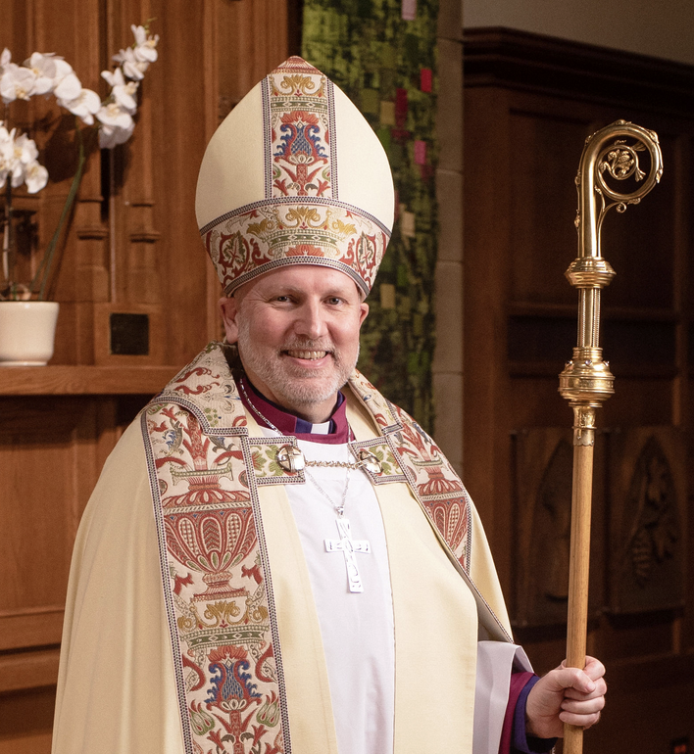

Archbishop John Stephens Visit
Sunday August 23rd, 2026


~Save the Date~

Saturday October 3rd

All Saints Anglican Church
Garage Sale

