City Road United Methodist Church
A Lighthouse Congregation

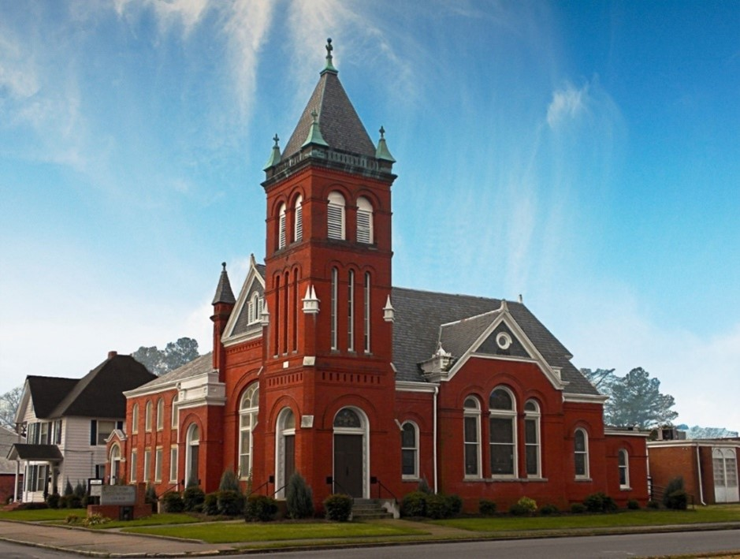
Rev. Tim Nicholson, Pastor

Office: (252) 335-2658
cityroadec.net crumcec@gmail.com

Facebook: https://www.facebook.com/CityRoadUMC

Sunday School: 10:00 a.m.
Sanctuary Worship: 11:00 a.m.

Tommy Venters- Organist/Choir Director
Dawn Baker- Secretary/Technology Specialist
JoAnn Herring- We Care

Service of Word
Pentecost Season
July 19th, 2026 11:00 am
Gathering
Prelude
*Introit “Surely the Presence of the Lord is in this Place” UMH 328

Words of Welcome
*Call to Worship
We come from many places to this place, carrying the burdens and blessings of the week.
Yet God meets us wherever we are.
Jacob laid his head upon a stone and discovered that heaven was nearer than he imagined.
God's presence fills the earth, even where we least expect it.
The Lord declares, "I am with you and will keep you wherever you go."
We are never alone. God's love surrounds us, and God's promises endure.
This place becomes holy not because of these walls, but because the living God is here among us.
Surely the Lord is in this place!
Come, let us awaken to God's presence.
Let us worship the God who meets us, blesses us, and calls us by grace. Amen.

*Hymn of Praise “God of Grace and God of Glory” UMH 557

Prayers of the People
Silent Prayer
Pastoral Prayer
The Lord’s Prayer
Our Father who art in heaven, hallowed be thy name. Thy kingdom come; thy will be done on earth as it is in heaven. Give us this day our daily bread, and forgive us our trespasses, as we forgive those who trespass against us; and lead us not into temptation but deliver us from evil. For thine is the kingdom, and power, and glory forever. Amen

Proclamation & Response
Psalms Reading: Psalm 139:1-12, 23-24

Children’s Time
Call to the Offering
Offertory
*Doxology UMH 95
*Prayer of Dedication

*Hymn of Preparation “On Eagle’s Wings” UMH 143

Anthem Chancel Choir

Scripture: Genesis 28:10-19a
Message: Tim Nicholson

*Apostle’s Creed UMH 881

Sending Fourth
*Sending Hymn “Blessed Assurance” UMH 369
*Benediction
*Postlude

