Parkside Lutheran Church
Rediscovering the Radical Love of Jesus
Gathering All
Serving All
Caring For All



July 19th, 2026
Holy Communion 10:00am
The Rev. Jeremiah Smith
Parkside Lutheran Values

Proclaiming Grace - Jesus shared and lived out a message of grace, love, and new life. We believe these promises come from God freely, as a gift for all. We are loved and the Spirit inspires us to share this good news in accessible, relevant, and new ways. Luke 4:17-19, John 1:16-17, John 3:16-17, Ephesians 2:8-9

Practicing Hospitality – Jesus welcomed the little children, broke bread with outcasts, and proclaimed the Good News to all. Whether you are strong in faith, wrestling with doubt, or somewhere in between, we affirm that you are welcome here. Jesus is for everyone. Leviticus 19:34, Matthew 9:10, Matthew 19:14, Hebrews 13:2

Loving Boldly - Jesus challenged traditions to demonstrate God’s justice and love of neighbor. His compassionate and sacrificial love inspires us to take risks. Striving to follow his command to love neighbor, our ministries serve, transform, and advocate for folks near and far. Micah 6:8, Mark 11:15-17, Luke 10:25-28, John 15:12-13

Cultivating Community - Jesus built communities that transformed lives. We are the body of Christ and we are called to continue this ministry of transformation. Guided by the Holy Spirit, we build connections within and outside of these walls, and with all of God’s creation. Ecclesiastes 4:9-12, Matthew 28:16-20, 1 Corinthians 12:12-14, Galatians 3:26-29

Welcome Visitors!
Please use QR code to let us know you were here today or to sign up for our weekly enewsletter. Find us on Facebook & Instagram
WIFI: Balcony password: FreeGrace

For your safety in the event of an emergency: In addition to the three exits in the back of the sanctuary, there are exits on either side of the altar (on left side: floor level near piano and up steps past altar. On right side: up steps to the altar, past band area)

Contact us: (716) 836-1361
2 Wallace Ave. Buffalo, NY 14214
parksidelutheran.org | parksidelutheran@gmail.com

GATHER
The Holy Spirit calls us together as the people of God.
Introduction to the Day: It is an age-old question: why is there evil in the world? In the parable of the wheat and the weeds Jesus suggests that both grow together until the harvest. Having both weeds and wheat within us, we humbly place our hope in the promises of God, and from the Lord’s table we go forth to bear the fruit of justice and mercy.

Prelude Michael Hooker, Music

Please stand as you are able

Call to Worship
WA: Come and worship, all you who love and serve the Lord:
C: There is no one like our God!
WA: The First and Last – the only One:
C: There is no one like our God!
WA: Creator, Sustainer, Redeemer and King:
C: There is no one like our God!
WA: The Rock in whom we place our trust:
C: There is no one like our God!
WA: Let’s worship God together.

+Gathering Hymn: Praise and Thanksgiving ELW #689 (printed next page)
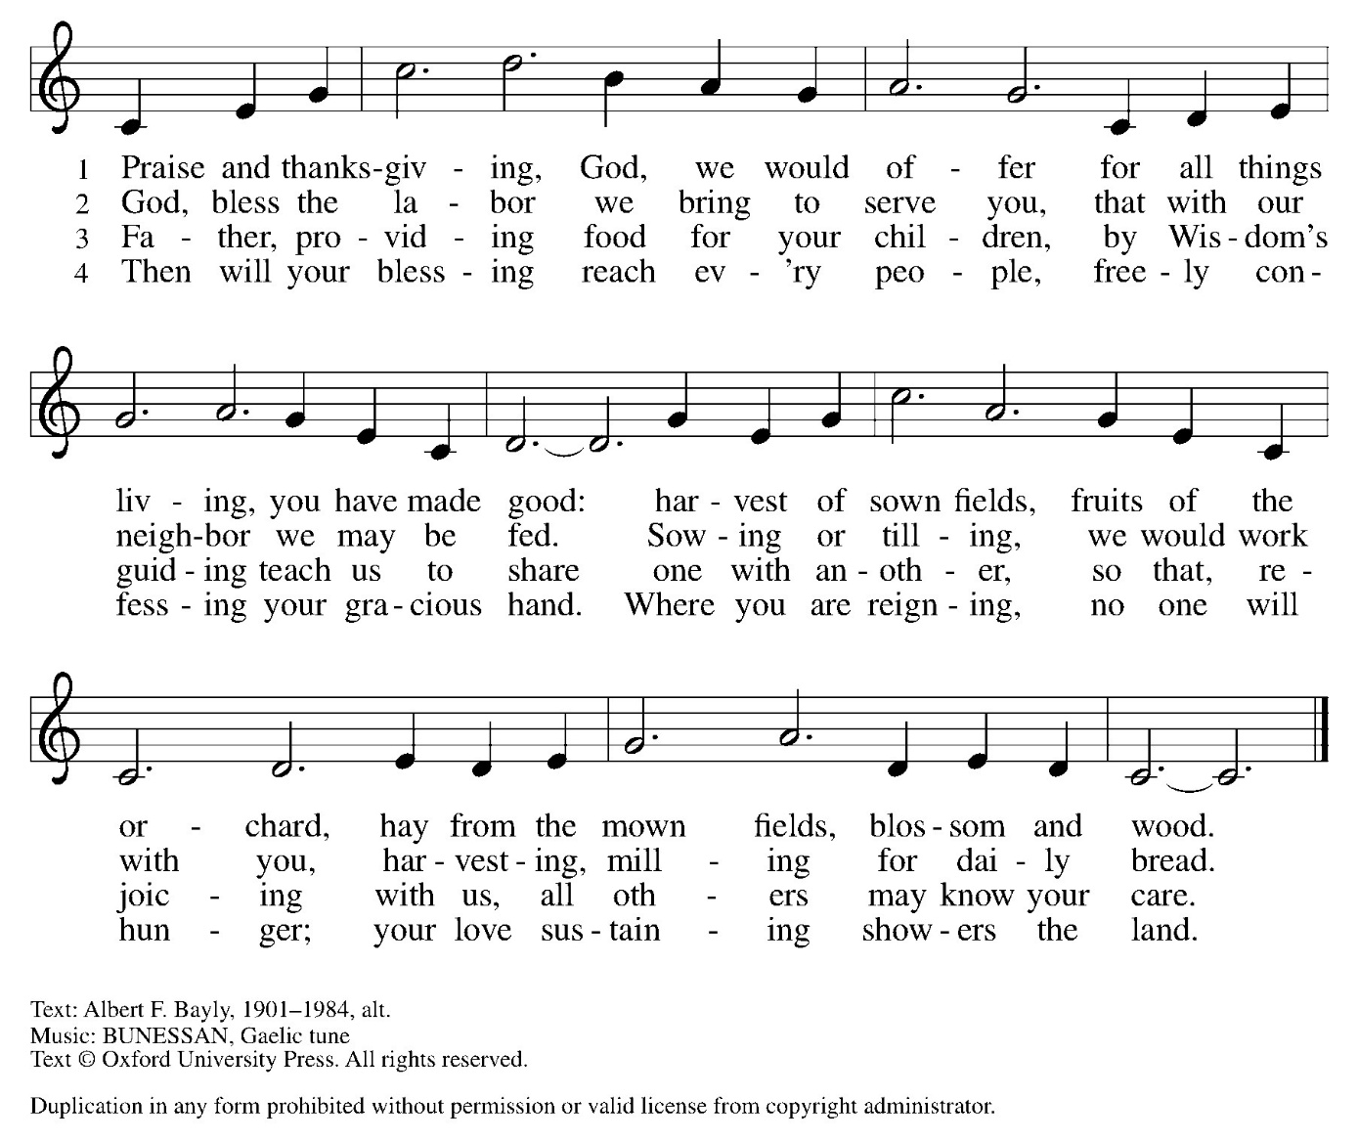

Welcome and Announcements

Confession and Forgiveness
P: Blessed be the holy Trinity, + one God, whose compassion endures forever.
C: Amen.
P: Let us confess our sins to God.
Silence is kept for reflection.
P: Compassionate God,
C: we confess to you all our sins. Our burden is heavy, and we cannot free ourselves. In your mercy, call us back to you. Your yoke is easy and your burden is light. Restore us to dwell in your peace. In Christ’s name we pray, Amen.
P: Jesus says, “Come to me, all you who are weary and are carrying heavy burdens, and I will give you rest.” In the name of God, Father, + Son, and Holy Spirit, your sins are forgiven. Rest in God’s love.
C: Amen.

Greeting

WA: The grace of our Lord, Jesus Christ, the love of God, and the communion of the Holy Spirit be with you all. C: And also with you.

Kyrie ELW #157
(printed next page)

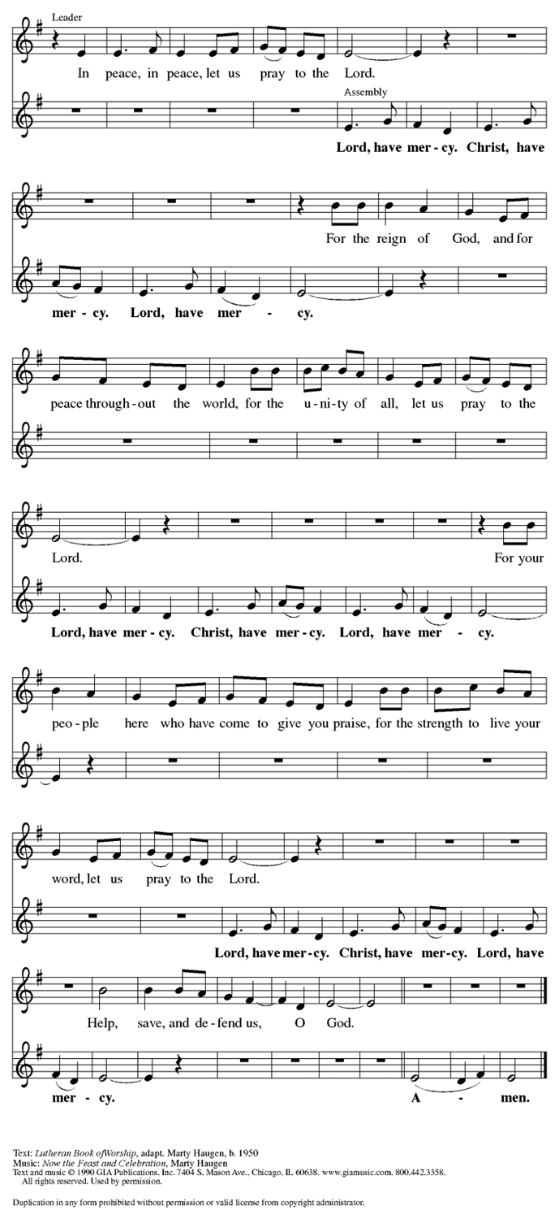
Prayer of the Day
WA: Let us pray together.
C: Faithful God, most merciful judge, you care for your children with firmness and compassion. By your Spirit nurture us who live in your kingdom, that we may be rooted in the way of your Son, Jesus Christ, our Savior and Lord. Amen.

Children’s Sermon: Jesus said, “Let the little children come to me!”
We welcome children in worship.

WORD
God speaks to us in scripture readings, preaching and song.

Please stand as you are able

Gospel Acclamation Setting 10 (p. 205)
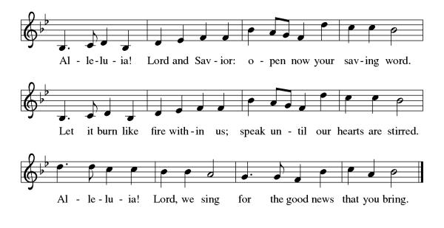

Gospel Reading: Matthew 13:24-30, 36-43
Jesus tells a parable about the coexistence of good and evil in this world. God’s judgment will remove all evil doers and causes of sin, but not until the end of human history.

L: The Holy Gospel according to Matthew. C: Glory to you, O Lord.
L: ²⁴ [Jesus] put before [the crowds] another parable: “The kingdom of heaven may be compared to someone who sowed good seed in his field,²⁵ but while everybody was asleep an enemy came and sowed weeds among the wheat and then went away. ²⁶ So when the plants came up and bore grain, then the weeds appeared as well. ²⁷ And the slaves of the householder came and said to him, ‘Master, did you not sow good seed in your field? Where, then, did these weeds come from?’ ²⁸ He answered, ‘An enemy has done this.’ The slaves said to him, ‘Then do you want us to go and gather them?’ ²⁹ But he replied, ‘No, for in gathering the weeds you would uproot the wheat along with them. ³⁰ Let both of them grow together until the harvest, and at harvest time I will tell the reapers, Collect the weeds first and bind them in bundles to be burned, but gather the wheat into my barn.’ ”
³⁶ Then he left the crowds and went into the house. And his disciples approached him, saying, “Explain to us the parable of the weeds of the field.” ³⁷ He answered, “The one who sows the good seed is the Son of Man; ³⁸ the field is the world, and the good seed are the children of the kingdom; the weeds are the children of the evil one, ³⁹ and the enemy who sowed them is the devil; the harvest is the end of the age, and the reapers are angels. ⁴⁰ Just as the weeds are collected and burned up with fire, so will it be at the end of the age. ⁴¹ The Son of Man will send his angels, and they will collect out of his kingdom all causes of sin and all evildoers, ⁴² and they will throw them into the furnace of fire, where there will be weeping and gnashing of teeth. ⁴³ Then the righteous will shine like the sun in the kingdom of their Father. Let anyone with ears listen!” L: The Gospel of the Lord. C: Praise to you, O Christ.

Reading: Exodus 32:1-14
P: ¹ When the people saw that Moses delayed to come down from the mountain, the people gathered around Aaron and said to him, “Come, make gods for us, who shall go before us; as for this Moses, the man who brought us up out of the land of Egypt, we do not know what has become of him.” ² Aaron said to them, “Take off the gold rings that are on the ears of your wives, your sons, and your daughters and bring them to me.” ³ So all the people took off the gold rings from their ears and brought them to Aaron. ⁴ He took these from them, formed them in a mold, and cast an image of a calf, and they said, “These are your gods, O Israel, who brought you up out of the land of Egypt!” ⁵ When Aaron saw this, he built an altar before it, and Aaron made a proclamation and said, “Tomorrow shall be a festival to the Lord.” ⁶ They rose early the next day and offered burnt offerings and brought sacrifices of well-being, and the people sat down to eat and drink and rose up to revel.
⁷ The Lord said to Moses, “Go down at once! Your people, whom you brought up out of the land of Egypt, have acted perversely; ⁸ they have been quick to turn aside from the way that I commanded them; they have cast for themselves an image of a calf and have worshiped it and sacrificed to it and said, ‘These are your gods, O Israel, who brought you up out of the land of Egypt!’ ” ⁹ The Lord said to Moses, “I have seen this people, how stiff-necked they are. ¹⁰ Now let me alone so that my wrath may burn hot against them and I may consume them, and of you I will make a great nation.”
¹¹ But Moses implored the Lord his God and said, “O Lord, why does your wrath burn hot against your people, whom you brought out of the land of Egypt with great power and with a mighty hand? ¹² Why should the Egyptians say, ‘It was with evil intent that he brought them out to kill them in the mountains and to consume them from the face of the earth’? Turn from your fierce wrath; change your mind and do not bring disaster on your people. ¹³ Remember Abraham, Isaac, and Israel, your servants, how you swore to them by your own self, saying to them, ‘I will multiply your descendants like the stars of heaven, and all this land that I have promised I will give to your descendants, and they shall inherit it forever.’ ” ¹⁴ And the Lord changed his mind about the disaster that he planned to bring on his people.

Sermon Rev. Jeremiah Smith

Please stand as you are able

+Hymn of the Day: Lead Me, Guide Me ELW #768
(printed next page)

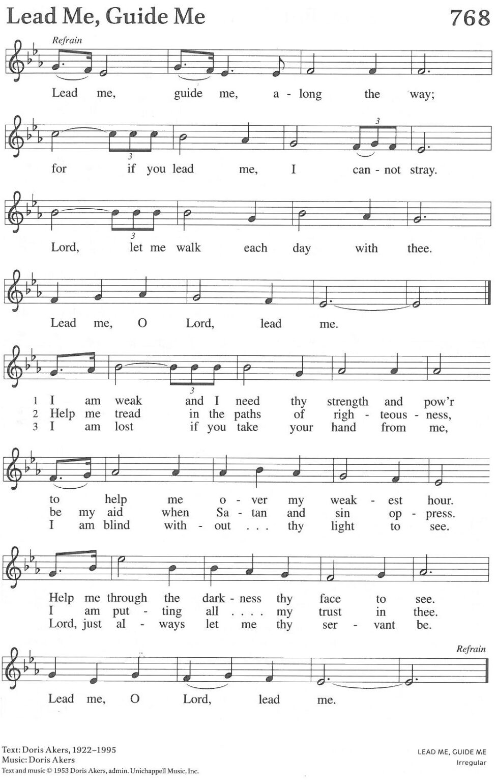

Apostle’s Creed WA: Let us confess the faith using the words of the Apostle’s Creed.
C: I believe in God, the Father almighty, creator of heaven and earth.
I believe in Jesus Christ, God’s only Son, our Lord, who was conceived by the Holy Spirit, born of the virgin Mary, suffered under Pontius Pilate, was crucified, died, and was buried; he descended to the dead. On the third day he rose again; he ascended into heaven, he is seated at the right hand of the Father, and he will come to judge the living and the dead.
I believe in the Holy Spirit, the holy catholic church, the communion of saints, the forgiveness of sins, the resurrection of the body, and the life everlasting. Amen.

Prayers of the People WA: Trusting in God’s steadfast love for all God has made, let us pray for the church, the nations, and all of creation. (a brief silence)
WA: God our source, protect your church from those who sow weeds among the wheat. Where we trade grace for judgment, restore us, and where we get lost among the complexities of life, guide us. God of grace, C: hear our prayer.

WA: God our soil, we yearn to live on your lands and waters with justice and in righteousness. Renew the hearts of all in authority, that our leaders guide wisely toward the flourishing of all. God of grace, C: hear our prayer.

WA: God our rock, be a source of constancy for those whose lives have been uprooted by war, eviction, global climate change, unemployment, harassment, false witness to their character, or illness or injury. We especially pray for those we name aloud or in the silence of our hearts…. God of grace, C: hear our prayer.

WA: God our teacher, guide and provide for all summer camp staff and campers, daycare professionals, librarians, summer school educators and coaches, teachers preparing for the coming academic year, and youth becoming first-time babysitters. God of grace, C: hear our prayer.

WA: God our hope, the message of your salvation is planted among us in all times and places. We give you thanks for the witness of all the saints who shine like the sun in your presence. God of grace, C: hear our prayer.

WA: Grateful for your abundant provision and trusting in your goodness, we cast all our cares upon you, through the abundant grace of Christ Jesus. C: Amen.

Peace
P: The peace of Christ be with you always. C: And also with you.
Meal - God feeds us with the presence of Jesus Christ

Offering
We are grateful to those who help sustain our mission. To donate online, please use QR code:


+ Offering Prayer
WA: Let us pray together:
C: Loving God, we offer at your table the gifts of our hearts. Help us take heart in you and share freely of your love, so that all creation can taste your abundance. We ask this in the name of Jesus, through the Spirit abiding with us now and forever. Amen.

+ Offertory Song: Let the Vineyards Be Fruitful ELW #184
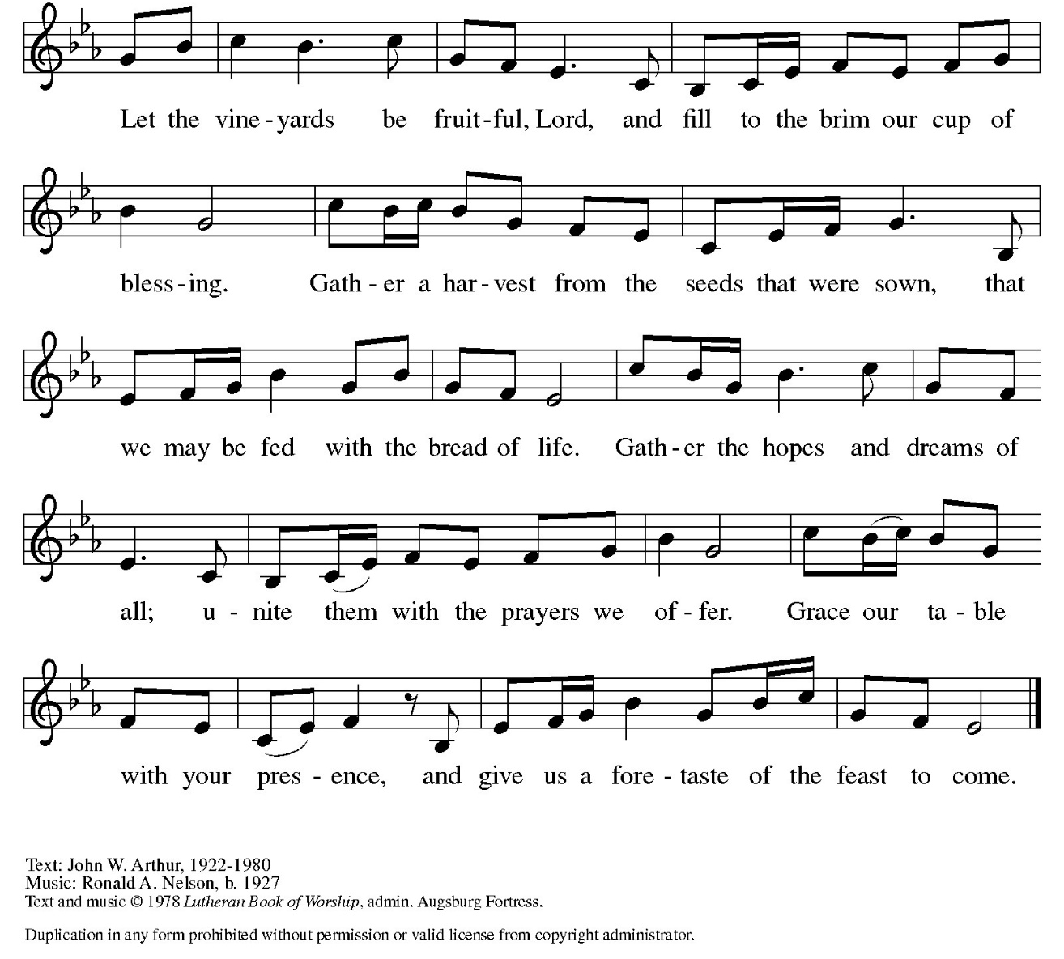

Great Thanksgiving
P: The Lord be with you. C: And also with you.
P: Lift up your hearts. C: We lift them to the Lord.
P: Let us give thanks to the Lord our God.
C: It is right to give our thanks and praise.

Preface
P: It is indeed right, our duty and our joy, that we should at all times and in all places give thanks and praise to you, almighty and merciful God, through our Savior Jesus Christ; who on this day overcame death and the grave, and by his glorious resurrection opened to us the way of everlasting life. And so, with all the choirs of angels, with the church on earth and the host of heaven, we praise your name and join their unending hymn:

Holy Holy Holy ELw setting 10 (p. 207)
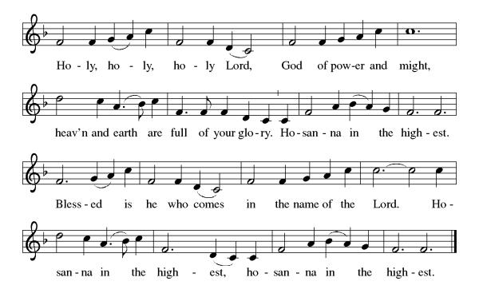
Thanksgiving at the Table

P: In the night in which he was betrayed, our Lord Jesus took bread, and gave thanks; broke it, and gave it to his disciples, saying: Take and eat; this is my body, give for you. Do this for the remembrance of me. Again, after supper, he took the cup, gave thanks, and gave it for all to drink, saying: This cup is the new covenant in my blood, shed for you and for all people for the forgiveness of sin. Do this for the remembrance of me.

Lord’s Prayer
P: Lord, remember us in your kingdom and teach us to pray.
C: Our Father in heaven, hallowed be your name, your kingdom come, your will be done, on earth as in heaven. Give us today our daily bread. Forgive us our sins as we forgive those who sin against us. Save us from the time of trial and deliver us from evil. For the kingdom, the power, and the glory are yours, now and forever. Amen.

Invitation to the Table
At Parkside Lutheran Church we have an open table. We believe the invitation to receive comes from Jesus himself and all are welcome at Christ’s table. More than just Bread and Wine these are tangible signs of God’s love for you! If you do not wish to receive communion but would like a blessing, come forward and cross your arms over your chest. The Pastor will give you a blessing before you return to your seat via the side aisle. You’ll receive a communion wafer* in your hands. You may dip it in the cup of wine or juice. When giving the bread and cup, the communion ministers say: “The body of Christ, given for you. The blood of Christ, shed for you.”
and each person may respond: Amen
*Please let Pastor know if you need a gluten-free wafer
P: Heaven has come near. Come, share in the feast!

The Communion Distribution

Communion Song ELW setting 10 (p. 208)
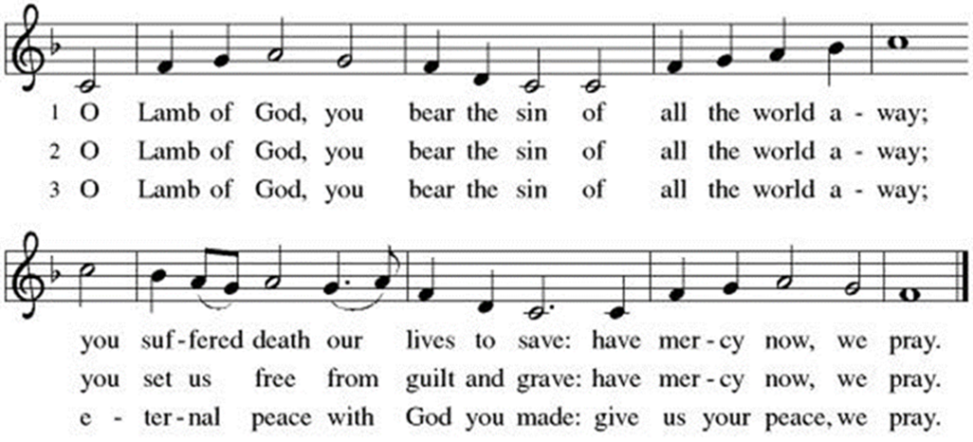

Communion Song: You Satisfy the Hungry Heart ELW # 484

Communion Song: Lord, Listen to Your Children Praying
Post Communion Blessing
P: The Body and Blood of our Lord and Savior, Jesus Christ, strengthen you and keep you in God's grace. C: Amen.

Prayer After Communion
WA: Let us pray together.
C: Compassionate God, through the gifts of bread and wine our hearts are filled with the abundance of your love. Strengthen us that we, through this holy meal, may share your love freely, as you have shared with us. We ask this in the name of Jesus, through the Spirit nourishing us now and forever. Amen.

Sending - God blesses us and sends us in mission to the world.

Blessing
P: Creator, Redeemer, Sustainer, + one God, bless, heal, and hold you today and always. C: Amen.

Sending Hymn: Hymn Raffle

Dismissal and Postlude
P: Parkside Lutheran Church is rediscovering the radical love of Jesus.
C: Gathering All, Serving All, Caring for All
P: Heaven has come near. Go, share the good news.
C: Thanks be to God.

ELW Music licensed from Sundays & Seasons, Augsburg Fortress CCLI MUSIC License # 11440069 , CCLI Streaming License#21835523 Do not duplicate any music or Liturgy herein without license and permission
scripture readings adapted and written by susan lukey

PARKSIDE STAFF:
• The Rev. Jeremiah Smith: prjeremiahpsmith@gmail.com
• Kris Pope & Suzanne Gracie, Admin. Assistants (Church Office): parksidelutheran@gmail.com
• Mike Hooker, Music Director: mrhooker@me.com
CHURCH OFFICE HOURS: M/T/R 10:00am-3:00pm (716)836-1361

Acolytes: |  | Worship Assistants:
7/19 – Max & Lucy |  | 7/19 – John
7/26 – Annalie & Lorenzo |  | 7/26 - Onda
Readers: |  | Ushers:
7/19 - Sarah |  | 7/19 – Nick, Tom, John, Charlie
7/26 - Jose |  | 7/26 - Ricky, Shannon, David

Coming up:
TODAY – Volunteer Meeting for Vacation Bible School, after Worship
August 2nd – Outdoor Worship
August 19th – Volunteer Meeting for Vacation Bible School – 5:30pm
August 24th – 28th – Vacation Bible School *SAVE THE DATE*
Visit our website for more information about these and other Events at Parkside – www.parksidelutheran.org/events

BURRITO PROJECT SNACK DONATIONS ARE NEEDED!
Single serve snacks such as granola bars, chips, pretzels, etc. are needed. Donations can be place in the Burrito Project bin, in the Narthex. Thank you to everyone who has contributed funds or snacks this year! Your generosity is greatly appreciated!

