TLC Weekly: Sunday, July 19- – July 26
Vicar Angie DeSmith cell: 507-828-4941 email: angiedesmith316@gmail.com
The Radio Broadcast (KMHL 1400AM or 101.7FM) is sponsored by Tom & Vicki Streifel in celebration and thanks for Vicar Angie and her ministry to Tracy Lutheran.
Sunday, July 19 9am Worship/Communion
10am Coffee Fellowship
Monday, July 20 9am Men in Mission
Wednesday, July 22 9am Do Day Mission Work Day
Friday, July 24 OFFICE CLOSED
Sunday, July 26 8:30am Blessing & Sendoff for the Youth Mission Trip
9am Worship
10am Coffee Fellowship

Please continue to Remember in Prayer:
Please…
We are happy to include people in our prayer list, but we must have their permission to be included. Many folks are very private about what is happening in their lives and we want to honor that.
Peggy Isaacson – LaVerne Jessen’s daughter, cancer
Steve Vickerman – hospitalized at St Mary’s hospital
Kim Mickelson – cancer-cousin of Kari Meyer & Kris Tiegs
Vicki Schaar – Cancer
Mike Hemish – son of Doris Hemish
Mary Christian – Fx in her back from fall
Cora Ourada – Cancer – granddaughter of David & Linda Rykhus
Judy Hagen – friend of John & Muriel Coulter
Dan Nyquist – recurring foot problems
Matt Olivier – Cancer, brother of Sue Magnuson
Family of Joy Osland
The funeral for Joyce Osland will be held at Tracy Lutheran Tuesday, July 21 at 10:30am, visitation one hour prior to the service. There will be visitation 5-7pm Monday at the Tracy Area Funeral Home.

July Acolytes: Otto Nyquist, Vincent Munson

July Altar Preparation: Carolyn Engelkes, Karen Krog

July Communion Servers: Sandy Fultz, Darcy Carlson, Eric Fultz

Coffee Fellowship: Sunday, July 19 Tom & Vicki Streifel
Sunday, July 26 Tom & Deb Hesse

Scripture Readers: Sunday, July 19 Matt Pierson
Sunday, July 26 Mary Kay Frisvold

Greeters: Sunday, July 19 Denny & Anita Fultz
Sunday, July 26 OPEN

Sunday Counters: Sunday, July 19 Kari Meyer
Sunday, July 26

Ushers: Sunday, July 19 Dennis Fultz, Chad Anderson, Jim Christian
Sunday, July 26 Jim Nicks, Loren Rykhus, Tim Jones, Terry Filter
English Lutheran Church, Walnut Grove. Quilt Show 11am-5pm July 11th, 18th, & 25th. Free Will donation. Check the kiosk for further details.
There is a sign up sheet in the office for volunteers to help with the service at Painted Prairie Vineyard, August 16th, 10am worship service. If you are able please stop in the office. Looking for a reader for the Psalm, 1 or 2 worship assistances to either usher or help serve communion and two (2) pans of bars. Stop in the office to sign up. Check the kiosk for information on the Painted Prairie Vineyard Ecumenical church service August 16th.
The Do Day Ladies are once again collecting school items to make up school backpacks to be sent to World Relief. The item list is on the table as you enter the sanctuary. You are welcome to purchase any of these items and bring to the church. A box will set up in the narthex to place items in.
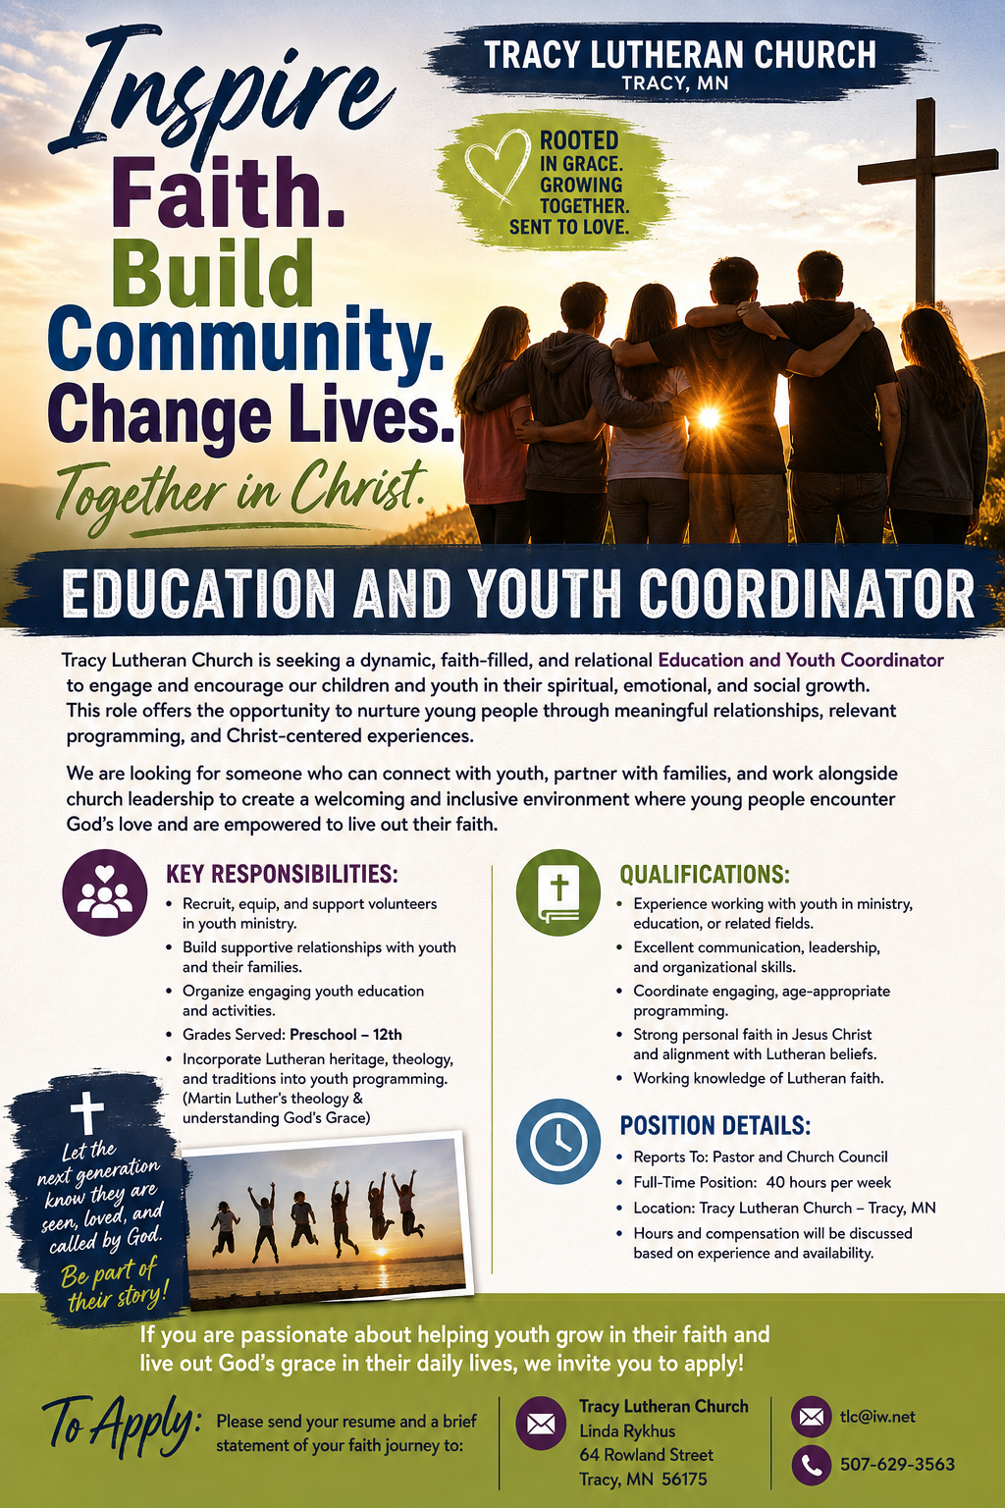
At the request of council president, Dennis Fultz, Tracy Lutheran Church is recognized as a Synod -Authorized Ministry site. Angie DeSmith has been authorized by Southwestern Minnesota Synod Bishop Dee Pederson to preach and preside for
Holy Communion in the congregation . The authorization is granted in accord with the ELCA’s guiding statement, The Use of the Means of Grace , which recognizes the witness of the sacrament as a celebration of the Church, serving its unity and
proclaiming the Gospel; and that where it is not possible to provide ordained pastoral leadership, a synod bishop may authorize a properly trained person to preside at a certain time.

