THE ORDER OF WORSHIP
July 12, 2026/7th Sunday of Pentecost
Greeter: Dale Dixon and Rachel Hawk
Please fill out your Prayer & Praise Cards. Announcements are on the screens. Please come to the front pews to meet with a member of our Prayer Team before or after the service.
Gathering
Prayer of Consecration: Pastor John
One: Wake up, sleeper, rise from the dead,
All: and Christ will shine on you. Jesus, I belong to you. I lift up my heart to you. I set my mind on you. I fix my eyes on you. I offer my body to you
as a living sacrifice. Jesus, we belong to you. Praying in the name of the Father, and the Son, and the Holy Spirit, amen.

Opening Chorus: “God Is So Good” No. 52
Prelude: “Something Worth Living For” William Gaither
Bringing In the Light of Christ: Jenny Nelson
Welcome and Announcement: Ann Ragland

*Call to Worship: Ann Ragland
One: Clap your hands! Shout for joy! Our Lord reigns on the throne of glory!
All: We open our hearts to the ascended Lord, who sits on the throne of glory!
One: Lord of Lords, illumine our hearts this day,
All: that we may feel your glory and live into the hope to which you have called us. Amen
Greeting Our Brothers and Sisters in Christ

Proclamation and Response
*Opening Hymn: “Come, Christians, Join to Sing” No. 36
(Collection of Prayer & Praise Cards)

Joys and Concerns: Pastor John
Prayer Chorus: “Jesus Be Praised” No. 2079 TFWS (Sing Twice)
Silent Prayer & Pastoral Prayer /Lord’s Prayer: Pastor John

Anthem: “The Blood Will Never Lose It’s Power” Solo by Rachel Kraus
Written by Andrae’ Crouch/Arr.by Matthew Summers
Collection of Tithes and Offerings: Stuart Walton & Bonnie Leffingwell
*The Doxology: “My Tribute” On the Screen
*The Apostle’s Creed: No. 691

Scripture Reading: Series “Letters of John” I John 2:15-17
One: The word of God for the people of God.
All: Thanks be to God and I believe it.

Sermon: “Loving the World” Pastor John
Sending Forth
*Closing Hymn: “Love Divine” No. 88
Postlude: “Pleading Savior” David Paxton

Please be seated. You are invited to close your eyes and use the few moments of music at the end of our service to practice Listening Prayer. This is a time to expect God to speak to you before you leave the sanctuary. In John 10:17, Jesus tells us; “My sheep hear my voice, and I know them, and they follow me.” Let’s try listening as we are silent and still. Members of the prayer team will remain on the front pews after the service. Feel free to come forward.
Benediction: Pastor John
ANNOUNCEMENTS

TO OUR VISITORS: We welcome you to Laurel Hill and hope that you feel at home. We invite you to join Laurel Hill if you do not have a church home. Please call our church office at 804-795-2772. You will find our Laurel Hill family both warm and eager to welcome you into our fellowship. Please fill out a visitor’s card and place it in the offering plate. The password for our public WiFi is LivingHope - feel free to connect with us.

THE ALTAR FLOWERS are presented to the Glory of Almighty and given in loving memory of Phyllis Nelson. Please keep the family in your prayers.

OUR SYMPATHY to the family of John Brockman who passed away on June 26th. There will be visitation on Monday, July 13th at Nelsen’s Funeral Home from 4 PM to 8 PM. Please keep Jay and Will, and their families, in your prayers during this difficult time.

OPERATION CHRISTMAS CHILD SHOEBOXES…As we continue to collecte for our shoeboxes this month, please consider giving school items like pens, pencils, sharpeners, crayons, markers, small notebooks and coloring books. Thank you.

LAST SUNDAY FOR MEMBERSHIP UPDATE SHEETS…Located on the table in the hallway, and in your newsletter, are new sheets to update any changes to your information that is currently in the Church Directory or to add new information. If you wish to have your name in the directory, and it is not listed as of now, please fill out a sheet and return it in the offering plate, give it to Ben Wilson or the church office. This is the last Sunday to collect new information. Watch for your updated directory soon.

FISH FUNDRAISER sponsored by Mexico Restaurant, July 12th-18th. You must present a flyer at the time of dining in or carrying out. Flyers are available on the table in the front hallway.

FISH BBQ LUNCH on Sunday, August 9th from 11:30 AM-1:30 PM at Ft. Lee Baptist Church. ADVANCE TICKETS ONLY. On sale today in the hallway.

SICK AND SHUT-INS – Kim Davis, Jean Miller, Mary Hicks, Evelyn Steele, Kathleen McKinsey, Sara Nelson, Regina Humphrey, David Torrence, Dot Gay, Sharon Loving & Family and ML Yuhas.

KEEP IN OUR PRAYERS
- Our Weekday School – Margo Keeles (Director), our teachers, students and families.
- Our community of Varina and all the residents, our churches in our neighborhoods, schools, students, teachers, administrators and all employees.
- Our state of Virginia, our residents and leaders.
- The United States of America, our citizens and leaders, the countries of the world, their people and leaders. May God bless us all and His will be done.
- Those affected by war in Israel and Ukraine

WEEKLY CALENDAR

Monday 10:30 AM New Life House Church (804) 303-4828
7:00 PM Bible Study/Hebrews, in person and on Zoom.

Tuesday 7:30 AM “Listening to God”

Wednesday 9:00 AM Prayer in Sanctuary with Holy Communion

10:30 AM Bible Study on “Finding the Holy Spirit”

Thursday 7:30 PM “Listening to God”
7:00 PM PTL House Church at the Wilson’s (804) 795-7723

Pastor John will leave this evening and return on Sunday evening.

Friday 10:00 AM Thankful Hearts House Church (804) 737-7450

Saturday 9:00 AM Prayer Station at Dorey Park.

Sunday 10:00 AM Sunday School
10:30 AM Chancel Choir
11:00 AM Sunday Worship Service – (also available online)

1 Peter 4:10: Stewardship and Spiritual Gifts
By Gary G. Hoag, Ph.D., www.generositymonk.com
“Each of you should use whatever gift you have received to serve others, as faithful stewards of God’s grace in its various forms” (1 Peter 4:10).

(3) God’s grace is revealed through our faithfulness.

This is perhaps the most motivating point. When we use our various spiritual gifts to serve others, God’s grace is illustrated in various ways. When we don’t use our gifts, which have been given to us for the common good (cf. 1 Corinthians 12:7), God’s work is not thwarted, but rather, we miss out on the privilege of participating.

This may explain why Paul exhorts Timothy to “fan to flame” the gift he had received (2 Timothy 1:3-6). Just as Timothy’s grandmother, Lois, and mother, Eunice, exhibited sincere faith, Paul wanted Timothy to be found faithful. I am writing this blog post today because the same desire Paul had for Timothy, I share for you!

How can you give at Laurel Hill GMC?

1 – Cash and checks may be placed in the offering plate. Please contact the church office for offering envelopes.
2 - You may also give online. The QR code below will take you to our website’s giving page: https://laurelhill.tithelysetup.com/give

3 – Planned giving – including the LHGMC in your will is a wonderful way to ensure the ministries we are called to provide for Varina will continue into the future.
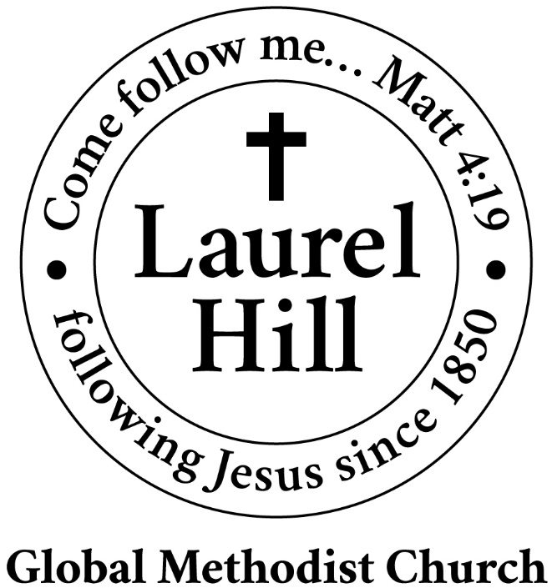
Our Mission: The Global Methodist Church exists to make disciples
of Jesus Christ and spread scriptural holiness across the globe.

1919 New Market Road, Henrico, VA 23231
On the web @ laurelhillchurch.org
Email to laurelhillchurch.varina@gmail.com
Phone: Office/804.795.2772 Pastor/804.437.0937

STAFF
Pastor: Rev. John Bright Organist/Choir Director: Pam Wilson
Secretary: Barbara Wendel School Director: Margo Keeles
Communications Assistant: Ben Wilson

that we you in thought, word, and deed.

