THE HOLY EUCHARIST
The Seventh Sunday after Pentecost

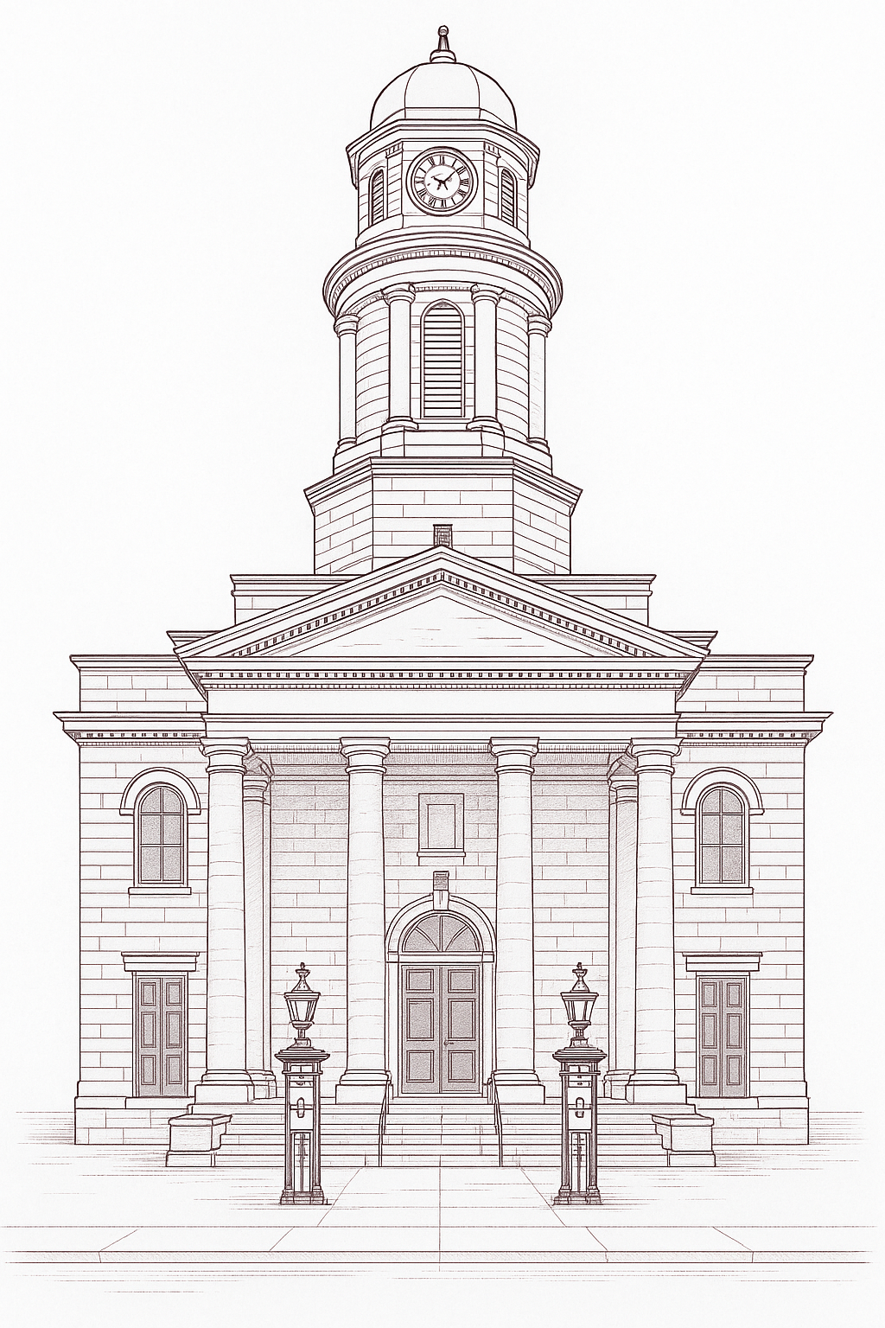
The Cathedral Church of Saint George
July 12, 2026 • 10:30 a.m.

Welcome to St George’s Cathedral
We are so glad you’re here! Wherever you are on your spiritual journey, and whether you are joining in the nave or via the livestream, you are welcome here! Please join us in the entryway for a time of fellowship after the service. Children and young people are invited to attend Sunday School in the Cathedral Library. We are thrilled you have decided to worship with us!

Land Acknowledgement
We acknowledge that in Kingston we are situated on traditional territory of the Anishinaabe, Haudenosaunee, and Huron Wendat peoples. We seek a new relationship with the original peoples of this land, one rooted in and based upon honour and deep respect.

Leading the Service
Preacher  Presider  Organist | The Reverend Gerald Moore, pastoral assistant  The Very Reverend Douglas Michael, dean  Brad Barbeau, director of music

Assisting with the Service
Reader  Servers  Lay Ministers  Livestream | Joanne Snyder  Derek Falkner & Gerald Courage  Eric Friesen  Derek Falkner & Peter McCubbin | Intercessor  Verger  Sidespeople | Ruth Oliver  Jane Kirkpatrick  Doug & Sylvia Green
Eucharistic Prayer
Eucharistic Prayer A, Book of Alternative Services.
The Gathering of the Community

Prelude
The people stand as the procession enters the Cathedral.

Processional Hymn | Sung by all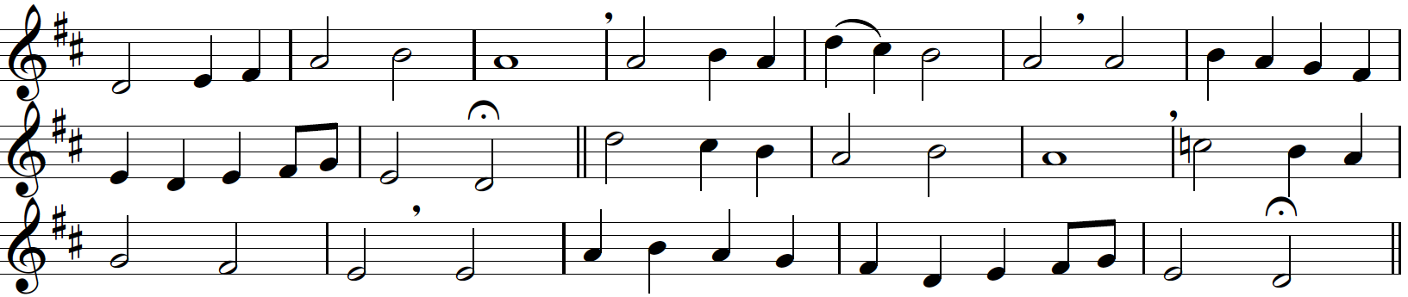
Come down, O Love divine,  Seek thou this soul of mine,  And visit it with thine own ardour glowing;  O Comforter, draw near,  Within my heart appear,  And kindle it, thy holy flame bestowing.  2 O let it freely burn,  Till earthly passions turn  To dust and ashes in its heat consuming;  And let thy glorious light  Shine ever on my sight,  And clothe me round, the while my path illuming. | 3 Let holy charity  Mine outward vesture be,  And lowliness become mine inner clothing;  True lowliness of heart,  Which takes the humbler part,  And o'er its own shortcomings weeps with loathing.  4 And so the yearning strong,  With which the soul will long,  Shall far outpass the power of human telling;  For none can guess its grace,  Till it become the place  Wherein the Holy Spirit makes his dwelling.
Down Ampney  Ralph Vaughan Williams 1872-1958 | Bianco da Siena d 1434  tr Richard Frederick Littledale 1833-90

The people are seated.
Welcome & Land Acknowledgement

The people stand as able at the invitation of the Celebrant
The Opening Acclamation
Celebrant The grace of our Lord Jesus Christ, and the love of God, and the fellowship of the Holy Spirit, be with you all.
People And with thy spirit.

Celebrant Almighty God,
People unto whom all hearts be open, all desires known, and from whom no secrets are hid: cleanse the thoughts of our hearts by the inspiration of thy Holy Spirit, that we may perfectly love thee, and worthily magnify thy holy name; through Christ our Lord. Amen.
Gloria in Excelsis | Said by all.
Celebrant Glory to God in the highest
People and peace to his people on earth.
Lord God, heavenly king,
almighty God and Father,
we worship you, we give you thanks,
we praise you for your glory.
Lord Jesus Christ, only Son of the Father,
Lord God, Lamb of God,
you take away the sin of the world:
have mercy on us;
you are seated at the right hand of the Father:
receive our prayer.
For you alone are the Holy One,
you alone are the Lord,
you alone are the Most High,
Jesus Christ, with the Holy Spirit,
in the glory of God the Father. Amen.

The Collect for the Day
Celebrant Almighty God, you have made us for yourself, and our hearts are restless until they find their rest in you. May we find peace in your service, and in the world to come, see you face to face; through Jesus Christ our Lord, who lives and reigns with you and the Holy Spirit, one God, now and for ever.
People Amen.

The people are seated.
The Proclamation of the Word

The First Lesson | Genesis 25:19-34
These are the descendants of Isaac, Abraham's son: Abraham was the father of Isaac, and Isaac was forty years old when he married Rebekah, daughter of Bethuel the Aramean of Paddanaram, sister of Laban the Aramean. Isaac prayed to the Lord for his wife, because she was barren; and the Lord granted his prayer, and his wife Rebekah conceived. The children struggled together within her; and she said, "If it is to be this way, why do I live?" So she went to inquire of the Lord. And the Lord said to her, "Two nations are in your womb, and two peoples born of you shall be divided; the one shall be stronger than the other, the elder shall serve the younger." When her time to give birth was at hand, there were twins in her womb. The first came out red, all his body like a hairy mantle; so they named him Esau. Afterward his brother came out, with his hand gripping Esau's heel; so he was named Jacob. Isaac was sixty years old when she bore them. When the boys grew up, Esau was a skillful hunter, a man of the field, while Jacob was a quiet man, living in tents. Isaac loved Esau, because he was fond of game; but Rebekah loved Jacob. Once when Jacob was cooking a stew, Esau came in from the field, and he was famished. Esau said to Jacob, "Let me eat some of that red stuff, for I am famished!" (Therefore he was called Edom.) Jacob said, "First sell me your birthright." Esau said, "I am about to die; of what use is a birthright to me?" Jacob said, "Swear to me first." So he swore to him, and sold his birthright to Jacob. Then Jacob gave Esau bread and lentil stew, and he ate and drank, and rose and went his way. Thus Esau despised his birthright.
Reader The word of the Lord.
People Thanks be to God.

Psalm 119:105-112 | The people repeat the refrain as indicated.

Refrain: Your word is a light upon my path.
Your word is a lantern to my feet and a light upon my path.
I have sworn and am determined to keep your righteous judgements. Refrain
I am deeply troubled; preserve my life, O Lord, according to your word.
Accept, O Lord, the willing tribute of my lips, and teach me your judgements. Refrain
My life is always in my hand, yet I do not forget your law.
The wicked have set a trap for me, but I have not strayed from your commandments. Ref.
Your decrees are my inheritance for ever; truly, they are the joy of my heart.
I have applied my heart to fulfil your statutes for ever and to the end. Refrain

The Second Lesson | Romans 8:1-11
There is therefore now no condemnation for those who are in Christ Jesus. For the law of the Spirit of life in Christ Jesus has set you free from the law of sin and of death. For God has done what the law, weakened by the flesh, could not do: by sending his own Son in the likeness of sinful flesh, and to deal with sin, he condemned sin in the flesh, so that the just requirement of the law might be fulfilled in us, who walk not according to the flesh but according to the Spirit. For those who live according to the flesh set their minds on the things of the flesh, but those who live according to the Spirit set their minds on the things of the Spirit. To set the mind on the flesh is death, but to set the mind on the Spirit is life and peace. For this reason the mind that is set on the flesh is hostile to God; it does not submit to God's law indeed it cannot, and those who are in the flesh cannot please God. But you are not in the flesh; you are in the Spirit, since the Spirit of God dwells in you. Anyone who does not have the Spirit of Christ does not belong to him. But if Christ is in you, though the body is dead because of sin, the Spirit is life because of righteousness. If the Spirit of him who raised Jesus from the dead dwells in you, he who raised Christ from the dead will give life to your mortal bodies also through his Spirit that dwells in you.

Reader The word of the Lord.
People Thanks be to God.

Gradual Hymn | Sung by all, standing as able.
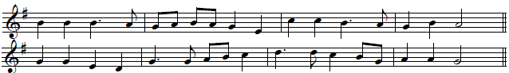
Rise and hear! The Lord is speaking,  as the gospel words unfold;  we, in all our age-long seeking,  find no firmer truth to hold.  2 Word of goodness, truth, and beauty,  heard by simple folk and wise,  word of freedom, word of duty,  word of life beyond our eyes. | 3 Word of God’s forgiveness granted  to the wild or guilty soul,  word of love that works undaunted,  changes, heals, and makes us whole.  4 Speak to us, O Lord, believing,  as we hear, the sower sows;  may our hearts, your word receiving,  be the good ground where it grow.
Sussex  English Traditional Melody | Howard Gaunt 1902-83  © Oxford University Press  Reprinted with permission under  ONE LICENSE A- 738803.  All rights reserved

The Holy Gospel | Matthew 13:1-9, 18-23
Gospeller The Lord be with you.
People And with thy spirit.
Gospeller The Holy Gospel of our Lord Jesus Christ according to Matthew.
People Glory be to thee, O Lord.

That same day Jesus went out of the house and sat beside the sea. Such great crowds gathered around him that he got into a boat and sat there, while the whole crowd stood on the beach. And he told them many things in parables, saying: "Listen! A sower went out to sow. And as he sowed, some seeds fell on the path, and the birds came and ate them up. Other seeds fell on rocky ground, where they did not have much soil, and they sprang up quickly, since they had no depth of soil. But when the sun rose, they were scorched; and since they had no root, they withered away. Other seeds fell among thorns, and the thorns grew up and choked them. Other seeds fell on good soil and brought forth grain, some a hundredfold, some sixty, some thirty. Let anyone with ears listen! Hear then the parable of the sower. When anyone hears the word of the kingdom and does not understand it, the evil one comes and snatches away what is sown in the heart; this is what was sown on the path. As for what was sown on rocky ground, this is the one who hears the word and immediately receives it with joy; yet such a person has no root, but endures only for a while, and when trouble or persecution arises on account of the word, that person immediately falls away. As for what was sown among thorns, this is the one who hears the word, but the cares of the world and the lure of wealth choke the word, and it yields nothing. But as for what was sown on good soil, this is the one who hears the word and understands it, who indeed bears fruit and yields, in one case a hundredfold, in another sixty, and in another thirty."
Gospeller The Gospel of Christ
People Praise be to thee, O Christ.
The people are seated at the invitation of the Preacher.
The Sermon | The Reverend Gerry Moore

Silence may be kept. The people stand as able.
The Nicene Creed
People I believe in one God, the Father almighty, maker of heaven and earth,
and of all things visible and invisible; And in one Lord Jesus Christ, the only
begotten Son of God, begotten of the Father before all worlds, God, of God; Light, of Light; very God, of very God; begotten, not made; being of one substance with the Father; through whom all things were made: who for us and for our salvation came down from heaven, and was incarnate by the Holy Ghost of the Virgin Mary, and was made man, and was crucified also for us under Pontius Pilate. He suffered and was buried, and the third day he rose again according to the scriptures, and ascended into heaven, and sitteth on the right hand of the Father. And he shall come again with glory to judge both the quick and the dead: whose kingdom shall have no end.

And I believe in the Holy Ghost, the Lord, the giver of life,
who proceedeth from the Father and the Son, who with the Father and the Son together is worshipped and glorified, who spake by the prophets.
And I believe one, holy, catholic, and apostolic Church. I acknowledge one baptism for the remission of sins. And I look for the resurrection of the dead, and the life of the world to come. Amen.

The people sit or kneel as they wish.
The Prayers of the People
Confession & Absolution
Celebrant Hear what comfortable words our Saviour Christ saith unto all that truly turn to him. Come unto me all that labour and are heavy laden, and I will refresh you. Matthew 1.28
God so loved the world, that he gave his only- begotten Son, to the end that all that believe in him should not perish, but have eternal life. John 3.16

Hear also what Saint Paul saith. This is a true saying, and worthy of all to be received, that Christ Jesus came into the world to save sinners. 1 Timothy 1.15

Hear also what Saint John saith. If anyone sin, we have an Advocate with the Father, Jesus Christ the righteous; and he is the propitiation for our sins: and not for ours only, but also for the sins of the whole world. 1 John 2.1,2

Let us humbly confess our sins to almighty God.

People Almighty God, Father of our Lord Jesus Christ, Maker of all things and judge of all people: We acknowledge and confess our manifold sins and wickedness, Which we from time to time most grievously have committed, By thought, word and deed, Against thy divine majesty. We do earnestly repent and are heartily sorry for these our misdoings. Have mercy upon us, most merciful Father; For thy Son our Lord Jesus Christ’s sake, Forgive us all that is past; And grant that we may ever hereafter Serve and please thee In newness of life, To the honour and glory of thy name; Through Jesus Christ our Lord. Amen.

Celebrant Almighty God, our heavenly Father, who of his great mercy hath promised forgiveness of sins to all them that with hearty repentance and true faith turn unto him: have mercy upon you; pardon and deliver you from all your sins; confirm and strengthen you in all goodness; and bring you to everlasting life; through Jesus Christ our Lord. Amen.

The people stand as able.
The Peace
Celebrant The peace of the Lord be always with you.
People And with thy spirit.

The people greet one another with a sign of God’s peace.

The Holy Communion
Offertory Hymn | Sung by all, standing as able. 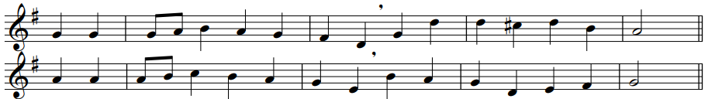
Love divine, all loves excelling,  joy of heaven, to earth come down,  fix in us thy humble dwelling,  all thy faithful mercies crown.  2 Jesu, thou art all compassion,  pure unbounded love thou art;  visit us with thy salvation,  enter every trembling heart.  3 Come, almighty to deliver,  let us all thy grace receive;  suddenly return, and never,  never more thy temples leave. | 4 Thee we would be always blessing,  serve thee as thy hosts above;  pray, and praise thee, without ceasing,  glory in thy perfect love.  5 Finish then thy new creation:  pure and spotless let us be;  let us see thy great salvation  perfectly restored in thee;  6 Changed from glory into glory  till in heaven we take our place,  till we cast our crowns before thee,  lost in wonder, love, and praise.
Love Divine  John Stainer 1840-1901 | Charles Wesley 1707-88


An offering is received to support the mission and ministry of the Cathedral.
All are invited to make a gift as the plate is passed, or by visiting www.stgeorgescathedral.ca/donate.

The Prayer Over the Gifts
Celebrant Father, your word creates in us a yearning for your kingdom. Receive all we offer you this day, and keep us in your peace; for the sake of Jesus Christ the Lord.
People Amen.

The Great Thanksgiving
Celebrant The Lord be with you.
People And with thy spirit.
Celebrant Lift up your hearts.
People We lift them up unto the Lord.
Celebrant Let us give thanks unto our Lord God.
People It is meet and right so to do.
Celebrant It is very meet, right, and our bounden duty, that we should at all times, and in all places, give thanks unto thee, O Lord, holy Father, almighty, everlasting God, creator and preserver of all things. Who by water and the Holy Spirit hast made us a holy people in Jesus Christ our Lord; thou dost renew that mystery in bread and wine and nourish us, to show forth thy glory in all the world. Therefore, with angels and archangels, and with all the company of heaven, we laud and magnify thy glorious name; evermore praising thee and saying:
People Holy, holy, holy Lord, God of power and might, heaven and earth are full of your glory. Hosanna in the highest. Blessed is he who comes in the name of the Lord. Hosanna in the highest.
Celebrant Blessing and glory and thanksgiving be unto thee, almighty God, our heavenly Father, who of thy tender mercy didst give thine only Son Jesus Christ to take our nature upon him, and to suffer death upon the cross for our redemption; who made there, by his one oblation of himself once offered, a full, perfect, and sufficient sacrifice, oblation, and satisfaction, for the sins of the whole world; and did institute, and in his holy Gospel command us to continue, a perpetual memorial of that his precious death, until his coming again.

Hear us, O merciful Father, we most humbly beseech thee; and grant that we receiving these thy creatures of bread and wine, according to thy Son our Saviour Jesus Christ’s holy institution, in remembrance of his death and passion, may be partakers of his most blessed body and blood;

who, in the same night that he was betrayed, took bread; and, when he had given thanks, he brake it; and gave it to his disciples, saying, “Take, eat; this is my body which is given for you: Do this in remembrance of me.”

Likewise after supper he took the cup; and when he had given thanks, he gave it to them, saying, “Drink ye all, of this; for this is my blood of the new covenant, which is shed for you and for many for the remission of sins: Do this, as oft as ye shall drink it, in remembrance of me.”

Wherefore, O Father, Lord of heaven and earth, we thy humble servants, with all thy holy Church, remembering the precious death of thy beloved Son, his mighty resurrection, and glorious ascension, and looking for his coming again in glory, do make before thee, in this sacrament of the holy bread of eternal life and the cup of everlasting salvation, the memorial which he hath commanded:
People We praise thee, we bless thee, we thank thee, and we pray to thee,
Lord our God.

Celebrant And we entirely desire thy fatherly goodness mercifully to accept this our sacrifice of praise and thanksgiving, most humbly beseeching thee to grant, that by the merits and death of thy Son Jesus Christ, and through faith in his blood, we and all thy whole Church may obtain remission of our sins, and all other benefits of his passion; And we pray that by the power of thy Holy Spirit, all we who are partakers of this holy communion may be fulfilled with thy grace and heavenly benediction; through Jesus Christ our Lord, by whom and with whom, in the unity of the Holy Spirit, all honour and glory be unto thee, O Father Almighty, world without end.
People Amen.

The Lord’s Prayer
Celebrant And now, as our Saviour Christ hath taught us, we are bold to say:
People Our Father, who art in heaven, hallowed be thy name,
thy kingdom come, thy will be done, on earth as it is in heaven.
Give us this day our daily bread. And forgive us our trespasses,
as we forgive those who trespass against us. And lead us not into temptation, but deliver us from evil. For thine is the kingdom, the power, and the glory, for ever and ever. Amen.

The Breaking of the Bread
People We do not presume to come to this thy table, O merciful Lord, Trusting in our own righteousness, But in thy manifold and great mercies. We are not worthy So much as to gather up the crumbs under thy table. But thou art the same Lord, Whose property is always to have mercy: Grant us therefore, gracious Lord, So to eat the flesh of thy dear Son Jesus Christ, And to drink his blood, That we may evermore dwell in him, And he in us. Amen.

All baptized Christians are welcome to receive communion in this Church. Please move to the rail at the direction of the ushers. You may receive the bread in open and outstretched hands, responding: “Amen.” Gluten-free wafers are available; please make your need known to the minister. If you prefer to not receive wine from the common cup, you may simply touch the base of the chalice, again responding: “Amen.” Should you wish to receive a blessing, please indicate that to the priest by crossing your arms over your chest.

The people stand as able.
The Prayer after Communion
Celebrant Living God, in this sacrament we have shared in your eternal kingdom.
May we who taste this mystery forever serve you in faith, hope, and love.
We ask this in the name of Jesus Christ the Lord.
People Amen.

Celebrant Glory to God,
People whose power, working in us, can do infinitely more than we can ask or imagine. Glory to God from generation to generation, in the Church and in Christ Jesus, for ever and ever. Amen.

The Blessing
Celebrant Life is short, and we do not have much time to gladden the hearts of those who journey with us. And so make haste to love and be swift to be kind; And may the God who travels with us, the God of pilgrimage, the God of Hope, bless, care and keep you, Father, Son and Holy Spirit, now and always.
People Amen.

The Dismissal
Celebrant Go in the peace of Christ.
People Thanks be to God.

Closing Hymn | Sung by all, standing as able.
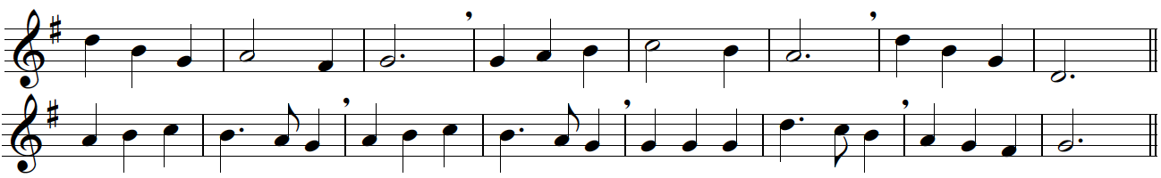
Thou, whose almighty word  chaos and darkness heard,  and took their flight;  hear us, we humbly pray,  and where the gospel-day  sheds not its glorious ray,  let there be light.  2 Thou, who didst come to bring  on thy redeeming wing  healing and sight,  health to the sick in mind,  sight to the inly blind,  O now to all mankind  let there be light. | 3 Spirit of truth and love,  life-giving, holy Dove,  speed forth thy flight;  move on the water's face,  bearing the lamp of grace,  and in earth's darkest place  let there be light.  4 Holy and blessèd Three,  glorious Trinity,  Wisdom, Love, Might;  boundless as ocean's tide  rolling in fullest pride,  through the earth far and wide  let there be light.
Moscow  Felice de Giardini 1716-96 | John Marriott 1780-1825

Postlude
The postlude concludes our worship service, sending us forth into the week ahead. You may choose to remain seated for the duration or depart following the closing hymn.

Summer @ St George’s
www.stgeorgescathedral.ca/summer

Sunday Services: 8am & 10:30am
Saturday Outdoor Concerts: 12-1pm Saturday Free Sightseeing: 11am-3pm

The Cathedral Church of St George
www.stgeorgescathedral.ca


