
Colington United Methodist Church
July 12, 2026
Seventh Sunday after Epiphany

welcome and announcements
call to worship
prelude and lighting of altar candles
Give Me Jesus Traditional/Hayes
invocation
introit
Every Day With Jesus
confession and pardon
Have mercy upon us, O God, according to your lovingkindness. According to the multitude of your tender mercies, blot out our transgressions. Wash us thoroughly from our iniquities, and cleanse us from our sins. For we acknowledge our transgressions, and our sin is every before us. Create in us clean hearts, O God, and renew a right spirit
within us; through Jesus Christ our Lord.
May the almighty and merciful Lord grant us remission of all our sins, true repentance, amendment of life, and the grace and consolation of the Holy Spirit. Amen.
†opening hymn
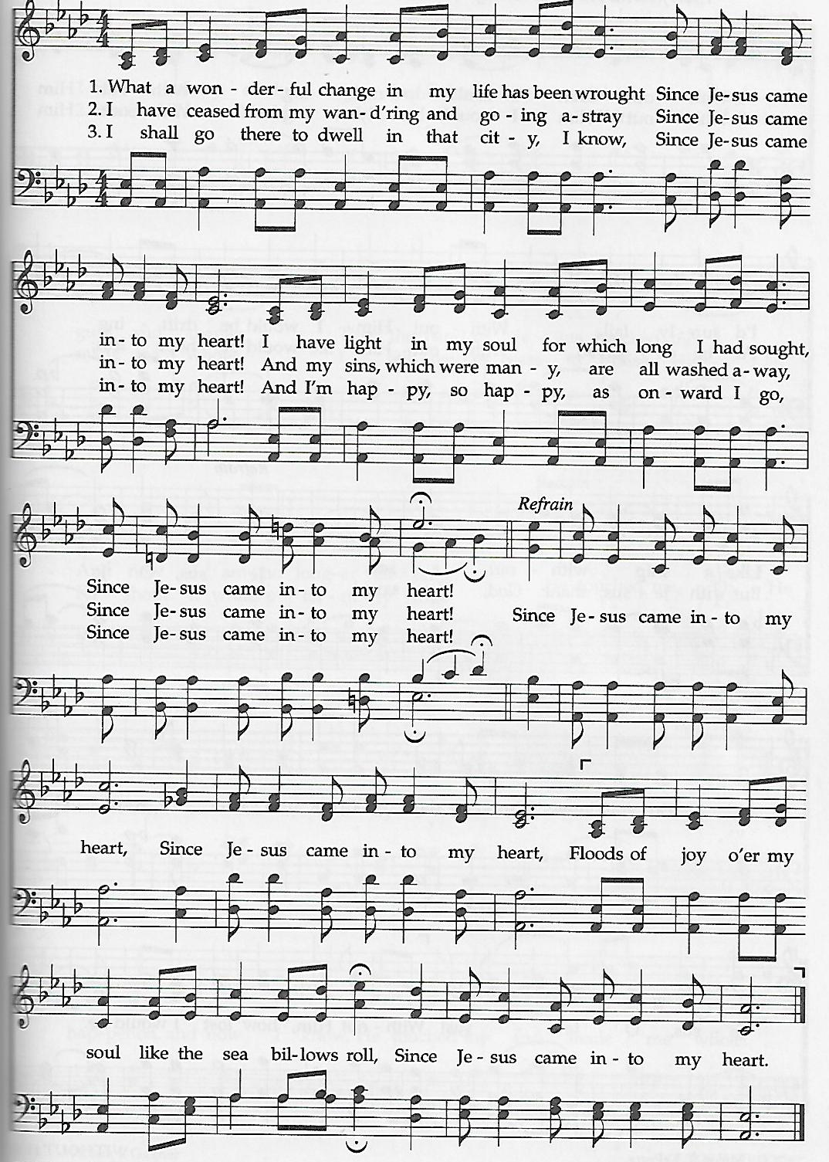
Since Jesus Came into My Heart

the prayers of the people
the old testament
Isaiah 55:10-13
anthem
Everybody Ought to Know Johnson
the gospel
Matthew 13:1-9, 18-23
sermon
“Good Dirt” ǀ Rev. Jack Colenda
†affirmation of praise
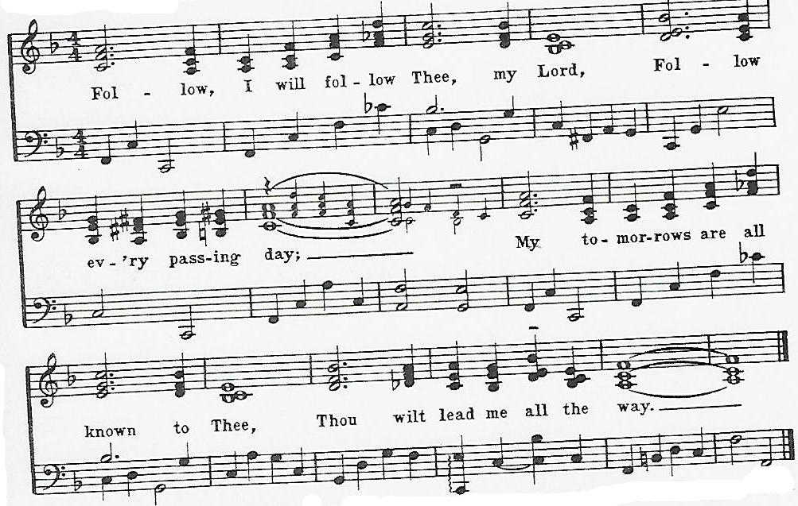
Follow, I Will Follow Thee

the apostles’ creed ǀ UMH 881
doxology
Praise God, from Whom All Blessings Flow ǀ UMH 95
†closing hymn
Pass It On ǀ UMH 572

this week at colington
These opportunities to serve as the Body of Christ are available.
Tuesday – 9 am – Prayer Group
6:15pm – Beach fellowship
Saturday – 9am – Men’s ministry breakfast meeting.
10:10 – Worship service at Spring Arbor Memory Care Unit. All are welcome to attend.

coming up
Next Sunday – 8:15 – choir practice
9:30 am – Worship, in-person and Facebook Live
Wed., July 22 – 10am – Knitters and crocheters meet.
1:46pm – Volunteers to Beach Food Pantry.

Thanks to today’s volunteers!
Ushers – Steve Knowles / Ozzie Gray
Scripture Reader – Bill Sport
The flowers on the altar are given by Becky Wamsley Blalock in loving memory of her Mom, Jean Wamsley.

Last week’s attendance – 62.

