All Saints Anglican Church
6904 Lougheed Highway, Agassiz, B.C. V0M 1A0
Bulletin July 6th, 2026 – July 12th, 2026

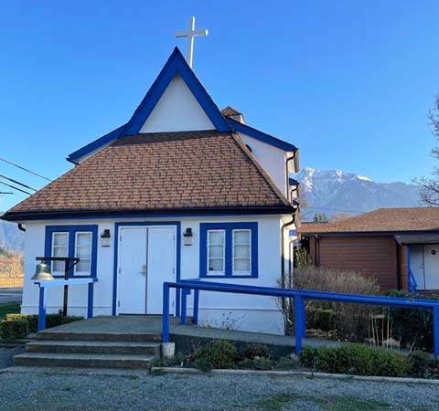

‘The ground we walk does not belong to us; for thousands of years it has been - and remains - the territory of the Stó:lō. We are grateful for their sharing.

Phone: 604-796-3553
Website: www.allsaints-agassiz.ca
https://www.facebook.com/groups/AllSaintsFamily
OUR DOOR IS OPEN AND ALL ARE WELCOME
July 12th, 2026, Seventh Sunday After Pentecost
Priest in Charge: The Reverend Philip Barker
Hosts: Graham Featherstone/Jennifer Pinlac
Intercessor: Graham Featherstone
Lay Administrator: Dorothy Cresswell
Announcer: Virginia Jennings
Organ/Piano: Francesca Froehlich
Readers: Greg Veltman/Andrea Hansen
Vicar’s cell phone: Revd. Philip Barker. 778-867-2461

Vicar’s Warden: Ginny Jennings. 604-796-2206
People’s Warden: Lynn Laughlin. 604-799-5131
Parish email: revpb1950@gmail.com
Please contact either warden if you have an issue that needs to be brought to the attention of the Vicar - or contact the Vicar direct (see above for details).

All Saint’s Calendar/Announcements:

- Book Club – On June 10th Book Club will be starting "Sensible Shoes" by Sharon Garlough Brown, an experienced leader of spiritual formation retreats in the UK and US. It follows 4 very different and very relatable female characters on their journey together through 12 one-day retreats.
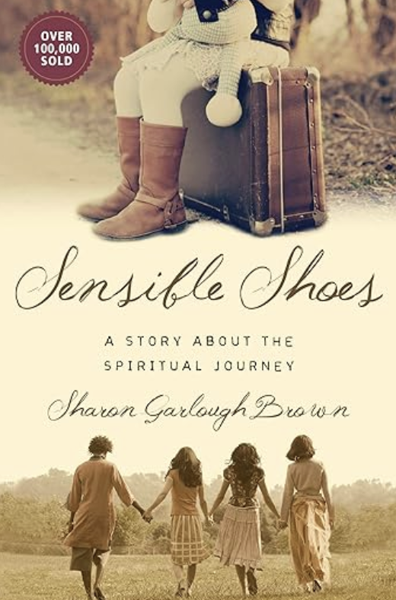

Please contact Sheila Barker at sjbarker0379@gmail.com
if you would like an invitation to the Zoom meetings
at 5.00 pm on Wednesdays or a copy of the book.
The book is available on amazon for $34.11 including tax.

- Bible Study is every Saturday morning 0830-0900 on Zoom. All are welcome to preview and discuss the readings for the Sunday service. Please ask Valerie to add your email address to the invitation list.

- Prayer Requests can be given on a piece of paper to either of the Wardens or the Vicar or entered in the Prayer Request Book on the lectern. Alternatively, you can contact Anthea Lewis at antheamlewis@shaw.ca for Pray First Prayer Circle, which is a confidential online prayer circle.

- Music Requests may be given to the Wardens or the Vicar.

- AA meets in the hall every Tuesday and Friday at noon.

- Every Thursday in the hall 1100-1200 we have a social time with coffee, games if you like or just talk.

- At 1000-1100 on Thursdays there is an Interactive Bible Study on the day’s Lectionary readings. All are welcome – discover the treasures in this amazing book!

- 5th Sunday of each month will be a potluck lunch after the service

Ministerial Meandering
Violation - who cares?

Of person, property, trust, and responsibility. A friend of mine told me a story few days ago that should have horrified me. But it didn’t; because this sort of treatment of the individual seems commonplace today. I’m going to recount it anyway, because I would be interested to know if any of my readers feel the same.

A lady ‘of a certain age’ had need of plumbers to replace her Poly-B piping. They arrived at the wrong time - over an hour early - whilst she was in the shower. Rushing to dress, she left her diamond ring on the counter. This was a family heirloom worth around $20,000. With contractors all over the house all day, she noticed one individual with a hoody walking through, but had no reason to challenge him at the time.
Predictably, at the end of the day, the ring was missing. No workmen - no ring.

Calling the contractor was met by the inference that she (the customer), being ‘of a certain age’, must have forgotten where she had left it. Two days of searching did not turn up the ring. At his insistence the contractor came to look too - through all her private things - amounting to property rape. He found nothing, so sent over his workers again. They attempted intimidation for her inference that one of them could have been responsible for the ring’s disappearance. My friend asked specifically who the hooded character had been - and received only the vague reply that he was ‘one of my crew’. But apparently not to be found - ever again.

The next step was to the newly formed Surrey Police Force - recently changed from the RCMP. They were ‘far too busy’ to be fussing about a ring when they had ‘all these fentanyl cases’ to deal with. Besides, ‘it wasn’t a crime, it was a civil case.’

Really? I was taught that theft was a crime - indeed it remains so and will give you a criminal record. Civil cases can be pursued in order to get compensation for damages and recover financial losses. So the police were of no help and gave clearly wrong advice. Theft is a crime.

The contractor then told my friend that her house insurance ought to cover the loss. Was he now beginning to feel uncomfortable?

The next step was to her lawyer, who suggested that investigation and litigation would soon make the $20,000 disappear, along with any other assets she might have, senior attorneys charging around $500 or more an hour for their services.

Having exhausted the useless responses of the plumbing firm and its contractor, the police, and her lawyer, she turned to scouring eight local pawn shops - with no luck.
To cap it all, the contractor - whose claim was to be ‘in-and-out in ten days’ was now running at day 40 and still not finished due to shoddy workmanship - he was claiming that it was due to his sub-contractor’s men who were all of a different ethnic origin - so what did she expect? Perhaps a competently done job, I suggest.

So my friend lost a precious and valuable family heirloom, was dismissed and insulted by the workforce who were most likely responsible for the theft, regarded as irrelevant by the police - who gave her wrong information, advised that attempting to retrieve it through legal channels might bankrupt her by her lawyer, and then failed to have any luck finding it at local pawn shops. The latter doesn’t surprise me, as no pawn shop owner is going to own up to fencing stolen goods.

I return to my first sentence; violation - of person, property, trust, and responsibility - and nobody cares, it seems.

Philip+

A Little Chuckle…



Birthdays in the July 

Cohen Hill – 5 Mary Kirksey - 11

Diocesan Cycle of Prayer: We Pray for the Clergy and Congregation:

The Anglican CanAsian Ministry (ACAM) Group; St. Dunstan, Aldergrove – The Rev. Clarence Li, The Revd Helen Tervo

Anglican Church of Canada Cycle of Prayer – We Pray for:

The Rt. Rev. Rachael Parker, Bishop, and the clergy and people of the Diocese of Brandon

Collect

Almighty God, you have made us for yourself, and our hearts are restless until they find their rest in you. May we find peace in your service, and in the world to come, see you face to face; through Jesus Christ our Lord, who lives and reigns with you and the Holy Spirit, one God, now and for ever.

Genesis 25:19-34 Greg Veltman

¹⁹ This is the account of the family line of Abraham’s son Isaac.

Abraham became the father of Isaac, ²⁰ and Isaac was forty years old when he married Rebekah daughter of Bethuel the Aramean from Paddan Aram and sister of Laban the Aramean.

²¹ Isaac prayed to the Lord on behalf of his wife, because she was childless. The Lord answered his prayer, and his wife Rebekah became pregnant. ²² The babies jostled each other within her, and she said, “Why is this happening to me?” So she went to inquire of the Lord.

²³ The Lord said to her,

“Two nations are in your womb,
and two peoples from within you will be separated;
one people will be stronger than the other,
and the older will serve the younger.”

²⁴ When the time came for her to give birth, there were twin boys in her womb. ²⁵ The first to come out was red, and his whole body was like a hairy garment; so they named him Esau. ²⁶ After this, his brother came out, with his hand grasping Esau’s heel; so he was named Jacob. Isaac was sixty years old when Rebekah gave birth to them.

²⁷ The boys grew up, and Esau became a skillful hunter, a man of the open country, while Jacob was content to stay at home among the tents. ²⁸ Isaac, who had a taste for wild game, loved Esau, but Rebekah loved Jacob.

²⁹ Once when Jacob was cooking some stew, Esau came in from the open country, famished. ³⁰ He said to Jacob, “Quick, let me have some of that red stew! I’m famished!” (That is why he was also called Edom.)

³¹ Jacob replied, “First sell me your birthright.”

³² “Look, I am about to die,” Esau said. “What good is the birthright to me?”

³³ But Jacob said, “Swear to me first.” So he swore an oath to him, selling his birthright to Jacob.

³⁴ Then Jacob gave Esau some bread and some lentil stew. He ate and drank, and then got up and left.

So Esau despised his birthright.

Psalm 119:105-112

¹⁰⁵ Your word is a lamp for my feet,
a light on my path.
¹⁰⁶ I have taken an oath and confirmed it,
that I will follow your righteous laws.
¹⁰⁷ I have suffered much;
preserve my life, Lord, according to your word.
¹⁰⁸ Accept, Lord, the willing praise of my mouth,
and teach me your laws.
¹⁰⁹ Though I constantly take my life in my hands,
I will not forget your law.
¹¹⁰ The wicked have set a snare for me,
but I have not strayed from your precepts.
¹¹¹ Your statutes are my heritage forever;
they are the joy of my heart.
¹¹² My heart is set on keeping your decrees
to the very end.

Romans 8:1-11 Andrea Hansen

¹Therefore, there is now no condemnation for those who are in Christ Jesus, ² because through Christ Jesus the law of the Spirit who gives life has set you free from the law of sin and death. ³ For what the law was powerless to do because it was weakened by the flesh, God did by sending his own Son in the likeness of sinful flesh to be a sin offering. And so he condemned sin in the flesh, ⁴ in order that the righteous requirement of the law might be fully met in us, who do not live according to the flesh but according to the Spirit.

⁵ Those who live according to the flesh have their minds set on what the flesh desires; but those who live in accordance with the Spirit have their minds set on what the Spirit desires. ⁶ The mind governed by the flesh is death, but the mind governed by the Spirit is life and peace. ⁷ The mind governed by the flesh is hostile to God; it does not submit to God’s law, nor can it do so. ⁸ Those who are in the realm of the flesh cannot please God.

⁹ You, however, are not in the realm of the flesh but are in the realm of the Spirit, if indeed the Spirit of God lives in you. And if anyone does not have the Spirit of Christ, they do not belong to Christ. ¹⁰ But if Christ is in you, then even though your body is subject to death because of sin, the Spirit gives life because of righteousness. ¹¹ And if the Spirit of him who raised Jesus from the dead is living in you, he who raised Christ from the dead will also give life to your mortal bodies because of his Spirit who lives in you.

Matthew 13:1-9, 18-23 Vicar Philip Barker

¹That same day Jesus went out of the house and sat by the lake. ² Such large crowds gathered around him that he got into a boat and sat in it, while all the people stood on the shore. ³ Then he told them many things in parables, saying: “A farmer went out to sow his seed. ⁴ As he was scattering the seed, some fell along the path, and the birds came and ate it up. ⁵ Some fell on rocky places, where it did not have much soil. It sprang up quickly, because the soil was shallow. ⁶ But when the sun came up, the plants were scorched, and they withered because they had no root. ⁷ Other seed fell among thorns, which grew up and choked the plants. ⁸ Still other seed fell on good soil, where it produced a crop—a hundred, sixty or thirty times what was sown. ⁹ Whoever has ears, let them hear.”

¹⁸ “Listen then to what the parable of the sower means: ¹⁹ When anyone hears the message about the kingdom and does not understand it, the evil one comes and snatches away what was sown in their heart. This is the seed sown along the path. ²⁰ The seed falling on rocky ground refers to someone who hears the word and at once receives it with joy. ²¹ But since they have no root, they last only a short time. When trouble or persecution comes because of the word, they quickly fall away. ²² The seed falling among the thorns refers to someone who hears the word, but the worries of this life and the deceitfulness of wealth choke the word, making it unfruitful. ²³ But the seed falling on good soil refers to someone who hears the word and understands it. This is the one who produces a crop, yielding a hundred, sixty or thirty times what was sown.”

Odds and Ends

Church Cleaning – August 8th
Volunteers Needed

~Save the Date~

Saturday October 3rd

All Saints Anglican Church
Garage Sale



