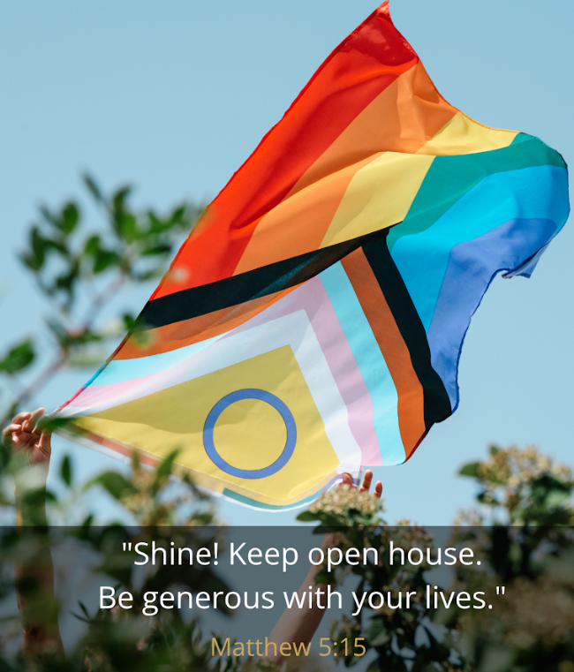

Trinity United Church

July 12, 2026
Pride Sunday
Summer Sabbath Series
RAINBOWS
Shining Brightly

Land Acknowledgement
One: On this Pride Sunday, we honour that many Indigenous cultures, who first lived on the land we now call Collingwood, have understandings of gender roles, spirituality and sexuality that are more diverse than those imposed by western colonialism. The specific names and understandings of gender and sexuality are unique to each Indigenous language and cultural group but in the 1990s, the term “Two-Spirit” was adopted by some Indigenous people to honour these diverse traditions. That’s the 2S at the beginning of the acronym 2SLGBTQIAP+. Before colonization, Two-Spirit people were respected as valued community members, often holding revered roles such as healers, matchmakers, and counsellors, among many others. As part of the colonization process, western religious and cultural beliefs which opposed any sort of sexual or gender diversity were imposed on Indigenous people and many Two-Spirit people were killed or forced into assimilation and hiding.
All: As we continue to unlearn the ways in which the Christian Church has been complicit in promoting homophobia and transphobia in western culture, we also acknowledge that through colonization, those biases were imposed on others, including Indigenous peoples.

God Welcomes Each One of Us with Loving Grace

Lighting the Christ Candle lit by: Ariel Scotney
We light this candle to remember the presence of God amongst us. May its light guide us to truth talking and to travelling good paths. May we in turn share the light with those we meet.

Introit: VU 399 (verse 1) “God, Whose Love is Reigning O’er Us”

Announcements and Opportunities @Trinity

Gathering Words (Modified from a prayer by Hannah Roberts Villnave, led by: Sarah Bruer, Laura Traynor and Tanya Gonalves-Traynor)

One: People sometimes ask: is Pride a protest or a party?
All: And the answer is, of course: Yes.
Two: And why not?
All: Why not rejoice as we resist,
dance as we demand change,
celebrate as we create community that delights in all of who we are?
Three: So bring all of that with you this morning.
All: Bring your policy demands.
Bring your glitter.
Bring your rainbow socks.
Bring the emptiness you feel for our siblings gone too soon.
Bring your tender hope for change.
Bring your most garish eyeshadow.
Bring your spirit, tattered and battered by a world that seems insistent on choosing fear and hate.
One: Gather up all these things and bring them here to a place where we don’t have to shoulder these burdens or celebrate these joys alone.
All: Come, let us worship together.

Opening Hymn: MV 1 (verses 1, 2, 4 and 5) “Let Us Build a House”

Opening Prayer (Read by Barbara Downie)
God of brilliant sunsets and shining rainbows, God of bright red roses and glowing autumn leaves, God of all the blues of the sunlit bay, God of all the greens in bush and field, in rivers and oceans and lakes, in rough stones on a beach and polished jewels in a showcase. God of people, brown and amber, pink and ebony, artistic and athletic, practical and visionary, compassionate and laughter-bringing. God who colours us a world of variety, we thank you. We thank you that you have made each of us unique, that you call us to contribute our special colours to the life around us. We come to you in thanksgiving and worship. Amen.

Prayer of Confession (Modified from a prayer from enfleshed.com), (Read by: David Collinson)
One: God of Justice, even as we celebrate your love for the 2SLGBTQPIA+ community today,
All: we remember that the church has not always done so. We acknowledge the harm that continues to be done in your name today.
One: As we gather for worship today,
All: we renew our commitment to interrupt prejudice and practice solidarity. We press on together until people of every sexual orientation and gender identity can live freely and without fear, receiving the love and support all people deserve.
Pause for silent reflection

Assurance of Pardon (Modified from a prayer by Robin Wardlaw) (Read by: David Collinson)
Let us never forget these deep truths. Love persists. Love knocks on the door and doesn’t stop. Love waits for us to open and welcome it in. Be assured that you are lovable and loved. Be assured that you have endless love within you because you are God’s beloved child. Thanks be to God!

Theme Conversation (Children’s Time) – “Rainbows”

Hymn -VU 585 “Jesus Bids Us Shine”

God Speaks to Us with Peace and Assurance

Prayer for Illumination (Inspired by a prayer by Sam Lundquist)
God of wild love and extravagant acceptance, Spirit of boldness and beauty, you are faithfully present with us in the grit and the glitter of life and you are present with us here and now in this place. As we listen for wisdom in these words of faith both ancient and new, may you ignite in us a passion for your dream for creation: a colourful world in which every human being, every creature, is free to flourish however you made them. Ignite the Divine Light within us to sparkle through the prism of our bodies and brighten every corner of this Earth. Amen.

Gospel: Matthew 5: 14-16 (The Message Paraphrase)
(Read by: Phyllis Fleming)
Psalm 139 (Translated by David Rosenberg in “A Poet’s Bible”) (Read by: Beth Theis)

Contemporary Reading: “To Become is a Lifelong Process”( by M. Jade Kaiser) (Read by: John Clemant)

Choir: “We’re the light of all the world” (TLUS 30)

Message: “Shine Brightly”

God Supports and Lifts Us

Glitter Blessing
Today we offer a glitter blessing, a recognition of the sacred beauty inherent in every person. Glitter has long been a symbol for the 2S and LGBTQIAP+ movement of gritty, sparkly hope in the face of prejudice and oppression, of joy and pride in the face of hatred and bigotry. Glitter is resilient and tenacious. The briefest beam of sunlight causes it to shine out even in the dustiest and dreariest of spaces, and its beauty comes from its brokenness. Glitter sparkles because it is many different broken pieces coming together, changing in every moment as the light changes. This glitter that we share with each other today is a reminder that each of us is beautiful in our sacred imperfection, our ever-changing selves, our glorious plurality. As we play some poetry and music accompanied by some images on your screens from The Many Are Here, a group of faith-based musicians resisting oppression in all forms, you are invited to come forward for a glitter blessing if you wish. Getting blessed with glitter is totally optional and you are also welcome to stay in your spot and enjoy the music and images. If you wish, come forward once the music starts and show us where on your face, arm, or hand you would like to receive your glitter blessing, and then circle back to your seat. If you cannot come forward today and wish to receive this blessing, please raise your hand and one of us will come to you.

During Glitter Blessings, “Jesus at the Pride Parade” and “Come As You Are” by The Many Are Here will play on the screens.

Prayers of the People (Solo - Bob Bruer; “A Plowshare Prayer” by Spencer LaJoye)

Prayer of Jesus (Queer Paraphrase by M Jade Kaiser)


Weaver of Life, Ancient and Unfolding,
How sacred is your Presence!
We lean on your guidance.
We seek your love.
We open to your transformation.
Provide us bread in body and spirit
to sustain us in faith and solidarity.
Companion us with grace
as we seek to live lives of forgiveness and compassion,
repair and accountability.
We remember those who have supported us
as we seek to support others
in all the mess and glory of this human journey.
Guard our minds and hearts from the temptations of domination and turn our loyalty away from all systems of evil.
For the whole cosmos hums with your wisdom.
Everything that lives, returns to your care.
Our thanks and honour to you,
Gracious Web of Existence,
Our Source and our Home. Amen.

Acknowledging our Offerings in Support of Trinity United’s ministries
We are an amazing, talented, fabulous, diverse group of people! Our light and sparkle are astounding. Together we bring many skills and gifts. God has made each one of us unique and special, empowering us to enhance the world with our presence. If you are visiting us today, know that your presence is gift enough. If you find a spiritual home here and are financially able to help us continue our work as an inclusive and welcoming community of faith, cash or cheques can be left in the offering plate at either entrance or mailed or dropped off at the church office. You can also give by e-transfer to office@collingwoodunitedchurch.ca or by signing up to donate monthly through PAR. If this is your first donation, please make sure we have your name and address and email address (if available) for tax receipt purposes. Thank you for all the ways you support us with your time, your talents and your financial resources. With grateful hearts we pray:

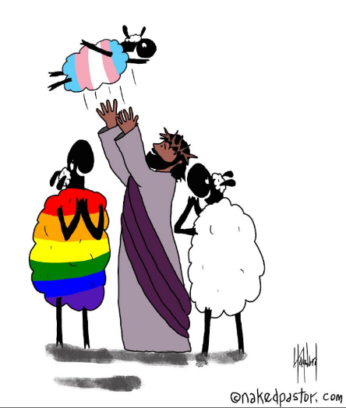
Holy One, all of us belong to your family.
We’re all different.
We bring different gifts.
We have different needs.
We dream different dreams.
Yet, together we are fearfully
and wonderfully made in your image.
Bless all of our gifts, both those offered here
and those we keep for our own use
and the good of our loved ones and community.
May these gifts help us to share love
wherever our journey may take us. Amen.

Closing Hymn - MV 145 “Draw the Circle Wide”

Commissioning (Modified from a prayer by the Unitarian Universalists)
As we go forth this day, may you receive and reflect love, everywhere you go, and know - in your deepest heart and in every day - you matter and you belong. May you hold on to hope and your inner sparkle even when discouragement and despair beckon. May the beauty that is you shine out, bright as the stars from which we came and to which we will return. Together, may we make this a place of welcome and healing, of connection and plurality. Together may we practice compassion and courage, being and celebrating and supporting each other. Together may we be the sparkling force of love that our world needs. Blessed by this community and by the Divine, go forth and shine brightly with pride!

Benediction
And now may God, who colours the world with love, colour you with all the beauty God’s love holds. May Christ, who walks the path with all — straight, queer, beloved, rejected, shining dimly or shiny brightly — assure you of his sturdy companionship in all the places life calls you to be. And may Spirit, who blows through creation to stir, refresh and disturb, blow through your living moment by moment, day by day, until the whole world is filled with the wild blessing of God’s love. May it be so! May it be so! Amen.

Choral Blessing - VU 298 “When You Walk From Here”

Music to Inspire Our Serving

