Announcements
Monday, July 13
Beaver Valley Band Banquet hall 5:30p.m.

Wednesday, July 15
Community dinner Banquet hall 5:00p.m.

Thursday, July 16
Sunset manor service Sunset manor 10:00a.m.

Sun. July 26 Outdoor service at the Arboretum Bring lawn chair, hat and a bagged lunch to visit with others after the service. If it is raining, we will have service at the church.

Over the Summer, we will be using the Prayer Bench resource “Summer Sabbath” by Janice MacLean as a jumping off point for our final service in June and the Sundays of July. Our themes are as follows:

July 12: “RAINBOWS: Shining Brightly”, this is also our Pride Service with a pop-up choir meeting at 9:30 to prepare a special music offering for this joyful celebration
July 19: “MOSQUITOES: Praying Through Hard Times”
July 26: “FIREFLIES: Praying for Others”, this is also our Outdoor Service at the Collingwood Arboretum (weather-permitting, bad weather location is at Trinity)

You can share in this summer reflection series by attending worship in person or online, by picking up a copy of a reflection booklet from either church entrance to take home with you, and/or by following along on our social media (Instagram “collingwoodunited” or Facebook “Trinity United Church, Collingwood’).
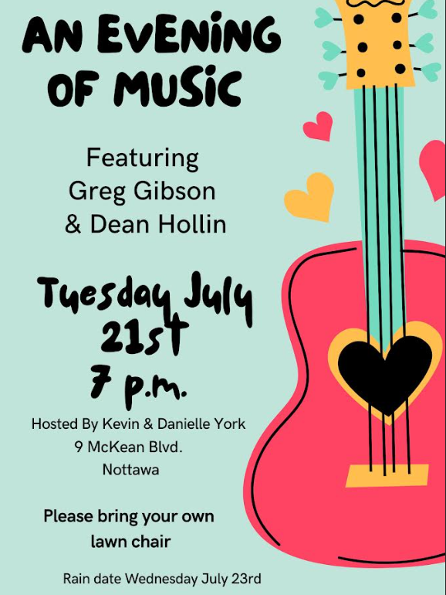

Rev. Beth Kerr Vacation time.
Beth will be away on a combination of vacation and study leave in the month of August. Mary Elizabeth Piercy is available for pastoral emergencies (maryelizabethpiercy@gmail.com or 705-445-4740). Our guest worship leaders in August will be:

August 2: Mary Elizabeth Piercy
August 9: Rick Horst
August 16: Mary Elizabeth Piercy
August 23: Danielle York
August 30: Sarah Bruer

Church office hours
The office will be closed on Friday’s until the end of summer.

Please remember that if you are away during the summer but still want to catch our service, with the exception of our outdoor service on July 26, you can follow us on YouTube https://www.youtube.com/@collingwoodtrinityunitedch5278/streams

Rev. Beth Kerr (she/her)
Diaconal Minister
Trinity United Church
140 Maple Street,
Collingwood, ON L9Y 2P8
www.collingwoodunitedchurch.ca
705-445-3901 (church)
204-872-2370 (cell)
Please note: Friday and Saturday are my sabbath days. I will reply to emails received on those days on the following Monday. For emergencies, please contact my cell phone.

Affirming Vision
As an affirming congregation in the United Church of Canada, we seek to be an inclusive and safe community, nurturing spiritual growth, responding to community and world needs. Where everyone feels at home and no one feels alone.
We are all invited guests of God.

Core Values:
- Belonging
- Spiritual growth
- Outreach

Jesus at the Gay Bar
By Jay Hulme
He’s here in the midst of it –
right at the centre of the dance floor,
robes hitched up to His knees
to make it easy to spin.
At some point in the evening
a boy will touch the hem of His robe
and beg to be healed, beg to be
anything other than this;
and He will reach His arms out,
sweat-damped, and weary from dance.
He’ll cup the boy’s face in His hand
and say,
my beautiful child
there is nothing in this heart of yours
that ever needs to be healed.

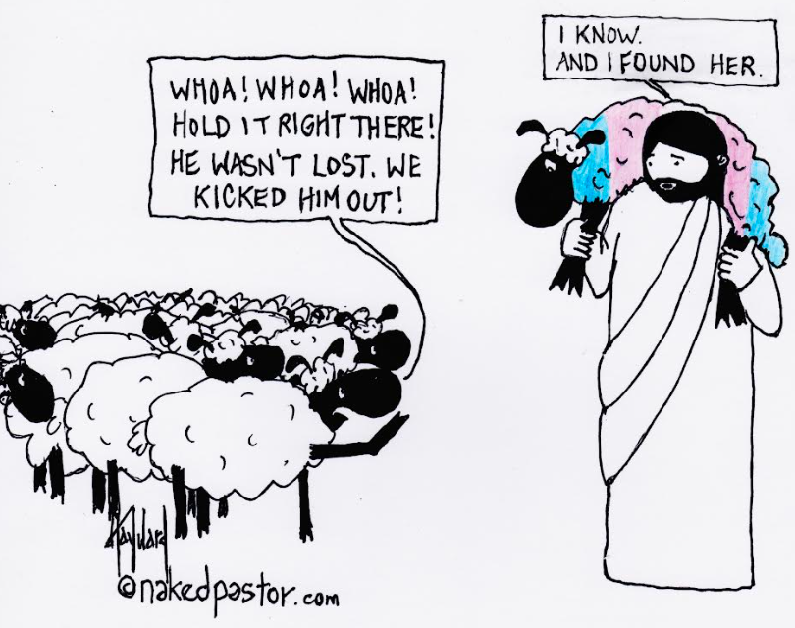

JESUS AT THE PRIDE PARADE
By Lenora Rand

Guess what…last year…
I saw Jesus at the pride parade.
It’s true.
Dancing and weeping and shouting, hugging everyone
and singing
A Christ as queer as they come.
Hallelujah.
Hallelujah.
And I heard Jesus calling out to everyone
The marchers and the watchers, even the haters
Tossing blessings like confetti:
Blessings on you who love glitter and rainbows.
Eye shadow and spandex.
Show tunes and leather.
Blessings on you who are still learning to love the skin you’re in
And blessed are you
who thirst for love and laughter and
the deep in your bones belief that who you are is
a holy and altogether lovely child of God.
Blessed are you whatever label you give yourself
Gay, lesbian, bi or pan, intersex, trans, ace,
non-conforming, straight, cis, yet to be determined…
You are precious in my sight.
Precious. And blessed.
Blessed are you who are weary and worn.
Who are tired of the fight, yet still somehow, fighting,
with the radical power of love,
Always only love…
for a better world
for everyone.
You are truly blessed.
Rejoice and be exceedingly glad,
Let your joy reverberate, echo…earthquake us into a new day.
Rejoice and be exceedingly glad, Because you are mine, I am yours.
And yes, no matter what you may have heard to the contrary
You are not alone.
And yes, yes, a thousand times yes,
You belong here.
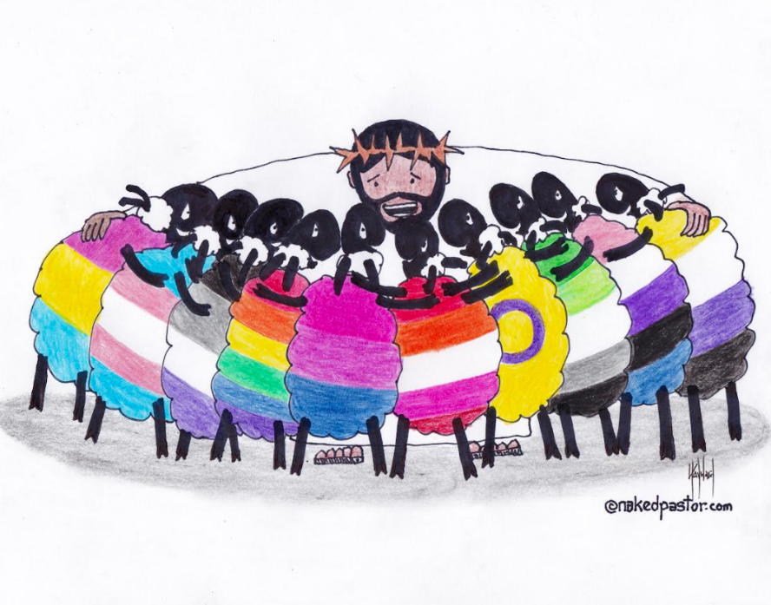

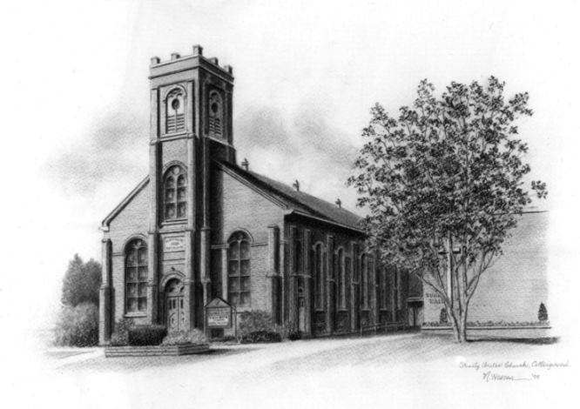

Trinity United .Church: Collingwood
Minister: Rev. Beth Kerr, 204.872.2370 (cell)
Minister’s Email minister@collingwoodunitedchurch.ca
Ministry of Music: Paul Sloan, 705.730.3121 (cell)
Choir Director: Lesley Joosten, 705.984.3243
Handbell Director: Maryellen Burgess, 705.443.1422 (cell)
UCW President: Joy Barr 705.445.0726
Office Assistant: Lori Forsythe
Church Office: office@collingwoodunitedchurch.ca
Office Hours: Tuesday to Friday, 8:30 am-12:00 pm
140 Maple Street, Collingwood, ON L9Y 2P8
Telephone: 705.445.3901
Website: www.collingwoodunitedchurch.ca

