City Road United Methodist Church
A Lighthouse Congregation

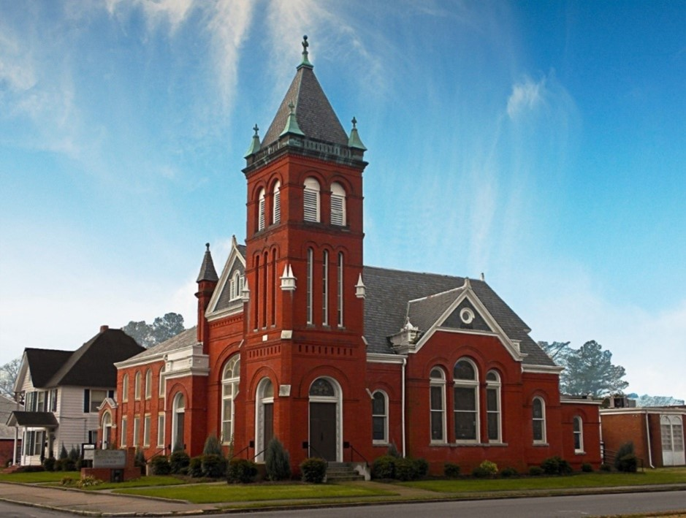
Rev. Tim Nicholson, Pastor

Office: (252) 335-2658
cityroadec.net crumcec@gmail.com

Facebook: https://www.facebook.com/CityRoadUMC

Sunday School: 10:00 a.m.
Sanctuary Worship: 11:00 a.m.

Tommy Venters- Organist/Choir Director
Dawn Baker- Secretary/Technology Specialist
JoAnn Herring- We Care

Service of Word & Table
Pentecost Season
July 12th, 2026 11:00 am
Gathering
Prelude
*Introit “Freely, Freely” UMH 389
Verse 1
Words of Welcome
*Call to Worship
God scatters the seeds of reconciliation and love, and waits….
So much of it lands on flat pathways or rocky roads and won’t take root….
God scatters the seeds of healing and hope, and waits….
Shallowness and fear claim the seeds and they cannot live.
God scatters the seeds of redemption and peace, and waits….
These are the places of deep growth where the seed will cast down strong roots.
Welcome this day to a seed-scattering station!
May our hearts be the rich soil in which God’s love takes root. AMEN.

*Hymn of Praise “Wonderful Words of Life” UMH 600

Pastoral Prayer

Proclamation & Response
Psalms 119:105-112

Children’s Time
Call to the Offering
Offertory
*Doxology UMH 95
*Prayer of Dedication

*Hymn of Preparation “Hymn of Promise” UMH 707

Anthem Chancel Choir

Scripture: Matthew 13:1-9; 18-23
Message: Pastor, Tim Nicholson

Invitation to Christ’s Table 7
Prayer of Confession 8
In the name of Jesus Christ, you are forgiven.
In the name of Jesus Christ, you are forgiven.
Glory to God, Amen!

Sharing Peace
The Peace be with you!
And also with you!

Holy Communion

Prayer of Great Thanksgiving 9
The Lord’s Prayer
*Receiving the Bread and Cup
*Apostles Creed UMH 881

Prayer after Communion

Sending Fourth
*Sending Hymn “Spirit Song” UMH 347
*Benediction “Freely, Freely” UMH 389
Verse 2
*Postlude

