Tuesday’s Table at First UMC
First United Methodist Church is looking for volunteers interested in helping with their Tuesday’s Table ministry. They serve approximately 220 to-go meals in our community every Tuesday. They would like some help on Monday or Tuesday mornings prepping the meals and then on Tuesdays late afternoon to serve the meals as they are picked up and then clean up the kitchen. If you’re interested in helping, please contact Teri Spengler-Andreas at
620-229-4306.

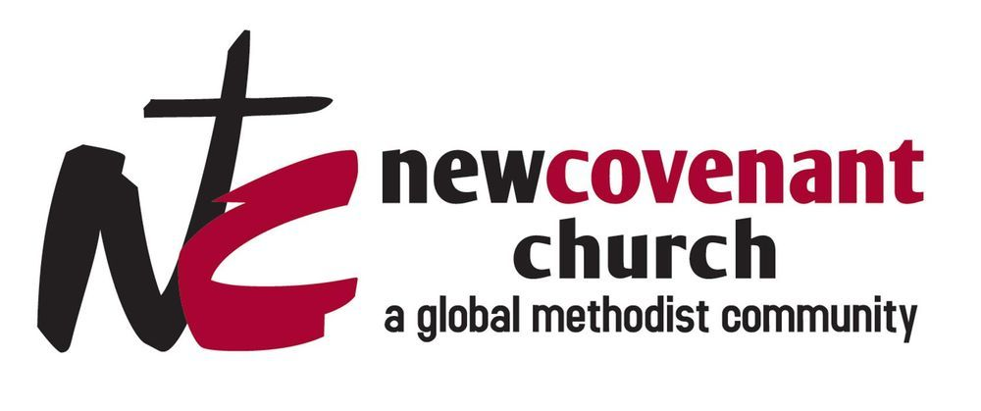

New Covenant Global Methodist Community and Life Support Center
The Heartland Conference of the GMC has a missional church right in our midst! It is located in the Delano District of Wichita. Pastor Cathy Holley has been pastoring at New Covenant Church for 19 years and her vision helped the church transition from a small storefront church to a thriving community outreach center to reach people challenged in life by addiction, poverty, and other brokenness. This is a new model of charity that is sustainable and transformative. Cathy will be here to give a presentation about New Covenant and the Life Support Center on Wednesday, July 8 at 6:30 pm in Apostles Hall. Desserts are needed for the evening. Please speak with Pastor Lisa to help. A free-will offering for the Life Support Center will be received.

ANNOUNCEMENTS
July 5, 2026

TODAY
9:30 a.m. – Morning Worship
10:30 a.m. – Fellowship Time
11:00 a.m. – Sunday School Classes
Noon - - - - Financial Review Committee

TUESDAY, July 6
9:00 a.m. – Women’s Coffee Fellowship at Oasis

WEDNESDAY, July 8
6:30 p.m. – Presentation about New Covenant Church

THURSDAY, July 9
6:00 p.m. – Prayer Hour
5:00 - 8:00 p.m. – Garage Sale in the Gym

FRIDAY, July 10
7:00 a.m. - Noon – Garage Sale

SATURDAY, July 11
7:00 a.m.-Noon - Garage Sale

SUNDAY, July 12
Noon - “Pig Out” Corn Feed Fundraiser
For the Van Fund

LOOKING AHEAD
July 13 – Chicken/Salad Lunch at 1st UMC
For House of Hope and Habit for Humanity
July 14 – Pack Up Garage Sale Leftovers
July 15 - Love Goes First Study
July 15 – Leadership Board

Mission for the Month of July

Sunflower Outreach Services – School Supplies

BIRTHDAYS

James Musler – July 7

Ava Eastman – July 8

Chad Eastman – July 8

Brian Buffum – July 9

Adam Barrier – July 11

ANNIVERSARIES

Roger and Icel Meyer – July 7


July 6 – Luke 10:38-42, Luke 12:1-34

July 7 – Numbers 35

July 8 – Numbers 36, Deuteronomy 1:1-18

July 9 – Deuteronomy 1:19-46, Deuteronomy 2:1-23

July 10 – Deuteronomy 2:24-37, Deuteronomy 3

July 11 – Deuteronomy 4:1-40

July 12 – Luke 12:35-59, Luke 13:1-9


2 Chronicles 7:14

If my people, who are called by my name, will humble

themselves and pray and seek my face and turn from

their wicked ways, then I will hear from heaven, and I

will forgive their sin and will heal their land.

Financial Information – FYI
Tisdale Church 2026 Budget: $209, 261.00
Needed Monthly to Meet Budget: $17,438.92
Total Giving in June: $17,626.75
Mission of the Month – Brothers in Blue: $2,715.00


February - Fashion Accessories
March – Personal Care Items
April – Small Toys
May - Stuffed Animals
June - “WOW” Items

Our Operation Christmas Child collection for
July is Clothes/Shoes
Boys or Girls
General sizes that fit ages 2-4, 5-9, 10-14
Shirts, leggings, socks, shoes & sandals, dresses
(No wearable camo)
Remember, they must fit in a shoebox with other items.

TISDALE CHURCH GARAGE SALE
Thursday July 9 – 5:00-8:00 p.m.
Friday/Saturday July 10 -11 – 7:00 a.m. -Noon
Now accepting donations.
Please remember, ALL items you bring must be:
CLEAN, CLEAN, CLEAN
In good working order (not broken or torn)
(Tables are marked with signs to help you know where to place
your items.)

July 26 has been designated as NEW MEMBER
SUNDAY. If anyone has an interest in joining the church
at that time, please see Pastor Lisa.

