TLC Weekly: Sunday, July 12 – July 19
Vicar Angie DeSmith cell: 507-828-4941 email: amgiedesmith316@gmail.com
The Radio Broadcast (KMHL 1400AM or 101.7FM) is sponsored anonymously.
Sunday, July 12 9am Worship
Food Shelf Sunday
10am Coffee Fellowship
Monday, July 13 9am Men in Mission
6:30pm Church Council
Wednesday, July 15 9am Do Day Mission Work Day
Friday, July17 OFFICE CLOSED
Sunday, July 19 9am Worship/Communion
10am Coffee Fellowship

Please continue to Remember in Prayer:
Please…
We are happy to include people in our prayer list, but we must have their permission to be included. Many folks are very private about what is happening in their lives and we want to honor that.
Peggy Isaacson – LaVerne Jessen’s daughter, cancer
Steve Vickerman – health issues
Kim Mickelson – cancer-cousin of Kari Meyer & Kris Tiegs
Vicki Schaar – Cancer
Lawrence Nyquist – Cancer, starting treatments, uncle of Dan &
Carl Nyquist
Mike Hemish – son of Doris Hemish
Mary Christian – fell, fracture of L2 (back)
Cora Ourada – Cancer – granddaughter of David & Linda Rykhus
Judy Hagen – friend of John & Muriel Coulter
Dan Nyquist – recurring foot problems

July Acolytes: Otto Nyquist, Vincent Munson

July Altar Preparation: Carolyn Engelkes, Karen Krog

July Communion Servers: Sandy Fultz, Darcy Carlson, Eric Fultz

Coffee Fellowship: Sunday, July 12 Don & Eileen Stanek
Sunday, July 19 Tom & Vicki Streifel

Scripture Readers: Sunday, July 12 Kim Torkelson
Sunday, July 19 OPEN

Greeters: Sunday, July 12 Keith & Pam Peterson
Sunday, July 19 Denny & Anita Fultz

Sunday Counters: Sunday, July 12 Darci Anderson
Sunday, July 19 Kari Meyer

Ushers: Sunday, July 12 Bruce Lerohl, Greg Carlson, Tom Streifel, Matt Loftness
Sunday, July 19 Dennis Fultz, Chad Anderson, Jim Christian
English Lutheran Church, Walnut Grove. Quilt Show 11am-5pm July 11th, 18th, & 25th. Free Will donation. Check the kiosk for further details.
There is a sign up sheet in the office for volunteers to help with the service at Painted Prairie Vineyard, August 16th, 10am worship service. If you are able please stop in the office. Looking for a reader for the Psalm, 1 or 2 worship assistances to either usher or help serve communion and two (2) pans of bars. Stop in the office to sign up. Check the kiosk for information on the Painted Prairie Vineyard Ecumenical church service August 16th.
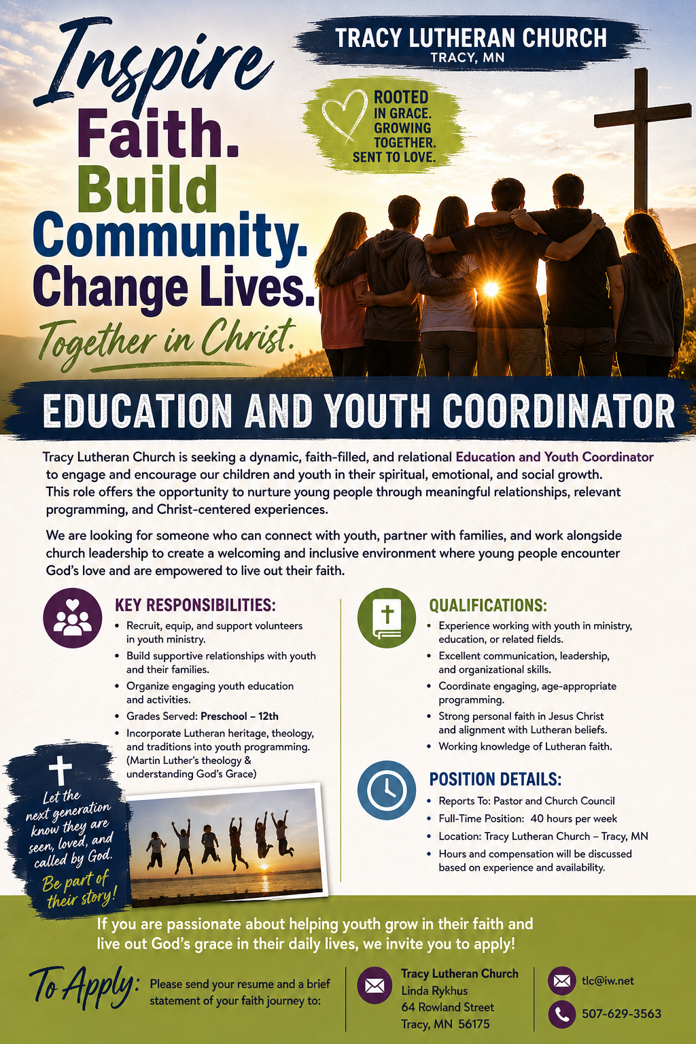
At the request of council president, Dennis Fultz, Tracy Lutheran Church is recognized as a Synod -Authorized Ministry site. Angie DeSmith has been authorized by Southwestern Minnesota Synod Bishop Dee Pederson to preach and preside for
Holy Communion in the congregation . The authorization is granted in accord with the ELCA’s guiding statement, The Use of the Means of Grace , which recognizes the witness of the sacrament as a celebration of the Church, serving its unity and
proclaiming the Gospel; and that where it is not possible to provide ordained pastoral leadership, a synod bishop may authorize a properly trained person to preside at a certain time.

