
THE ANGLICAN PARISH OF ST. MARK
138 Hoylake Road, Qualicum Beach, BC V9K 1K3
Celebrant: The Rev. Susan Hermanson
The Rev. Helen Lingham, Deacon
Sixth Sunday after Pentecost, 10:00 am, July 5, 2026
HOLY EUCHARIST — Book of Common Prayer
In a state of openness, and with a desire to learn the truth of our shared history, we acknowledge that we worship on the unceded territory of the Qualicum First Nation. We give thanks for their careful stewardship of the forests, rivers, oceans, lands and air, so that we might walk with them and celebrate the gift of the Creator. We commit to a lifelong journey of respectful understanding.

Welcome & Announcements
Call to Worship.
Processional Hymn: CP #167 — “’Tis Good, Lord, to be Here”
The service begins with the COLLECT for Purity page 67
ALMIGHTY God, unto whom all hearts be open, it all desires known, and from whom no secrets are hid: Cleanse the thoughts of our hearts by the inspiration of thy Holy Spirit, that we may perfectly love thee, and worthily magnify thy holy Name; through Christ our Lord. Amen.
Priest: Two Great Commandments of the Law page 69
People: Lord, have mercy upon us, and write both these thy laws in our hearts, we beseech thee (CP #677)
Kyrie (sung): Lord, have mercy upon us.
Christ, have mercy upon us.
Lord, have mercy upon us.
Priest : The Lord be with you;
People: And with thy spirit.
Priest: Let us pray.
The Collect
Grant, O Lord, we beseech thee, that the course of this world may be so peaceably ordered by thy governance, that the Church may joyfully serve thee in all godly quietness; through Jesus Christ our Lord. Amen.

First Lesson - Genesis 24: 34 - 38; 42 - 49; 58 - 67
Psalm 45: 10 - 17 (read responsively at the half-verse) page 387
Second Lesson: Romans 7: 15 - 25a
Gradual Hymn: CP #447-“Lord, We Hear Your Word With Gladness” (vv. 1 & 2)
The Gospel: Matthew 11: 16 - 19; 25- 30
Before the Gospel: Glory be to thee, O Lord
After the Gospel: Praise be to thee, O Christ
Gradual Hymn: CP #447 – “Lord, We Hear Your Word With Gladness” (v. 3)
The Nicene Creed (Said together) page 71
Sermon: The Rev. Susan Hermanson
Offertory sentence: Offer unto God the sacrifice of thanksgiving, and pay thy vows unto the Most High.
Offertory Hymn: CP #354 - “Come Thou Fount of Every Blessing”
Blessed be thou, LORD God of Israel, for ever and ever. All that is in the heaven and in the earth is thine. All things come of thee, and of thine own have we given thee.
Intercessions: page 75
Invitation to Confession: page 76
Confession (Said together) page 77
Absolution
Comfortable Words
Thanksgiving and Consecration page 78
Sanctus and Benedictus (Sung CP #683) page 79
Eucharistic Prayer page 82
The Peace
Priest: The peace of the Lord be always with you;
People. And with thy spirit.
Prayer of Humble Access page 83

Agnus Dei (Sung CP #685) page 84
O Lamb of God, that takest away the sin of the world, have mercy upon us.
O Lamb of God, that takest away the sin of the world, have mercy upon us.
O Lamb of God, that takest away the sin of the world, grant us thy peace.
The Communion

Our Prayer Ministry
Our healing prayer team invites you to join them to pray or give thanks to God in the narthex (entrance) during or after communion, or in the alcove under the Exit sign after the service. Confidentiality is assured.

The Lord’s Prayer page 85
Gloria (Sung CP #679) - Please stand page 86
The Blessing:
Recessional Hymn: CP #425 “Joyful, Joyful, We Adore Thee”
Dismissal
ALTAR FLOWERS
The flowers are given by Pamela and Graham Brown to the glory of God and in memory of our beloved son, Pipe Major Thomas Brown.

EMERGENCY CONTACTS FOR PASTORAL CARE
Morag Atherstone: 250-240-6731
Cynthia Preyser: 250-954-9122
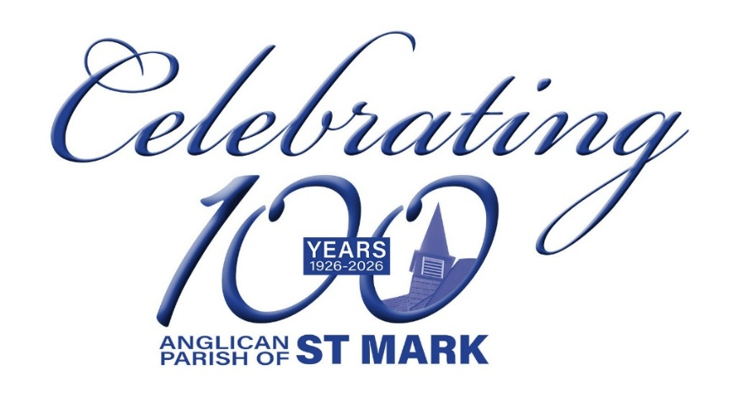

Service Schedule
Date | Time | Service
Wed July 8 | 11:30 am | BCP Morning Prayer
Sun July 12 | 8:30 am | BCP Morning Prayer
 | 10:00 am | BAS Service of the Word
Wed July 15 | 11:30 am | BAS Morning Prayer
Sun July 19 | 8:30 am | BCP Holy Eucharist
 | 10:00 am | BAS Holy Eucharist
Wed July 22 | 11:30 am | BCP Morning Prayer
Sun July 26 | 8:30 am | BCP Morning Prayer
 | 10:00 am | BAS Service of the Word
Wed July 29 | 11:30 am | BAS Morning Prayer
Sun Aug 2 | 8:30 am | BCP Holy Eucharist
 | 10:00 am | BCP Holy Eucharist

CALENDAR: July 6 – July 12

Tuesday, July 7
9:15 – 11:00 am — Men’s Study Group
9:00 am – 3:00 pm — Seaside Quilters

Wednesday, July 8
11:30 am – 12:00 pm — Morning Prayer
5:30 pm — NAC (downstairs)

Thursday, July 9
9:00 am – 9:00 pm — Parksville Quilt House

Friday, July 10
9:00 am – 9:00 pm — Parksville Quilt House
4:00 pm — Manna preparation

Sunday, July 12
8:30 am — BCP — Holy Eucharist
10:00 am — BAS — Service of the Word

