Colington United Methodist Church
We are a Lighthouse Congregation, committed to offering safety and stability to United Methodists who have been displaced or wounded through disaffiliation.

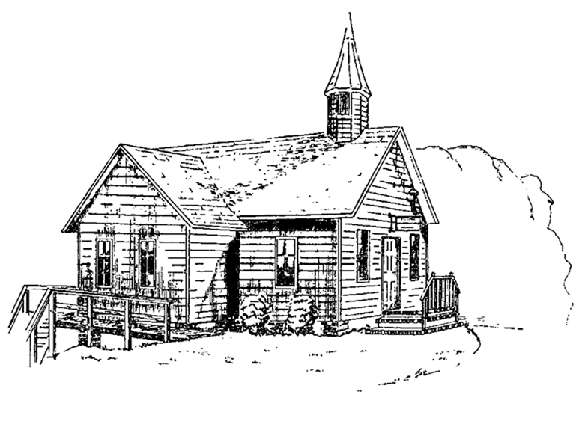

July 5, 2026
Sixth Sunday after Pentecost

welcome and announcements
call to worship
prelude and lighting of altar candles
The Old Rugged Cross Medley
opening prayer
Our heavenly Father, we your humble children invoke your blessing on us. We adore you, whose name is love, whose nature is compassion, whose presence is joy, whose Word is truth, whose Spirit is goodness, whose holiness is beauty, whose will is peace, whose service is perfect freedom, and in knowledge of whom stands our eternal life. Unto you be
all honor and glory; through Jesus Christ our Lord. Amen.
introit
Holy Ground
litany of praise
Let us praise God:
For the day, for the glory and warmth of the sun, for the stir of life, and for honest toil that wins food and rest;
God be praised for the day.
For the earth, the sustainer of life; for the hills, the plains, and the valleys; for the beauty of meadows and fields, of flowers and of trees;
God be praised for the earth.
For the sky, for the shifting clouds, and for the glory of sunrise and sunset;
God be praised for the sky.
For the sea, that yields and receives again the water without which life would die, and is wonderful in its stillness and more wonderful in its storm;
God be praised for the sea.
For our food, and the pleasures God has given us in it, lest we should neglect the needs of life; may God help us to shun all waste and to rejoice in sharing with others;
God be praised for our food.
For the shelter from wind and weather, which hallowed by love becomes our home; may the Lord strengthen our will that no one shall go hungry or ill-housed or ill-clad;
God be praised for our home.
Let us praise God in whom we live and move and have our being.
All praise be to God. Amen.
†opening hymn
God of the Ages ǀ UMH 698
prayer for our country ǀ UMH 429
the prayers of the people
the first lesson
Psalm 56
anthem
If My People
the second lesson
2 Samuel 2:1-11; 3:1
sermon
“Human and Divine” ǀ Rev. Jack Colenda
silent reflection
†affirmation of praise
Let There Be Peace on Earth ǀ UMH 431
confession and pardon
O holy and merciful God, we confess that we have not always taken upon ourselves the yoke of obedience, nor been willing to seek and to do your perfect will. We have not loved you with all our heart and mind and soul and strength, neither have we loved our neighbors as ourselves. You have called us in the need of our sisters and brothers, and we have passed unheeding on our way. In the pride of our hearts, and our unwillingness to repent, we have turned away from the cross of Christ,
and have grieved your Holy Spirit.
In the name of Jesus Christ, we are a forgiven people. Glory to God!
Alleluia! Amen.
doxology
Praise God, from Whom All Blessings Flow ǀ UMH 94
the great thanksgiving ǀ UMH 13
†closing hymn
This Is My Song ǀ UMH 437

†benediction

this week at colington
These opportunities to serve as the Body of Christ are available.
Tuesday – 9 am – Prayer Group
6:15pm – Beach fellowship.
Wednesday – 10am – Knitters and crocheters meet.
Thursday – 4pm – Mobile food pantry at FFES.

coming up
Next Sunday – 8:30am – choir practice
9:30 am – Worship, in-person and Facebook Live and YouTube.
Sat., July 18 – 9am - Men’s ministry breakfast meeting.
10:10am – Worship service at Spring Arbor Memory Care Unit. All are welcome to attend.
Wed., July 22 – 10am – Knitters and crocheters meet.
1:46pm – Volunteers to Beach Food Pantry.

Thanks to today’s volunteers!
Ushers – Steve Knowles / Ozzie Gray
Scripture Reader – Temple Heggie
Communion Assistant – Jo Briggs

The flowers on the altar are given by Becky Wamsley Blalock in memory of her Mom, Jean Wamsley.

Last week’s attendance – 86.

