TLC Weekly: Sunday, July 5 – July 12
Vicar Angie DeSmith cell: 507-828-4941 email: amgiedesmith316@gmail.com
The Radio Broadcast (KMHL 1400AM or 101.7FM) is sponsored in memory of Don Engelkes by Carolyn Engelkes and family.
Sunday, July 5 9am Worship/Holy Communion
10am Coffee Fellowship
Monday, July 6 9am Men in Mission
Wednesday, July 8 9am Do Day Mission Work Day
1:30pm Glory Circle/C Fales home
Friday, July10 OFFICE CLOSED
Sunday, July 12 9am Worship
Food Shelf Sunday
10am Coffee Fellowship

Please continue to Remember in Prayer:
Please…
We are happy to include people in our prayer list, but we must have their permission to be included. Many folks are very private about what is happening in their lives and we want to honor that.
Peggy Isaacson – LaVerne Jessen’s daughter, cancer
Steve Vickerman – health issues
Kim Mickelson – cancer-cousin of Kari Meyer & Kris Tiegs
Vicki Schaar – Cancer
Lawrence Nyquist – Cancer, starting treatments, uncle of Dan &
Carl Nyquist
Mike Hemish – son of Doris Hemish
Mary Christian – fell, fracture of L2 (back)
Cora Ourada – stomach mass – granddaughter of David & Linda Rykhus
Judy Hagen – friend of John & Muriel Coulter

July Acolytes: Otto Nyquist, Vincent Munson

July Altar Preparation: Carolyn Engelkes, Karen Krog

July Communion Servers: Sandy Fultz, Darcy Carlson, Eric Fultz

Coffee Fellowship: Sunday, July 5 Marge Ostgaard
Sunday, July 12 OPEN

Scripture Readers: Sunday, July 5 Swede Campbell
Sunday, July 12 Kim Torkelson

Greeters: Sunday, July 5 OPEN
Sunday, July 12 Keith & Pam Peterson

Sunday Counters: Sunday, July 5 Melody Caron
Sunday, July 12 Darci Anderson

Ushers: Sunday, July 5 Mark Peterson ,Jim Julien, Mike Carlson, Larry Retzlaff
Sunday, July 12 Bruce Lerohl, Greg Carlson, Tom Streifel, Matt Loftness
Tracy Area Garden and Quilt Tour is July 8th, 2-7:30pm. Tickets $20 includes St Mary’s Pie and ice cream served at Key Largo. Check the kiosk for further details.
Help Tuck Them In! July 9, 6:30pm social hour 7:30pm premier of their new documentary at the Caboose. There will be Burger Bar, hors d’oeuvers and lemonade. Check the kiosk for further details.
English Lutheran Church, Walnut Grove. Quilt Show 11am-5pm July 11th, 18th, & 25th. Free Will donation. Check the kiosk for further details.
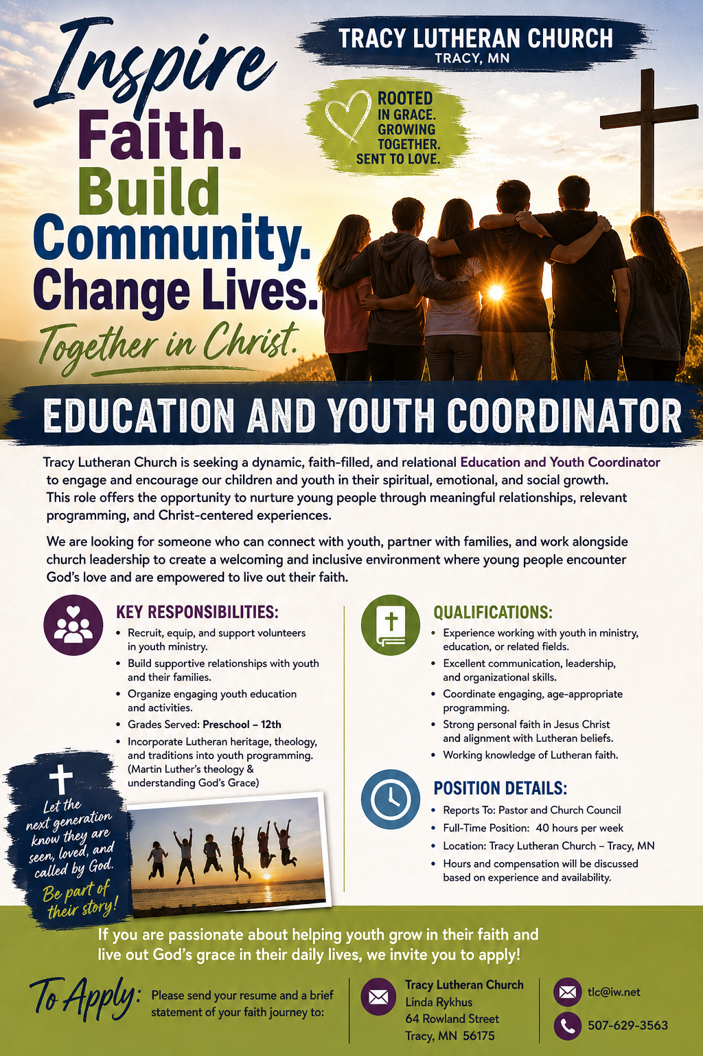
At the request of council president, Dennis Fultz, Tracy Lutheran Church is recognized as a Synod -Authorized Ministry site. Angie DeSmith has been authorized by Southwestern Minnesota Synod Bishop Dee Pederson to preach and preside for
Holy Communion in the congregation . The authorization is granted in accord with the ELCA’s guiding statement, The Use of the Means of Grace , which recognizes the witness of the sacrament as a celebration of the Church, serving its unity and
proclaiming the Gospel; and that where it is not possible to provide ordained pastoral leadership, a synod bishop may authorize a properly trained person to preside at a certain time.

