City Road United Methodist Church
A Lighthouse Congregation

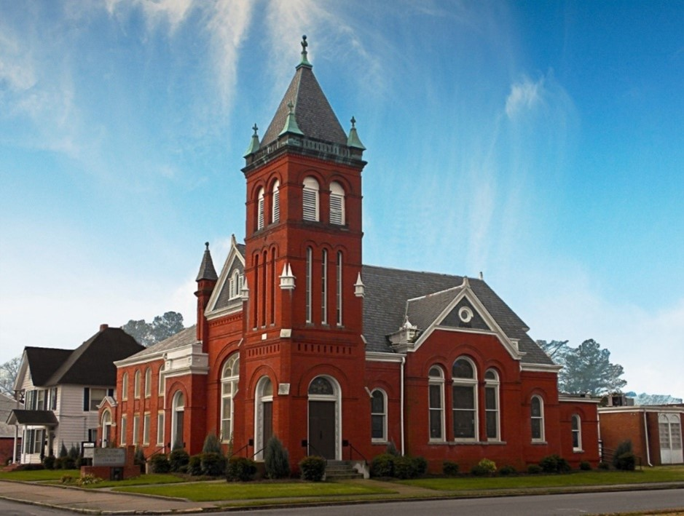
Rev. Tim Nicholson, Pastor

Office: (252) 335-2658
cityroadec.net crumcec@gmail.com

Facebook: https://www.facebook.com/CityRoadUMC

Sunday School: 10:00 a.m.
Sanctuary Worship: 11:00 a.m.

Tommy Venters- Organist/Choir Director
Dawn Baker- Secretary/Technology Specialist
JoAnn Herring- We Care

Service of Word
Pentecost Season
July 5th, 2026 11:00 am
Gathering
Prelude
*Introit “America the Beautiful” UMH 696
Verse 1
Words of Welcome
*Call to Worship
We gather to worship God with our full, imperfect selves.
We come to delight in the law of God, who is Love.
We gather as people who don’t always know what to do in the face of difficult and complex circumstances.
We come to delight in the law of God, who is Love.
We gather as people who desire to follow God with our actions but struggle to connect what we want to do with what we actually do.
We come to delight in the law of God, who is Love.
Whether you come to worship today wondering if there is anything good left in the world or rejoicing in the small moments of goodness that remind you grace is still at work among us, you are welcome here.
We come to delight in the law of God, whose grace shows us how to live, work, play, and rest as a community of faith woven together by Love. Amen.
Written by Dr. Lisa Hancock, Discipleship Ministries, January 2026.

*Sharing Peace
The Peace be with you!
And also with you!

*Hymn of Praise “To God be the Glory” UMH 98

Proclamation & Response
Pastoral Prayer
The Lord’s Prayer
Our Father who art in heaven, hallowed be thy name. Thy kingdom come; thy will be done on earth as it is in heaven. Give us this day our daily bread, and forgive us our trespasses, as we forgive those who trespass against us; and lead us not into temptation but deliver us from evil. For thine is the kingdom, and power, and glory forever. Amen

Children’s Time
Call to the Offering
Offertory
*Doxology UMH 95
*Prayer of Dedication

*Hymn of Preparation “Thy Word is a Lamp” UMH 601

Anthem Chancel Choir

Scripture: Matthew 11: 16-19, 25-30
Message “Let’s be Independent Together” Tom Santa, Moyock UMC

Sending Fourth
*Sending Hymn “Sent Forth by God’s Blessing” UMH 664

*Benediction “America the Beautiful UMH 696
Verse 3
*Postlude

