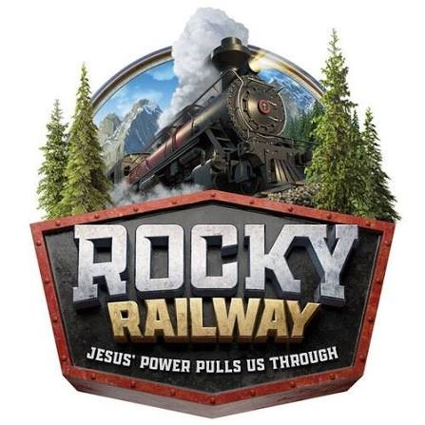
ALL ABOARD!
ROCKY RAILWAY VACATION BIBLE SCHOOL IS COMING TO BLANCHARDVILLE!
New Hope Lutheran is hosting Vacation Bible School (VBS).
This year’s theme is discovering how to trust Jesus’ power through life’s ups and downs.
WHO: All children entering K - 6th grade
WHAT: VBS
WHEN: Saturday August 1, 2026
WHERE: New Hope Lutheran Church
305 Madison Street, Blanchardville
TIME: 9:00am - 2:00pm


Open to the Community – No Charge
Register here by July 26

