EAST FAIRFIELD UNITED METHODIST CHURCH
Pastor: Kristen Buchs
Organist: Ruth Rowley Ministers: The Congregation
Pianist: Nancy Setinsek Choir Director: Randy Hart
Sunday, July 5, 2026
Sixth Sunday after Pentecost

*Please stand in body or spirit as you are able

Welcome! We invite you to take this time to prepare for worship. In these
moments, quiet your inner voice, become aware of being in community with
others, and open your heart and mind to the leading of the Holy Spirit.

GATHERING

CHRIST LIGHT ENTERS

MISSIONS AND MINISTRY UPDATEs Jon Vollnogle, Liturgist

PREPARING OUR HEARTS AND MINDS FOR WORSHIP

WORDS OF PREPARATION AND CENTERING

PRELUDE

*CALL TO WORSHIP

Welcome this day to a time of rest.
We come, bearing burdens and cares.
Place your lives in the loving hands of God.
May God heal our spirits and strengthen us.
Trust in God who is always with you.
Lord, this day we come to You in faith and trust for
Your healing mercies.

*OPENING PRAYER
Almighty God, like an oasis in the desert, worship satisfies our sin-besieged souls. Today, help us find the good in this life
by delighting in Your presence, and help us find the hope
You have placed in our innermost selves.

For in the adventure of life, by Your powerful grace, we are so blessed that You have found us. As we proclaim Your mighty deeds, we celebrate Your justice, mercy, and love. Amen.

*OPENING HYMN “America the Beautiful” UMH #696

READING FROM THE PSALMS Psalm 45:10-17 (NIV) Page 454

CHILDREN’S MOMENT
OFFERING OURSELVES & OUR GIFTS
INVITATION
OFFERTORY
*DOXOLOGY UMH #95
*DEDICATION OF GIFTS

SEEKING GOD’S WORD

OLD TESTAMENT READING Genesis 25:19-34 (NIV) Page 19

SHARING OF JOYS & CONCERNS
SILENT PRAYER
PASTORAL PRAYER
THE LORD’S PRAYER

*HYMN “O God, Our Help in Ages Past” UMH #117

SERMON TEXT Ecclesiastes 3:1-15 (NIV)

SERMON “This is Our Time” Pastor Kristen
Prayer of Dedication

RESPONDING TO GOD’S WORD

SACRAMENT OF HOLY COMMUNION UMH pg 12

COMMUNION PRAYER
Eternal God, we give you thanks for this holy mystery in which you have given yourself to us. Grant that we may go into the world in the strength of your Spirit, to give ourselves for others, in the name of Jesus Christ our Lord. Amen.

*CLOSING HYMN “My Country Tis of Thee ” UMH #697

SENDING FORTH WITH BLESSING
*BLESSING
LIGHT OF CHRIST GOES INTO THE WORLD
~ Go with joy to serve the Lord ~

As we conclude our service, please join us downstairs for a time to relax, continue conversations, and enjoy coffee and refreshments.

The flowers on the altar are in honor of the beginning of
Pastor Kristen’s ministry to our congregation.

Sound: Bill Rowley
Computer: Vicki Freeman
Livestream: Hannah Vollnogle

Next Sunday: David Vollnogle, Liturgist
Please keep in mind that the service is live-streamed and
recorded for public access. Please keep prayer requests
brief and do not use last names or identifying details.

PRAYER REQUESTS JULY 5, 2026
To submit a prayer request call Denise at 330-457-2465 or 330-727-9832
If you desire a home or hospital visit call Pastor Kristen (216-559-9893)
Prayer Blankets: call Joyce Ward (330-692-3346)

Jim B – now at home under hospice care.
Becky R – cataract surgery July 1 and July 15.
Nate (Jim & JoAnne’s son-in-law) – improving. still needs prayers.
Linda W – having heart ablation Thursday, July 2 at Cleveland Clinic.
Lee & Joann (Matt Stevens’ parents) car accident. multiple broken bones.
Steph (Missy Fieldhouse’s sister) – brain surgery July 1 at Cleveland Clinic.
Barry (Kay’s son) – high blood pressure and blood clots.
Mike (Kay) – liver biopsy.
Drive-by-Shooting in East Palestine this morning. Pray for protection.

Mike Wylie (Sparky) – passed away June 19.
Bob & his sister, Karen (Sparky) - both have cancer.
Cindy W - seeing a chiropractor for neuropathy. Pray for good results.

Georgia Farmer – passed away June 16. Keep Denny in your prayers.
Bob Smith - passed away June 8. Keep Kathleen in your prayers.
Ron Chamberlin – passed away June 3. Keep Sally in your prayers.

HOMEBOUND
Dolly K. Bill & Barb H. Anita M.
Tom & Marie Linda S. Walt D. (Christian House)
Dorothy F. Esther C. Zelda C. (Whispering Pines)

IN MINISTRY
Kristen Buchs Edie Boles Jeff Pellin

Ch Ph: 330-457-2465 Pastor: 216-559-9893
Ch Email:efumc@comcast.net Pastor Email: pastorkristen0712@gmail.com
Website: www.eastfairfieldumc.com
CCLI # 1994841 CVLI #504 011 134


East Fairfield
United Methodist Church

July 5, 2026
9:30 AM

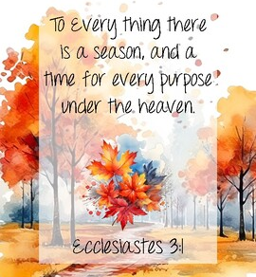

Pastor Kristen Buchs
216-559-9893
45675 State Route 558
New Waterford, OH 44445

“Working, playing, and praying together on our
faith journey, to share Jesus Christ with everyone.”

Sun | Mon | Tue | Wed | Thu | Fri | Sat
July 5  COMMUNION  9:30 Worship  10:30 Coffee  10:45 Sunday  School  12:30  WELCOME PICNIC FOR PASTOR KRISTEN | July 6 | July 7  8:00 Men’s  Coffee at  Larrys pavilion | July 8 | July 9 | July 10  Pastor’s Day Off  Office Closed | July 11  Pastor Kristen on vacation July 9 - 13
July 12  9:30 Worship  - Edie Boles  10:30 Coffee  10:45 Sunday  School | July 13  Pastor Kristen on vacation July 9 - 13 | July 14  8:00 Men’s  Coffee at  Larrys pavilion  Ladies’ Day | July 15 | July 16 | July 17  Pastor’s Day Off  Office Closed | July 18
July 19  9:30 Worship  10:30 Coffee  10:45 Sunday  School | July 20  12:00 JOY CIRCLE PICNIC in the Pavilion  7:00  Leadership  Board | July 21  8:00 Men’s  Coffee at  Larrys pavilion | July 22 | July 23 | July 24  Pastor’s Day Off  Office Closed | July 25  8:30-10  Caring for  God’s  Lambs at  Trinity UM
July 26  9:30 Worship  10:30 Coffee  10:45 Sunday  School | July 27 | July 28  8:00 Men’s  Coffee at  Larrys pavilion | July 29 | July 30 | July 31  Pastor’s Day Off  Office Closed

LAST WEEK’S ATTENDANCE (June 28)
In-Person: 62 Online: 24

Mission of the Month
Fund # 2 – General Mission Fund

4C’s Item
Ramen Noodles

Joy Circle Picnic
Monday, July 20 at 12:00 noon

The Joy Circle will meet for lunch on July 20 at 12:00 noon at the church pavilion. The Men’s Coffee Group is invited to join the
Joy Circle for their annual summer picnic. Sandwiches, beverages, and table service will be provided.
Ladies, please bring a covered-dish to share.

(In case of inclement weather, we will meet in the Fellowship Hall.)

Lay Servant Ministry Fall Classes
Sat., Nov. 14, 8:00 am – 5 pm, at Western Reserve UMC. $35
Pick up a flyer on the small stand in the foyer.

Church History Book

Plans are underway to write a history book of our church. Anyone with pictures, writings, stories, or information of any kind that pertain to our church (from the very beginning to now)
please see Kay Crook, Joyce Ward, or Randy Hart.

Update on Mission Giving for 2026
FUND | NAME OF FUND | NEED | RECEIVED | STILL NEED
2 | General Mission Fund | 5,099 | 4,122 | 977
33 | 4C’s | 125 | 675 | 0
32 | Cub Scouts | 150 | 405 | 0
37 | Way Station | 150 | 160 | 0
22 | Flat Rock | 175 | 265 | 0
64 | Farmer to Farmer – Liberia | 300 | 285 | 15
13 | UMCOR Sunday | Any  Donation | 75
21 | UMCOR – U.S. Disasters | Any  Donation | 5
14 | Blanket Sunday | Any  Donation | 65
15 | Peace With Justice | Any  Donation | 0
16 | World Communion | Any  Donation | 0
17 | Student Day | Any  Donation | 0
46 | Heroes & Halos | Any  Donation | 100
63 | InStep Program | Any  Donation | 30
38 | Operation Christmas Child Shoeboxes |  | 118 plus 90

Fund Balances as of end of MAY
Fund # 1 Ministry Operating - 8,379
Fund # 2 Mission Fund 2,887
Fund # 3 Building Fund 62,350
Fund # 28 Elevator Fund 7,964

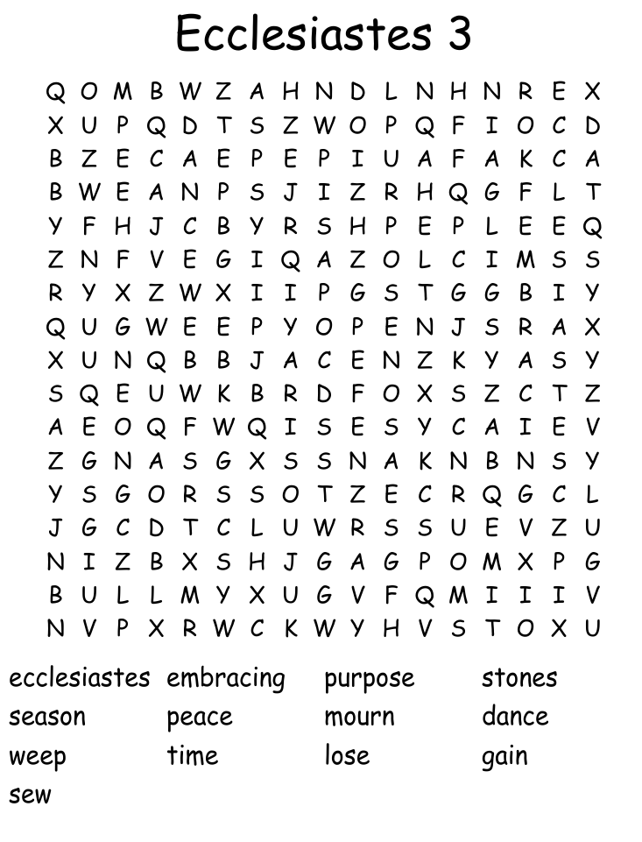

(from WordMint)
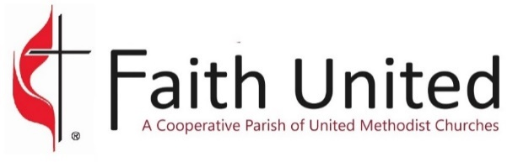
07-05-26
UPCOMING EVENTS

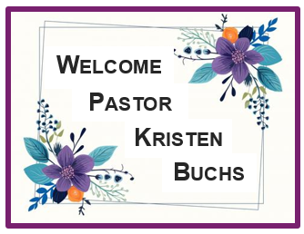

Welcome Picnic TODAY !!!
Sunday, July 5
at 12:30 PM

You are invited to help us welcome Pastor Kristen to our
church family on Sunday, July 5 at 12:30 pm at East Fairfield UMC.
Hot dogs, cheesy potatoes, drinks, and tableware are provided.
Please bring a covered dish or dessert to share.

We will gather for lunch outside in the pavilion.
(In case of inclement weather, this will be in the fellowship hall.)

Caring for God’s Lambs Food Pantry
Saturday, July 25 from
8:30 - 10:00 AM
at Trinity UMC

Pastor Kristen Buchs
pastorkristen0712@gmail.com
216-559-9893

Pastor Edie Boles Pastor Jeff Pellin
boles19@comcast.net jpellin86@yahoo.com
330-429-0699 330-953-8797

The purpose of Faith United is to grow spiritually,
learn and love together, and to lead others to Christ.

