

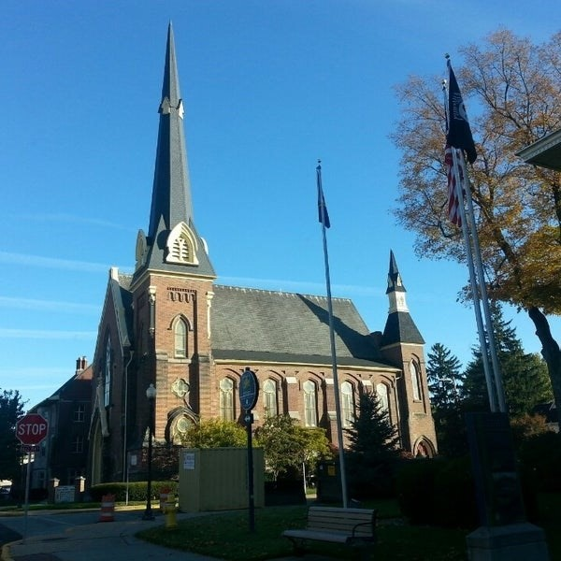
June 10, 2026

A Global Methodist Church
214 S. 5th Street
Goshen, IN 46528
Phone: 574-533-9518
Web Site: goshenfirstgmc.org

Office Hours: Monday-Friday,
8:00 a.m.-12:00 noon
Worship: 9:00 a.m.
Sunday School: 10:30 a.m.
Pastor Jeff & Lisa
Associate Pastor Rich Hull
OUR VISION: “Growing in Faith, Gathering in Community, and Giving in Love”.

Pastor Jeff is leading a Bible Study on Tuesday mornings at 10:00 a.m. and Wednesday evenings at 6:00 p.m. They are studying the book, “Prevailing in the Battle Zone,” by Dr. Rob McCorkle. All are welcome.

On June 23, from 10:00 a.m.-4:00 p.m., our church is doing a local mission project at the homeless shelter, First Light Mission, formerly known as Goshen Interfaith Hospitality. This will involve doing a choice of tasks: sorting clothing and baby things, painting, and yard work. People will sign up for 2-hour shifts selecting their preferred tasks. You may sign up in the gym during Coffee Hour.


On Wednesday, June 17, the Primetimers will go to Blue Gate Theatre to watch a musical about America’s 250th Celebration. Tickets are $20. Lunch will be beforehand. Everyone should meet at the Life Center at 10:00 a.m. The bus will be going. Pay for your tickets in the gym on Sunday during Coffee Hour.

COMING UP!
Vacation Bible School will be held at our church on August 3-6, from 9:00-11:00 a.m. Tell your friends and neighbors!

We are trying a new schedule for Coffee Hour. The Sunday School classes will take turns providing refreshments for Coffee Hour. They will do it for a month at a time. We will remind you when it is time for your class to serve.

VOLUNTEERS – Thank you for your service! Sunday morning, June 14
Greeters: Bob & Donna Shirk VIP: Max Leatherman
Elevator Hosts: Ted & Shirley Fairfield
Ushers: Randy Cripe,Pam Lichty, Dan Seltenright, Mateo Tenorio, Williston Tenorio
Scripture Reader: Ann Stutsman
Elementary Junior Church: Lori Warner, Kelley Leeper
Junior High Church: Jeanne Bigler
Coffee Hour: Faith Weaver’s S.S. Class
Bus Driver: Al Eppert


OUR MISSION OF THE MONTH
Bashor Children’s Home is our Mission of the Month for June. Bashor Children’s Home is a non-profit social services organization in Elkhart County, Indiana, affiliated with the United Methodist Church. They provide residential care, day treatment, and family support for troubled children and their families, including specialized programs for substance abuse, trauma, and sex trafficking victims, operating as the Youth Services for the county.

LAST SUNDAY
Attendance: 117
Offering: $9,125.50

