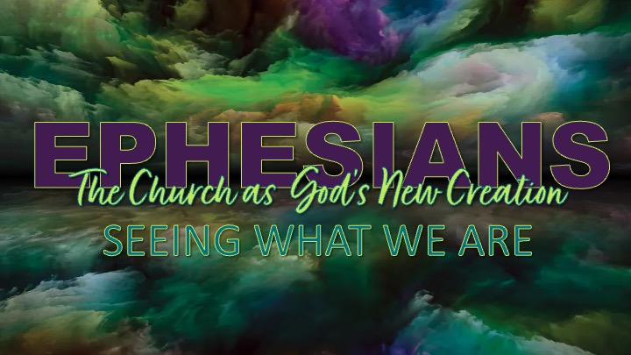
Discussion Questions & Practice

- What is something in your life right now that you may be "looking at" so intently that you are missing what God is doing right in front of you?

(Connects with the gorilla illustration and the idea of spiritual sight.)

- Paul prays that the eyes of our hearts would be enlightened. What is the difference between knowing something about God and truly seeing it in a way that changes your life?

- Which of these realities do you most need to see more clearly right now?
- The hope of your calling
- The beauty of being God's treasured people
- The greatness of God's power
- The supremacy of King Jesus

Why?

- If our church truly saw itself as God's treasured inheritance and Christ's body, what might change in the way we love one another and serve our community?

Spiritual Practice for the Week

The Prayer of Seeing

This week, practice five minutes of holy noticing each day.

Step 1 – Read

Slowly read Ephesians 1:17–19.

Step 2 – Pray

Pray:

"Lord Jesus, open the eyes of my heart.
Help me see the hope You have given me,
the beauty of Your people,
and the greatness of Your power."

Step 3 – Notice

Sit quietly for two or three minutes and ask:
- Where did I see hope today?
- Where did I see God's power at work?
- Where did I see the beauty of Christ in another person?
- What might Jesus be inviting me to see differently?

Step 4 – Record

Write down one sentence each day beginning with:

"Today, God opened my eyes to…"

