Exaltation of the Messiah (2:33-35)

The claim
- Jesus ascended to the right hand of God
- Jesus received the Spirit from the Father and is the sender
- Acts 2:33 33 Being therefore exalted at the right hand of God and having received from the Father the promise of the Holy Spirit, he has poured out this that you yourselves are seeing and hearing.

The evidence
- Acts 2:34-35 34 For David did not ascend into the heavens, but he himself says, “‘The Lord said to my Lord, “Sit at my right hand, 35 until I make your enemies your footstool.”’
- Psalms 110:1 1 The LORD (Yahweh) says to my Lord (Adoni): “Sit at my right hand, until I make your enemies your footstool.”
  - David was king of Israel, who would David call “Adoni” (master)?
  - The future Messiah – Jesus

Who are the enemies?
1 Corinthians 15:24-26 24 Then comes the end, when he delivers the kingdom to God the Father after destroying every rule and every authority and power. 25 For he must reign until he has put all his enemies under his feet. 26 The last enemy to be destroyed is death.

The Verdict for the Messiah (2:36)

Acts 2:36 36 Let all the house of Israel therefore know for certain that God has made him both Lord and Christ, this Jesus whom you crucified.”

Peter is drawing a conclusion from everything he has set out to prove:
  - The Joel prophecy established Jesus is the LORD - Yahweh - on whose name you must call to be saved.
  - The mighty works, the resurrection, the testimony of King David, and the eyewitness account establish Jesus as the Christ - the Messiah that the entire nation of Israel had been waiting for!
  - Jesus the Lord and Christ now sits at the right hand of the Father and sends the Holy Spirit.
- The devastating conclusion: “this Jesus whom you crucified”

Want a copy of the charts and graphs used? Happy to share! Scan the QR code below:


Sunday, June 28, 2026 ACTS—The Confident Witness of Jesus Christ
Chris Lenoir No. 6 | Arrival of the Holy Spirit, pt. 2
Acts 2:16-36
Review and Context

Throughout Chapter 1 the disciples faithfully wait for the promise of the Holy Spirit.

Acts 1:4-5 (ESV) 4 And while staying with them he ordered them not to depart from Jerusalem, but to wait for the promise of the Father, which, he said, “you heard from me; 5 for John baptized with water, but you will be baptized with the Holy Spirit not many days from now.”

Acts 1:8 (ESV) 8 But you will receive power when the Holy Spirit has come upon you, and you will be my witnesses in Jerusalem and in all Judea and Samaria, and to the end of the earth.”

The Holy Spirit’s arrival comes on the day of Pentecost

Acts 2:1-3 1 When the day of Pentecost arrived, they were all together in one place. 2 And suddenly there came from heaven a sound like a mighty rushing wind, and it filled the entire house where they were sitting. 3 And divided tongues as of fire appeared to them and rested on each one of them.

Acts 2:6 6 And at this sound the multitude came together, and they were bewildered, because each one was hearing them speak in his own language.

Acts 2:12-13 12 And all were amazed and perplexed, saying to one another, “What does this mean?” 13 But others mocking said, “They are filled with new wine.”

Prophetic fulfillment of the Messiah (Acts 2:14-21)

Peter’s Declaration of the Last Days
- Acts 2:16 16 But this is what was uttered through the prophet Joel:
- Joel 2:28 28 “And it shall come to pass afterward, …
- Acts 2:17 17 “‘And in the last days it shall be, God declares,

The Last Days
- Old Testament views the “last days” as a future coming of God’s kingdom, judgment, and restoration. (Isaiah 2:2-5; Jer 23:20, 30:24; Ezekiel 38:16; Daniel 10:13-14; Hosea 3:4-5; Micah 4:1 – 7:20)
  - Hosea 3:4-5 4 For the children of Israel shall dwell many days without king or prince, without sacrifice or pillar, without ephod or household gods. 5 Afterward the children of Israel shall return and seek the LORD their God, and David their king, and they shall come in fear to the LORD and to his goodness in the latter days.

Acts and the Epistles assets we are living in the last days waiting for Christ’s return. (Acts 2:17; Hebrews 1:2; 2 Peter 3:3; 1 John 2:18)
  - Hebrews 1:1-2 1 Long ago, at many times and in many ways, God spoke to our fathers by the prophets, 2 but in these last days he has spoken to us by his Son, whom he appointed the heir of all things, through whom also he created the world.

Joel’s Prophecy
Acts 2:17-21 17 “‘And in the last days it shall be, God declares, that I will pour out my Spirit on all flesh, and your sons and your daughters shall prophesy, and your young men shall see visions, and your old men shall dream dreams; 18 even on my male servants and female servants in those days I will pour out my Spirit, and they shall prophesy. 19 And I will show wonders in the heavens above and signs on the earth below, blood, and fire, and vapor of smoke; 20 the sun shall be turned to darkness and the moon to blood, before the day of the Lord comes, the great and magnificent day. 21 And it shall come to pass that everyone who calls upon the name of the Lord shall be saved.’

Peter leaves out part of the Joel prophecy
Joel 3:1-2 “For behold, in those days and at that time, when I restore the fortunes of Judah and Jerusalem, 2 I will gather all the nations and bring them down to the Valley of Jehoshaphat. And I will enter into judgment with them there, on behalf of my people and my heritage Israel, because they have scattered them among the nations and have divided up my land,
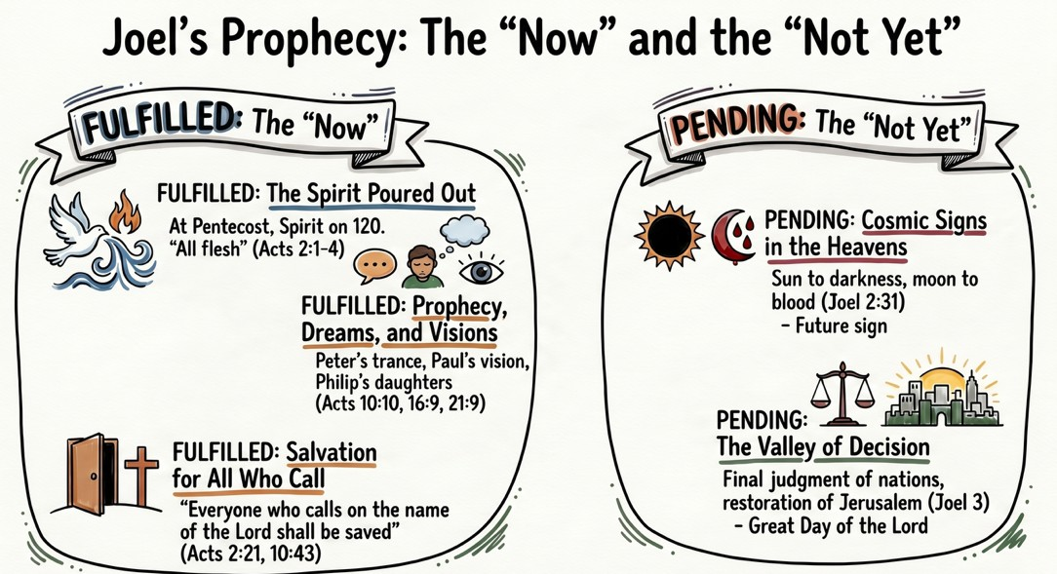

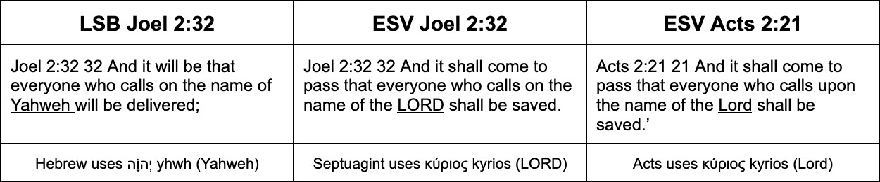

Acts 2:36 36 Let all the house of Israel therefore know for certain that God has made him both Lord and Christ, this Jesus whom you crucified.”

Evidence for the Messiah (2:22-32)

Evidenced by mighty works, wonders, and signs (Acts 2:22)
Acts 2:22 22 “Men of Israel, hear these words: Jesus of Nazareth, a man attested to you by God with mighty works and wonders and signs that God did through him in your midst, as you yourselves know—

Evidenced by His resurrection from the dead (Acts 2:23-24)
Acts 2:23-24 23 this Jesus, delivered up according to the definite plan and foreknowledge of God, you crucified and killed by the hands of lawless men. 24 God raised him up, loosing the pangs of death, because it was not possible for him to be held by it.

Evidenced by His superiority to King David (Acts 2:25-31)
Acts 2:25-28 25 For David says concerning him, “‘I saw the Lord always before me, for he is at my right hand that I may not be shaken; 26 therefore my heart was glad, and my tongue rejoiced; my flesh also will dwell in hope. 27 For you will not abandon my soul to Hades, or let your Holy One see corruption. 28 You have made known to me the paths of life; you will make me full of gladness with your presence.’

David could not have been speaking of himself
Acts 2:29 29 “Brothers, I may say to you with confidence about the patriarch David that he both died and was buried, and his tomb is with us to this day.

David understood it as a future fulfillment of the Davidic covenant
Acts 2:30-31 30 Being therefore a prophet,and knowing that God had sworn with an oath to him that he would set one of his descendants on his throne, 31 he foresaw and spoke about the resurrection of the Christ, that he was not abandoned to Hades, nor did his flesh see corruption.

Evidenced by eyewitness testimony (Acts 2:32)
Acts 2:32 32 This Jesus God raised up, and of that we all are witnesses.

120 standing with Peter
- 1 Corinthians 15:3-7 3 For I delivered to you as of first importance what I also received: that Christ died for our sins in accordance with the Scriptures, 4 that he was buried, that he was raised on the third day in accordance with the Scriptures, 5 and that he appeared to Cephas, then to the twelve. 6 Then he appeared to more than five hundred brothers at one time, most of whom are still alive, though some have fallen asleep. 7 Then he appeared to James, then to all the apostles.

The resurrection of Jesus was not a legend or a myth… it was recent, verifiable, public history!

