City Road United Methodist Church
A Lighthouse Congregation

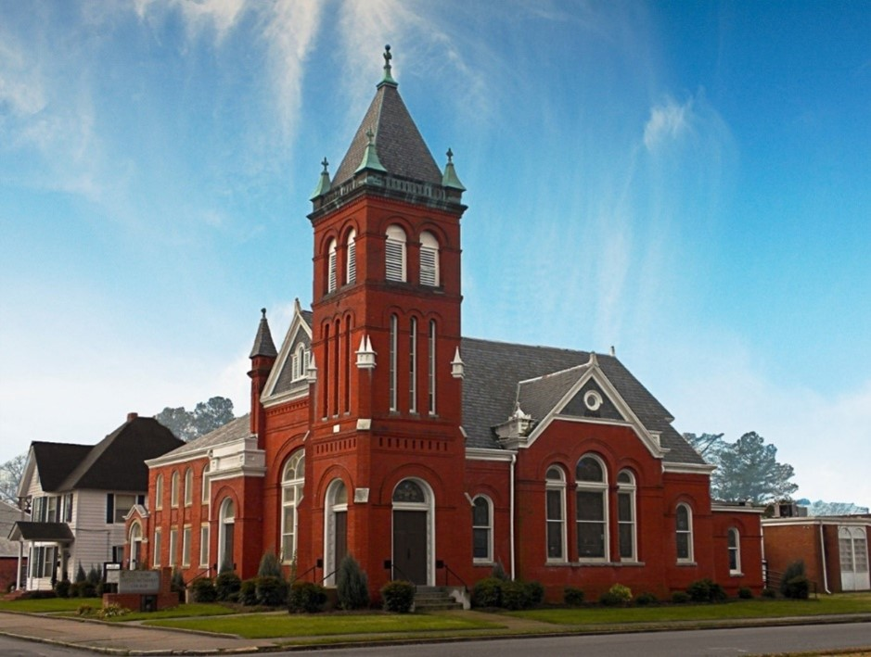
Rev. Josh Tester, Pastor

Office: (252) 335-2658
cityroadec.net crumcec@gmail.com

Facebook: https://www.facebook.com/CityRoadUMC

Sunday School: 10:00 a.m.
Sanctuary Worship: 11:00 a.m.

Tommy Venters- Organist/Choir Director
Dawn Baker- Secretary/Technology Specialist
JoAnn Herring- We Care

Service of Word & Table
Pentecost Season
June 28th, 2026 11:00 am
Gathering
Prelude
*Introit “Spirit of the Living God” UMH 393
Words of Welcome
*Call to Worship
When our way seems unclear
God will provide.
This day, bring us together just as you called the children of Jacob to gather manna in the desert to eat and sustain life.
God of unity, give us this day our daily bread.
Offer us the nutrients we need to remain connected to you. As spiritual beings, we desire to receive food that endures— faith, hope, and love.
God of grace, give us this day our daily bread.
All life is created and nourished by you!
May we grow to reflect the ways in which we have been filled by your holy manna.
Holy Spirit, come! Give us this day our daily bread.

*Sharing Peace
The Peace be with you!
And also with you!

*Hymn of Praise “Amazing Grace” UMH 378

Proclamation & Response
Pastoral Prayer

Children’s Time
Call to the Offering
Offertory
*Doxology UMH 95
*Prayer of Dedication

*Hymn of Preparation “Spirit song” UMH 347
Verse 1

Anthem Chancel Choir

Old Testament Lesson Exodus 16, Selected Verses
Message “God will Provide” Pastor Josh

Invitation to Christ’s Table 7
Prayer of Confession 8
Psalter of Assurance excerpts from Psalm 13
In the name of Jesus Christ, you are forgiven.
In the name of Jesus Christ, you are forgiven.
Glory to God, Amen!

Holy Communion
Prayer of Great Thanksgiving 9
The Lord’s Prayer
*Receiving the Bread and Cup
*Prayer after Communion
Eternal God,
We give you thanks for this holy mystery
in which you have given yourself to us.
Grant that we may go into the world
in the strength of your Spirit,
to give ourselves for others,
in the name of Jesus Christ our Lord. Amen.

Sending Fourth
*Sending Hymn “Blessed be the Tie” UMH 557
Verses 1&4

And Order of Farewell to a Pastor
Pastor Josh: I thank you, the members and friends of City Road United Methodist Church, for the love and support you have shown me and my family while I have ministered among you. I am grateful for the ways my leadership has been accepted. I ask forgiveness for the mistakes I have made. As I leave, I carry with me all that I have learned here.
Congregation: We receive your thankfulness, offer forgiveness, and accept that you now leave to minister elsewhere. We express our gratitude for your time among us.
We ask your forgiveness for our mistakes. Your influence on our faith and faithfulness
will not leave with your departure.
Pastor Josh: I accept your gratitude and forgiveness, and I forgive you, trusting that our time together and our parting are pleasing to God. I release you from turning to me and depending on me. I encourage your continuing ministry here
and will pray for you and for your new Pastor.
Let us pray:
Eternal God, whose steadfast love for us is from everlasting to everlasting, we give you thanks for cherished memories and commend one another into your care as we move in new directions. Keep us one in your love forever, through Jesus Christ our Lord. Amen.

*Benediction
*Responsive Hymn “Shalom to You” UMH 666
*Postlude

