Sunday, June 7th Sermon by The Venerable Jonathan Lloyd
The Second Sunday after Pentecost Matthew 9:9-13, 18-26 ‘Follow Me’
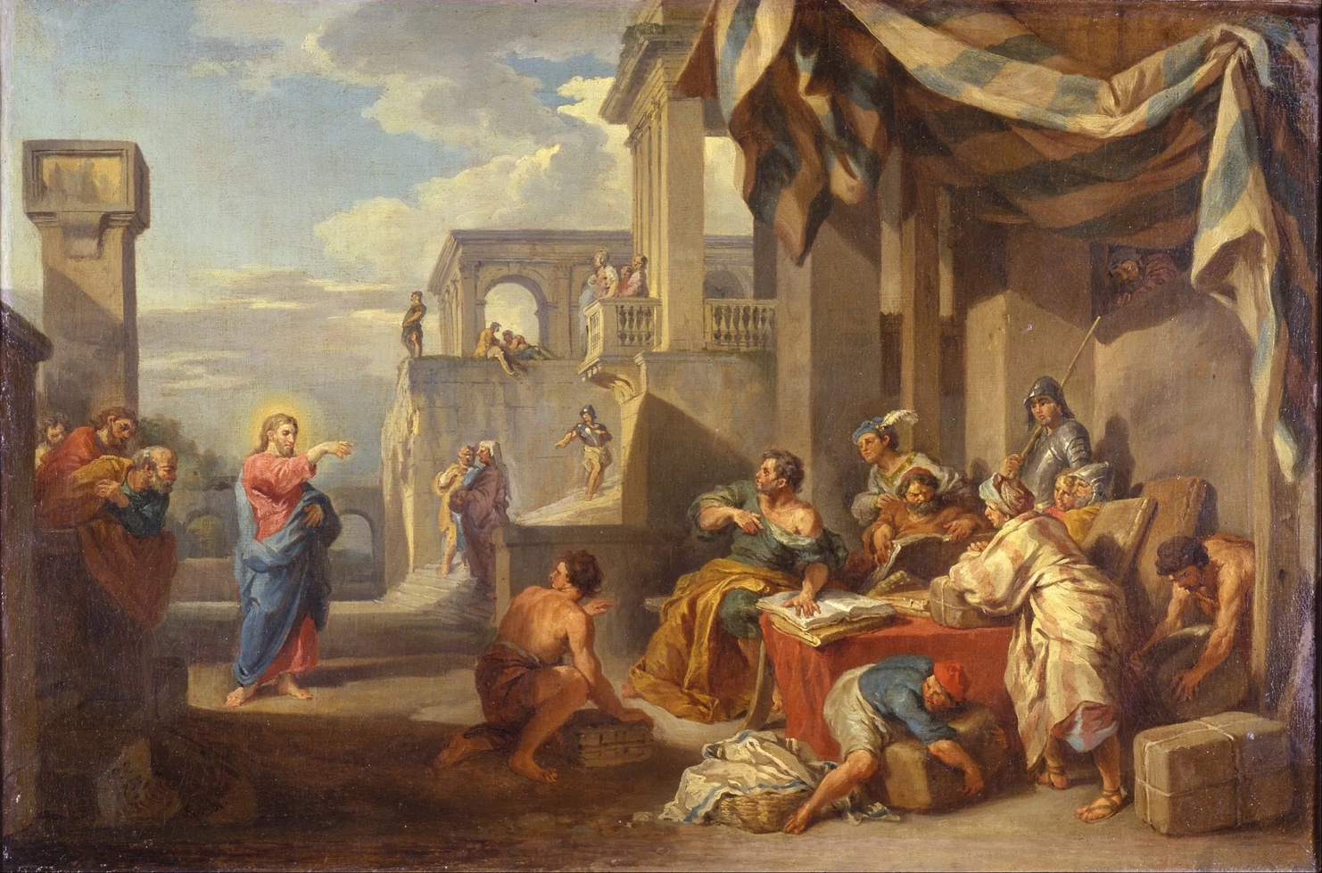
The Calling of Saint Matthew,
Painted by Giovanni Paolo Panini (1691-1765),
Painted in 1752,
Oil on canvas
© Museo Poldi Pezzoli, Milan

In the name of the loving God, Father, Son and Holy Spirit. Amen.
Standing here in front of you, I just want to pause for a moment to look at your faces – the faces of God’s beautiful people. We last saw each other through face masks and laptop screens, and in a context of uncertainty that the pandemic brought to us. Today we meet in person – with no zoom, no face masks, no lockdown, no covid. Here we are - worshipping God in freedom in this special community of West Vancouver!
Thank you, Rector Jonathan Pinkney, for kindly inviting me to say a few words. Sue and I are delighted to be worshipping with you today here at St Christopher’s West Van. We bring greetings from our Diocese and Bishop of Bath and Wells… and also, of course from our Chocolate Lab Bella who loved the streams, forests and mountains of the North Shore so much. She sulked when we packed our suitcases – although is probably happy to be a long way away from the skunks that attacked her not once but twice!
We arrived here in West Van ten years ago and returned to England five years ago. Serving as your Rector of St Stephen’s was a privilege and a joy for me. The first thing I want to say is thank you for having us! We had great fun together, and it was wonderful to be part of this community. Five years later we have all changed a bit. We are all older. Sue and I are now Canadian citizens, and I have just hit 70. We have two grandchildren and are greatly enjoying being grandparents with all its joys.
One thing I learnt from being here is that age in Canada is just a number in your head. Snowshoeing every week up the Cypress slopes with 94-year-old parishioner Dutchman Jan Jansen as our guide and teacher… we had trouble keeping up with him as he disappeared through the pine trees ahead of us, and I was usually begging for a stop at the hut for a cinnamon bun and coffee!
I remember fondly what I call the ‘saints of St Stephen’s. All those who have been promoted to glory, who have gone before us and now rest in peace. Dear Mary Parsons who died recently. I remember her amazing floral (or garden) displays in front of the altar, and her devoted care for Barry over many years.
When I reflect on those St Stephen’s days I cherish the deep sense of community, service, music, worship and the all the different ways you live your lives responding to what Jesus says to Matthew – ‘follow me’. Jesus was direct and to the point – simply ‘follow me’, he said to this unlikely tax collector. And Matthew did just that.
A decade has passed since I arrived in West Van, and things have changed. We have all faced change in our lives, in our community, in our world. The completion of the life of the St Stephen’s church building must have been a challenging time of sorrow, grief and uncertainty for you. I thank God for your resilience and faith as you moved forward. At the same time a moment of prayerful dependence on God’s Holy Spirit. The re-uniting of St Stephen’s and St Christopher’s was a God-given moment of transformation and hope. The shared histories of the two churches inter-twine in a holy dance through almost a century.
There has always been an inter-twining. In 1933 the St Stephen’s Sunday School was so overcrowded that the St Stephen’s Rector and Churchwardens initiated the construction of Inglewood Hall on this site to have a Mission Sunday School. Much of the fundraising was achieved by the people of St Stephen’s and its Women’s Auxiliary. The Inglewood Mission then had its first service here in 1941, with this beautiful church of St Christopher following in the 1950’s. So, your new church community today is a creative uniting again – and a celebration - of two Anglican churches that started as one, then became two, and then became one again. Always shaped and led by the Holy Spirit. The Holy Spirit always reminding you of Jesus words - ‘follow me’.
You are not only a welcoming, uniting, engaging and vibrant Christian community, but also a sign of unity in a troubled world. In the last five years the world has changed. More war. More authoritarianism. More uncertainty and more inequality. We need hope and unity more than ever. I commend a new book by Father Richard Rohr, the Franciscan priest, called ‘The Tears of Things – Prophetic Wisdom in an Age of Outrage’. Father Richard asks - how do we live compassionately in a time of violence and despair? What can we do with our disappointments and the anger we feel in such as unjust world? To follow Jesus we must seek a compassionate way of living.
Remember always that Saint Stephen was the first Deacon of the early Church – in fact he was in charge of the Deacons, so one could say that he was the first Arch-Deacon. Serving those in need with compassion.
Jesus tells us that our faith is not only about us, but about the ones who are most in need of love and healing. Jesus asks us to remember our need of God, and to risk taking God’s love to others.
Following Jesus may not always mean grand actions. Often it means simply taking time to stop, notice, watch and listen. Or to fly backwards a little whilst keeping focused, just like your beautiful hummingbirds do. It means allowing compassion to interrupt our plans. When we dare to do that, even in small ways, we begin to reflect the heart of Christ. And God’s life-giving love becomes visible in the world.
Archbishop Desmond Tutu talked about ‘the audacity of hope’. May we have the audacity of hope to believe in the purposes of God – for with God nothing is impossible. May the Holy Spirit go on stirring you up to build unity, live compassionately, and build God’s kingdom here in West Vancouver, this Diocese of New Westminster and beyond.
I thank God for the past, present and future of this special church community. I thank God for all of you, and I will continue to pray for you all as you journey together into God’s future as a loving, living, compassionate community – responding daily to the words of Jesus to Matthew and to all of us – ‘follow me’.

