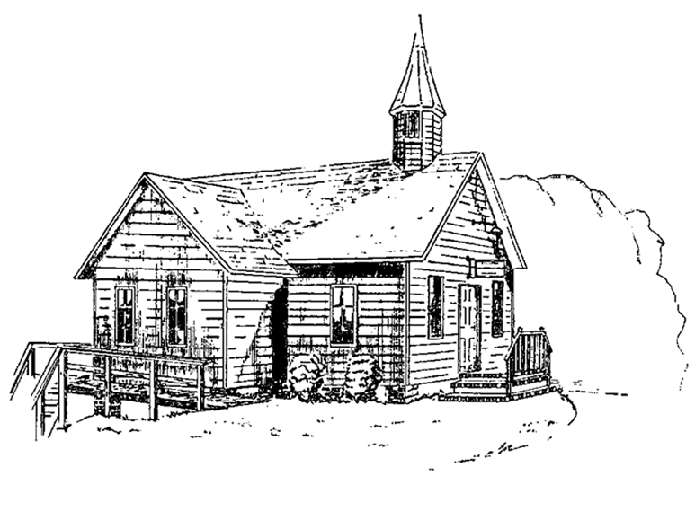
Colington United Methodist Church
June 28, 2026
Fifth Sunday after Pentecost

welcome and announcements
centering
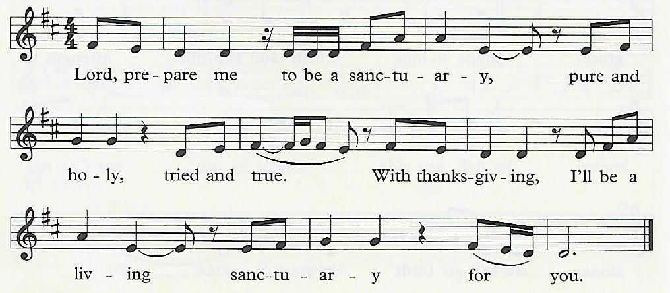

prelude and lighting of altar candles
Wonderful Words of Life Bliss/Berry
call to worship
We gather in peace, graced by the living, risen Christ, who welcomes us!
We come with joy to meet our Savior. Alleluia!
introit
Victory Chant
opening prayer
†opening hymn
O Worship the King ǀ UMH 73
the prayers of the people
the first lesson
Psalm 13
special music
The King Is Coming ǀ William Walter
the second lesson
Genesis 22:1-14
sermon
“Marked For Life” ǀ Rev. Jack Colenda
silent reflection
†affirmation of praise
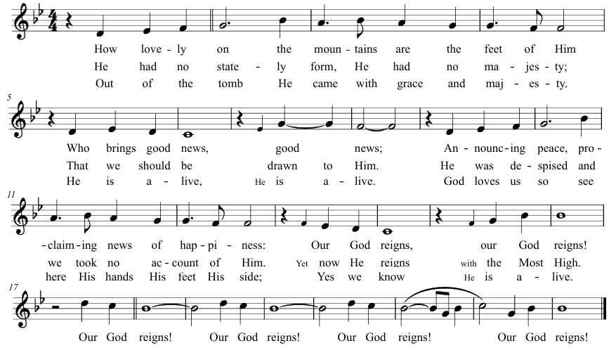
Our God Reigns

holy baptism ǀ UMH 33
litany of thanksgiving
Almighty God, fountain of all goodness, God of all grace, we bless you for the earliest beginnings of your work in us and in our children, for the awakening of faith, for gracious memories and holy desires, and for the ceaseless strivings of your Spirit within us;
we praise you, O God.
That you have helped us in times of temptation, remembered us when we have forgotten you, pursued us when we have fled from you, tarried for us with unwearied patience, and met us with forgiveness when we have turned back to you;
we praise you, O God.
For light and inspiration from your holy Word, for moments of wonder and worship in your house, for the fellowship of your Church, for the reality of things unseen and eternal, and for every remembrance of friends who dwell with you within the veil;
we praise you, O God, Father Son, and Holy Spirit. Amen.
†closing hymn
All Praise to Thee, For Thou, O King Divine ǀ UMH 166

†benediction

this week at colington
These opportunities to serve as the Body of Christ are available.
Tuesday – 9 am – Prayer Group
6:15pm – Beach fellowship at Ocean Bay Blvd. beach access.
Wednesday – 12pm - Veterans lunch at Spring Arbor.
Saturday – July 4th - Celebrate America 250years old! 

coming up
Next Sunday – 8:30am – choir practice
9:30 am – Worship, in-person and Facebook Live and YouTube
Wed., July 8 – 10am – Knitters and crocheters meet.
Thurs., July 9 – 4pm – Mobile food pantry at FFES.
** UWIF will not meet in July.
Sat., July 18 – 9am - Men’s ministry breakfast meeting.
Wed., July 22 – 10am – Knitters and crocheters meet.
1:46pm – Volunteers to Beach Food Pantry.
**We are collecting NEW toiletries and paper products for July’s mobile food pantry. Please place your donations in the big box in the fellowship room by next Sunday. Thank you!

Thanks to today’s volunteers!
Ushers – Steve Knowles/ Ozzie Gray
Scripture Reader – Becky Eanet
The flowers on the altar are given by Becky Wamsley Blalock in memory of Howard Wamsley.

Last week’s attendance – 60.

