

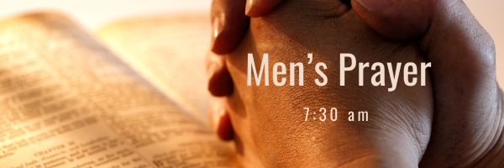

This Week at PPBC
July 11, 2026

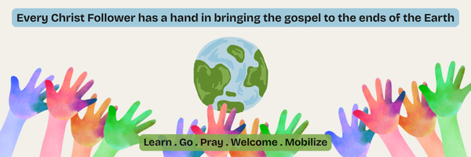A Prayer Request for Outreach to our Canadian Indigenous: The PPBC Mission Committee continue to seek God’s guidance and provision of an open door to become involved in an outreach to our Canadian Indigenous. Pastor Jim is in contact with representatives from Rural Life Mission/Round Lake Bible Camp about possible involvement with them. Please pray with us for God’s leading towards this or other opportunities to serve.


Notes

Sunday Ministry Schedules

Below are ministry schedules for Nursery, Jr. Church, Greeters, Ushers, and Sound & Video:

Nursery
June 28: Laura Saunders, Amber Saunders, Grace Brown
July 5: TBA

Jr. Church; ages 3 to grade 1
June 28: Ellianne McLaren, Abby Saunders
July 5: TBA

Jr. Church; Grades 2 to 6
June 28: Gregg & Karen Anderson, Kim St-Onge
July 5: TBA

Greeters
June 28: Paul & Helen Jones
July 5: Scott & Caterine Willison

Ushers
June 28: Graeme Foster, Leno Araujo
July 5: Matt Saunders, Joe Colwell

Sound & Video
June 28: Sound: Wyatt Werner | Video: Josh Myers
July 5: Sound: TBA | Video: TBA

Help Wanted
We're looking for 5 Parking Attendants to join the Welcome Team.
We are in need of assistance with our parking lot on Sunday mornings.
Help us keep our parking lot safe and orderly by considering serving in this way.
Please speak with Paul Sammut if you are interested.
Thank you

Sunday Service
Song – O Worship the King
Welcome
Song – Victory in Jesus
Song- Welcome Home
Scripture
Prayer
Song – All Sufficient Merit
Message – Pastor Jim Clemens
Song – You Made Us Your Own

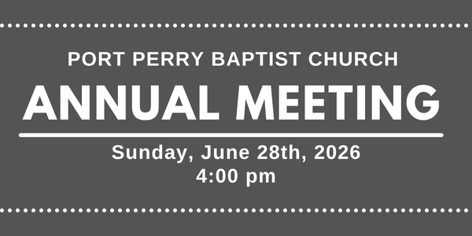

Praise & Prayer Highlights
PRAY for John and Joan Mank and their ongoing health concerns.

PRAISE for the engagement of Peter and Kate Anderson. PRAY for them and their families as they prepare for their wedding and marriage in the fall.
PRAISE for Josh & Jenna Anderson as they are expecting another baby in 2027. PRAY for them as they prepare and that mom and baby would continue to be healthy and safe.
PRAY for Dave & Mandy Myers. Dave was in a serious car crash. PRAY for continued health and recovery for Dave.
PRAY for Martin & Tina McCurley and their ongoing health concerns.
PRAY for Rob & Shelley VanUden and their nieces family. Their nieces daughter Bryte passed away. PRAY for Lindsey, her husband and their family as they mourn this loss. PRAY for Gods comfort and peace through this time.
PRAY for the Youth as they end their school year and prepare for summer jobs and camps. PRAY for their spiritual growth as they are away from home throughout the summer.
PRAISE for Josh & Chelse Myers as they are expecting another baby in December. PRAY for them as they prepare and that mom and baby would continue to be healthy and safe.

Giving
Just as a reminder, there are several ways you can give:
In Person using the offering box located on the back wall of the sanctuary. Donation envelopes are available at the Welcome Centre. Please contact the church office if you would like a box of donation envelopes (office@portperrybaptist.ca)
Through your online banking, you may send electronic transfers to ppbcdonations@gmail.com.
You can also give through Canada Helps. Donation receipts will be provided by Canada Helps, and transaction fees apply.
***********************************************************************
Weekly Newsletter
The PPBC Newsletter is emailed to the church family every Friday. If you would like to be added to the weekly email list, please contact the office by phone: 905-985-8681 or by email: office@portperrybaptist.ca.
*****************************************************************
Church Information:
Location:
2210 Hwy 7A
Port Perry, ON
L9L 1B4
Office Hours:
Monday: 8:30am – 4:00pm
Tuesday: 8:30am – 4:00pm
Wednesday: Closed
Thursday: 8:30am – 4:00pm
Friday: 8:30 am - 3:00 pm
Contact:
Phone: 905.985.8681
Email: office@portperrybaptist.ca
Website: www.portperrybaptist.ca
Staff:
Sr. Pastor – Rev. Jim Clemens
Administrative Assistant – Madeline Werner
Family Ministries Director – Josh Anderson
Pastoral Intern – Scott McKenzie

PPBC Newsletter
Sunday, June 28th, 2026


Sunday Starting Point
Sunday, June 28th, 2026 - 9:30 am
“Beginning the day with the Word and prayer”
Adults:
Adults will meet in the sanctuary for a time of study and prayer.
Youth:
Jr High (Grades 7-8) will meet in room 18 with Kate Anderson to study Thessalonians.
Children:
Children ages 3 - grade 6 will meet in room 26.
(Please note nursery is unavailable during Starting Point)
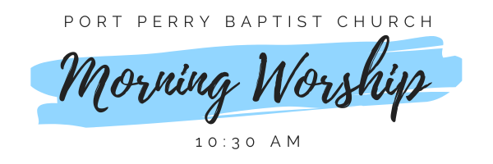Sunday Morning Worship
Sunday, June 28th, 2026 - 10:30 am
We are meeting in the sanctuary and will continue to live-stream for those who are unable to attend.
Message: Living With Gospel Purpose
Scripture: 1 Corinthians 9:24-10:33
Pastor Jim Clemens

