
Holy Trinity Evangelical Lutheran Church

5th Sunday After Pentecost

June 28, 2026, at 10:30 am

Pastor Tina Crog

*Prelude

* Welcome and Announcements Worship Assistant

* Opening Hymn “Softly and Tenderly Jesus is Calling” ELW 608

1.Softly and Tenderly Jesus is calling, calling for you for me.
See, on the portals he’s waiting and watching, watching for you and for me.
refrain: “Come home, Come home! You who are weary, come home.” Earnestly, tenderly, Jesus is calling, calling, “O Sinner, Come Home.”

2.Why should we tarry when Jesus is pleading, pleading for you
and for me? Why should we linger and heed not his mercies, mercies for you and for me?
refrain: “Come home, come home! You who are weary, come home.” Earnestly, tenderly, Jesus is calling, calling, “O Sinner, come home.”

3.Oh, for the wonderful love he has promised, promised for you and for me! Though we have sinned, he has mercy and pardon, pardon for you and for me.
Refrain: “Come home, come home! You who are weary, come home.” Earnestly, tenderly, jesus is calling, calling, “O sinner, come home.”

* Confession and Forgiveness Pastor Tina
Blessed be the holy Trinity, ☩ one God, who calls us by name, claims us as family, and keeps covenant with us through every generation. Amen.

Trusting in God’s mercy, let us confess our sin. Silence is kept for reflection.

God of Abraham and Hagar, you have called us into your family by grace, not by earning. Yet we forget who we belong to. We trust our own striving more than your promise. We cling to favoritism, resentment, fear, and scarcity. We wound one another in word and deed. We doubt your provision, resist your calling, and turn away from our neighbors. Forgive us. Remind us whose we are. Teach us to live as people shaped by your covenant of mercy; through Jesus Christ, our Lord. Amen.

Hear the good news: God’s promise does not depend on human perfection. The covenant is gift, not reward. Your past does not define you; God’s mercy does. In the name of Jesus Christ, your sins are forgiven. Amen.

*Greeting Pastor Tina

*Prayer of the Day Worship Assistant
O God, you direct our lives by your grace, and your words of justice and mercy reshape the world. Mold us into a people who welcome your word and serve one another, through Jesus Christ, our Savior and Lord. Amen.

*Children’s Moment Pastor Tina

*First Lesson: Genesis 22:1-14 Reader
¹ God tested Abraham. He said to him, “Abraham!” And he said, “Here I am.” ² He said, “Take your son, your only son Isaac, whom you love, and go to the land of Moriah and offer him there as a burnt offering on one of the mountains that I shall show you.” ³ So Abraham rose early in the morning, saddled his donkey, and took two of his young men with him and his son Isaac; he cut the wood for the burnt offering and set out and went to the place in the distance that God had shown him. ⁴ On the third day Abraham looked up and saw the place far away. ⁵ Then Abraham said to his young men, “Stay here with the donkey; the boy and I will go over there; we will worship, and then we will come back to you.” ⁶ Abraham took the wood of the burnt offering and laid it on his son Isaac, and he himself carried the fire and the knife. And the two of them walked on together. ⁷ Isaac said to his father Abraham, “Father!” And he said, “Here I am, my son.” He said, “The fire and the wood are here, but where is the lamb for a burnt offering?” ⁸ Abraham said, “God himself will provide the lamb for a burnt offering, my son.” And the two of them walked on together.
⁹ When they came to the place that God had shown him, Abraham built an altar there and laid the wood in order. He bound his son Isaac and laid him on the altar on top of the wood. ¹⁰ Then Abraham reached out his hand and took the knife to kill his son. ¹¹ But the angel of the Lord called to him from heaven and said, “Abraham, Abraham!” And he said, “Here I am.”¹² [The angel] said, “Do not lay your hand on the boy or do anything to him, for now I know that you fear God, since you have not withheld your son, your only son, from me.”¹³ And Abraham looked up and saw a ram, caught in a thicket by its horns. Abraham went and took the ram and offered it up as a burnt offering instead of his son. ¹⁴ So Abraham called that place “The Lord will provide,” as it is said to this day, “On the mount of the Lord it shall be provided.”
The Word of the Lord. Thanks be to God.

*Psalmody “How Long Will You Forget Me Lord" Psalm 13
Sung by Pastor Tina
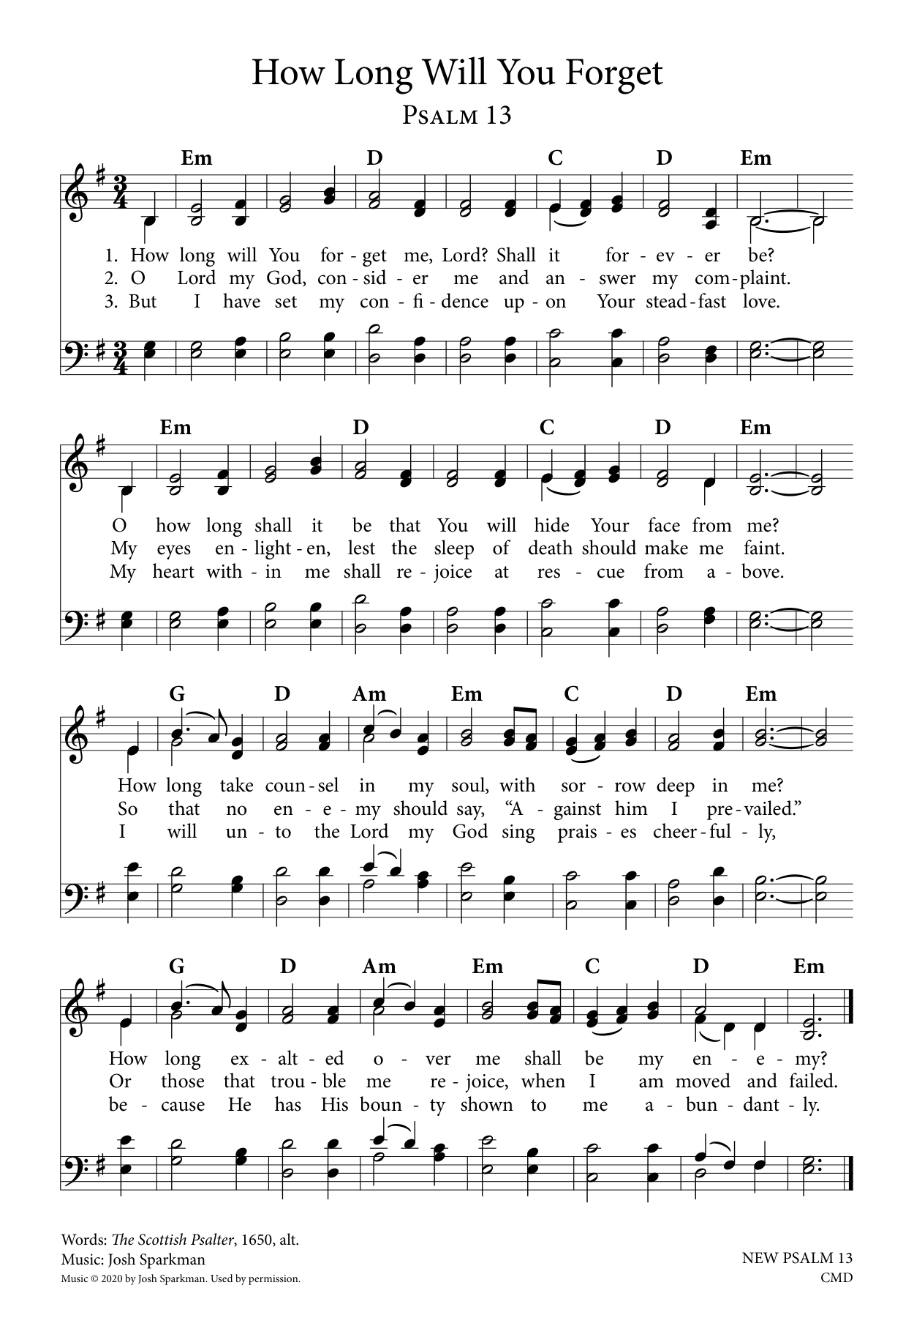

* Gospel Acclamation “Word of Life, Jesus Christ” WOV pg. 48
Word of life, Jesus Christ, all glory to you!
Word of life, Jesus Christ, all glory to you!
Our hearts burn within us while you open to us the Scriptures.
Word of life, Jesus Christ, all glory to you!
Word of life, Jesus Christ, all glory to you!

* Gospel: Matthew 10:40-42 Pastor Tina
The Holy Gospel according to Matthew, the 10th chapter. Glory to you, O Lord.
[Jesus said to the twelve:] ⁴⁰ “Whoever welcomes you welcomes me, and whoever welcomes me welcomes the one who sent me. ⁴¹ Whoever welcomes a prophet in the name of a prophet will receive a prophet’s reward, and whoever welcomes a righteous person in the name of a righteous person will receive the reward of the righteous, ⁴² and whoever gives even a cup of cold water to one of these little ones in the name of a disciple—truly I tell you, none of these will lose their reward.”

The Gospel of the Lord. Praise to you, O Christ.

*Sermon Pastor Tina

* Hymn of the Day "Just As I Am, without One Plea" ELW 592

1.Just as I am, without one plea, but that thy blood was shed for me, and that thou bidd’st me come to thee, O Lamb of God, I come, I come.

2.Just as I am, though tossed about with many a conflict, many a
doubt, fightings and fears within, without, O Lamb of God, I come, I come.

3.Just as I am, thou wilt receive, wilt welcome, pardon, cleanse, relieve; because thy promise I believe, O Lamb of God, I come, I come.

4. Just as I am; thy love unknown has broken every barrier down; now to be thine, yea, thine alone, O Lamb of God, I come, I come.

* Apostle’s Creed Worship Assistant
let us proclaim our faith in the words of the apostle’s creed.
I believe in God, the Father almighty,
creator of heaven and earth.
I believe in Jesus Christ, God's only Son, our Lord,
who was conceived by the power of the Holy Spirit,
born of the Virgin Mary,
suffered under Pontius Pilate,
was crucified, died, and was buried;
he descended to the dead.
On the third day he rose again;
he ascended into heaven,
he is seated at the right hand of the Father,
and he will come to judge the living and the dead.
I believe in the Holy Spirit,
the holy catholic Church,
the communion of saints,
the forgiveness of sins,
the resurrection of the body,
and the life everlasting. Amen.

* Prayers of Intercession Pastor Tina
Be Seated
Prayer Requests or Joys to Share
Gathered together by the Holy Spirit, let us pray for the church and the needs of the world. A brief silence.

Faithful God, establish your church to offer welcome and proclaim your peace. Nourish us so we can proclaim your hope to the world. God of grace, hear our prayer.

Creator God, bring life to places experiencing drought, deforestation, and pollution. Help us to cultivate and care for the natural world around us. God of grace, hear our prayer.

Loving God, bring an end to conflict and division (places experiencing division may be named). Sustain the work of prophets in our time, and work through world leaders to foster understanding, justice, and peace. God of grace, hear our prayer.

Provider God, give your children what they need physically, emotionally, and spiritually. (We pray especially for . . . .) Bless caregivers as they show God’s hospitality through their generous service. God of grace, hear our prayer.

Living God, lead us from death to life. Inspire new ministries and endeavors, renew established ones, and strengthen our welcoming presence to our neighbors. God of grace, hear our prayer.

Eternal God, we remember the faithful departed of this community and of the wider church and world. We give thanks for saints of all times and places. God of grace, hear our prayer.

Trusting you receive all our prayers, we commend our spoken and unspoken prayers to you, O God, through Jesus our Savior.
Amen.

*Offering Worship Assistant
The monthly mission for June is for “The Fellowship Ministry.” Let us give to God what He has first given us.

* Offering Music by Jared

* Offering Hymn “Glory to You” WOV Service of Word
Season of Pentecost Verse
Glory to you, God, for yours is the earth;
Yours the Anointing, the radiant worth.
Ours the rejoicing for spirits aflame;
Ours the thanksgiving to your Holy Name.
Ours be the telling of deeds greatly done;
Yours be the glory, O God, yours alone.

* Offering Prayer Worship Assistant
Loving God, we offer at your table the gifts of our hearts. Help us take heart in you and share freely of your love, so that all creation can taste your abundance. We ask this in the name of Jesus, through the Spirit abiding with us now and forever. Amen.

*The Great Thanksgiving (spoken) Pastor Tina
The Lord be with you.
And also with you.
Lift up your hearts,
We lift them to the Lord.
Let us give thanks to the Lord, our God.
It is right to give God our thanks and praise.

*Eucharistic Prayer and Words of Institution Pastor Tina

* Lord’s Prayer
Our Father, who art in heaven, hallowed be thy name, they kingdom come, thy will be done, on earth as it is in heaven.
Give us this day our daily bread, and forgive us our trespasses, as we forgive those who trespass against us; and lead us not into temptation, but deliver us from evil. for thine is the kingdom, and the power, and the glory, forever and ever. amen.
Special Music during Holy Communion by Jared

*Post Communion Blessing Pastor Tina

* Post Communion Hymn “Praise God from Whom All Blessings Flow” ELW 884

Praise God, from whom all blessings flow;
Praise God, all creatures here below;
Praise God above, ye heav’nly host;
Praise Father, Son, and Holy Ghost.

* Prayer After Communion Pastor Tina
Compassionate God, through the gifts of bread and wine our hearts are filled with the abundance of your love. Strengthen us that we, through this holy meal, may share your love freely, as you have shared with us. We ask this in the name of Jesus, through the Spirit nourishing us now and forever. Amen.
* Blessing

* Closing Hymn “Just a Closer Walk with Thee” ELW 697

Refrain: Just a closer walk with thee, grant it, Jesus, is my plea;
daily walking close to thee, let it be, dear Lord, let it be.
1.I am weak, but thou art strong: Jesus, keep me from all wrong;
I’ll be satisfied as long as I walk, let me walk close to thee.

Refrain: Just a closer walk with thee, grant it, Jesus, is my plea;
daily walking close to thee, let it be, dear Lord, let it be.
2.Through this world of toil and snares, if I falter, Lord who cares? Who with me my burden shares? None but thee, dear Lord, none but thee.

Refrain: Just a closer walk with thee, grant it, Jesus, is my plea;
daily walking close to thee, let it be, dear Lord, let it be.
3.When my feeble life is o’er, time for me will be no more;
guide me gently, safely o’er to thy kingdom shore, to thy shore.

Refrain: Just a closer walk with thee, grant it, Jesus, is my plea;
daily walking close to thee, let it be, dear Lord, let it be.

* Dismissal Worship Assistant
Go in peace, sharing the gifts of Christ! Thanks be to God!

*Postlude

