EAST FAIRFIELD UNITED METHODIST CHURCH
Pastor: Rev. Lisa Courtwright
Organist: Ruth Rowley Ministers: The Congregation
Pianist: Nancy Setinsek Choir Director: Randy Hart
Sunday, June 28, 2026
Fifth Sunday after Pentecost

*Please stand in body or spirit as you are able

Welcome! We invite you to take this time to prepare for worship. In these
moments, quiet your inner voice, become aware of being in community with
others, and open your heart and mind to the leading of the Holy Spirit.

GATHERING “Adoration” - Gounod
“I Am Thine, O Lord” - Doane
CHRIST LIGHT ENTERS

MISSIONS AND MINISTRY UPDATEs Jeannie Arnoto, Liturgist

PREPARING OUR HEARTS AND MINDS FOR WORSHIP

WORDS OF PREPARATION AND CENTERING

PRELUDE “Be Thou My Vision” - arr. by Larry Shackley
Sarah Thorne
*CALL TO WORSHIP

Behold, how good and pleasant it is when God’s people
live together in unity!
It is like precious oil poured on the head, running down on
the beard, running down on the collar of the robes.

It is as if the dew of Mount Hermon were falling on the hills of Zion.
For there the Lord bestows his blessing, even life forevermore.
Let us worship the Lord together in spirit and in truth!

*OPENING PRAYER
Heavenly Father, we come before you with hearts filled with gratitude and praise. Thank you for the gift of unity and the joy that comes from living together in harmony. You have created us for community, and we are blessed by the relationships you have placed in our lives.

We acknowledge our deep need for you, especially in our relationships. We confess that pride, misunderstanding, and selfishness often create divisions among us. We need your guidance and grace to live in unity.

Fill us with your love and compassion, enabling us to extend grace and forgiveness to others. Help us to see each person as a beloved child of God. Empower us to pursue peace, build each other up, and reflect your love and unity to the world. Amen.

*OPENING HYMN “Sweet, Sweet Spirit” UMH #334

READING FROM THE PSALMS Psalm 133 (NIV) pg 503

CHILDREN’S MOMENT

OFFERING OURSELVES & OUR GIFTS
INVITATION
OFFERTORY “How Great Thou Art” - Swedish Melody
*DOXOLOGY UMH #95
*DEDICATION OF GIFTS

SEEKING GOD’S WORD

OLD TESTAMENT READING Leviticus 19:18 pg 95

SHARING OF JOYS & CONCERNS
SILENT PRAYER
PASTORAL PRAYER
THE LORD’S PRAYER

*HYMN “Open My Eyes That I May See” UMH #454

SERMON TEXT Galatians 5:13-18, 22-26 (NIV) pg 946

SERMON To Live By the Spirit: Unity for Our Community
Cindy Wright

RESPONDING TO GOD’S WORD

*CLOSING HYMN “Spirit of the Living God” UMH #393

SENDING FORTH WITH BLESSING
*BLESSING
LIGHT OF CHRIST GOES INTO THE WORLD
~ Go with joy to serve the Lord ~

As we conclude our service, please join us downstairs for a time to relax, continue conversations, and enjoy coffee and refreshments.

Sound: Bill Rowley
Computer: Vicki Freeman
Livestream: Hannah Vollnogle

Next Sunday: Jon Vollnogle, Liturgist
Please keep in mind that the service is live-streamed and
recorded for public access. Please keep prayer requests
brief and do not use last names or identifying details.

PRAYER REQUESTS JUNE 28, 2026
To submit a prayer request call Denise at 330-457-2465 or 330-727-9832
If you desire a home or hospital visit call Pastor Lisa (440-339-6463)
Prayer Blankets: call Joyce Ward (330-692-3346)

Linda W – having heart ablation Thursday, July 2 at Cleveland Clinic.
Mike Wylie (Sparky) – passed away June 19.
Bob & his sister, Karen (Sparky) - both have cancer.

Georgia Farmer – passed away June 16. Keep Denny in your prayers.
Bob Smith - passed away June 8. Keep Kathleen in your prayers.
Ron Chamberlin – passed away June 3. Keep Sally in your prayers.
Cindy W - seeing a chiropractor for neuropathy. Pray for good results.
Brittany (Jon) – had twin boys. Both are doing well now and are home.
Xavi – had eye surgery on June 12.
David (Jeannie’s friend) – had a stroke years ago. Still struggling.
Shawn M – was at Mercy in Boardman after a TIA. Now home.
Melissa (Missy Roberts’ niece) – breast cancer.
Chaney (Denise W) - breast cancer.
Cortney (Denise W) – Chaney’s 54 yr old sister, brain aneurysm.
Sue (Kermit’s wife) – improving. Still at Briarfield in Boardman.

HOMEBOUND
Dolly K. Bill & Barb H. Anita M.
Tom & Marie Linda S. Walt D. (Christian House)
Dorothy F. Esther C. Zelda C. (Whispering Pines)
Jim Bable (Shepherd of the Valley)

IN MINISTRY
Lisa Courtwright Edie Boles Jeff Pellin

Ch Ph: 330-457-2465 Pastor: 440-339-6463
Email: revlisa18@gmail.com Ch Email:efumc@comcast.net Website: www.eastfairfieldumc.com CCLI # 1994841 CVLI #504 011 134


East Fairfield
United Methodist Church

June 28, 2026
9:30 AM

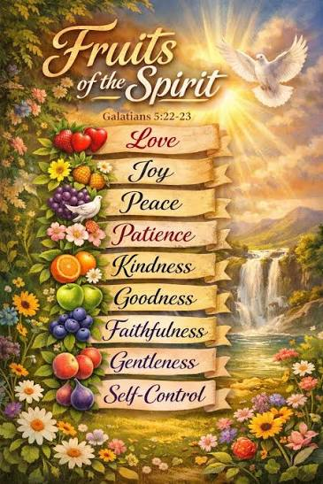

Rev. Lisa Courtwright
440-339-6463
45675 State Route 558
New Waterford, OH 44445

“Working, playing, and praying together on our
faith journey, to share Jesus Christ with everyone.”

Sun | Mon | Tue | Wed | Thu | Fri | Sat
June 28  9:30 Worship  - Cindy Wright  10:30 Coffee  10:45 Sunday  School | June 29  12:00  Joy Circle  meets at  Belleria in  Columbiana | June 30  8:00 Men’s  Coffee at  Dale Wilhelm’s cabin | July 1 | July 2  Office Closed  until noon | July 3  Office Closed | July 4  
July 5  COMMUNION  9:30 Worship  10:30 Coffee  10:45 Sunday  School  12:30  WELCOME PICNIC FOR PASTOR KRISTEN | July 6 | July 7  8:00 Men’s  Coffee at  Larrys pavilion | July 8 | July 9 | July 10  Office Closed | July 11  Pastor Kristen on vacation July 9 - 13
July 12  9:30 Worship  - Edie Boles  10:30 Coffee  10:45 Sunday  School | July 13  Pastor Kristen on vacation July 9 - 13 | July 14  8:00 Men’s  Coffee at  Larrys pavilion  Ladies’ Day | July 15 | July 16 | July 17  Office Closed | July 18
July 19  9:30 Worship  10:30 Coffee  10:45 Sunday  School  2:00 Concert 15 Firestone Park in Columbiana  (Leeann Binder) | July 20  12:00 Joy Circle Picnic in Pavilion  7:00 Leadership Board Meeting | July 21  8:00 Men’s  Coffee at  Larrys pavilion | July 22 | July 23 | July 24  Office Closed | July 25  8:30-10  Caring for God’s Lambs at  Trinity UM
July 26  9:30 Worship  10:30 Coffee  10:45 Sunday  School | July 27 | July 28  8:00 Men’s  Coffee at  Larrys pavilion | July 29 | July 30 | July 31  Office Closed

Joy Circle
Monday, June 29 at 12:00 noon

The Joy Circle will meet for lunch on Monday, June 29 at 12:00 noon at Belleria in Columbiana.

We will order from the menu and pay individually.
Since we need to make reservations, please let Carol
or JoAnne know by Friday, June 26 if you plan to attend.

LAST WEEK’S ATTENDANCE (June 21)
In-Person: 73 Online: 26

Mission of the Month
Fund #64 – Farmer to Farmer


4C’s Item
Soup

Update on Mission Giving for 2026
FUND | NAME OF FUND | NEED | RECEIVED | STILL NEED
2 | General Mission Fund | 5,099 | 3,241 | 1,858
33 | 4C’s | 125 | 175 | 0
32 | Cub Scouts | 150 | 405 | 0
37 | Way Station | 150 | 160 | 0
22 | Flat Rock | 175 | 265 | 0
64 | Farmer to Farmer – Liberia | 300 | 260 | 40
13 | UMCOR Sunday | Any  Donation | 75
21 | UMCOR – U.S. Disasters | Any  Donation | 5
14 | Blanket Sunday | Any  Donation | 65
15 | Peace With Justice | Any  Donation | 0
16 | World Communion | Any  Donation | 0
17 | Student Day | Any  Donation | 0
46 | Heroes & Halos | Any  Donation | 100
63 | InStep Program | Any  Donation | 30
38 | Operation Christmas Child Shoeboxes |  | 118 plus 90

Fund Balances as of end of MAY
Fund # 1 Ministry Operating - 8,379
Fund # 2 Mission Fund 2,887
Fund # 3 Building Fund 62,350
Fund # 28 Elevator Fund 7,964

Children’s Worship Bulletin

All Puffed Up

Luke 14:7-14

Word Search Puzzle

East Fairfield
United Methodist Church

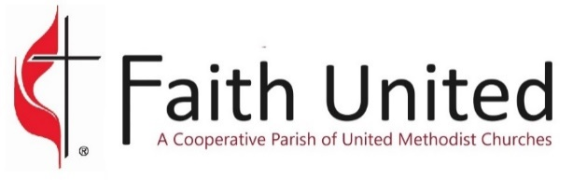
06-28-26
UPCOMING EVENTS

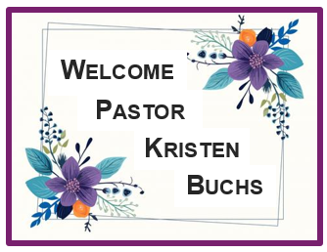

Welcome Picnic
Sunday, July 5
at 12:30 PM

You are invited to help us welcome Pastor Kristen to our church family on Sunday, July 5 at 12:30 pm at East Fairfield UMC.

We will gather for lunch outside in the pavilion, weather permitting. We will provide hot dogs, cheesy potatoes, drinks, and tableware. Please bring a covered dish or dessert to share.

Concert in the Park
Sunday, July 19 at 2:00 PM
at Firestone Park in Columbiana

Leeann Binder will be the featured performer.

This concert is sponsored by East Fairfield UMC.

Caring for God’s Lambs Food Pantry
Saturday, July 25 from 8:30-10:00 AM at Trinity UMC

The purpose of Faith United is to grow spiritually,
learn and love together, and lead others to Christ.

