Parkside Lutheran Church
Rediscovering the Radical Love of Jesus
Gathering All
Serving All
Caring For All

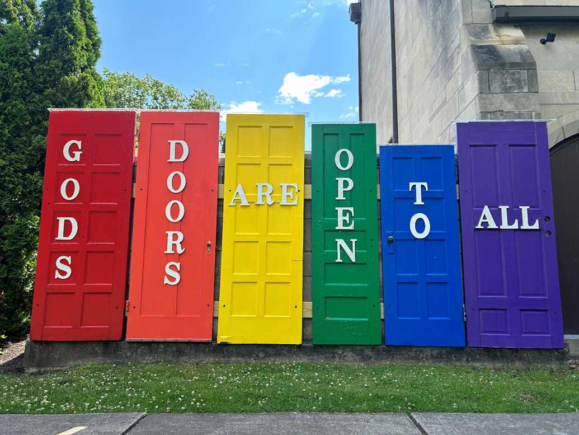

June 28th, 2026
Pride Sunday
Holy Communion 10:00am
Rev. Jeremiah Smith
Parkside Lutheran Values

Proclaiming Grace - Jesus shared and lived out a message of grace, love, and new life. We believe these promises come from God freely, as a gift for all. We are loved and the Spirit inspires us to share this good news in accessible, relevant, and new ways. Luke 4:17-19, John 1:16-17, John 3:16-17, Ephesians 2:8-9

Practicing Hospitality – Jesus welcomed the little children, broke bread with outcasts, and proclaimed the Good News to all. Whether you are strong in faith, wrestling with doubt, or somewhere in between, we affirm that you are welcome here. Jesus is for everyone. Leviticus 19:34, Matthew 9:10, Matthew 19:14, Hebrews 13:2

Loving Boldly - Jesus challenged traditions to demonstrate God’s justice and love of neighbor. His compassionate and sacrificial love inspires us to take risks. Striving to follow his command to love neighbor, our ministries serve, transform, and advocate for folks near and far. Micah 6:8, Mark 11:15-17, Luke 10:25-28, John 15:12-13

Cultivating Community - Jesus built communities that transformed lives. We are the body of Christ and we are called to continue this ministry of transformation. Guided by the Holy Spirit, we build connections within and outside of these walls, and with all of God’s creation. Ecclesiastes 4:9-12, Matthew 28:16-20, 1 Corinthians 12:12-14, Galatians 3:26-29

Welcome Visitors!
Please use QR code to let us know you were here today or to sign up for our weekly enewsletter. Find us on Facebook & Instagram
WIFI: Balcony password: FreeGrace

For your safety in the event of an emergency: In addition to the three exits in the back of the sanctuary, there are exits on either side of the altar (on left side: floor level near piano and up steps past altar. On right side: up steps to the altar, past band area)

Contact us: (716) 836-1361
2 Wallace Ave. Buffalo, NY 14214
parksidelutheran.org | parksidelutheran@gmail.com

GATHER
The Holy Spirit calls us together as the people of God.
Introduction to the Day: Pride Sunday is a celebration of the image of God in everyone and the diversity of humanity. In the beginning when God breathed the breath of life in us, God blessed us and called us very good. There is no better way to celebrate the fact that we were created in the image of the Divine than by being unapologetically ourselves and becoming the people God called us to be: authentic, whole, complex, and made to love. Today, you are welcome in this worship service exactly as you are, embracing all aspects of yourself: your doubts, curiosity, anger, hope, disappointment, complexities, faith, and joy. You were made very good. Let’s rejoice in this truth and worship the One who made us all.

Prelude Michael Hooker, Music Director

Call to Worship Please stand as you are able
WA: Source of life, in the beginning,
C: you made us and called us beloved.
WA: When we forget how to love,
C: you remind us we are beloved.
WA: When the powers of the world try to oppress us,
C: you name us beloved. We are your beloved, so today we sing your praises, Source of Love.

+Gathering Hymn: All are Welcome ELW #641
(printed next page)

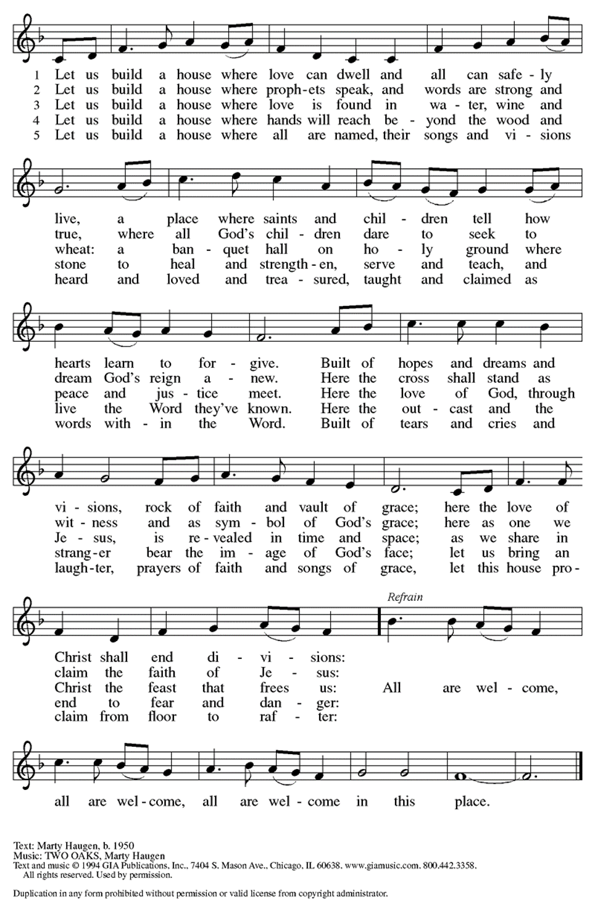
Welcome and Announcements

Confession and Forgiveness
P: Let us confess our sin before God and one another …
Silence is kept for reflection.
C: God, who made me in your image, teach me to love myself as you love me. God, who made me in your image, allow me to show that image to the world. God who made me in your image, help me to see your image in all those I meet. God, who made me in your image, teach me to conserve and protect all your creation. God, who made me in your image, bless, protect, and keep me and all your children safe.
P: The One who breathed life into our lungs continues to be present with us. God, who has made us reflective of God’s own image, has forgiven us all and
made us new creations. As a called and ordained minister of the church of Christ and by his authority I therefore declare to you the entire forgiveness of all your sins in the name of the Creator, Redeemer +, and Sustainer. Let us go forth with love and peace, honoring and upholding the dignity of all we meet, knowing
we see reflections of God’s image all around. Thanks be to God! C: Amen.

Greeting

WA: The grace of our Lord, Jesus Christ, the love of God, and the communion of the Holy Spirit be with you all. C: And also with you.

Kyrie ELW #157
(printed next page)

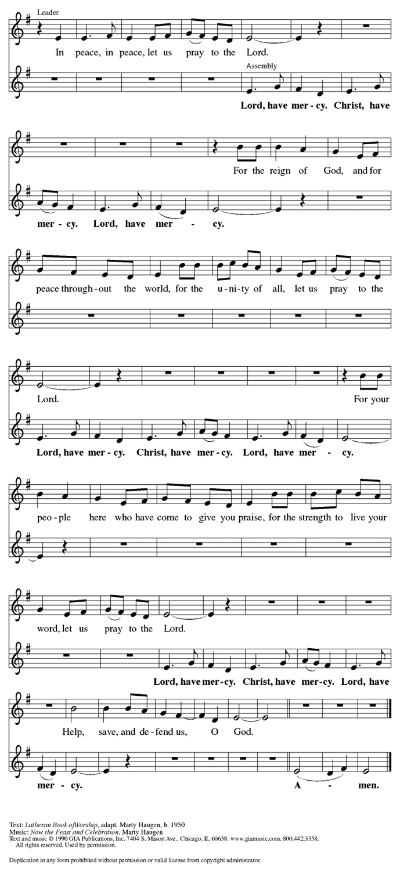
Prayer of the Day
WA: Let us pray together.
C: God of all Creation, you have made us in your image, a rainbow of every color, culture, gender expression, language, orientation, and nation; grant that, when we look at one another, we may see you, expressed in yet another language of love; and grant that we may honor your holy presence in every life. We pray because of Jesus, who shows us the way. Amen.

Children’s Sermon: Jesus said, “Let the little children come to me!”
We welcome children in worship.

A Poem by Asher O’Callahan
In the beginning, God created day and night. But have you ever seen a sunset!?!? Well trans and non-binary people are kind of like that. Gorgeous. Full of a hundred shades of color you can’t see in plain daylight or during the night.
In the beginning God created land and sea. But have you ever seen a beach?!?! Well trans and non-binary people are kind of like that. Beautiful. A balanced oasis that’s not quite like the ocean, nor quite like the land.
In the beginning God created birds of the air and fish of the sea. But have you ever seen a flying fish, or a duck or a puffin that swims and flies, spending lots of time in the water and on the land!?!? Well trans and non-binary people are kind of like that. Full of life. A creative combination of characteristics that blows people’s minds.
In the beginning God also created male and female, in God’s own image, God created them. So in the same way that God created realities in between, outside of, and beyond night and day, land and sea, or fish and birds, so God also created people with genders beyond male and female. Trans and non-binary and agender and intersex, God created us. All different sorts of people for all different sorts of relationships. Created from love to love and be loved. In God’s image we live.
God is still creating you. You are no less beautiful and wild than a sunset or a beach or a puffin. You are loved. You have a place here.

WORD
God speaks to us in scripture readings, preaching and song.

Please stand as you are able

Gospel Acclamation Setting 10 (p. 205)
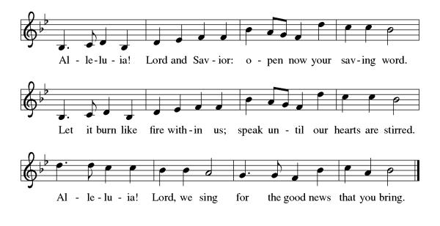

Gospel Reading: Matthew 10:40-42

L: The Holy Gospel according to Matthew. C: Glory to you, O Lord.
L: ⁴⁰ “Whoever welcomes you welcomes me, and whoever welcomes me welcomes the one who sent me. ⁴¹ Whoever welcomes a prophet in the name of a prophet will receive a prophet’s reward, and whoever welcomes a righteous person in the name of a righteous person will receive the reward of the righteous, ⁴² and whoever gives even a cup of cold water to one of these little ones in the name of a disciple—truly I tell you, none of these will lose their reward.”
L: The Gospel of the Lord. C: Praise to you, O Christ.

Reading: Genesis 1-2:2 ¹ When God began to create the heavens and the earth, ²the earth was complete chaos, and darkness covered the face of the deep, while a wind from God swept over the face of the waters. ³Then God said, “Let there be light,” and there was light. ⁴And God saw that the light was good, and God separated the light from the darkness. ⁵God called the light Day, and the darkness he called Night. And there was evening and there was morning, the first day.

⁶ And God said, “Let there be a dome in the midst of the waters, and let it separate the waters from the waters.” ⁷ So God made the dome and separated the waters that were under the dome from the waters that were above the dome. And it was so. ⁸ God called the dome Sky. And there was evening and there was morning, the second day.

⁹And God said, “Let the waters under the sky be gathered together into one place, and let the dry land appear.” And it was so. ¹⁰ God called the dry land Earth, and the waters that were gathered together he called Seas. And God saw that it was good. ¹¹ Then God said, “Let the earth put forth vegetation: plants yielding seed and fruit trees of every kind on earth that bear fruit with the seed in it.” And it was so. ¹² The earth brought forth vegetation: plants yielding seed of every kind and trees of every kind bearing fruit with the seed in it. And God saw that it was good. ¹³ And there was evening and there was morning, the third day.

¹⁴ And God said, “Let there be lights in the dome of the sky to separate the day from the night, and let them be for signs and for seasons and for days and years, ¹⁵ and let them be lights in the dome of the sky to give light upon the earth.” And it was so. ¹⁶ God made the two great lights—the greater light to rule the day and the lesser light to rule the night—and the stars. ¹⁷ God set them in the dome of the sky to give light upon the earth, ¹⁸ to rule over the day and over the night, and to separate the light from the darkness. And God saw that it was good. ¹⁹ And there was evening and there was morning, the fourth day.

²⁰ And God said, “Let the waters bring forth swarms of living creatures, and let birds fly above the earth across the dome of the sky.” ²¹ So God created the great sea monsters and every living creature that moves, of every kind, with which the waters swarm and every winged bird of every kind. And God saw that it was good. ²² God blessed them, saying, “Be fruitful and multiply and fill the waters in the seas, and let birds multiply on the earth.” ²³ And there was evening and there was morning, the fifth day.

²⁴ And God said, “Let the earth bring forth living creatures of every kind: cattle and creeping things and wild animals of the earth of every kind.” And it was so. ²⁵ God made the wild animals of the earth of every kind and the cattle of every kind and everything that creeps upon the ground of every kind. And God saw that it was good.
²⁶ Then God said, “Let us make humans in our image, according to our likeness, and let them have dominion over the fish of the sea and over the birds of the air and over the cattle and over all the wild animals of the earth and over every creeping thing that creeps upon the earth.”
²⁷ So God created humans in his image, in the image of God he created them; male and female he created them. ²⁸ God blessed them, and God said to them, “Be fruitful and multiply and fill the earth and subdue it and have dominion over the fish of the sea and over the birds of the air and over every living thing that moves upon the earth.” ²⁹ God said, “See, I have given you every plant yielding seed that is upon the face of all the earth and every tree with seed in its fruit; you shall have them for food. ³⁰ And to every beast of the earth and to every bird of the air and to everything that creeps on the earth, everything that has the breath of life, I have given every green plant for food.” And it was so. ³¹ God saw everything that he had made, and indeed, it was very good. And there was evening and there was morning, the sixth day.

2 ¹Thus the heavens and the earth were finished and all their multitude. ² On the sixth day God finished the work that he had done, and he rested on the seventh day from all the work that he had done.

Sermon Rev. Jeremiah Smith

Please stand as you are able

+Hymn of the Day: The Church of Christ in Every Age ELW #729

Apostle’s Creed WA: Let us confess the faith using the words of the Apostle’s Creed.
C: I believe in God, the Father almighty, creator of heaven and earth.
I believe in Jesus Christ, God’s only Son, our Lord, who was conceived by the Holy Spirit, born of the virgin Mary, suffered under Pontius Pilate, was crucified, died, and was buried; he descended to the dead. On the third day he rose again; he ascended into heaven, he is seated at the right hand of the Father, and he will come to judge the living and the dead.
I believe in the Holy Spirit, the holy catholic church, the communion of saints, the forgiveness of sins, the resurrection of the body, and the life everlasting. Amen.

Prayers of the People WA: Drawn into the embrace of the holy Trinity, we lift our prayers for the wholeness of the church, the world, and all creation. (a brief silence)
WA: Guide your church, O God. Anoint us for service and make us messengers of your peace. Empower us to walk in the way of love, to welcome the excluded and care for the vulnerable, to work for justice, and rejoice in the spirit of life. God of grace, C: hear our prayer.

WA: Uphold all who suffer, O God. Give refuge to those of us who know
rejection, to LGBTQ+ children and youth who struggle with isolation and shame, and bring your loving presence to those we name aloud or in the silence of our hearts…. God of grace, C: hear our prayer.

WA: Set free this assembly, O God. Grow your Spirit’s fruits within us and within our congregation’s ministries. Set our faces always on you, that we might live in the freedom to which you have called us and build a community where are all truly welcomed. God of grace, C: hear our prayer.

WA: Fill our hearts with joy, O God. We give thanks for the gift of diversity and bodies of all colors, sizes, and genders. For the gift of love and different ways in which we can love one another. For the gift of community and families that extend beyond biology. God of grace, C: hear our prayer.

WA: Embrace all your saints, O God. On this Pride Sunday, we remember those who have gone before us. Those like Joan of Arc who challenged gender norms, those like Marsha Johnson whose courage inspired, those like Matthew Shepherd who were martyred. We give thanks for all who blazed the trail for equality and pray for those who continue to fight for justice. Let us rejoice that you do not abandon us to the grave but lead us on the path of life. God of grace, C: hear our prayer.
WA: Gather all our prayers in your mercy, O God, through Jesus Christ, our Savior. C: Amen.

Peace
P: The peace of Christ be with you always. C: And also with you.
Meal - God feeds us with the presence of Jesus Christ

Offering
We are grateful to those who help sustain our mission. To donate online, please use QR code:


Offering Music: “Testify to Love” by Henk Pool, Robert Riekerk, Ralph Van Manen & Paul Field.
PLC Choir

+ Offering Prayer
WA: Let us pray together:
C: Loving God, we offer at your table the gifts of our hearts. Help us take heart in you and share freely of your love, so that all creation can taste your abundance. We ask this in the name of Jesus, through the Spirit abiding with us now and forever. Amen.

+ Offertory Song: For the Fruit of All Creation ELW #679
(printed next page)

Great Thanksgiving
P: The Holy One be with you. C: And also with you.
P: Open your hearts to the One who is Love.
C: We open our hearts to you, O God.
P: Let us give thanks to God who shapes our world.
C: For every creature and creation, we give you thanks, O God!

Preface
P: Indeed, we give you thanks, our Divine Creator. You declared from the beginning that we were created in your image, a reflection of what is holy, each, in our own way, a glimpse of you. We praise the works of your creative hand that fills our life with beauty. Every flower that blooms, every animal that delights, every body of water that sustains our life – all part of your good works.
Despite the abundance of life around us, we still turn to destruction. Each in our own ways, we have failed to embrace you by failing to embrace all your people, especially those different than us. We have, at times, sided with political and religious powers that refuse to recognize your image in all people.
And so we turn to Jesus, who showed us what it looks like to live into our true selves as people of God. He was humble yet grounded in your love for him. He sought out the despised and made them friends. He confronted every power that belittled, marginalized, and oppressed. His commitment to living out the image of God enfleshed could not be swayed, even in the face of death. And so, with all the choirs of angels, with the church on earth and the host of heaven, we praise your name and join their unending hymn:

Holy Holy Holy ELw setting 10 (p. 207)
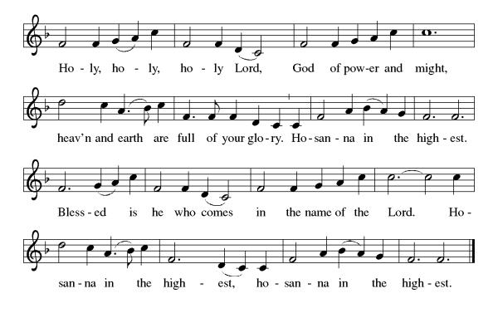

Thanksgiving at the Table

P: On the night of his arrest, he gathered around table with his companions.
He took bread, blessed it, broke it, gave it to his disciples and said, “This is my body which is given for you. Do this in remembrance of me.”
He did the same with the cup after the supper, saying, “This cup that is poured out is the new covenant. Do this for the remembrance of me.”
Even in death, O God, your love prevailed. Through you Spirit, Christ was raised from the grave. No person, no institution, no force of evil could extinguish the work of your hand.
And so, by the same Spirit, bless these gifts of bread and cup that they may be the living Christ within us today; compelling us to be agents of love, uncompromising on our commitment to protecting every one of your creatures and creations.
C: Amen.

Lord’s Prayer
P: Lord, remember us in your kingdom and teach us to pray.
C: Our Father in heaven, hallowed be your name, your kingdom come, your will be done, on earth as in heaven. Give us today our daily bread. Forgive us our sins as we forgive those who sin against us. Save us from the time of trial and deliver us from evil. For the kingdom, the power, and the glory are yours, now and forever. Amen.

Invitation to the Table
At Parkside Lutheran Church we have an open table. We believe the invitation to receive comes from Jesus himself and all are welcome at Christ’s table. More than just Bread and Wine these are tangible signs of God’s love for you! If you do not wish to receive communion but would like a blessing, come forward and cross your arms over your chest. The Pastor will give you a blessing before you return to your seat via the side aisle. You’ll receive a communion wafer* in your hands. You may dip it in the cup of wine or juice. When giving the bread and cup, the communion ministers say: “The body of Christ, given for you. The blood of Christ, shed for you.”
and each person may respond: Amen
*Please let Pastor know if you need a gluten-free wafer
P: Heaven has come near. Come, share in the feast!

The Communion Distribution

Communion Song ELW setting 10 (p. 208)
(printed next page)

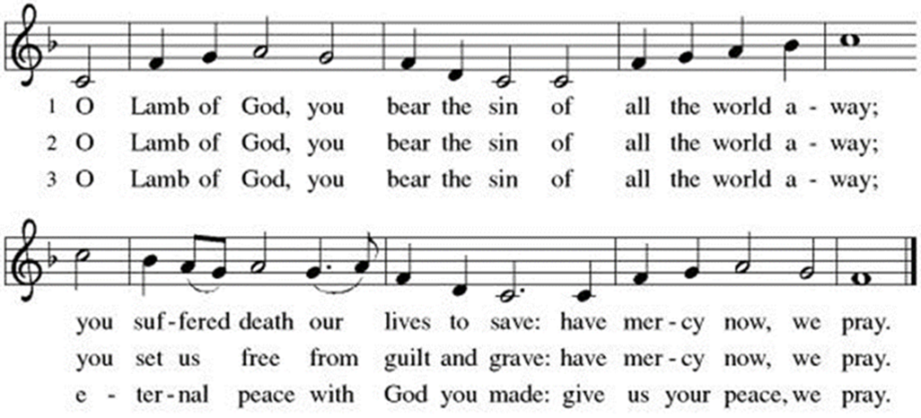

Communion Song: Let Us Break Bread Together ELW # 471
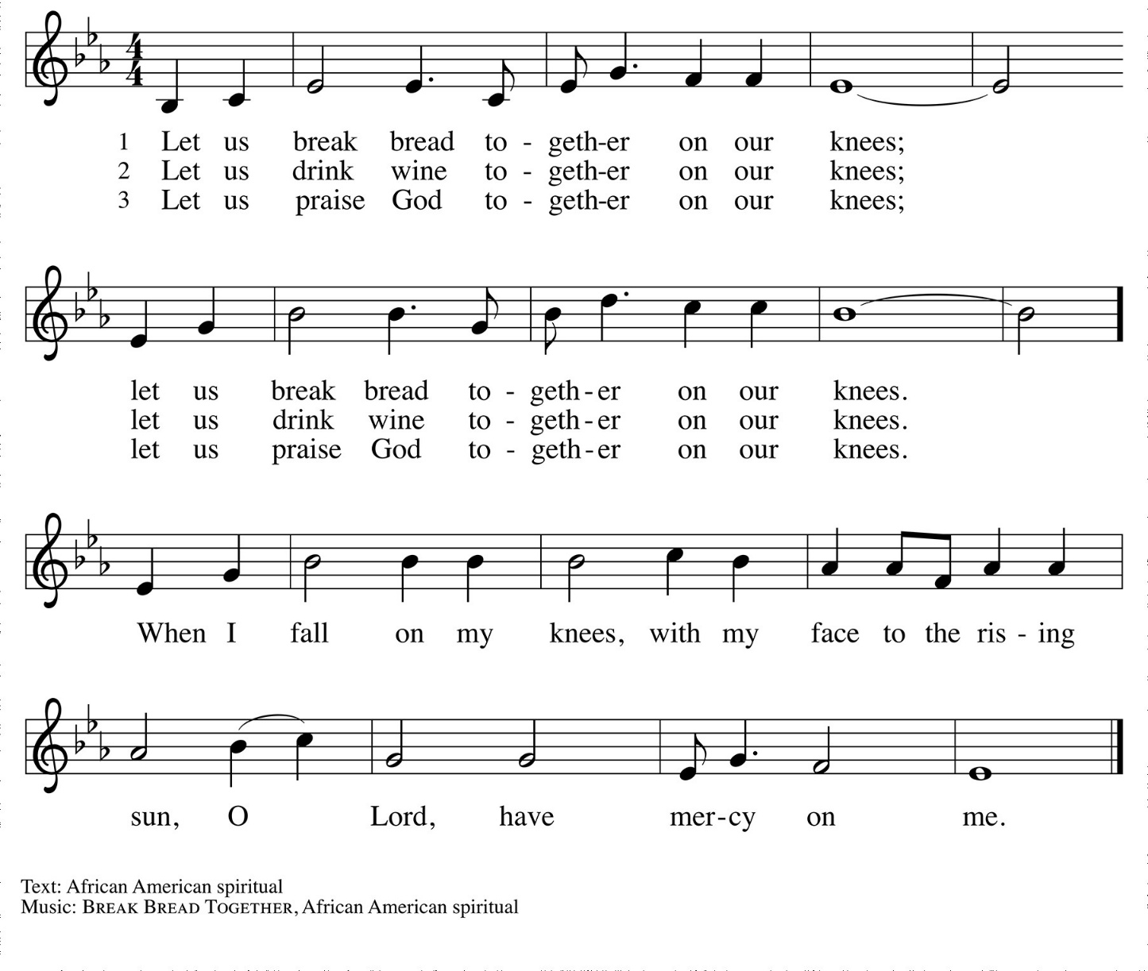

Communion Song: Sanctuary
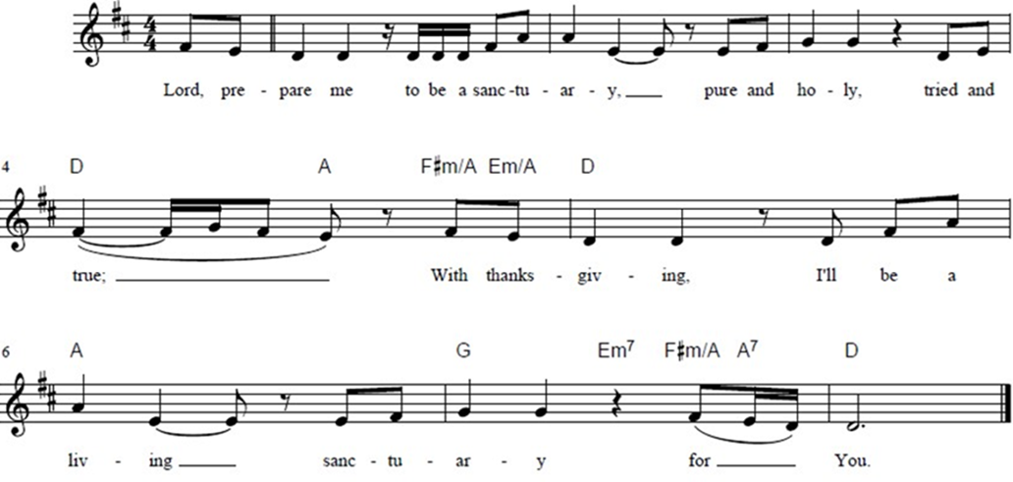

Post Communion Blessing
P: The Body and Blood of our Lord and Savior, Jesus Christ, strengthen you and keep you in God's grace. C: Amen.

Prayer After Communion
WA: Let us pray together.
C: God of abundance, we give you thanks for the grace we experience at your Table. For forgiveness. For connection. For sustenance. For a renewed vision of who we are. Our gratitude abounds. Amen.

Sending - God blesses us and sends us in mission to the world.

Blessing
P: Beloveds, may we go from here looking for every opportunity to take our place in God’s lineage of love and liberation. May we refuse to comply with evil’s demands. May we delight in the opportunity to share what we have. May we search our hearts and seek understanding. For Christ is alive in this beautiful and burdened world. Let us go and live the good news. In the name of the Father, Son+, Holy Spirit, Mother, Beloved +, Love. C: Amen.

Sending Hymn: A Hymn for Self-Acceptance
(printed next page)
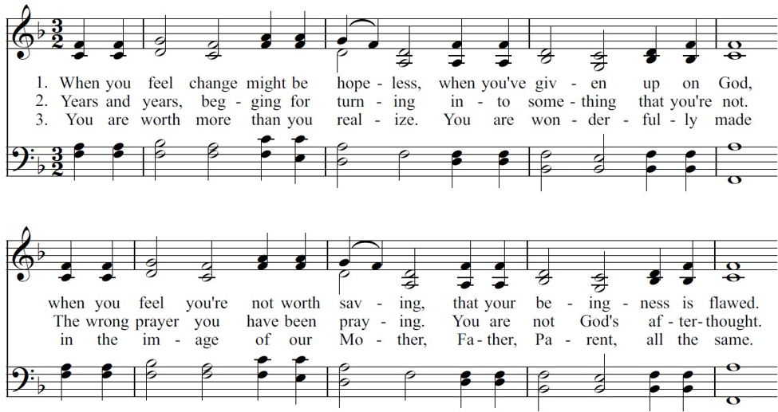

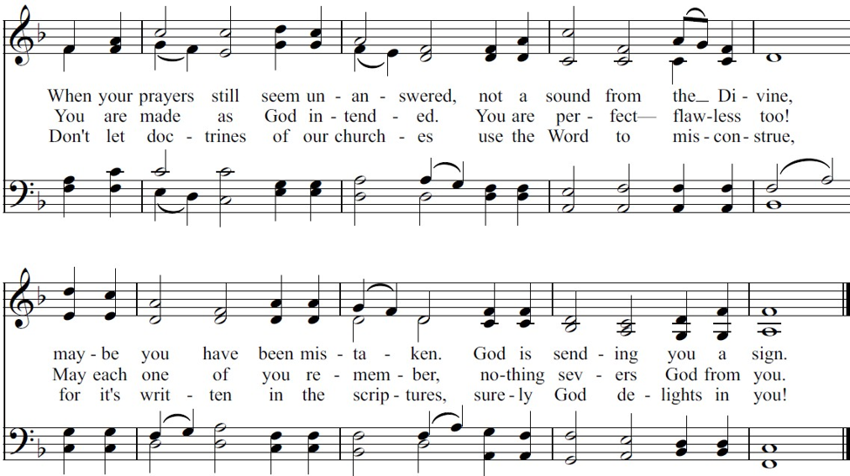

Dismissal and Postlude
P: Parkside Lutheran Church is rediscovering the radical love of Jesus.
C: Gathering All, Serving All, Caring for All
P: Heaven has come near. Go, share the good news!
C: Thanks be to God.

ELW Music licensed from Sundays & Seasons, Augsburg Fortress CCLI MUSIC License # 11440069 , CCLI Streaming License#21835523 Do not duplicate any music or Liturgy herein without license and permission
scripture readings adapted and written by susan lukey

PARKSIDE STAFF:
• The Rev. Jeremiah Smith: prjeremiahpsmith@gmail.com
• Kris Pope & Suzanne Gracie, Admin. Assistants (Church Office): parksidelutheran@gmail.com
• Mike Hooker, Music Director: mrhooker@me.com
CHURCH OFFICE HOURS: M/T/R 10:00am-3:00pm (716)836-1361

Acolytes: |  | Worship Assistants:
6/28 – Annalie & Lorenzo |  | 6/28 – John
7/5 – David & Chris |  | 7/5 – Susan
Readers: |  | Ushers:
6/28 – Josiah |  | 6/28 – Shannon, Rickey, John
7/5 – Kathie |  | 7/5 – Sue, Zack, Elaine

Coming up:
July 5th – Confirmation Sunday
July 19th – Volunteer Meeting for Vacation Bible School, after Worship
July 15th – Brewing Theology 7pm at the Nowhere Lounge
August 2nd – Outdoor Worship
August 19th – Volunteer Meeting for Vacation Bible School – 5:30pm
August 24th – 28th – Vacation Bible School *SAVE THE DATE*

Visit our website for more information about these and other Events at Parkside – www.parksidelutheran.org/events

