TLC Weekly: Sunday, June 28 – July 5
Vicar Angie DeSmith cell: 507-828-4941 email: amgiedesmith316@gmail.com
The Radio Broadcast (KMHL 1400AM or 101.7FM) is sponsored in honor of Kathy Filter’s birthday. Happy Birthday Kathy!
Sunday, June 28 9am Worship
10am Coffee Fellowship
Monday, June 29 NO Men in Mission
Wednesday, July 1 9am Do Day Mission Work Day
Friday, July 3 OFFICE CLOSED
Saturday, July 4 Happy 4th of July
Sunday, July 5 9am Worship/Holy Communion
10am Coffee Fellowship

Please continue to Remember in Prayer:
Please…
We are happy to include people in our prayer list, but we must have their permission to be included. Many folks are very private about what is happening in their lives and we want to honor that.
Peggy Isaacson – LaVerne Jessen’s daughter, cancer
Steve Vickerman – health issues
Kim Mickelson – cancer-cousin of Kari Meyer & Kris Tiegs
Vicki Schaar – Cancer
Lawrence Nyquist – Cancer, starting treatments, uncle of Dan &
Carl Nyquist
Mike Hemish – son of Doris Hemish
Mary Christian – fell, fracture of L2 (back)
Cora Ourada – mass in stomach – granddaughter of David & Linda Rykhus

July Acolytes: Otto Nyquist, Vincent Munson

July Altar Preparation: Carolyn Engelkes, Karen Krog

July Communion Servers: Sandy Fultz, Darcy Carlson, Eric Fultz

Coffee Fellowship: Sunday, June 28 Dennis & Anita Fultz
Sunday, July 5 OPEN

Scripture Readers: Sunday, June 28 Sheila Helleson
Sunday, July 5 Swede Campbell

Greeters: Sunday, June 28 OPEN
Sunday, July 5 OPEN

Sunday Counters: Sunday, June 28 Matt LaVoy
Sunday, July 5 Melody Caron

Ushers: Sunday, June 28 Chris Kamrud, Ronnie Dahl, Wayne Anderson, Darrell Christian
Sunday, July 5 Mark Peterson ,Jim Julien, Mike Carlson, Larry Retzlaff

Radio opening for the month of July: 12th and 26th
Tracy Area Garden and Quilt Tour is July 8th, 2-7:30pm. Tickets $20 includes St Mary’s Pie and ice cream served at Key Largo. Check the kiosk for further details.
Attention youth group and families, or anyone who would like to help:
Currie Town and Country needs 12 volunteers to work the community picnic on July 4th. Arrive at 10:30, serve the hotdog and hamburger meal from 11am-1pm. For several years now they have been very generous and donated to our youth program to help offset the cost of our mission trips. Please contact Sara Swenhaugen if you are able to volunteer.

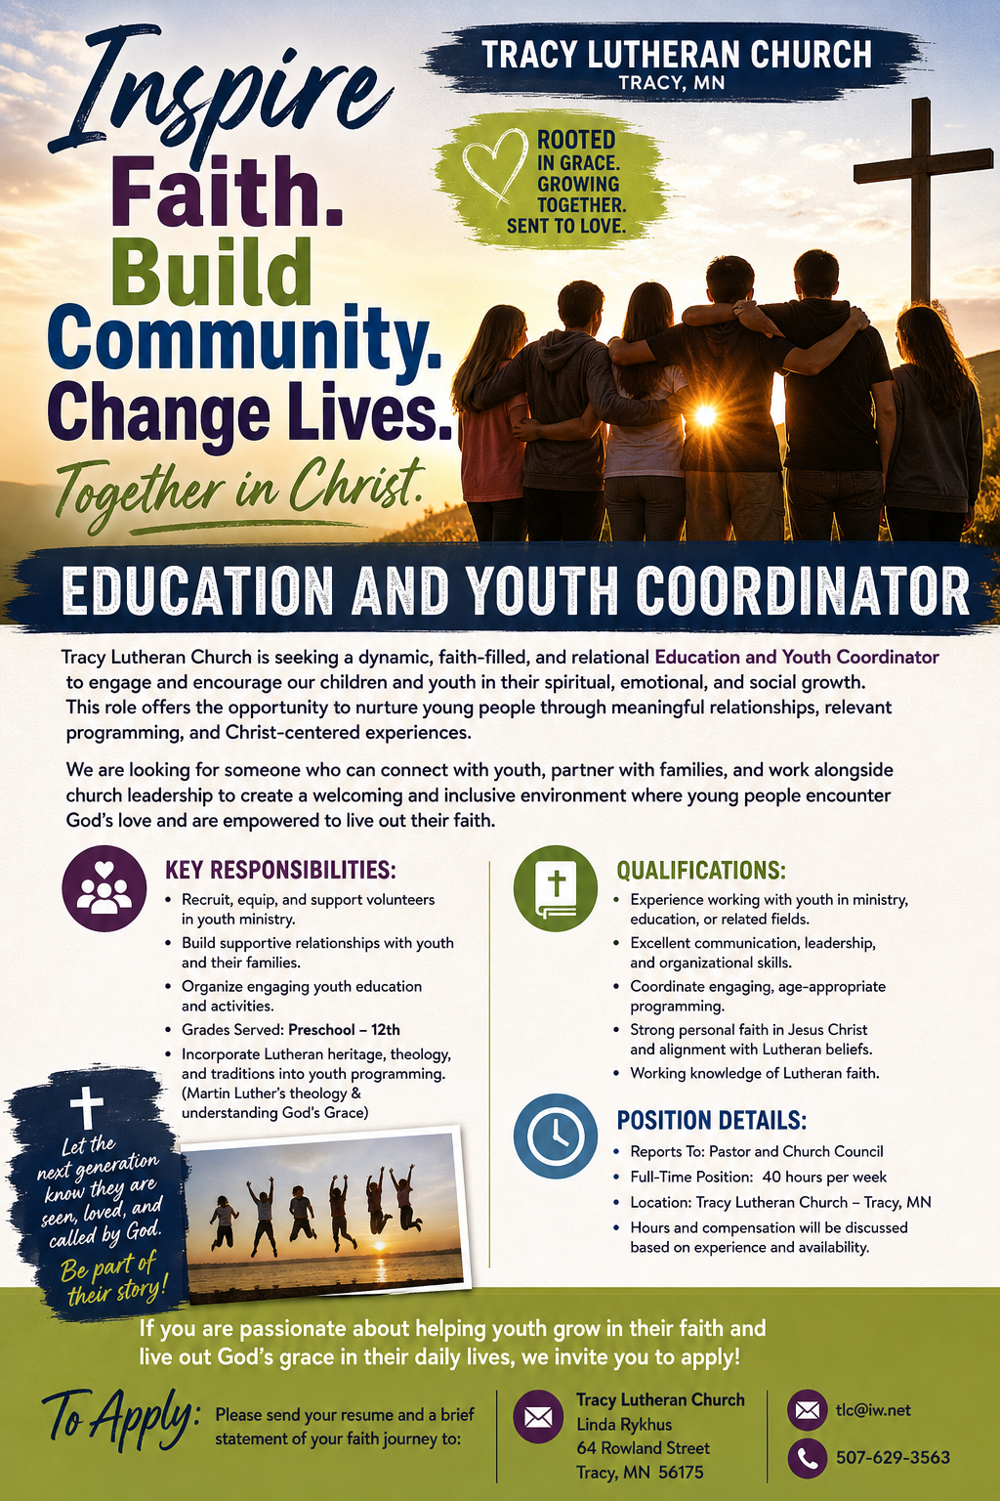
At the request of council president, Dennis Fultz, Tracy Lutheran Church is recognized as a Synod -Authorized Ministry site. Angie DeSmith has been authorized by Southwestern Minnesota Synod Bishop Dee Pederson to preach and preside for
Holy Communion in the congregation . The authorization is granted in accord with the ELCA’s guiding statement, The Use of the Means of Grace , which recognizes the witness of the sacrament as a celebration of the Church, serving its unity and
proclaiming the Gospel; and that where it is not possible to provide ordained pastoral leadership, a synod bishop may authorize a properly trained person to preside at a certain time.

