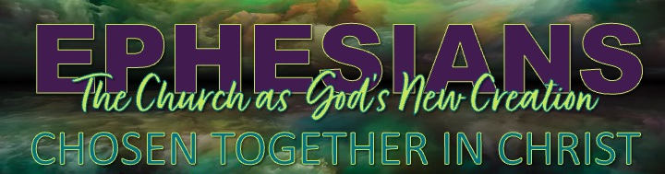

Discussion Questions & Practice

- Where do people today look for identity and belonging?
- Why do those places often leave us feeling unsatisfied?
- How is Paul's vision of belonging in Christ different?

- Paul repeatedly uses the words "us," "we," and "our."
- Why do you think Paul emphasizes the church as a community rather than focusing only on individual faith?
- How does this challenge the way many Christians view church today?

- What stood out to you about the idea that predestination is about purpose as well as destination?
- What does it mean that God chose His people to display His grace, reflect His character, and participate in His mission?

- The church is meant to be a "preview of God's future world."
- Where have you experienced glimpses of that reality through forgiveness, generosity, reconciliation, or love?
- What might God be inviting you to contribute to His family this week?

Spiritual Practice for the Week

Practicing Family Belonging

Theme Verse: Ephesians 1:5
"He predestined us for adoption to sonship through Jesus Christ, in accordance with his pleasure and will."

This week, intentionally move from being a spectator to being a participant in God's family. Each day:

1. Begin with Belonging
Spend two minutes in silence and pray:

“Father, thank You that I am not an outsider.
Through Christ, You have welcomed me into Your family.
Teach me to live today as Your beloved child.”

2. Read Ephesians 1:3–14 Slowly
Pay attention to every occurrence of: us, we, and our

Notice how often Paul speaks of God's people together.

3. Practice One Family Action
Each day choose one intentional act that reflects life in God's family:
- encourage someone
- share a meal
- make a phone call
- pray for another believer
- offer forgiveness
- serve someone quietly
- invite someone into conversation
- write a note of encouragement

4. End the Day with Reflection
Ask:
- When today did I experience God's family?
- When did I act like a participant rather than a consumer?
- How did I help make God's future kingdom visible today?

Closing Thought

The goal of this practice is not simply to think about belonging. It is to experience it.

Because Ephesians reminds us that the church is not an event we attend. It is a family we belong to. And every act of love becomes a small preview of the day when heaven and earth are finally brought together in Christ.

