Libya belonging to Cyrene, and visitors from Rome, 11 both Jews and proselytes, Cretans and Arabians

Probably a partial list given the statement in Acts 2:5 about Jews from “every nation under heaven”.

Compare the list of nations in Acts 2 to Genesis 10

Genesis 10:32 (ESV) 32 These are the clans of the sons of Noah, according to their genealogies, in their nations, and from these the nations spread abroad on the earth after the flood.

Genesis 11:7-9 (ESV) 7 Come, let us go down and there confuse their language, so that they may not understand one another’s speech.” 8 So the LORD dispersed them from there over the face of all the earth, and they left off building the city. 9 Therefore its name was called Babel, because there the LORD confused the language of all the earth. And from there the LORD dispersed them over the face of all the earth.

Deuteronomy 32:7-9 (ESV) 7 Remember the days of old; consider the years of many generations; ask your father, and he will show you, your elders, and they will tell you. 8 When the Most High gave to the nations their inheritance, when he divided mankind, he fixed the borders of the peoples according to the number of the sons of God.9 But the LORD’S portion is his people, Jacob his allotted heritage.

Pentecost is not a complete reversal of Babel—different languages remain—but it marks the beginning of God's plan to reclaim the nations through the gospel.

The Human Response: Sincere Inquiry or Human Mockery (Acts 2:12-15)

Miracles are never the point in and of themselves. They are never self-authenticating. A miracle does not bypass the will but creates a moment of decision that demands an interpretation and explanation.

Luke 16:31 (ESV) 31 He said to him, ‘If they do not hear Moses and the Prophets, neither will they be convinced if someone should rise from the dead.’”

Romans 1:18-19 (ESV) 18 For the wrath of God is revealed from heaven against all ungodliness and unrighteousness of men, who by their unrighteousness suppress the truth. 19 For what can be known about God is plain to them, because God has shown it to them.

Two Responses:
Group # 1 Acts 2:12 (ESV) 12 And all were amazed and perplexed, saying to one another, “What does this mean?”
Group # 2 Acts 2:13 (ESV) 13 But others mocking said, “They are filled with new wine.”

Peter’s response: Acts 2:15 (ESV) 15 For these people are not drunk, as you suppose, since it is only the third hour of the day. (9am)

The miracle was never meant to be the focus but merely the platform.

Acts 2:41 (ESV) 41 So those who received his word were baptized, and there were added that day about three thousand souls.
Sunday, June 21, 2026 ACTS—The Confident Witness of Jesus Christ
Chris Lenoir No. 5 | Arrival of the Holy Spirit, pt. 1

Acts 2:1-15

Context

Throughout Chapter 1 the disciples faithfully wait for the promise of the Holy Spirit.

Acts 1:4-5 (ESV) 4 And while staying with them he ordered them not to depart from Jerusalem, but to wait for the promise of the Father, which, he said, “you heard from me; 5 for John baptized with water, but you will be baptized with the Holy Spirit not many days from now.”

Acts 1:8 (ESV) 8 But you will receive power when the Holy Spirit has come upon you, and you will be my witnesses in Jerusalem and in all Judea and Samaria, and to the end of the earth.”

Pentecost = Greek word for “fiftieth”

Known as the “Feast of Weeks” in the Old Testament (Exodus 23:16, 34:22; Leviticus 23:15-21; Numbers 28:26-31; Deuteronomy 16:9-12)

Leviticus 23:15-16 (ESV) 15 “You shall count seven full weeks from the day after the Sabbath, from the day that you brought the sheaf of the wave offering. 16 You shall count fifty days to the day after the seventh Sabbath. Then you shall present a grain offering of new grain to the LORD.

One of three pilgrimages that every Jewish male was expected to appear before God in Jerusalem

Deuteronomy 16:16-17 (ESV) 16 “Three times a year all your males shall appear before the LORD your God at the place that he will choose: at the Feast of Unleavened Bread, at the Feast of Weeks, and at the Feast of Booths. They shall not appear before the LORD empty-handed. 17 Every man shall give as he is able, according to the blessing of the LORD your God that he has given you.”

The diaspora scattered the Jewish people among the nations; Pentecost brought pilgrims from those nations to Jerusalem.

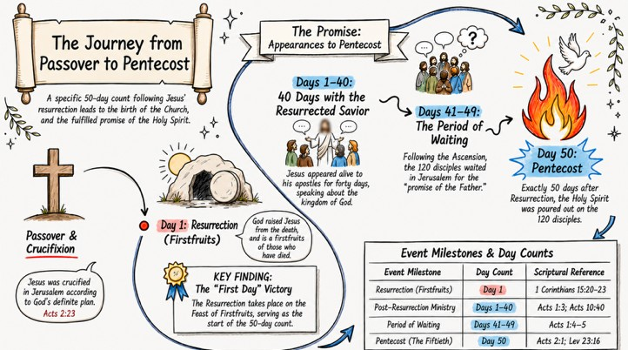
Acts 2:5 (ESV) 5 Now there were dwelling in Jerusalem Jews, devout men from every nation under heaven.

The Holy Spirit's Arrival: Unmistakable Presence of God (Acts 2:1-4)

The Holy Spirit arrives with Audible and Visible signs of His presence (Acts 2:2-3)

The Audible Sign
- Acts 2:2 (ESV) 2 And suddenly there came from heaven a sound like a mighty rushing wind, and it filled the entire house where they were sitting.

Loud enough that it drew a large crowd
- Acts 2:6 (ESV) 6 And at this sound the multitude came together,

3000+ people (Acts 2:41)

The Visual Sign
- Acts 2:3 (ESV) 3 And divided tongues as of fire appeared to them and rested on each one of them.

o “Rested” - “to sit down to settle”
- Not actual fire but “as of fire” (it did not consume them; it did not burn them)
- Why fire? – The Tongues of fire portray the presence of God.
  - Genesis 15:17; Exodus 3:2-6, 13:21-22, 19:18, 40:38)
  - Exodus 3:2-6 (ESV) 2 And the angel of the LORD appeared to him in a flame of fire out of the midst of a bush. He looked, and behold, the bush was burning, yet it was not consumed… 4 When the LORD saw that he turned aside to see, God called to him out of the bush, “Moses, Moses!” And he said, “Here I am.”
… 6 And he said, “I am the God of your father, the God of Abraham, the God of Isaac, and the God of Jacob.” And Moses hid his face, for he was afraid to look at God.

Baptism of the Spirit (Acts 2:3)

While the words “baptism of the Spirit” is never used in Acts 2. Acts 2:3 is generally considered the point in which the baptism of the Spirit first takes place among the church.

Romans 8:9 (ESV) 9 You, however, are not in the flesh but in the Spirit, if in fact the Spirit of God dwells in you. Anyone who does not have the Spirit of Christ does not belong to him.

Acts 11:15-18 (ESV) 15 As I began to speak, the Holy Spirit fell on them just as on us at the beginning. 16 And I remembered the word of the Lord, how he said, ‘John baptized with water, but you will be baptized with the Holy Spirit.’ 17 If then God gave the same gift to them as he gave to us when we believed in the Lord Jesus Christ, who was I that I could stand in God’s way?” 18 When they heard these things they fell silent. And they glorified God, saying, “Then to the Gentiles also God has granted repentance that leads to life.”

Definition: Spirit baptism is the work of the ascended Jesus "immersing" or "inundating" the believer with the Spirit of God to connect them to the church and empower them for His mission from Pentecost to the end of this age.
“they were all filled with the Holy Spirit” (2:4)

Separate and distinct from the baptism of the Spirit

In Acts filling of the Spirit is associated with the following:
- Speak in foreign languages (Acts 2:4)
- Boldness (Acts 4:8, 31)
- Visions (Acts 7:55)
- Miracles of healing/judgement (Acts 9:17, 13:9)
- Joy (Acts 13:52)

Filling of the Spirit could take place prior to Pentecost
- John the Baptist (Luke 1:15-16)
- Elizabeth (Luke 1:41)
o Zechariah (Luke 1:67)
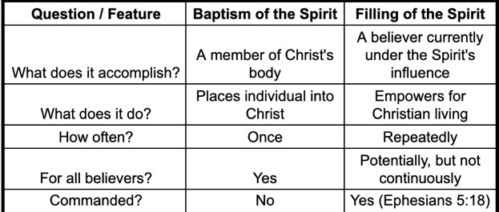

God’s Strategy: Seeding the Nations for Global Reach (Acts 2:5-11)

Tongues are real understandable languages, not ecstatic utterances

Definition: “tongue” - γλῶσσα glōssa - the tongue; by implication, a language

Acts 2:4 (ESV) 4 And they were all filled with the Holy Spirit and began to speak in other tongues as the Spirit gave them utterance.

Acts 2:6 (ESV) 6 And at this sound the multitude came together, and they were bewildered, because each one was hearing them speak in his own language.

Acts 2:7 (ESV) 7 And they were amazed and astonished, saying, “Are not all these who are speaking Galileans?
Acts 2:8 (ESV) 8 And how is it that we hear, each of us in his own native language? Acts 2:11 (ESV) we hear them telling in our own tongues the mighty works of God.”
1 Corinthians 14:22 (ESV) 22 Thus tongues are a sign not for believers but for unbelievers,
while prophecy is a sign not for unbelievers but for believers.

Seeding the Nations with the Gospel

Acts 2:9-11 (ESV) 9 Parthians and Medes and Elamites and residents of Mesopotamia, Judea and Cappadocia, Pontus and Asia, 10 Phrygia and Pamphylia, Egypt and the parts of

